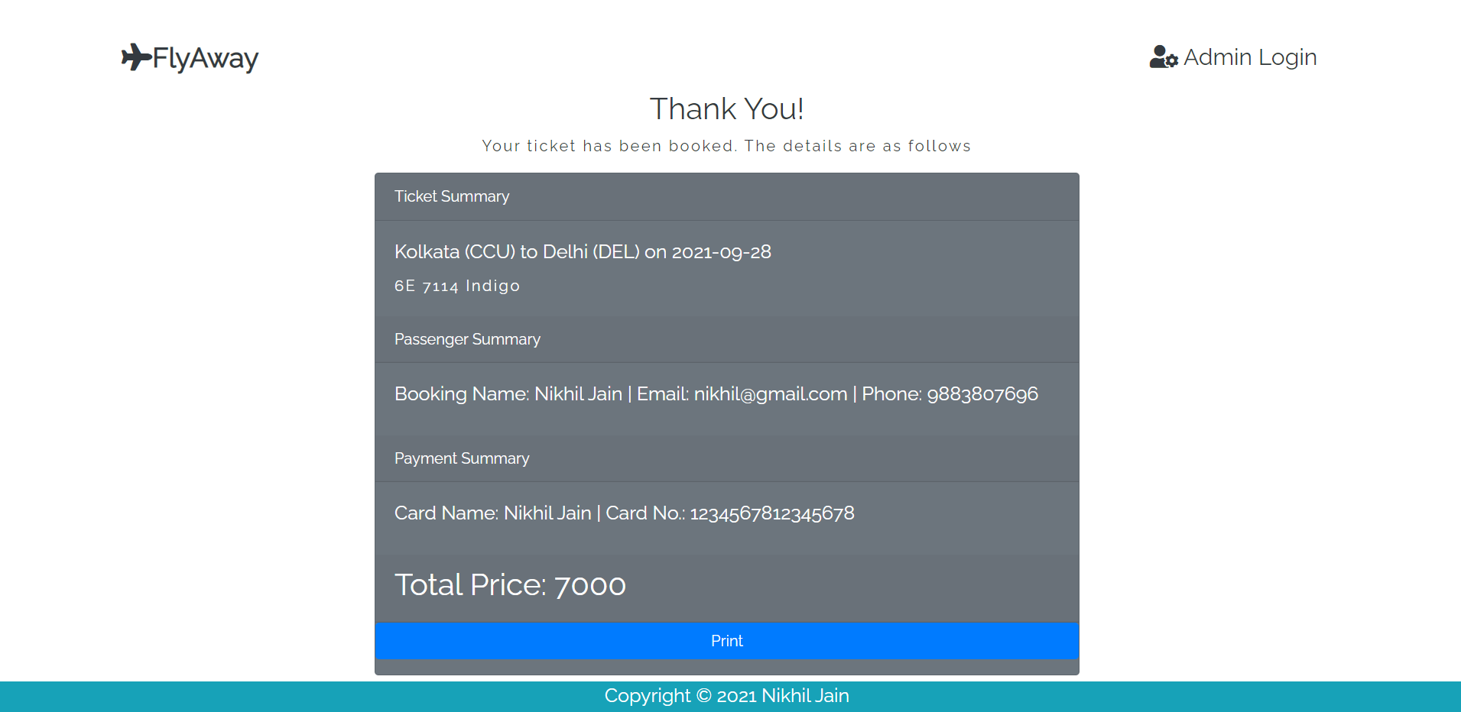

Print

Ticket Summary

Kolkata (CCU) to Delhi (DEL) on 10-01-2023

6E 249 Indigo

Passenger Summary

Booking Name: Jaydeep K M| Email: [Jay04shiva@gmail.com|](mailto:Jay04shiva@gmail.com|) Mob: 9836559288

Payment Summary

Card Name: Jaydeep K M | Card No: 1234567891234567989

Total Price : 7000

Copyright © 2023 Jaydeep Kumar Mandal

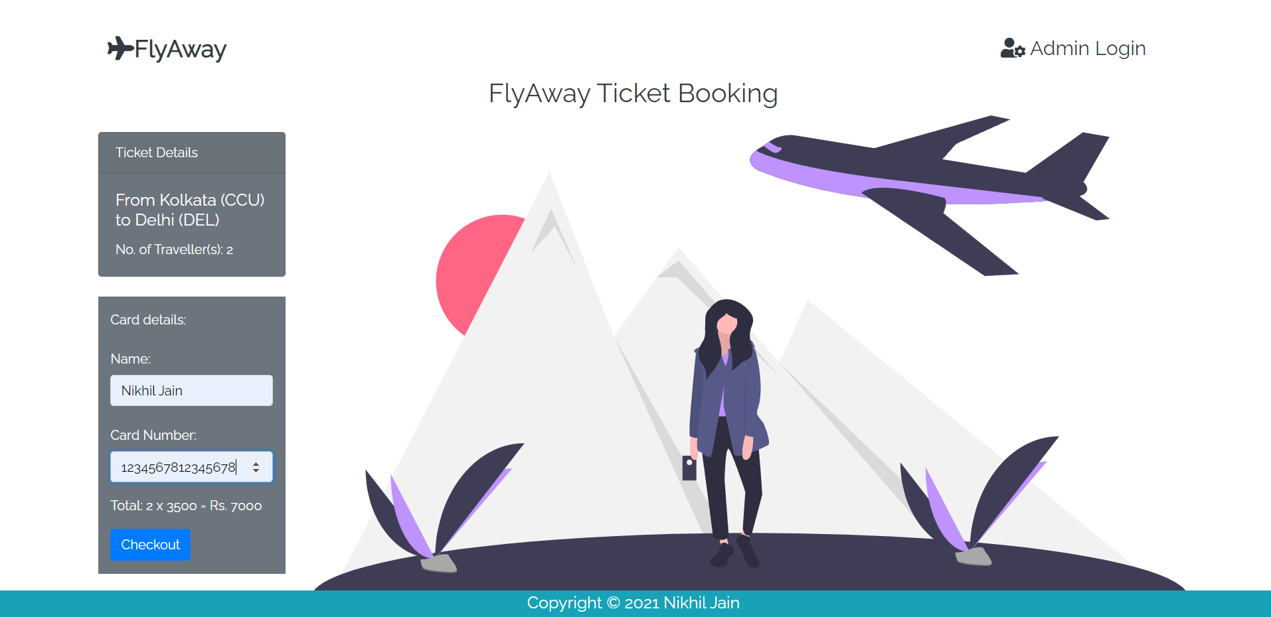

12345678912345678

Jaydeep K M

Copyright © 2023 Jaydeep Kumar Mandal

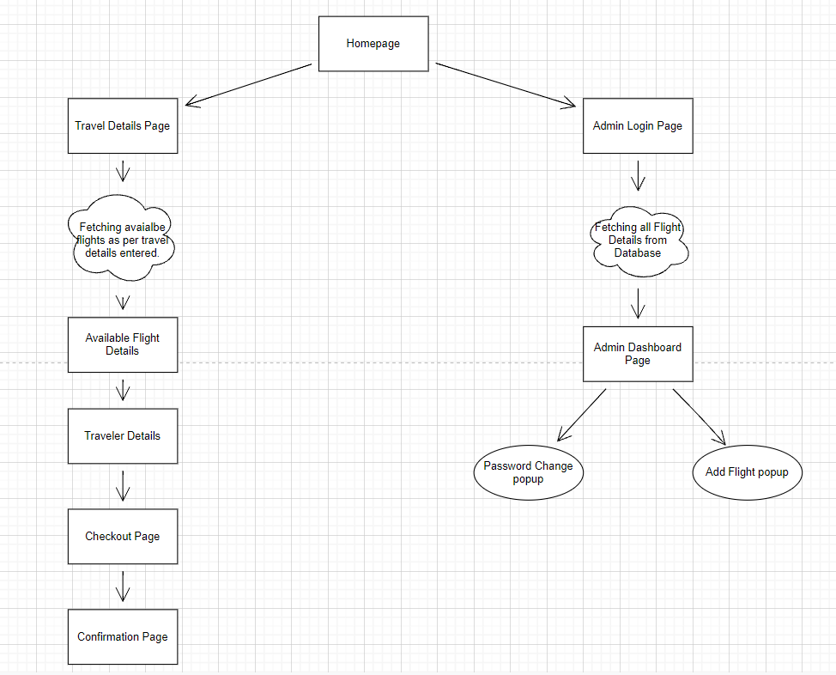

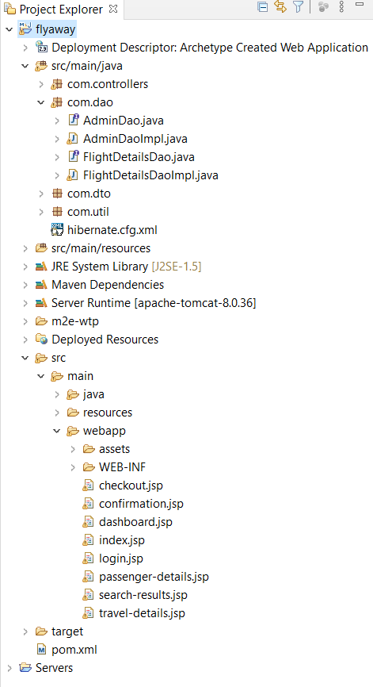

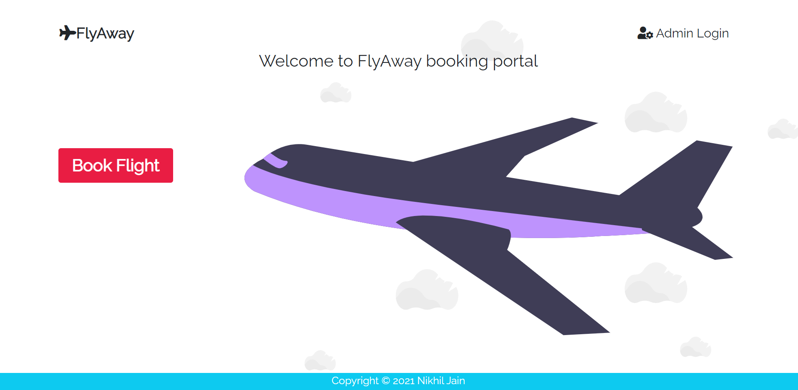

Copyright © 2023 Jaydeep Kumar Mandal

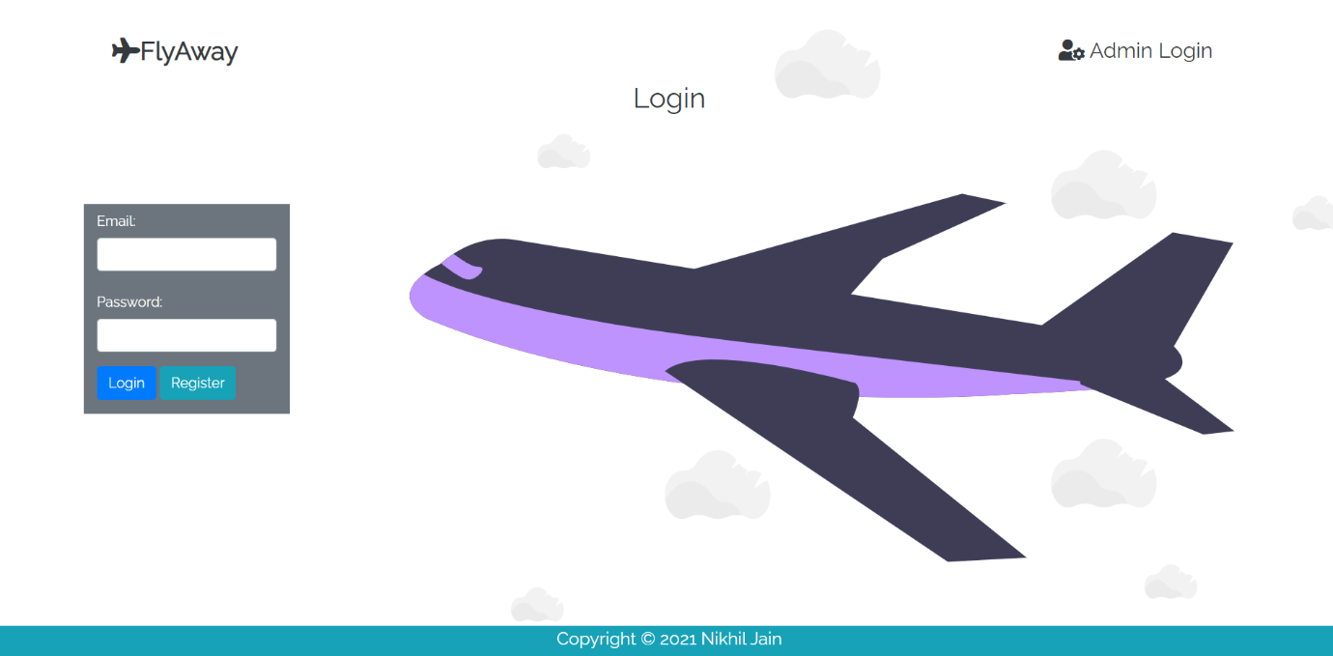

Copyright © 2023 Jaydeep Kumar Mandal

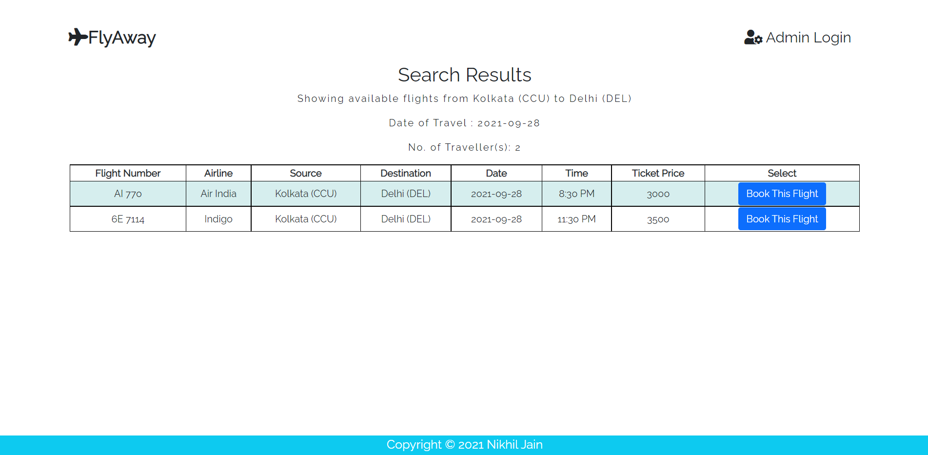

6E 249

Copyright © 2023 Jaydeep Kumar Mandal

10-01-2023

10-01-2023

10-01-2023

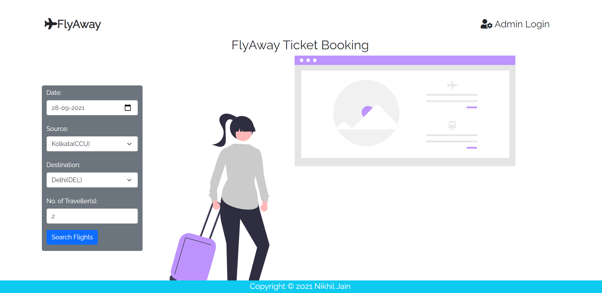

15-01-2023

Copyright © 2023 Jaydeep Kumar Mandal

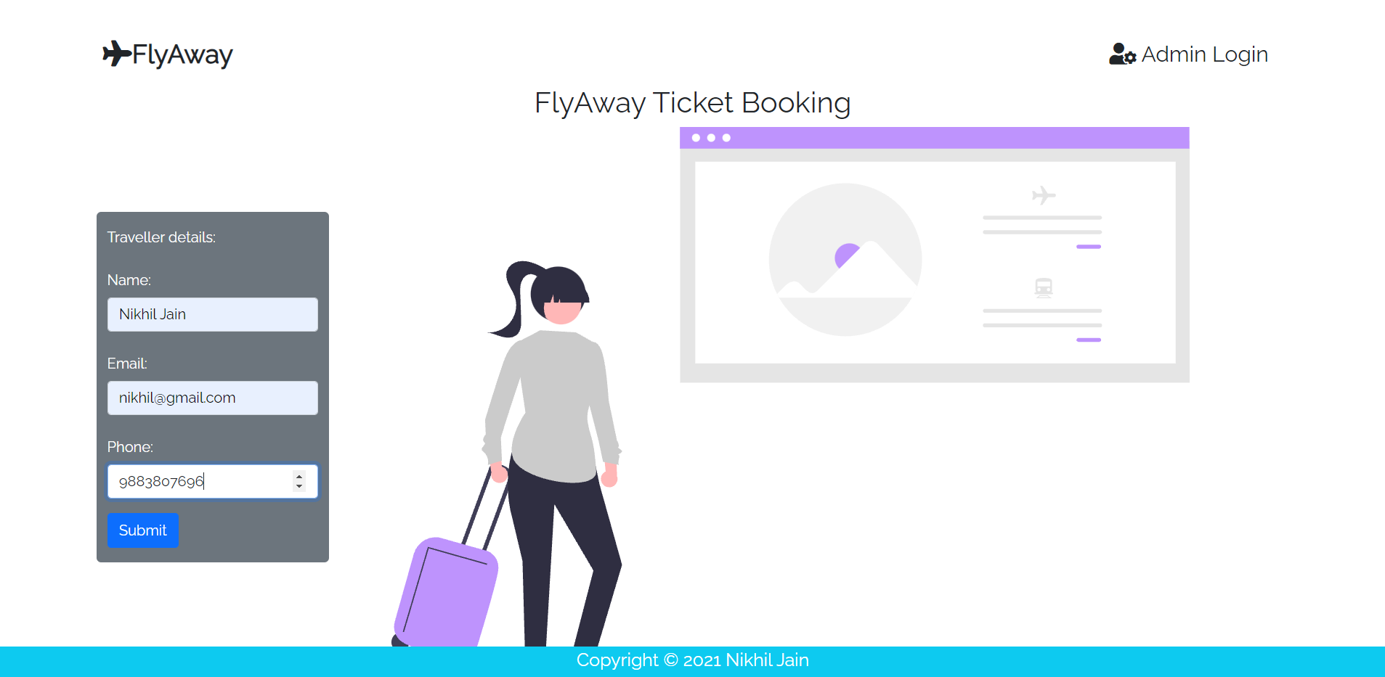

9836559288

Jay04shiva@gmail.com

Jaydeep K M

Copyright © 2023 Jaydeep Kumar Mandal