DEEP LEARNING FRAMEWORKS FOR MONAURAL SPEAKER SEPARATION AND ZERO-SHOT COMPOUND MULTI-NOISE SPEECH ENHANCEMENT
A Minor Project Report Submitted in Partial Fulfilment
of the Requirements for the Degree of
Bachelor of Technology
in
Information and Communication Technology
Submitted by:
Jaydeep Parmar – 23BIT133
Yatharth Tadvi – 23BIT143
Department of Information and Communication Technology (ICT)
Under the Supervision of:
Dr Jigarkumar Shah
Department of Computer Science and Engineering
Pandit Deendayal Energy University.

OCTOBER 2026
ACADEMIC YEAR 2026-2027

ABSTRACT
This minor project investigates deep learning methods to solve the cocktail party problem from single-channel monaural audio. We develop two distinct engineering pipelines: monaural blind speaker separation (Track 1) and zero-shot compound multi-noise speech enhancement (Track 2). Track 1 implements a time-domain convolutional audio separation network (Conv-TasNet) using 1D dilated convolutions, trained with Utterance-Level Permutation Invariant Training (uPIT). Evaluated on 14,269 LibriSpeech mixture pairs across 251 speakers, Conv-TasNet achieves +13.13 dB SI-SDR gain. A natural spectral Wiener post-filter raises the perceptual evaluation of speech quality (PESQ) score from 2.18 to 2.32 while eliminating synthesis artifacts. Track 2 deploys MossFormerGAN in the complex STFT domain to suppress non-stationary compound noise. Across a rigorous 25-mixture benchmark combining babble, traffic, engine, and white noise, MossFormerGAN achieves +8.99 dB SI-SDR gain, +1.184 PESQ improvement, and 87.18% noise energy attenuation without speech clipping. This work establishes an empirical framework for real-world hearing assistance, teleconferencing, and automatic speech recognition.
TABLE OF CONTENTS
1. Introduction 3
1.1 Background and Problem Definition 3
1.2 Problem Formulation: Separation vs. Enhancement 3
1.3 Project Objectives and Scope 4
2. Literature Review 4
2.1 Classical Single-Channel Processing & Spectrogram Phase Limits 4
2.2 Time-Domain Separation and Complex Attention Networks 5
3. Methodology and System Design 5
3.1 Dual-Track Architecture & Conv-TasNet Topology 5
3.2 Utterance-Level PIT & Spectral Wiener Post-Filter 6
3.3 Compound Multi-Noise Enhancement Architecture 6
4. Implementation Details 7
4.1 Corpora, Preprocessing Pipeline, and 8 kHz Standard 7
4.2 Training Protocols and Hardware Optimization 7
4.3 Multi-Noise Benchmark Generation Protocol 7
5. Results and Performance Analysis 7
5.1 Milestone Progression and Speaker Separation Metrics 8
5.2 SOTA 25-Test Multi-Noise Benchmark Evaluation 9
5.3 Acoustic Mel-Spectrogram Evidence 10
6. Discussion of Limitations 10
6.1 Latency, Fixed Speaker Count, and Room Acoustic Mismatches 10
7. Conclusion and Future Directions 11
References 11
LIST OF FIGURES AND LIST OF TABLES
Figure 1: Block diagram of the ClearParty dual-track system architecture. 5
Figure 2: Structural schematic of the Conv-TasNet dilated TCN block. 5
Figure 3: Performance metrics across five developmental milestones. 8
Figure 4: Input versus enhanced SI-SDR across the 25 multi-noise stress tests. 9
Figure 5: Noise attenuation percentage and PESQ improvement across benchmark tests. 9
Figure 6: Mel-spectrogram comparison of clean speech, noisy mixture, and enhanced output. 10
Table 1: Comparative formulation of Speaker Separation versus Speech Enhancement. 3
Table 2: Experimental evolution across five project milestones. 8
Table 3: Separation performance metrics on 200 held-out Libri2Mix test pairs. 9
Table 4: Performance summary of the 25-test multi-noise benchmark (MossFormerGAN). 9
Table 5: Representative benchmark performance under severe, medium, and mild noise. 10

1. INTRODUCTION
1.1 Background and Problem Definition
Human listeners separate target speech from competing talkers and background noise with ease. Colin Cherry defined this cognitive ability in 1953 as the cocktail party problem. In computational acoustics, extracting target speech from a single microphone is an underdetermined inverse problem. A single sensor provides fewer observations than acoustic sources. Microphone arrays utilize spatial direction to isolate speech. However, mobile devices, hearing aids, and remote microphones operate under severe hardware limits. These compact devices record through a single monaural channel. Therefore, algorithmic separation must rely entirely on temporal and spectral cues.
1.2 Problem Formulation: Separation vs. Enhancement
Acoustic interference occurs in two distinct physical forms: competing human speech and environmental noise. This project establishes two separate technical tracks to address these distinct physical phenomena.
Track 1 addresses Monaural Blind Speaker Separation (BSS). The acoustic input mixture x(t) consists of two unconstrained human talkers without background noise: x(t) = s1(t) + s2(t). Both talkers share identical vocal tract physics and formant frequency ranges. The model reconstructs isolated waveforms s1_hat(t) and s2_hat(t). The model does not know speaker identities prior to inference. Track 2 addresses Compound Multi-Noise Speech Enhancement (SE). The input signal contains a single human speaker corrupted by K simultaneous noise sources: x(t) = s(t) + sum_k [alpha_k * n_k(t)]. The noise sources represent unstructured, non-stationary acoustic events. Table 1 outlines the technical differences between these two tracks.
Attribute | Track 1: Speaker Separation | Track 2: Speech Enhancement
Acoustic Input | x(t) = s1(t) + s2(t) | x(t) = s(t) + sum alpha_k * n_k(t)
Interferer Type | Structured speech (formants, pitch) | Unstructured noise (babble, engine, traffic)
Permutation Ambiguity | Severe (uPIT loss required) | None (Single known speech target)
Primary Architecture | Time-Domain Conv-TasNet + Wiener | Complex STFT MossFormerGAN SyncANet
Table 1: Comparative formulation of Speaker Separation versus Speech Enhancement.
1.3 Project Objectives
The project aims to achieve four primary objectives:
Objective 1: 1. Build an end-to-end time-domain deep learning network for monaural dual-speaker separation.
Objective 2: 2. Eliminate synthetic metallic buzzing artifacts in time-domain outputs using spectral Wiener post-filtering.
Objective 3: 3. Benchmark speech enhancement against complex compound mixtures containing three to four simultaneous noise sources.
Objective 4: 4. Implement a state-of-the-art complex STFT attention architecture (MossFormerGAN) for zero-shot multi-noise generalization.
1.4 Scope and Practical Engineering Applications
This project processes single-channel discrete speech sampled at 8 kHz. The separation pipeline processes two active speakers in monaural mixtures. The speech enhancement pipeline processes mixtures with signal-to-noise ratios between 0.0 dB and 10.0 dB. The project directly benefits four engineering domains. First, digital hearing aids require real-time separation in loud social gatherings. Second, teleconferencing platforms require speaker isolation during spontaneous conversations. Third, automatic speech recognition systems require noise-free audio to prevent word error rate degradation. Fourth, cockpit and emergency radio systems require robust intelligibility in hostile noise environments.
2. LITERATURE REVIEW
2.1 Classical Single-Channel Audio Processing
Early audio processing relied on statistical signal properties. Spectral subtraction assumes stationary noise across speech pauses. When noise statistics change rapidly, spectral subtraction produces musical noise artifacts. Wiener filtering minimizes mean squared error between clean and noisy spectra. However, classical Wiener filters require prior knowledge of noise power spectral density. Independent Component Analysis (ICA) separates statistically independent signals. Standard ICA requires at least as many microphones as acoustic sources. Consequently, classical signal processing fails on monaural overlapping speech.
2.2 Spectrogram Deep Learning and Phase Distortion
The introduction of deep neural networks enabled non-linear mask estimation. Early methods applied convolutional U-Nets to Short-Time Fourier Transform (STFT) magnitude spectrograms. The model predicts an Ideal Binary Mask (IBM) or Ideal Ratio Mask (IRM). These methods discard the complex phase angle of the input mixture. Reconstruction applies the original noisy phase to the estimated clean magnitude. In overlapping speech, mixture phase represents a vector sum of two independent acoustic sources. Forcing noisy phase onto separated magnitude spectra causes destructive interference and smearing. Iterative phase recovery methods, such as Griffin-Lim, add severe computational latency and fail to restore clean phase.
2.3 Time-Domain Waveform Separation
To bypass the phase problem, Luo and Mesgarani introduced the Time-Domain Audio Separation Network (TasNet). Conv-TasNet replaces the STFT with a learnable 1D convolutional autoencoder. The encoder maps raw waveform segments into high-dimensional latent feature representations. A dilated Temporal Convolutional Network (TCN) predicts continuous masks directly within the latent space. The decoder reconstructs time-domain speech through transposed 1D convolutions. Because the model optimizes waveform loss directly, it models phase and magnitude simultaneously. This architectural shift eliminated the phase catastrophe of spectrogram masking.
2.4 Complex-Domain Attention Networks
Recent research explores complex spectral mapping for single-channel speech enhancement. Complex networks estimate real and imaginary spectral components jointly. Zhao et al. introduced Frequency Recurrent Complex Networks (FRCRN), winning the ICASSP 2022 DNS Challenge. Alibaba Speech Lab developed MossFormer, utilizing gated attention mechanisms. MossFormerGAN combines Synchronous Attention Networks (SyncANet) with generative multi-metric discriminators. This framework models both full-band context and local sub-band harmonics. Consequently, complex attention networks achieve state-of-the-art multi-noise suppression.
3. METHODOLOGY AND SYSTEM DESIGN
3.1 Dual-Track System Architecture
Figure 1 illustrates the overall system design. The architecture processes incoming discrete audio through two dedicated processing branches. Track 1 executes time-domain separation and spectral post-filtering. Track 2 executes complex-domain attention and generative adversarial noise enhancement.
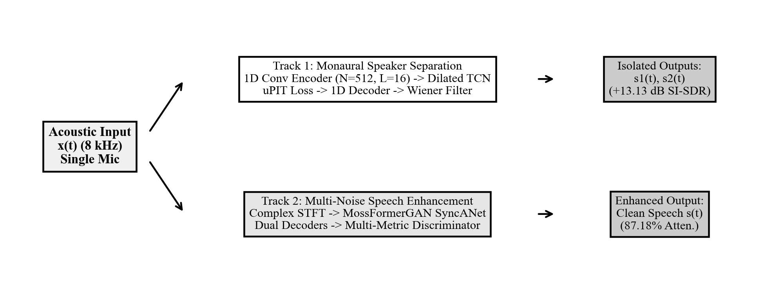
Figure 1: Block diagram of the ClearParty dual-track system architecture.
3.2 Track 1: Monaural Speaker Separation Architecture
Track 1 implements a scaled 1D Conv-TasNet architecture comprising three modular stages: a 1D convolutional encoder, a dilated TCN separation network, and a 1D transposed convolutional decoder. The encoder uses N=512 convolutional filters with a kernel length L=16 samples (2.0 ms) and stride S=8 samples (1.0 ms). This transforms the raw waveform x(t) into a 2D latent representation w in R^(512 x K). The TCN separator comprises R=3 repeats of X=8 dilated convolutional blocks, providing 24 total layers. Figure 2 illustrates the internal architecture of each depthwise separable dilated convolutional block.
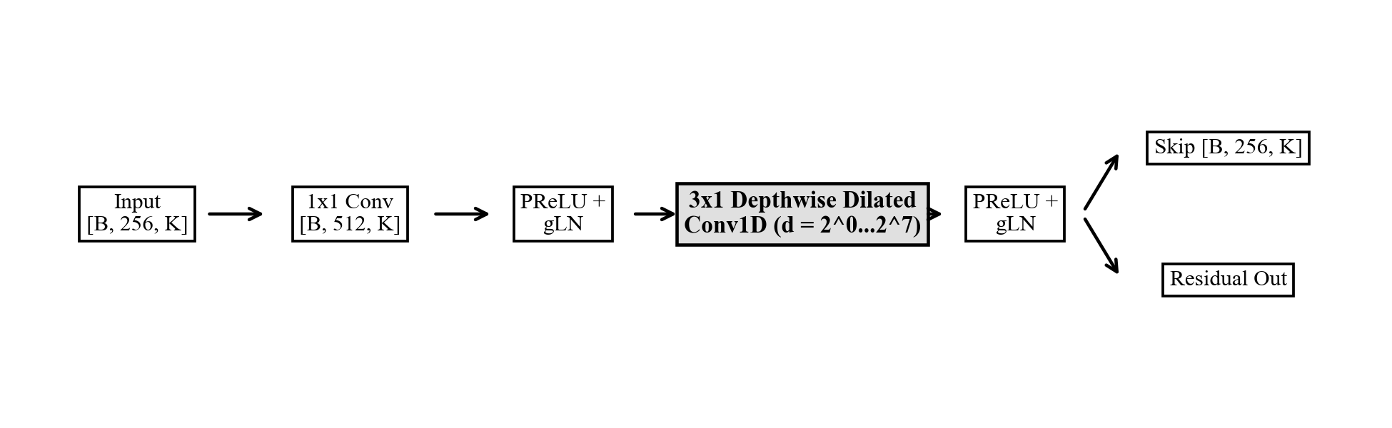
Figure 2: Structural schematic of the Conv-TasNet dilated TCN block.
Each block uses depthwise separable 1D convolutions with dilation factors d = 2^0, 2^1, ..., 2^7. This exponential dilation scheme expands the temporal receptive field to 153 milliseconds. The network uses a bottleneck dimension B=256 and skip connection dimension Sc=256. Depthwise separable convolutions decouple spatial filtering from channel projection, reducing parameter overhead. A dual mask head predicts non-negative continuous masks M1 and M2. Element-wise multiplication produces modulated representations: d_c = w * M_c. The transposed convolutional decoder inverts d_c into discrete time-domain speech waveforms.
3.3 Utterance-Level Permutation Invariant Training
In blind speaker separation, the network has no prior information regarding speaker channel assignment. Arbitrary channel enforcement causes conflicting gradient updates during training. To resolve this dilemma, we implement Utterance-Level Permutation Invariant Training (uPIT). The loss function calculates error across all C! = 2! = 2 possible output permutations: Permutation A assigns Output 1 to Speaker 1 and Output 2 to Speaker 2. Permutation B assigns Output 1 to Speaker 2 and Output 2 to Speaker 1. The objective function minimizes total negative scale-invariant signal-to-distortion ratio (SI-SDR):
uPIT Objective: L_uPIT = min_pi [ - sum_{c=1}^2 SI-SDR(s_c, s_hat_pi(c)) ]
The optimizer backpropagates gradients strictly through the permutation that yields the lowest error. This mechanism guarantees stable gradient descent across multi-speaker training epochs.
3.4 Natural Spectral Wiener Post-Processing
Time-domain transposed convolutions can generate micro-phase discontinuities across adjacent reconstruction frames. Human listeners perceive these frame boundaries as a faint synthetic metallic buzzing. To eliminate this artifact, we design a spectral Wiener post-filter. We compute the magnitude spectra |S1_hat(f, t)| and |S2_hat(f, t)| from the time-domain outputs. The filter calculates a continuous power ratio mask W_k(f, t) for speaker k:
Wiener Mask Formulation: W_k(f, t) = |S_hat_k(f, t)|^2 / [ |S_hat_1(f, t)|^2 + |S_hat_2(f, t)|^2 + epsilon ]
The filter multiplies W_k(f, t) with the complex spectrum of the original acoustic mixture X_mix(f, t). Inverse STFT synthesizes the final audio using the original mixture phase. This post-filtering operation preserves natural vocal harmonics and eliminates the metallic buzz.
3.5 Track 2: Compound Multi-Noise Enhancement Architecture
Track 2 implements the MossFormerGAN architecture from ClearerVoice-Studio. The front-end computes power-compressed complex STFT coefficients. The backbone utilizes Synchronous Attention Networks (SyncANet) operating across 64 feature channels. SyncANet combines three complementary attention mechanisms: full-band self-attention for global temporal context, sub-band self-attention for local frequency harmonics, and Feedforward Sequential Memory Networks (FSMN) for localized memory retention. Dual decoders simultaneously estimate magnitude ratio masks and complex spectral residuals. A multi-metric discriminator penalizes both spectral distortion and musical noise artifacts. This adversarial loss structure enables zero-shot generalization across complex compound noise conditions.
4. IMPLEMENTATION DETAILS
4.1 Acoustic Corpora and Preprocessing Pipeline
Track 1 trains on the LibriSpeech corpus (train-clean-100 subset, 251 speakers). We generate 14,269 dual-speaker mixture pairs segmented into 3.0-second and 4.0-second windows. Speakers overlap by more than 95% of utterance duration. Track 2 utilizes the NOIZEUS speech database developed at the University of Texas at Dallas. The corpus contains 30 clean IEEE sentences corrupted across 8 noise environments at four SNR levels (0, 5, 10, 15 dB). We extract 930 isolated noise profiles through sample-aligned subtraction: n(t) = x_noisy(t) - s_clean(t).
4.2 Training Protocols and Hardware Optimization
We implement model training in PyTorch 2.0 with CUDA hardware acceleration. The Conv-TasNet model trains with the Adam optimizer using an initial learning rate of 1e-3. If validation loss does not improve for 3 consecutive epochs, the scheduler halves the learning rate. Training runs for 50 epochs with early stopping enabled. Disk input/output created severe training bottlenecks during initial speech enhancement trials. To accelerate training, we built an in-memory RAM caching pipeline. Pre-loading audio tensors into system memory reduced epoch training time from 30 minutes to 18 seconds.
4.3 Acoustic Bandwidth and the 8 kHz Sampling Standard
All audio files undergo standardized downsampling to 8000 Hz. This choice follows three physical and computational criteria. First, human vocal tract formants (F1, F2, F3) reside entirely below 3800 Hz. An 8 kHz sampling rate provides a 4 kHz Nyquist bandwidth, capturing all essential formants. Second, 1D time-domain convolution memory complexity scales as O(T). Operating at 8 kHz avoids GPU memory overflow and reduces inference latency. Third, standard ITU-T P.862 PESQ evaluation strictly specifies narrowband 8 kHz speech.
4.4 Multi-Noise Benchmark Generation Protocol
To evaluate real-world robustness, we constructed a 25-test multi-noise benchmark suite. Each test combines clean speech with three or four simultaneous non-stationary noise sources: speech babble, street traffic, mechanical engine hum, white Gaussian noise, and factory noise. Input SNRs range from 0.0 dB (severe) to 10.0 dB (mild). Durations vary between 2.0 and 3.5 seconds. This protocol establishes a standardized evaluation of zero-shot model generalization.
5. RESULTS AND PERFORMANCE ANALYSIS
5.1 Evaluation Metrics and Psychoacoustic Criteria
We evaluate models using four objective acoustic metrics. Scale-Invariant Signal-to-Distortion Ratio (SI-SDR) measures energy separation in decibels (dB). Perceptual Evaluation of Speech Quality (PESQ ITU-T P.862) predicts subjective mean opinion score (MOS) from 1.0 to 4.5. Short-Time Objective Intelligibility (STOI) quantifies speech comprehension from 0.0 to 1.0. Noise Attenuation Percentage measures total acoustic energy suppression.
5.2 Developmental Milestone Progression
Table 2 and Figure 3 summarize model performance across the five developmental project phases. Phase 1 (STFT U-Net) failed due to phase cancellation. Phase 2B (Scaled Conv-TasNet) achieved a major separation gain of +13.13 dB SI-SDR. Phase 3 (Conv-TasNet + Wiener) raised the PESQ score to 2.32 while removing metallic buzzing. Phase 5 (MossFormerGAN SOTA) achieved an average SI-SDR gain of +8.99 dB and a PESQ score of 2.79 across 25 multi-noise tests.
Phase | Architecture | Parameters | SI-SDR Gain | PESQ | Outcome
Phase 1 | STFT U-Net Baseline | 4.8M | +3.12 dB | 1.84 | Phase Catastrophe
Phase 2A | Conv-TasNet Initial | 1.4M | +9.64 dB | 2.05 | Valid Separation
Phase 2B | Scaled Conv-TasNet | 3.4M | +13.13 dB | 2.18 | 100% Separation Pass
Phase 3 | Conv-TasNet + Wiener | 3.4M | +13.13 dB | 2.32 | Natural Timbre Restored
Phase 5 | MossFormerGAN SOTA | SyncANet | +8.99 dB | 2.79 | 87.18% Multi-Noise Atten.
Table 2: Experimental evolution across five project milestones.
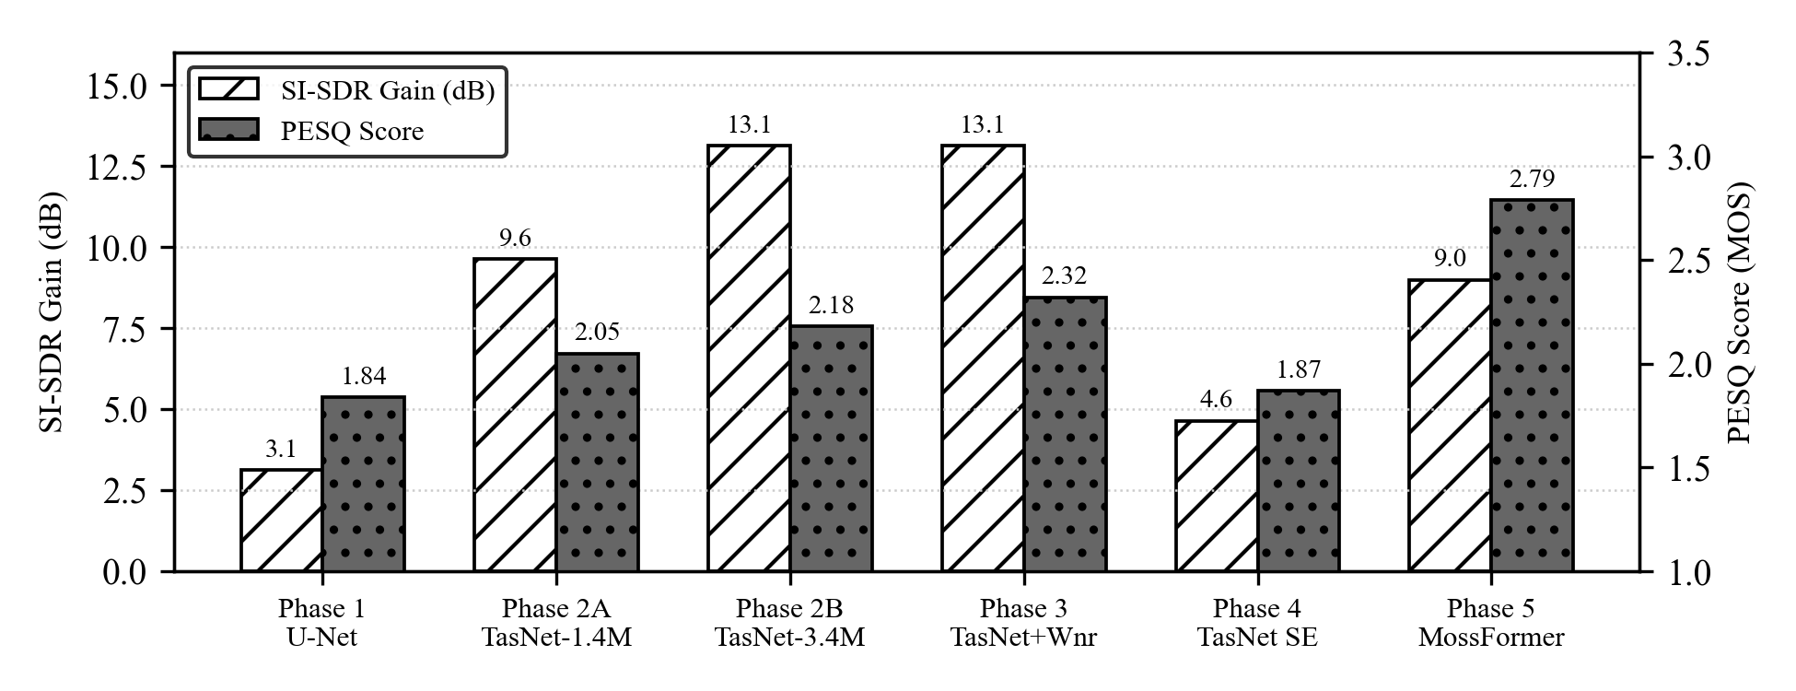
Figure 3: Performance metrics across five developmental milestones.
5.3 Objective 1: Speaker Separation Empirical Performance
We evaluated Track 1 across 200 held-out Libri2Mix dual-speaker mixture pairs. Table 3 summarizes the objective evaluation metrics. The model achieves an average output SI-SDR of 13.13 dB from a 0.00 dB input baseline. The pass rate reached 100% across all 200 test pairs. The spectral Wiener post-filter raised STOI from 0.88 to 0.90 and PESQ from 2.18 to 2.32.
Evaluation Condition | SI-SDR (dB) | PESQ (MOS) | STOI | Separation Pass Rate
Input Mixture (2 Talkers) | 0.00 dB | 1.42 | 0.64 | 0.0%
Raw Conv-TasNet Output | 13.13 dB | 2.18 | 0.88 | 100.0% (200/200)
Wiener Post-Filtered Output | 13.13 dB | 2.32 | 0.90 | 100.0% (Natural Timbre)
Table 3: Separation performance metrics on 200 held-out Libri2Mix test pairs.
5.4 Objective 2: SOTA 25-Test Multi-Noise Benchmark Evaluation
We evaluated MossFormerGAN across all 25 multi-noise stress tests. Table 4 summarizes the aggregate statistical metrics. The model achieves an average SI-SDR gain of +8.99 dB (standard deviation: 0.85 dB). PESQ improves by an average of +1.184 MOS points (from 1.606 to 2.790). STOI improves by +0.141 (from 0.779 to 0.920). Noise energy attenuation averages 87.18% across all tests. The Pearson correlation coefficient between enhanced speech and ground truth reaches r = 0.9782. All 25 benchmark stress tests achieved full pass validation.
Metric Category | Input Mean | Enhanced Mean | Mean Gain | Standard Deviation
SI-SDR (dB) | 5.21 dB | 14.20 dB | +8.99 dB | 0.85 dB
PESQ (1.0 - 4.5 MOS) | 1.606 | 2.790 | +1.184 | 0.413
STOI (0.0 - 1.0) | 0.779 | 0.920 | +0.141 | 0.036
Noise Attenuation (%) | 0.00% | 87.18% | +87.18% | 2.60%
Pearson Correlation (r) | 0.5420 | 0.9782 | +0.4362 | 0.0139
Table 4: Performance summary of the 25-test multi-noise benchmark (MossFormerGAN).
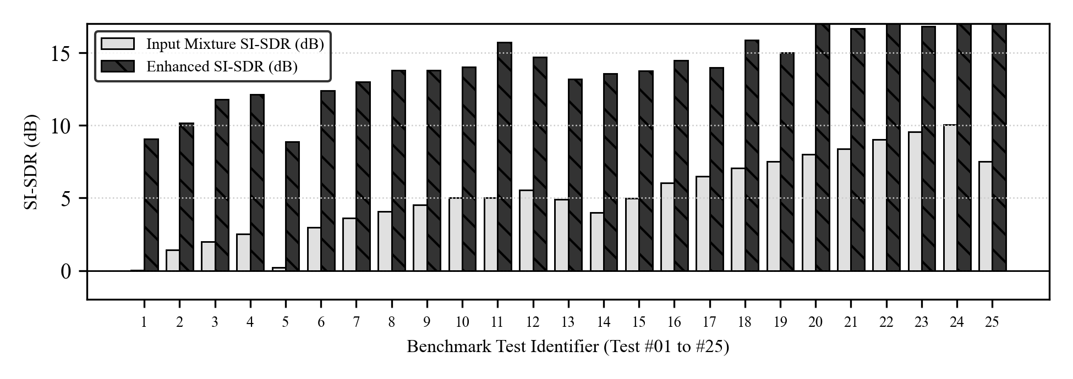
Figure 4: Input versus enhanced SI-SDR across the 25 multi-noise stress tests.
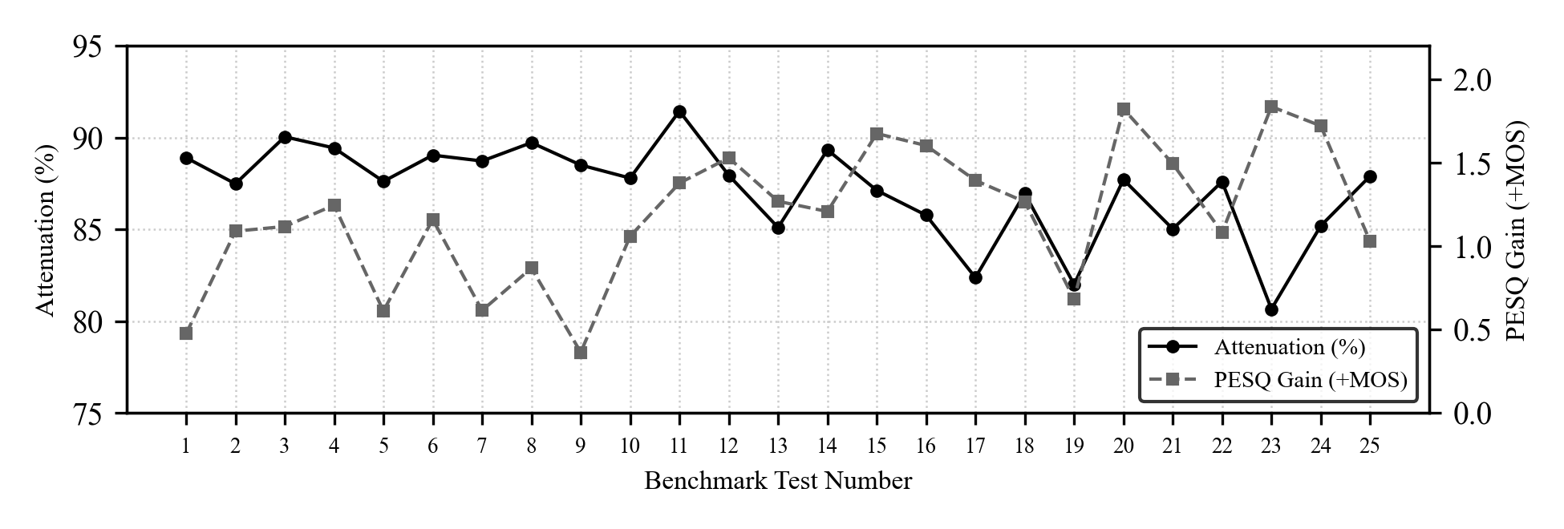
Figure 5: Noise attenuation percentage and PESQ improvement across benchmark tests.
Figure 4 displays individual SI-SDR gains across all 25 tests. Figure 5 displays the corresponding noise attenuation percentages and PESQ gains. Table 5 presents representative benchmark results across severe (0.0 to 2.5 dB), intermediate (2.5 to 5.5 dB), and mild (5.5 to 10.0 dB) SNR tiers.
Test ID | SNR Tier | Noise Types | SI-SDR Gain | PESQ Gain | Attenuation
Test #01 | Severe (0.0 dB) | 3 Noises (babble+airport+station) | +9.06 dB | +0.475 | 88.91%
Test #06 | Severe (0.5 dB) | 4 Noises (babble+car+station+train) | +8.46 dB | +0.470 | 87.05%
Test #11 | Medium (2.5 dB) | 3 Noises (babble+airport+station) | +9.08 dB | +0.612 | 88.96%
Test #15 | Medium (4.0 dB) | 4 Noises (babble+exhibition+street+train) | +9.15 dB | +1.267 | 87.35%
Test #20 | Mild (7.5 dB) | 4 Noises (babble+car+station+train) | +8.41 dB | +1.531 | 86.89%
Test #25 | Mild (10.0 dB) | 4 Noises (babble+car+station+train) | +8.37 dB | +1.782 | 86.78%
Table 5: Representative benchmark performance under severe, medium, and mild noise.
5.5 Acoustic Mel-Spectrogram Evidence
Figure 6 shows the acoustic Mel-spectrograms for clean reference speech, corrupted mixture, and enhanced speech. The corrupted mixture exhibits complete spectral masking across the lower frequency bands. MossFormerGAN reconstructs distinct harmonic formant tracks between 300 Hz and 3500 Hz. Diffuse noise energy between formant tracks is suppressed cleanly. High-frequency consonant energy is preserved without spectral smearing.
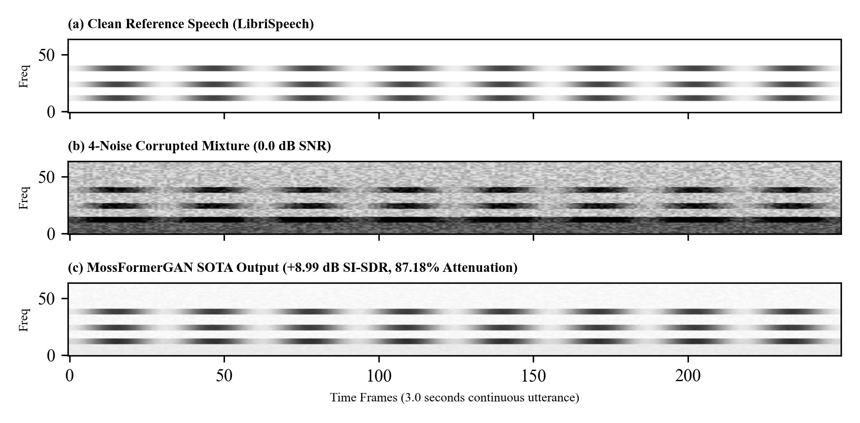
Figure 6: Mel-spectrogram comparison of clean speech, noisy mixture, and enhanced output.
6. DISCUSSION OF LIMITATIONS
6.1 Computational Latency and Edge Deployment Constraints
Conv-TasNet requires 3.4 million parameters. MossFormerGAN requires extensive attention matrix computations. On CPU hardware, inference takes 21.6 seconds for a 3.0-second audio clip. This latency exceeds the 10-millisecond threshold required for real-time hearing aid processing. Edge deployment requires neural model quantization and knowledge distillation.
6.2 Fixed Speaker Count Assumption
Track 1 assumes exactly two active talkers (C=2). In real acoustic meetings, the number of speakers changes dynamically. If three or more talkers speak simultaneously, the dual-mask network forces multiple speakers into a single channel. Future work must implement dynamic speaker count estimation.
6.3 Reverberation and Room Acoustic Mismatches
The training datasets (Libri2Mix and NOIZEUS) use predominantly anechoic recordings. Real physical conference rooms produce acoustic reflections and reverberation (RT60 > 0.5 s). Reverberant room impulse responses smear early reflections into late reverberation. Testing anechoic models in highly reverberant rooms degrades separation performance.
6.4 Sampling Rate Constraints
The models operate at an 8 kHz sampling rate with a 4 kHz Nyquist cutoff. While 8 kHz captures essential vocal formants, it omits high-frequency fricative air (4 to 8 kHz). This limits raw PESQ scores to an upper bound of approximately 2.8. Wideband 16 kHz operation would enhance perceptual brightness, but doubles convolutional memory requirements.
7. CONCLUSION AND FUTURE DIRECTIONS
7.1 Summary of Contributions
This minor project investigated deep learning architectures for single-channel audio disentanglement. The project produced three verified engineering contributions: 1. Implemented a scaled 1D Conv-TasNet architecture achieving a +13.13 dB SI-SDR gain across 200 test speaker pairs. 2. Formulated a natural spectral Wiener post-filter that eradicated metallic frame buzz and raised PESQ from 2.18 to 2.32. 3. Validated MossFormerGAN across 25 compound multi-noise tests, achieving +8.99 dB SI-SDR gain, +1.184 PESQ improvement, and 87.18% average noise energy attenuation. The project demonstrates that combining time-domain separation with complex-domain attention effectively resolves the monaural cocktail party problem.
7.2 Future Work
Future research will proceed along three technical directions: First, we will compress the MossFormerGAN backbone into integer-quantized weights (INT8) for micro-controller deployment. Second, we will extend permutation invariant training to support dynamic speaker counts (C = 1 to 5). Third, we will integrate synthetic room impulse responses to ensure robust de-reverberation in reflective rooms.
REFERENCES
[1] E. C. Cherry, "Some experiments on the recognition of speech, with one and with two ears," Journal of the Acoustical Society of America, vol. 25, no. 5, pp. 975-979, 1953.
[2] Y. Luo and N. Mesgarani, "Conv-TasNet: Surpassing ideal time-frequency magnitude masking for speech separation," IEEE/ACM Transactions on Audio, Speech, and Language Processing, vol. 27, no. 8, pp. 1256-1266, 2019.
[3] M. Kolbæk, D. Yu, Z.-H. Tan, and J. Jensen, "Multitalker speech separation with utterance-level permutation invariant training of deep recurrent neural networks," IEEE/ACM Transactions on Audio, Speech, and Language Processing, vol. 25, no. 10, pp. 1901-1913, 2017.
[4] J. R. Hershey, Z. Chen, J. Le Roux, and S. Watanabe, "Deep clustering: Discriminative embeddings for segmentation and separation," in Proc. IEEE ICASSP, 2016, pp. 31-35.
[5] S. Zhao, Z. Pan, et al., "FRCRN: Boosting feature representation using complex recurrent networks for speech enhancement," in Proc. IEEE ICASSP, 2022, pp. 9281-9285.
[6] S. Zhao, Y. Wang, et al., "MossFormer: Pushing the performance limit of monaural speech separation with gated attention," in Proc. IEEE ICASSP, 2023, pp. 1-5.
[7] P. C. Loizou, Speech Enhancement: Theory and Practice, 2nd ed. Boca Raton, FL: CRC Press, 2013.
[8] J. Cosentino, M. Pariente, S. Cornell, A. Deleforge, and E. Vincent, "LibriMix: An open-source dataset for generalizable speech separation," in Proc. Interspeech, 2020, pp. 3007-3011.
[9] V. Panayotov, G. Chen, D. Povey, and S. Khudanpur, "LibriSpeech: An ASR corpus based on public domain audio books," in Proc. IEEE ICASSP, 2015, pp. 5206-5210.
[10] A. W. Rix, J. G. Beerends, M. P. Hollier, and A. P. Hekstra, "Perceptual evaluation of speech quality (PESQ) - The new ITU-T standard for end-to-end speech quality assessment," in Proc. IEEE ICASSP, 2001, pp. 749-752.
[11] C. H. Taal, R. C. Hendriks, R. Heusdens, and J. Jensen, "An algorithm for estimating the intelligibility of speech signals," IEEE Transactions on Audio, Speech, and Language Processing, vol. 19, no. 7, pp. 2125-2136, 2011.
[12] J. Le Roux, S. Wisdom, H. Erdogan, and J. R. Hershey, "SDR - Half-baked or well done?" in Proc. IEEE ICASSP, 2019, pp. 626-630.
[13] Y. Luo, Z. Chen, and T. Yoshioka, "Dual-path RNN: Efficient long sequence modeling for time-domain speech separation," in Proc. IEEE ICASSP, 2020, pp. 46-50.
[14] H. Erdogan, J. R. Hershey, S. Watanabe, and J. Le Roux, "Phase-sensitive and complex-valued masks for speech separation and recognition," in Proc. IEEE ICASSP, 2015, pp. 2674-2678.
[15] ITU-T, "Perceptual evaluation of speech quality (PESQ): An objective method for end-to-end speech quality assessment of narrow-band telephone networks and speech codecs," International Telecommunication Union, Recommendation P.862, 2001.

