## **CIBINQO (abrocitinib)**

For the treatment of adults and pediatric patients 12 years of age and older with refractory, moderate-to-severe atopic dermatitis whose disease is not adequately controlled with systemic drug products, including biologics, or when use of those therapies is inadvisable.

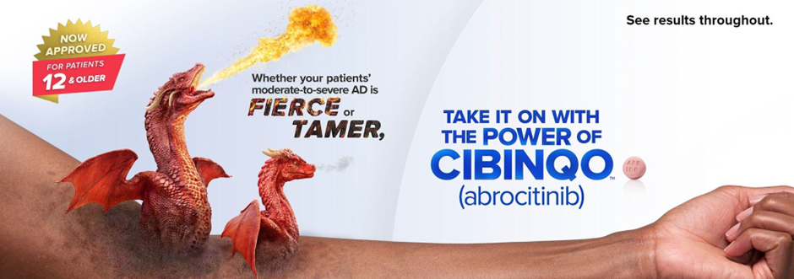

| Cards | |
| --- | --- |
|  | **Powerful Skin Clearance and Rapid Itch Relief**  EASI-75 at week 12 and PP-NRS4 as early as week 2 achieved for some patient  [**See Efficacy Data**](https://cibinqo.pfizerpro.com/efficacy/monotherapy-trial-results-2/skin-clearance) |
|  | **Flexibility to Increase Dose if Needed**  CIBINQO is an oral, once-daily treatment option1:   * **100 mg recommended dose** * 200 mg may be considered for patients uncontrolled on 100 mg after 12 weeks   Discontinue therapy if an adequate response is not achieved on 200 mg  [See Dosing](https://cibinqo.pfizerpro.com/dosing-monitoring/dosing) |
|  | **Well-studied Safety Profile in AD Population**  Studied in 3582 patients with AD across multiple clinical trials  [See Safety Information](https://cibinqo.pfizerpro.com/safety/safety-profile/safety-tolerability) |

| Columns | |
| --- | --- |
|  | **Request a Product Representative**  Have a product question? Request a call from your product representative  [Request a call](https://cibinqo.pfizerpro.com/savings-and-support/request-an-erep) |

| Cards2 |
| --- |
| **Explore Our Coverage and Patient Support**  Assisting with access and affordability for patients prescribed CIBINQO  [**Start Now**](https://cibinqo.pfizerpro.com/savings-and-support/access) |
| **Copay Savings Card**  Help eligible, commercially insured patients with access to co-pay savings*  [**See Savings Offer and Terms**](https://cibinqo.pfizerpro.com/savings-and-support/downloadable-copay-card)  *Limits, terms, and conditions apply. |

AD=atopic dermatitis; EASI-75= ≥75% improvement in lesion extent and severity from baseline on the Eczema Area and Severity Index; PP-NRS4= ≥4-point reduction from baseline on the Peak Pruritus Numerical Rating Scale.

##### **Reference:**

1. CIBINQO Package insert. Pfizer Inc; 2023.

| Section Metadata | |
| --- | --- |
| Style | highlight |

| Metadata | |
| --- | --- |
| Title | Home | Helix Project Boilerplate |
| Description | Use this template repository as the starting point for new Helix projects. |