## **JAYDEEP MAHAJAN -CE066-BDA-LAB 3**

## **Aim: "Interfacing to Distributed File System – HDFS commands and Web GUI file system browser usage"**

Exercises tasks:

**Task 1: Create a directory named 'Test' from HDFS web UI in '/user/hadoop'. It should give error message. Read this message and solve the error.**

So, I have created directory and gives me error like this below.

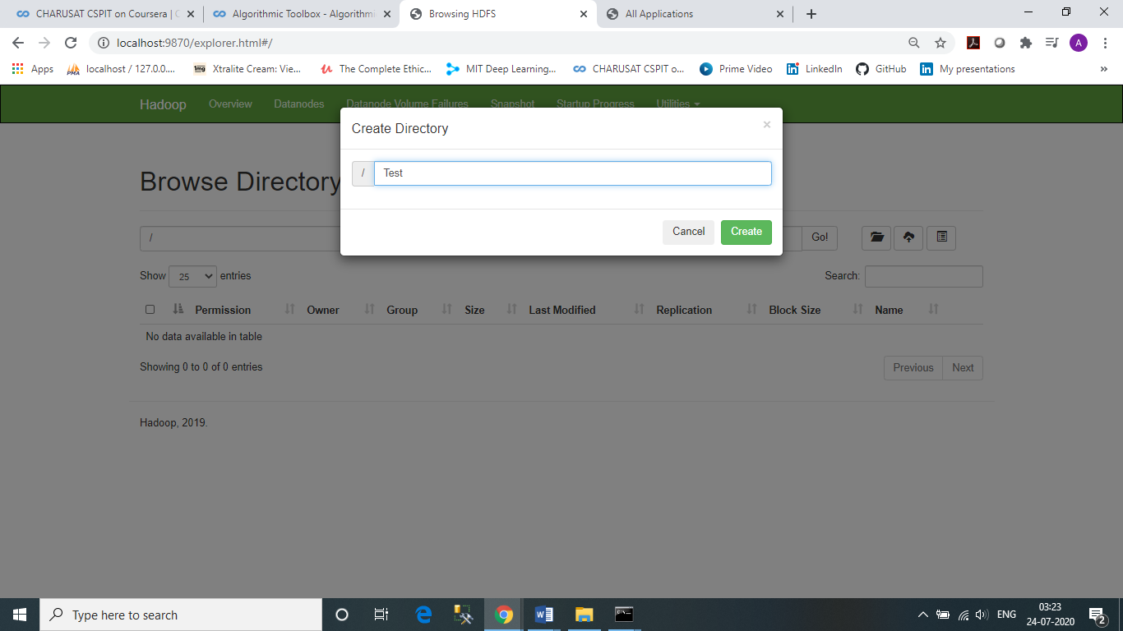

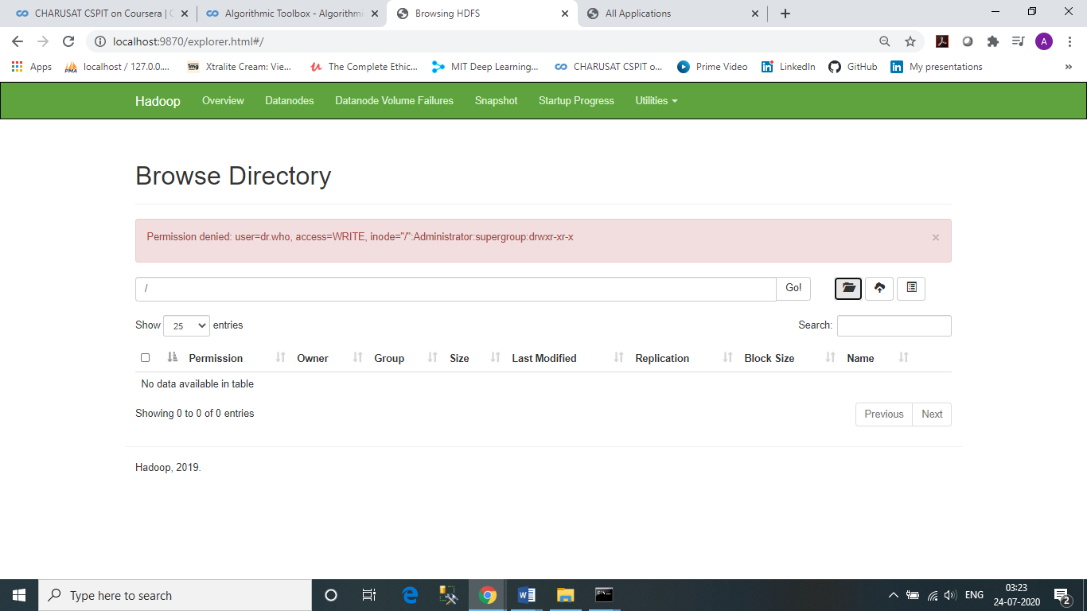

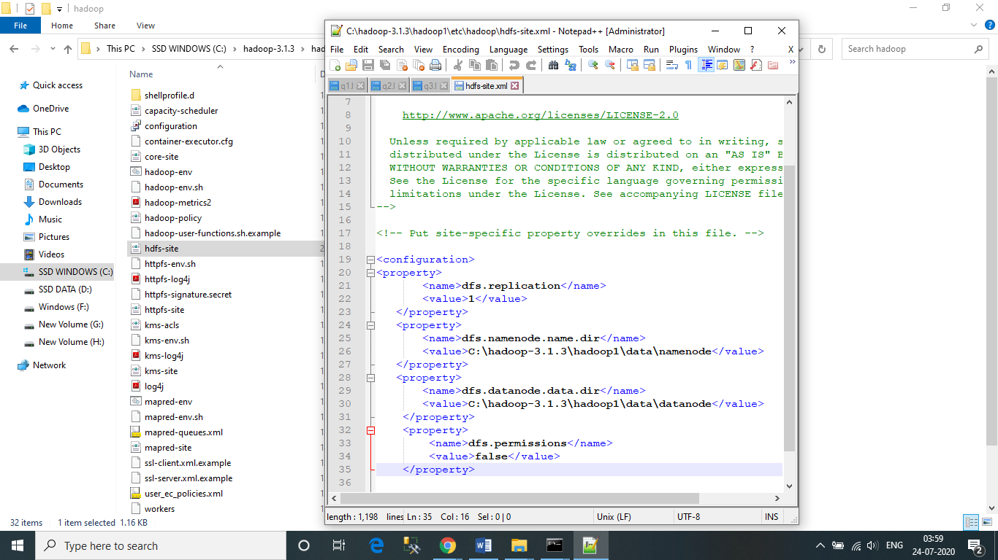To solve the error We need to add property called dfs.permission in hdfs-site.xml with value = “false”. As given bellow.

NOTE: you have to re-start all node again in cmd.

Now you can see that error is gone and it will show the Test directory.

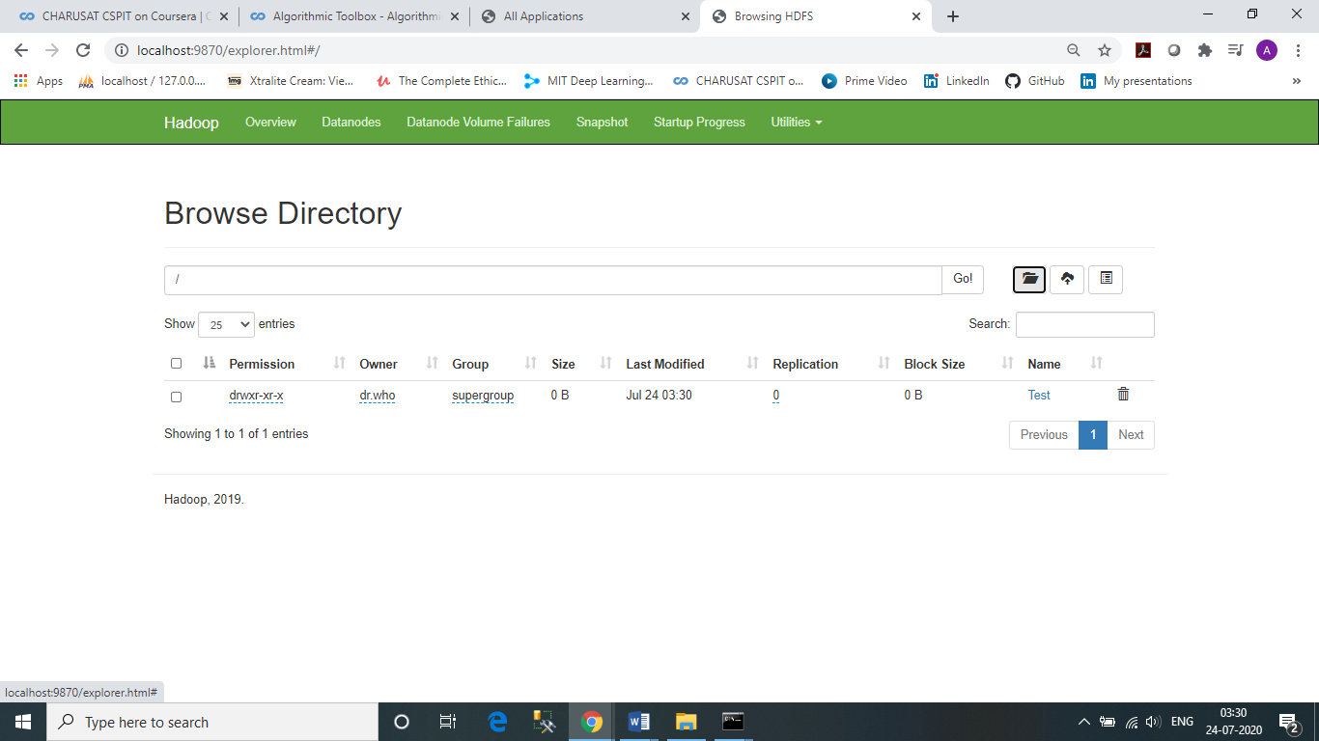

**Task 2: Create a text file in local file system and put the same file in HDFS using appropriate command**.

I have created potato.txt in my file system.

Now, Copied file using copyFromLocal command to copy from my local file system to created Test file.

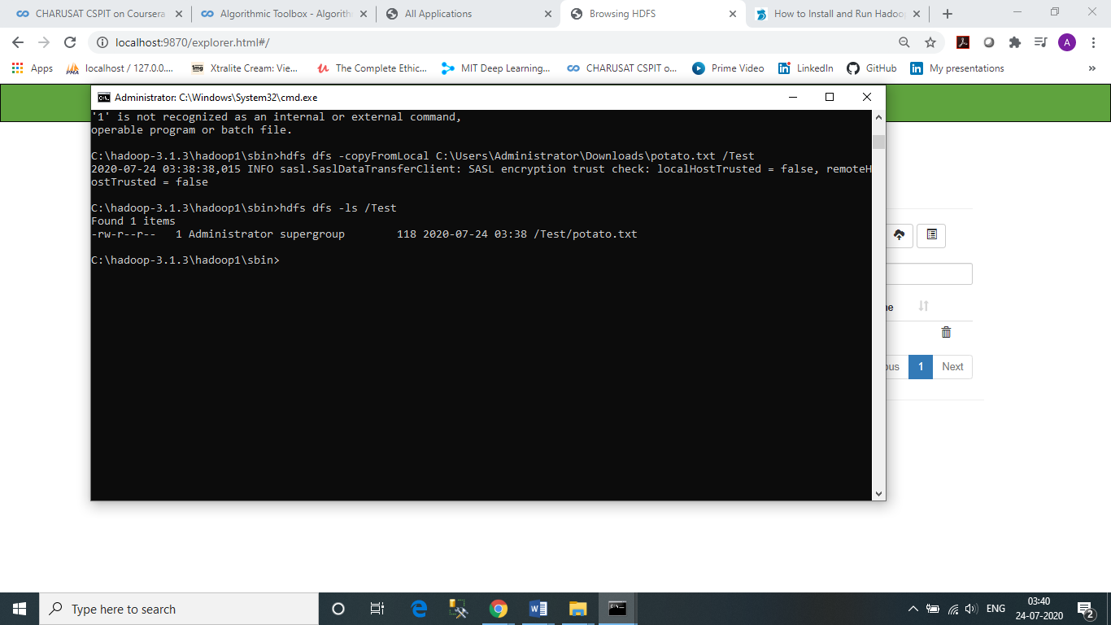

Task 3: **Display the contents of this file of HDFS on terminal.**

**Now to see file content of that text file use cat command as given below.**

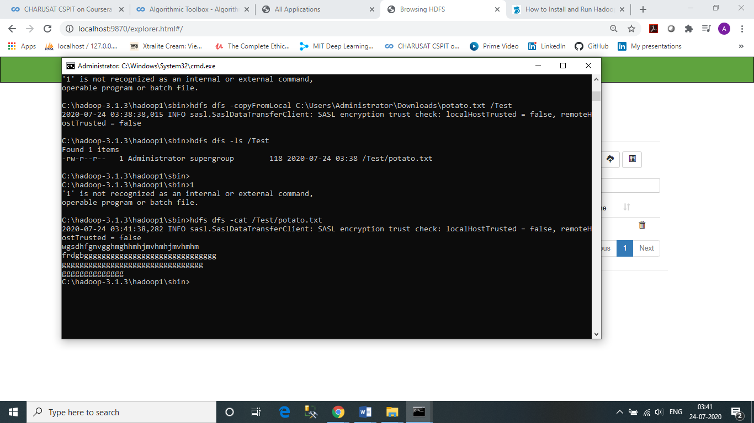

**Task 4: Download this file of HDFS on local machine and change its contents. Upload this modified file again on HDFS and verify its contents. Also make sure that this file should be deleted from local machine automatically.**

Here I use –copyToLocal,-movefromLocal,-cat command…which i display here

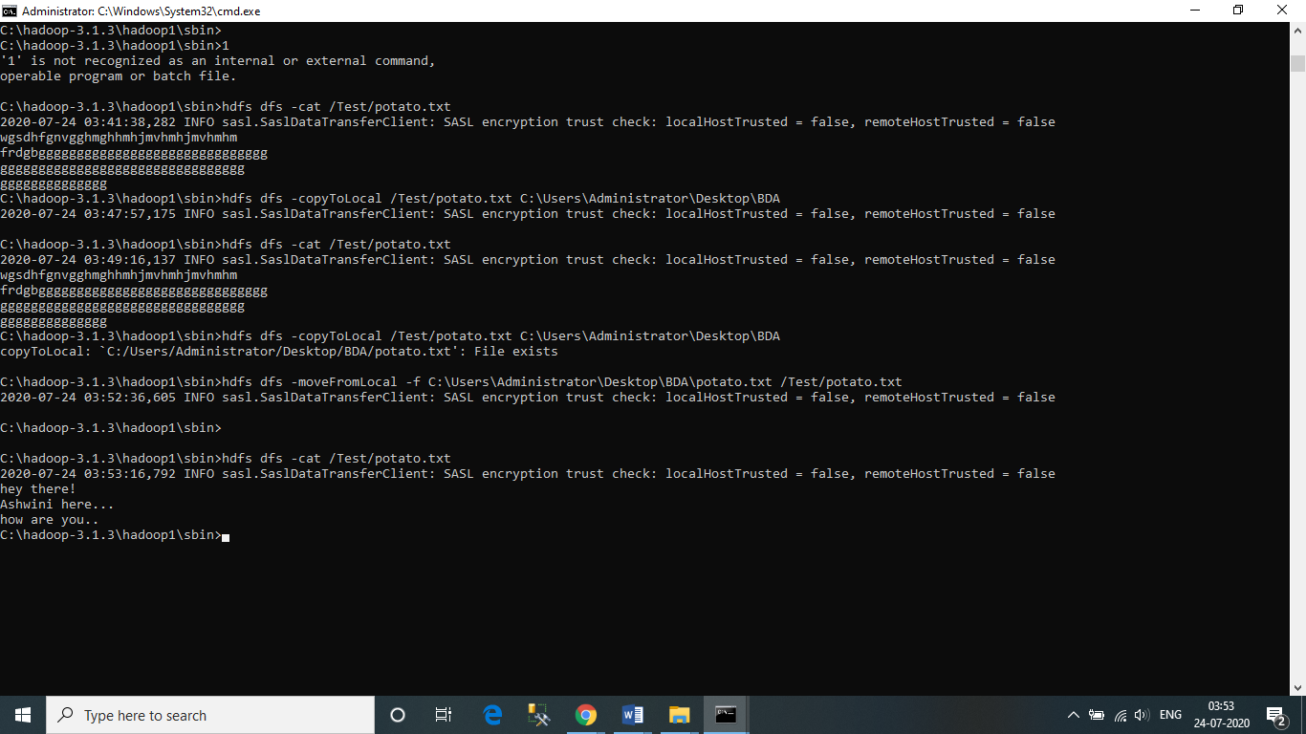

**Task 5: Find out a CLI way to display all file system commands supported by hdfs. Record the list.**

