**Big Data Analytics: Lab-6**

**CE066 | Jaydeep Mahajan**

# Aim: Connecting to NoSQL database/s and querying to provide analysis using api like aggregation, etc. To be able to successfully import/export from/to CSV.

# Table Of Contents.

**1. Interacting with MongoDB.**

**2. Inserting a record into DB.**

**3. MapReduce with MongoDB.**

**4. Inserting CSV file into MongoDB via mongoimport.**

**4. interacting with mongoDB.**

# Interacting with MongoDB.

Run MongoDB server using​ **'mongod'** command.​

-Run Mongo Client using ​**‘mongo’** ​command.

Show dbs

Use database

# Inserting a record into DB.

By using insert command…..

**Document To Store:**

Name : "Stephen More"

Address : {

"City" : "Banglore",

"Street" : "Electronics City",

"Affiliation" : "XYZ Ltd"

}

Hobbies : Chess, Lawn Tennis, Base Ball

Screenshots for step-1,2

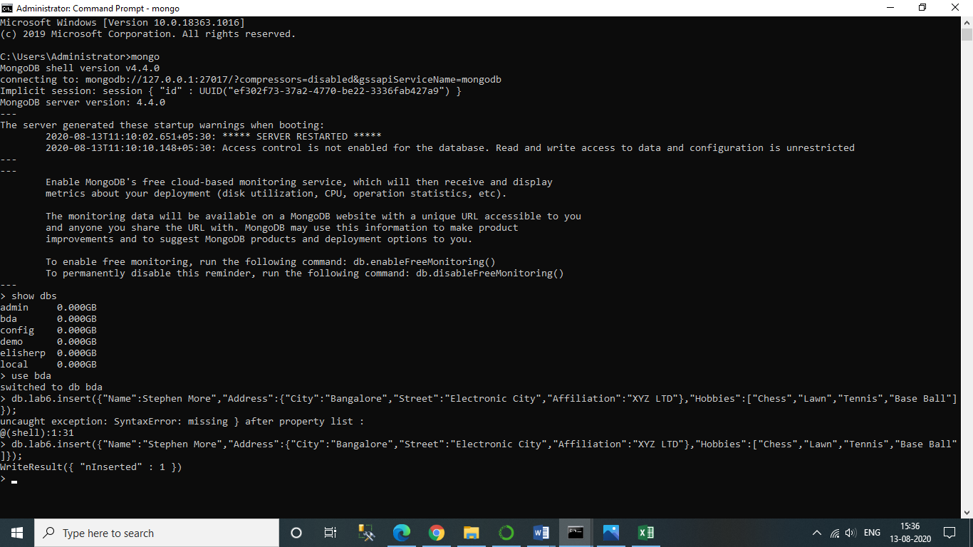

# MapReduce with MongoDB.

**Step. 3.1**​: Insert 5 documents as shown below snapshot in a collection named 'books'.

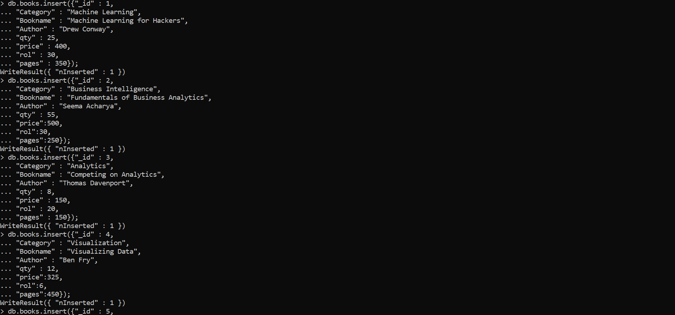

**Step. 3.2:** ​Confirm the presence of above documents in the “books” collection.

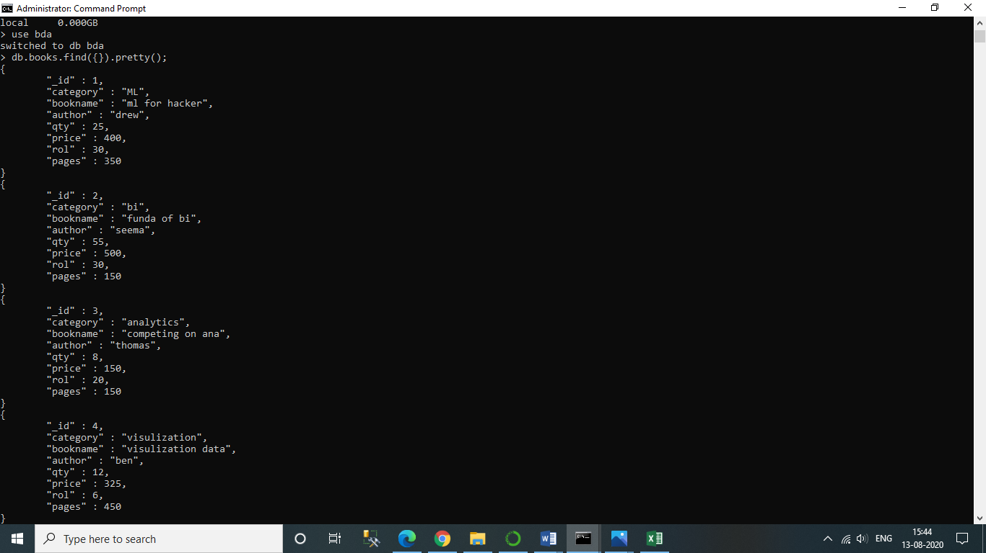

**Step. 3.3**:​ Write map and reduce functions to split the books into the following two categories 1)Big Books 2)Small Books.

**Step. 3.4**:​ Count the number of books in each category.

db.books.mapReduce(my_mapper,my_reducer,{query:{},out:"Book_Result"});

**Step 3.5**:​ Store the output as follows as documents in a new collection, called “Book_Result”.

db.Book_Result.find({});

**Screenshots for step-3.3,3.4,3.5…..**

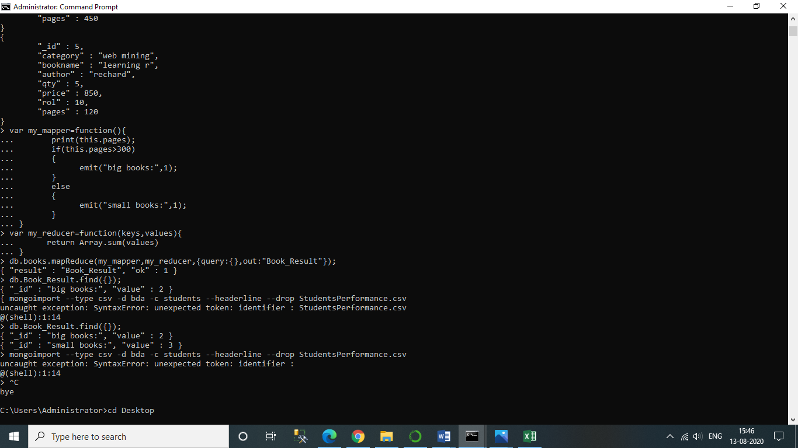

# Inserting CSV file into MongoDB via mongoimport.

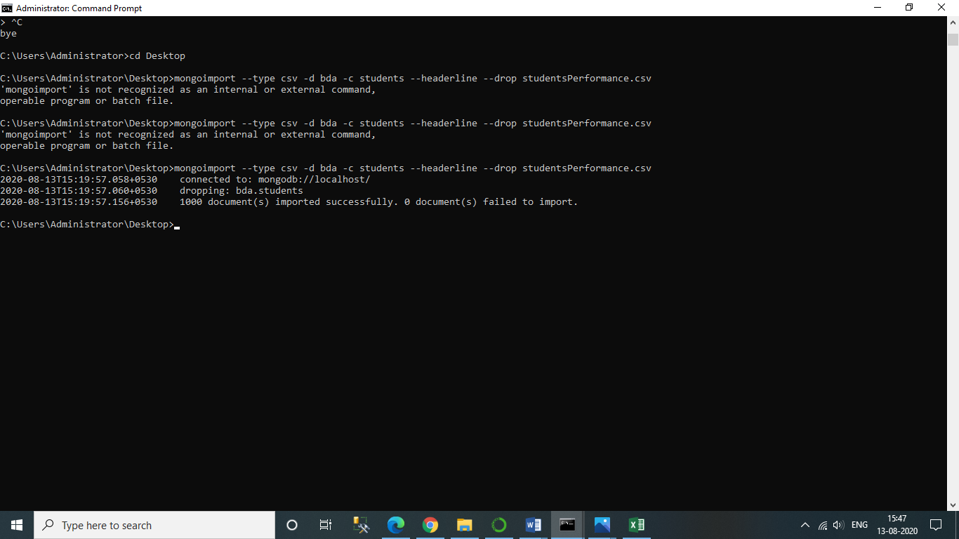

**5.Exercise Python to MongoDB Connectivity using JuPyter Notebook.**

**from**​ ​**pymongo**​ ​**import**​ MongoClient

**from**​ ​**pprint**​ ​**import**​ pprint

client ​=​ MongoClient(​"mongodb://localhost/bda"​)

db ​=​ client​.​bda

query ​=​ db​.​books​.​find({})

**for**​ doc ​**in**​ query:

pprint(doc)

