**Objective:**

Connecting to NoSQL database/s and querying to provide analysis using API like aggregation, etc. To be able to successfully import/export from/to CSV.

**Outline: 1**.

1.Run Mongo Client and perform basic commands.

2. Write the insert method to store the document in MongoDB.

3. To practice MapReduce programming in MongoDB.

4. To practice import, export and aggregation in MongoDB.

5. Exercise Python to MongoDB Connectivity using Jupyter Notebook.

**Task -1: Run Mongo Client and perform basic commands.**

-Run MongoDB server using 'mongod' command.

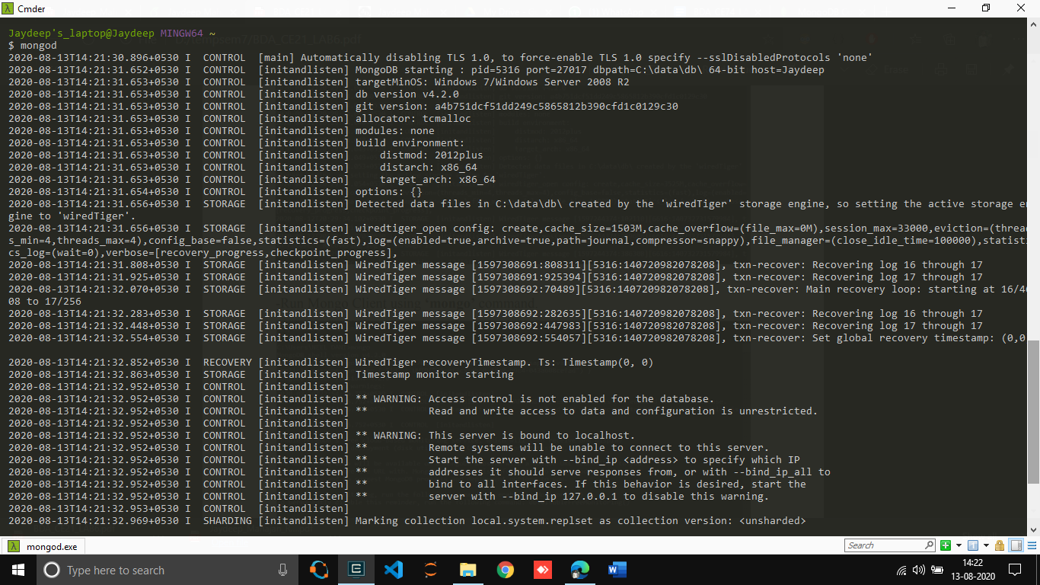  
  
  
  
  
  
  
**Task -2: Write the insert method to store the document in MongoDB.**

**Document To Store: Name: "Stephen More" Address: {"City” : "Banglore" , "Street" : "Electronics City" , "Affiliation" : "XYZ Ltd" } Hobbies : Chess, Lawn Tennis, Base Ball**

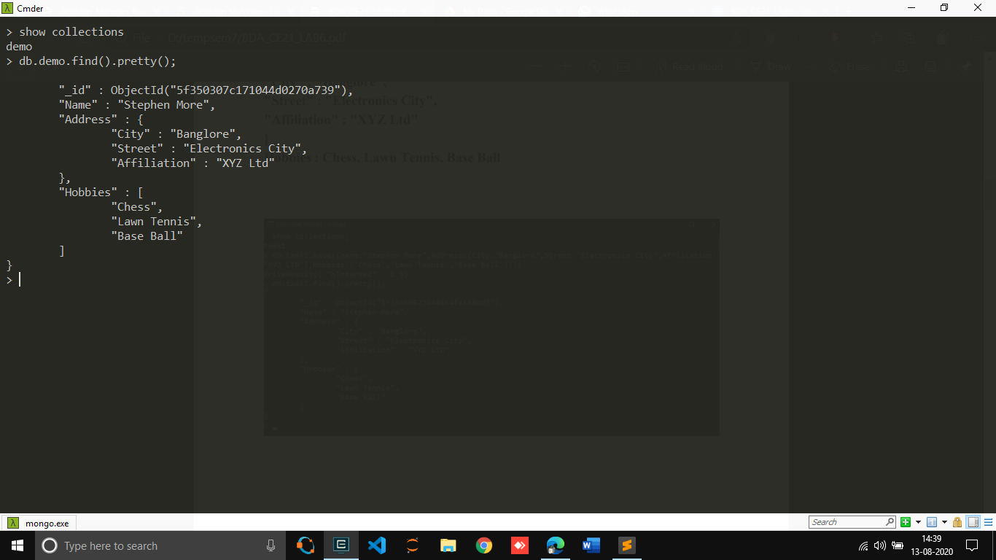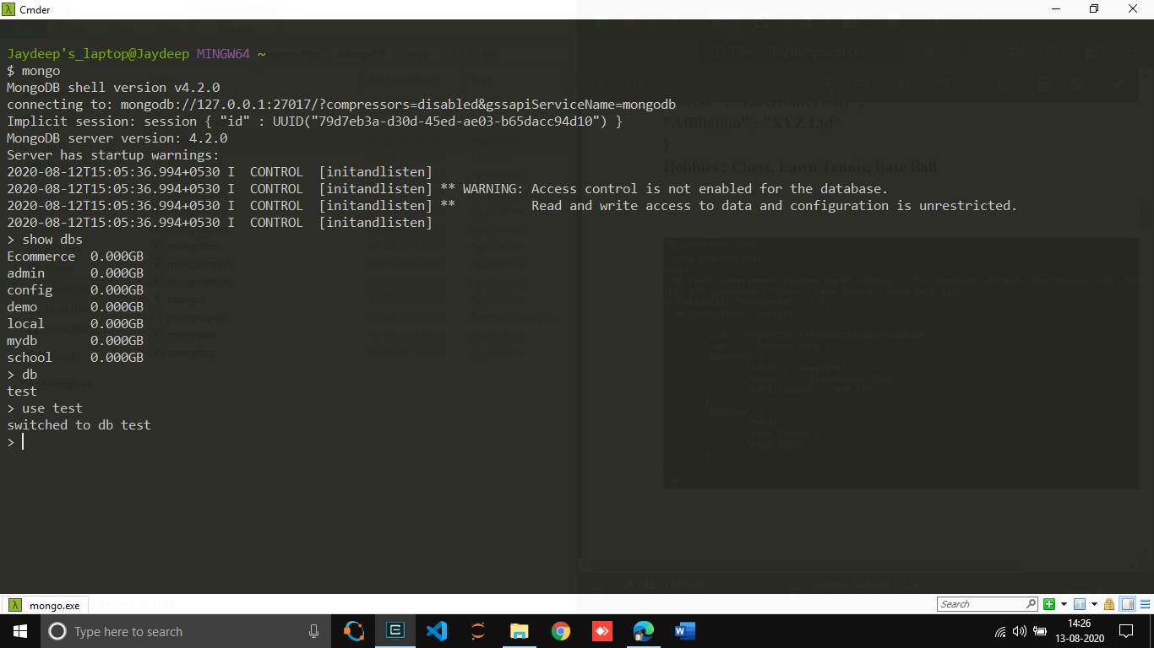

**Task - 3: To practice MapReduce programming in MongoDB.**

* **Step. 3.1**​: Insert 5 documents as shown below snapshot in a collection named 'books'.

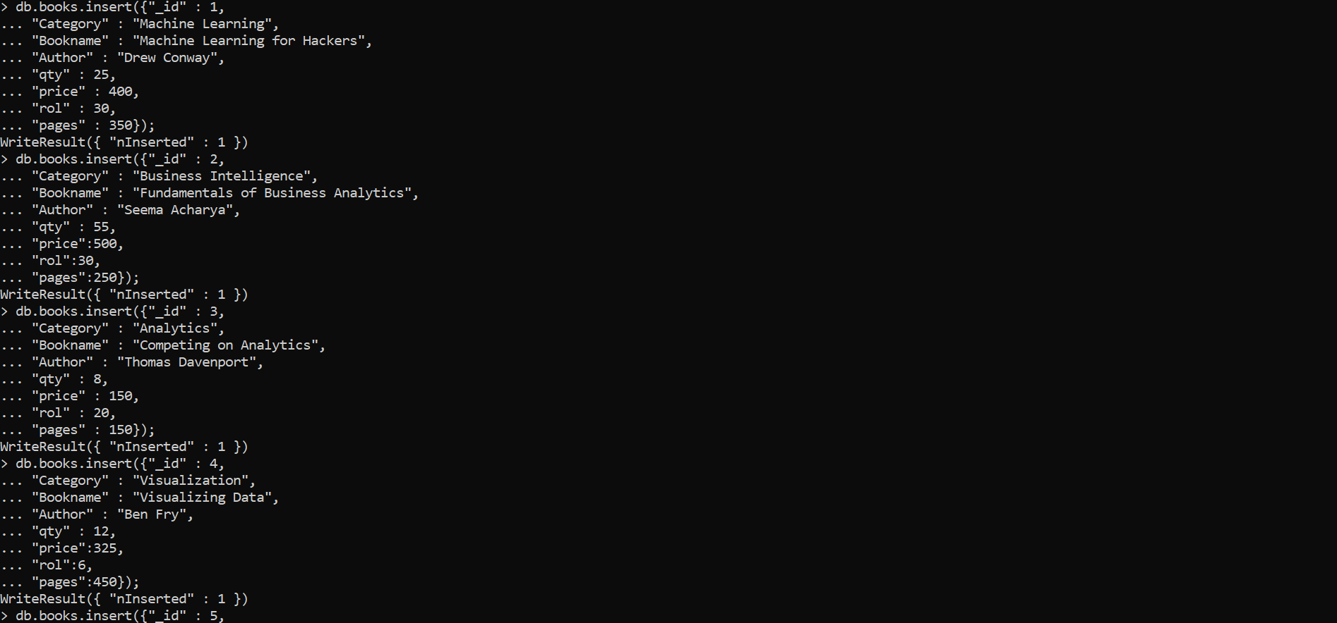

* 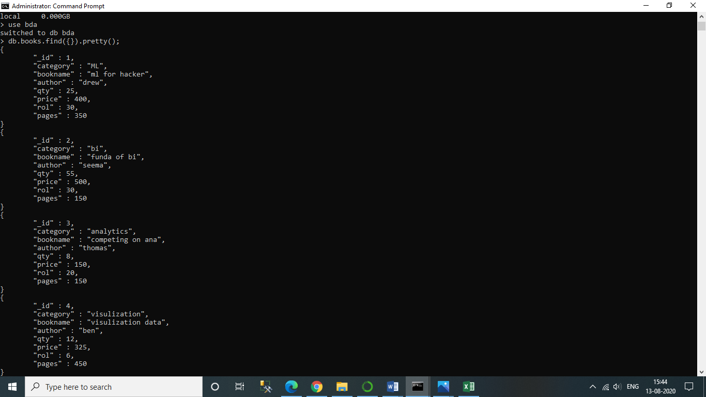**Step. 3.2:** ​Confirm the presence of above documents in the “books” collection.
* **Step. 3.3**:​ Write map and reduce functions to split the books into the following two categories 1)Big Books 2)Small Books.
* **Step. 3.4**:​ Count the number of books in each category.

db.books.mapReduce(my_mapper,my_reducer,{query:{},out:"Book_Result"});

* **Step 3.5**:​ Store the output as follows as documents in a new collection, called “Book Result”.

db.Book_Result.find({});

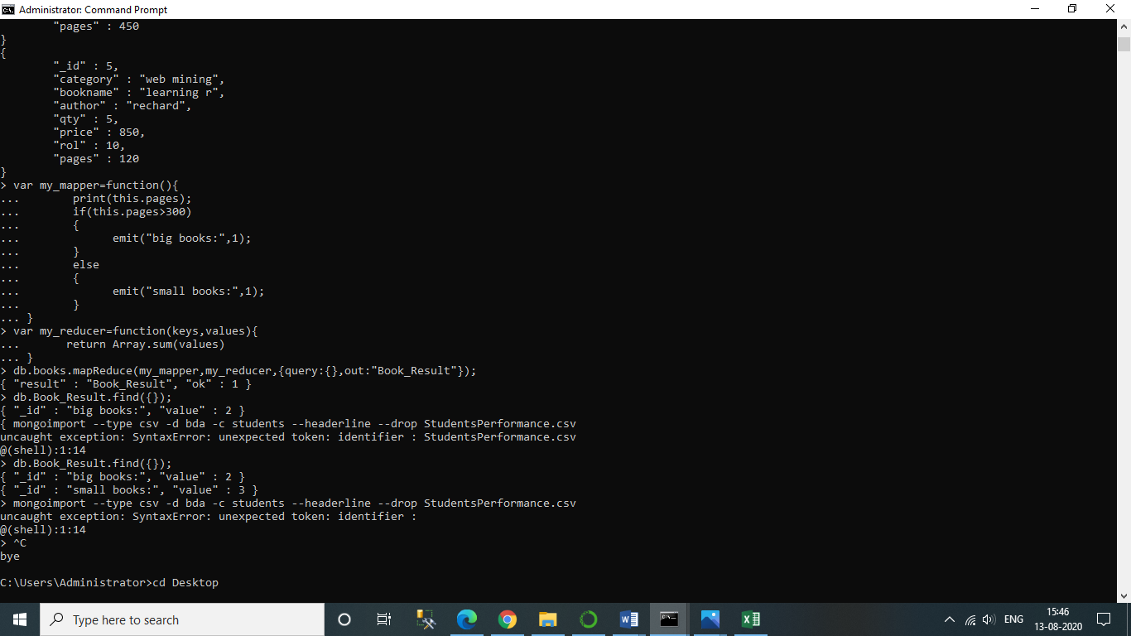**Screenshots for step-3.3,3.4,3.5…..**

# Task - 4: Inserting CSV file into MongoDB via mongoimport.

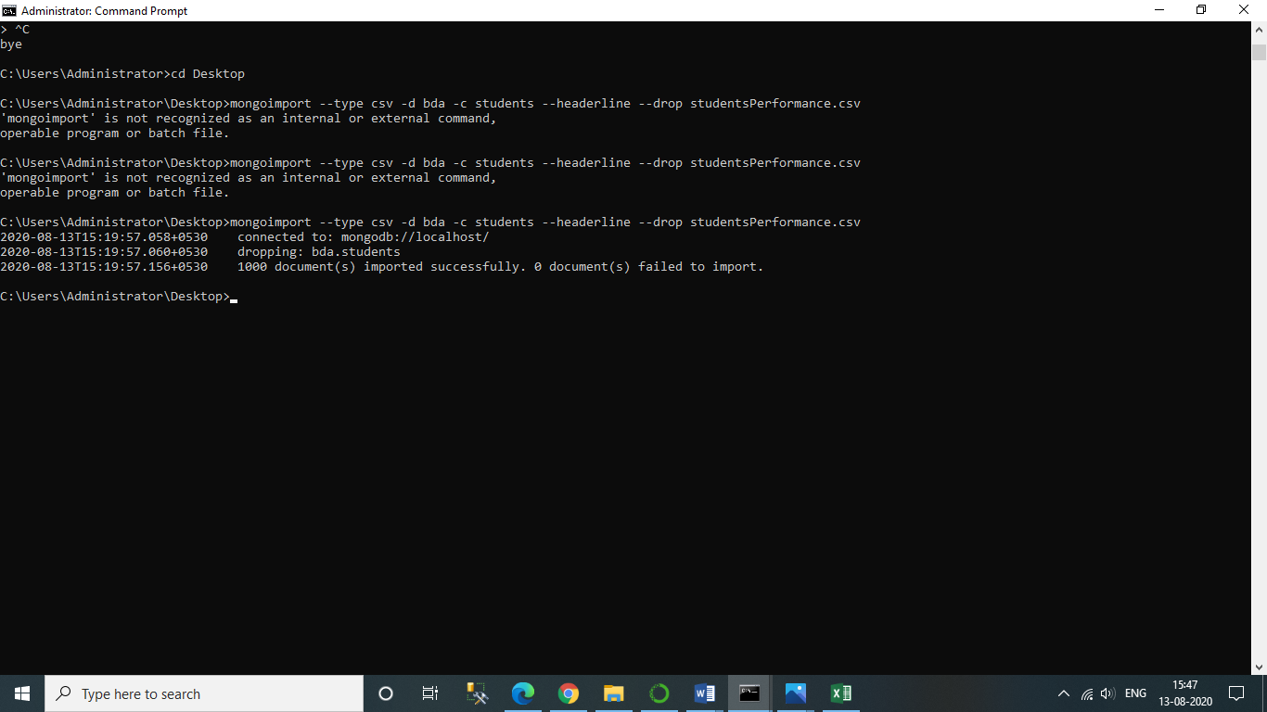

**Task -5: Exercise Python to MongoDB Connectivity using Jupyter Notebook.**

**from**​ ​**pymongo**​ ​**import**​ MongoClient

**from**​ ​**pprint**​ ​**import**​ pprint

client ​=​ MongoClient(​"mongodb://localhost/bda"​)

db ​=​ client​.​bda

query ​=​ db​.​books​.​find({})

**for**​ doc ​**in**​ query:

pprint(doc)

