Jaydeep Mahajan-CE066-IP-LAB2

**EXERSICE: 1.**

**In a surveillance system, two frames of the captured videos are given as image '1.jpg' and '2.jpg' Apply image subtraction to locate the foreground.**

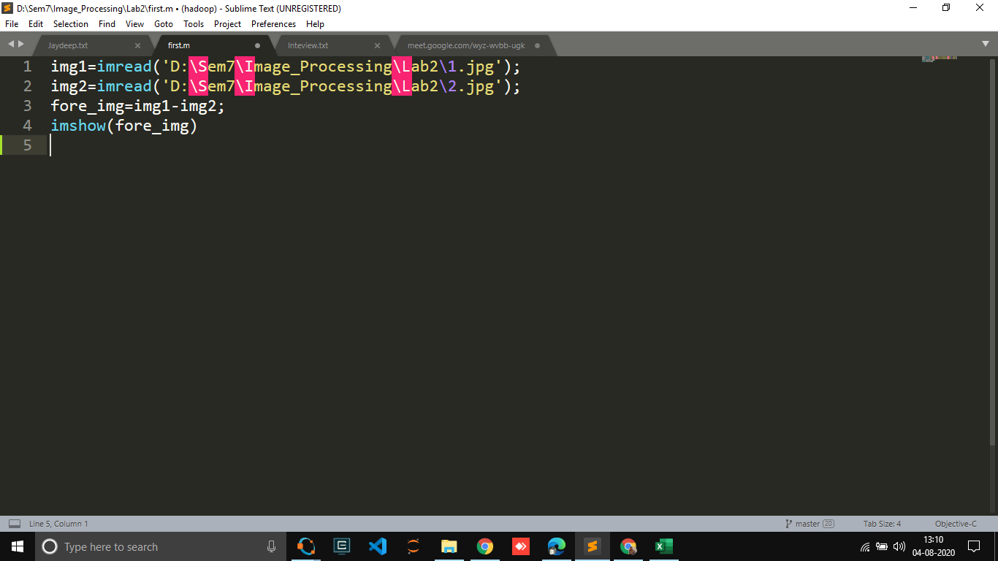

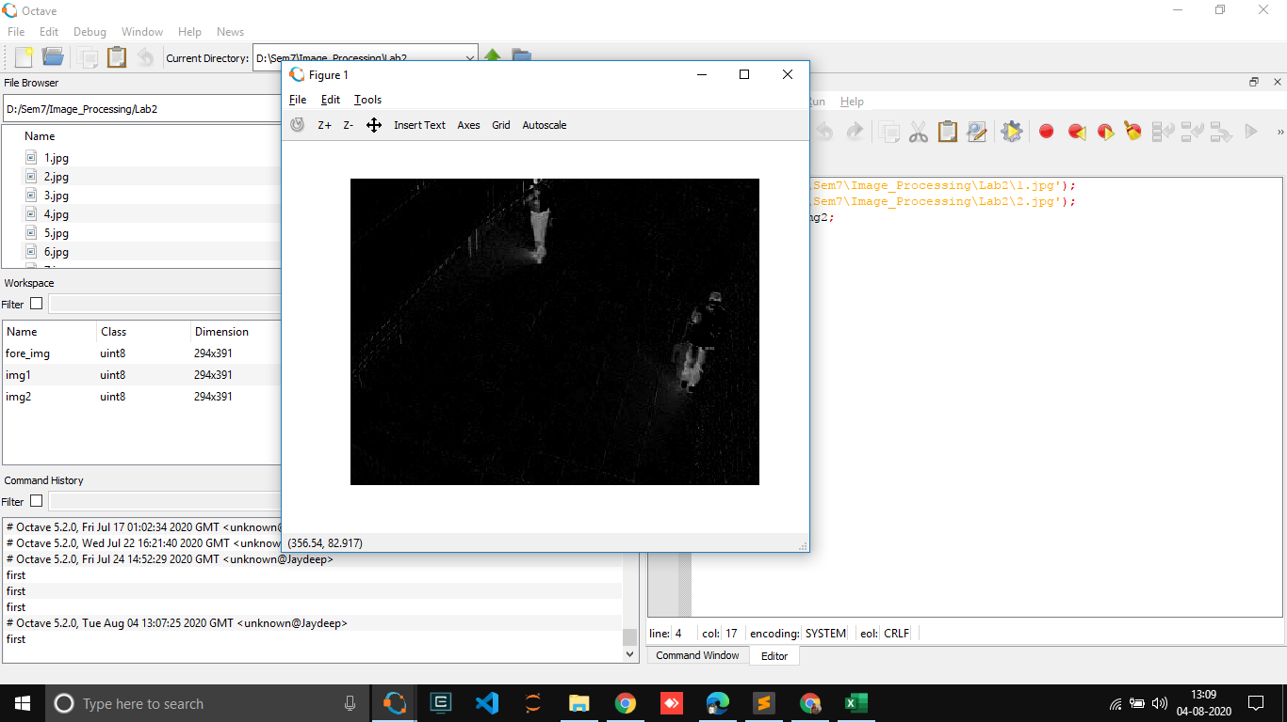

**2. Take your own black and white photo. Resize it to 256x256. Also consider given image 3.jpg. Demonstrate the logical operations like 'and', 'or', 'not' using these two images. Justify the results.**

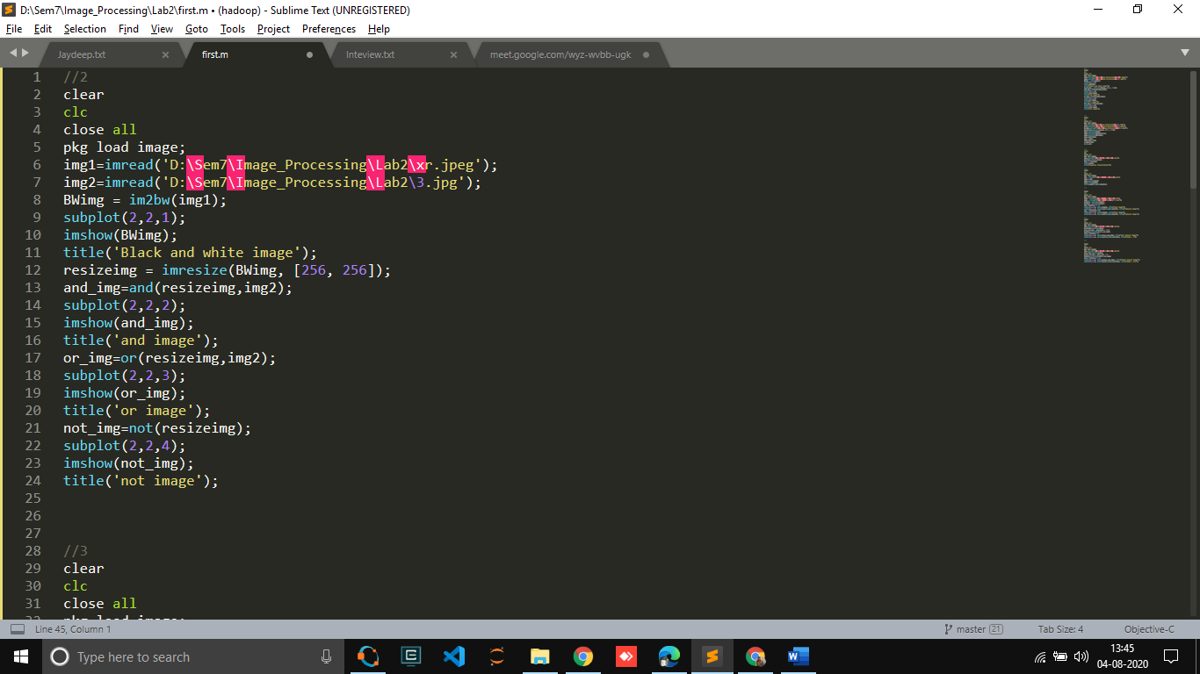

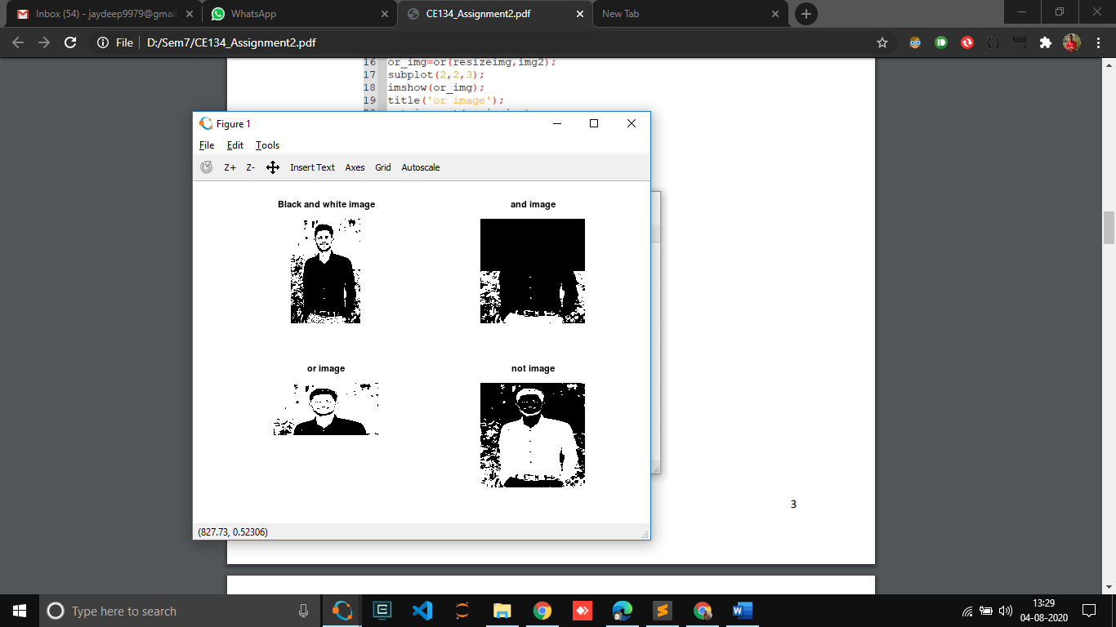

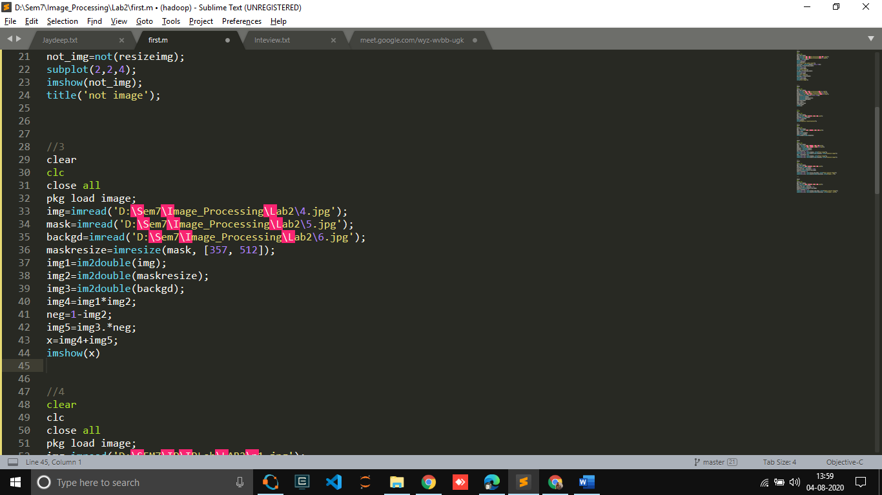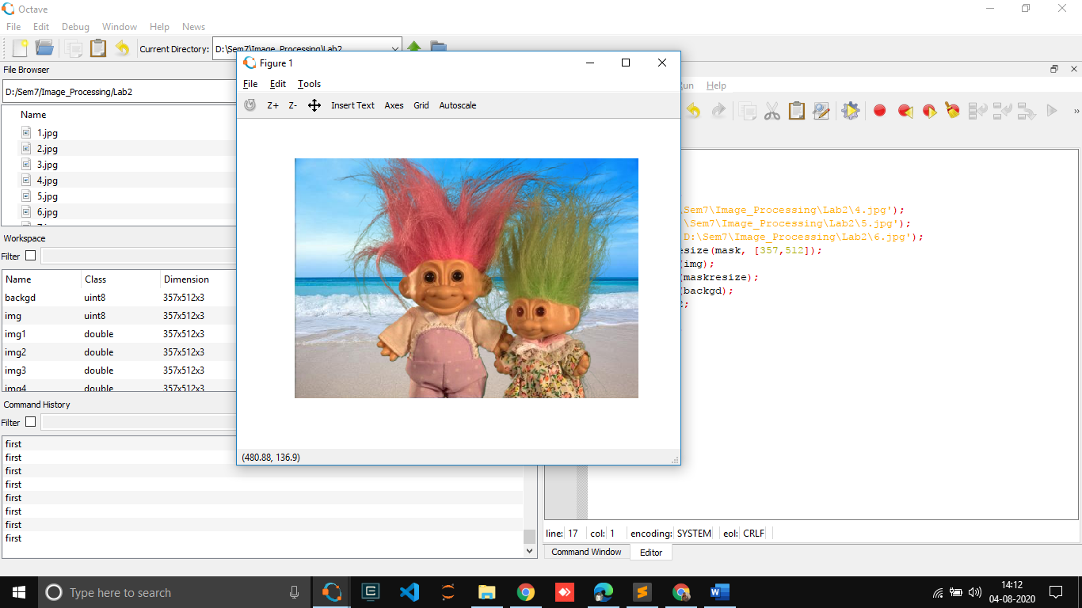**3. Consider image 4.jpg, 5.jpg and 6.jpg as input and apply arithmetic operations on input image to generate 7.jpg as output image**.

**4. Take your own grayscale photo and apply 'negative' transformation.**

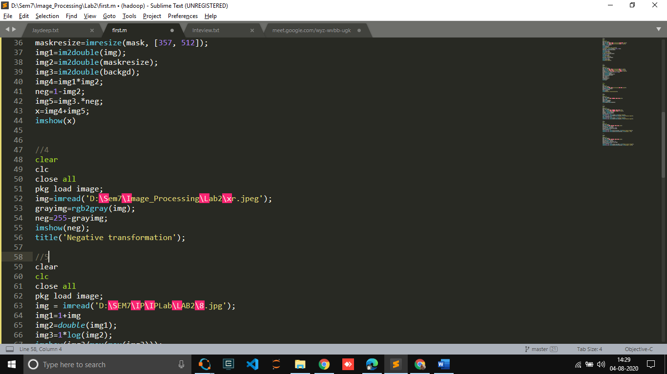

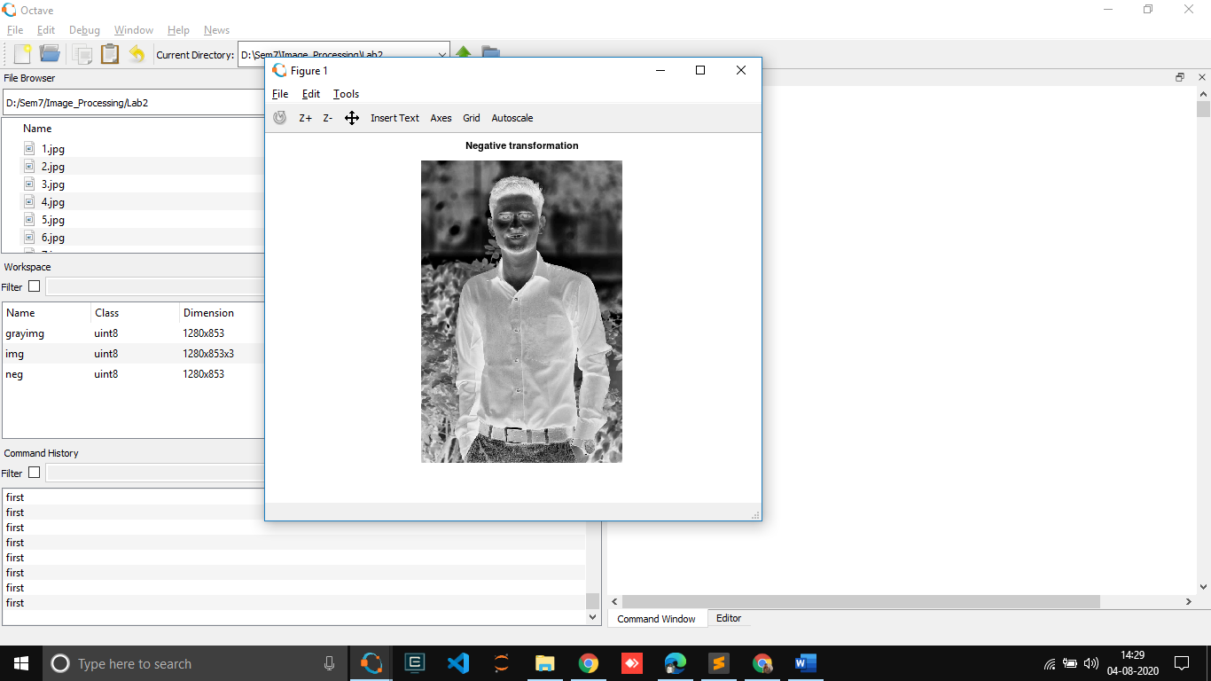

**5. Consider image 8.jpg. Enhance the image by applying the log transformation.**

**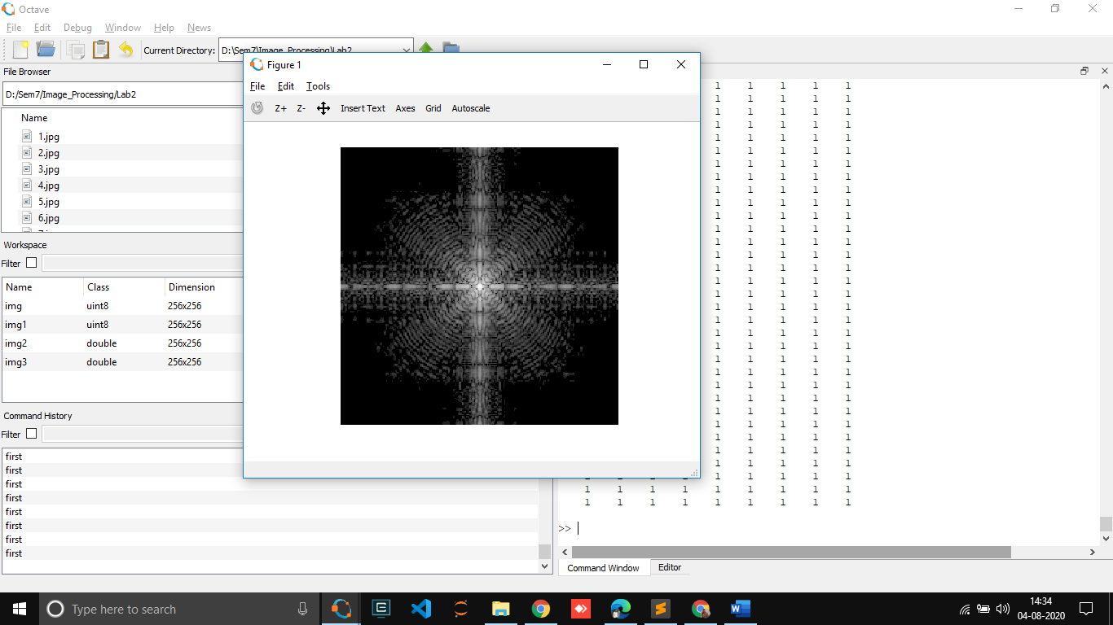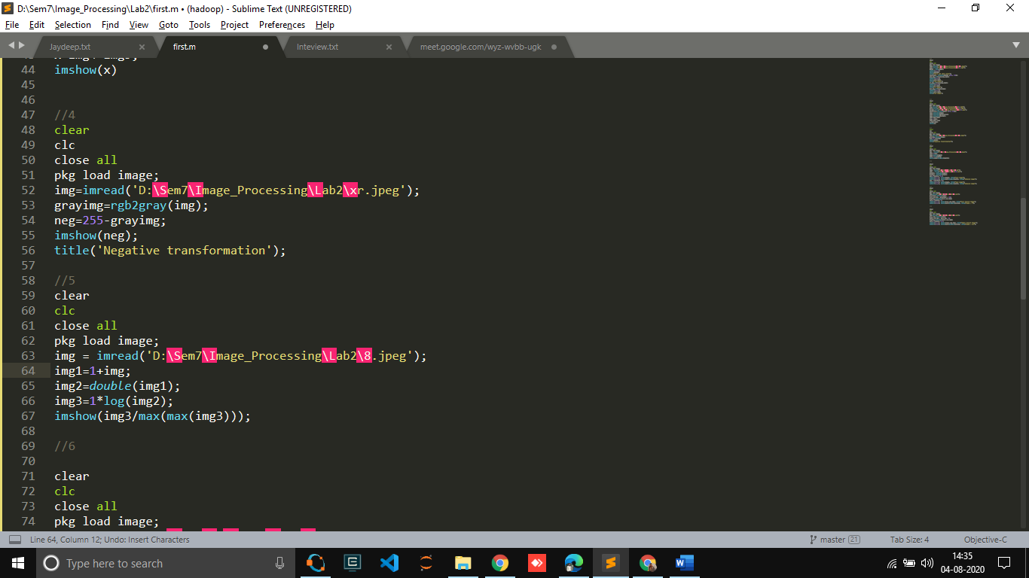  
  
  
  
  
  
  
  
  
  
  
  
6. Consider image 9.jpg and 10.jpg and enhance them with power law transformation.**

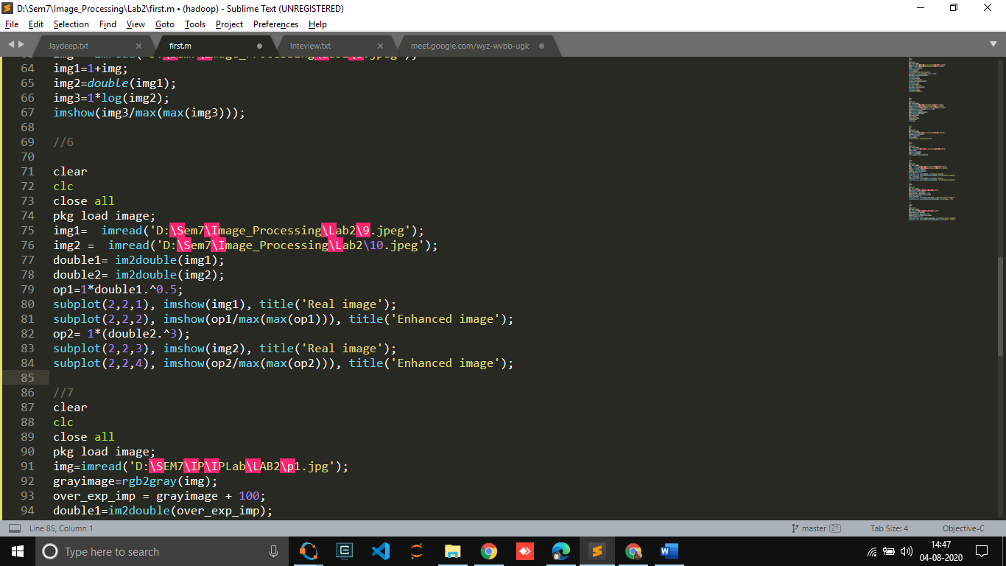

**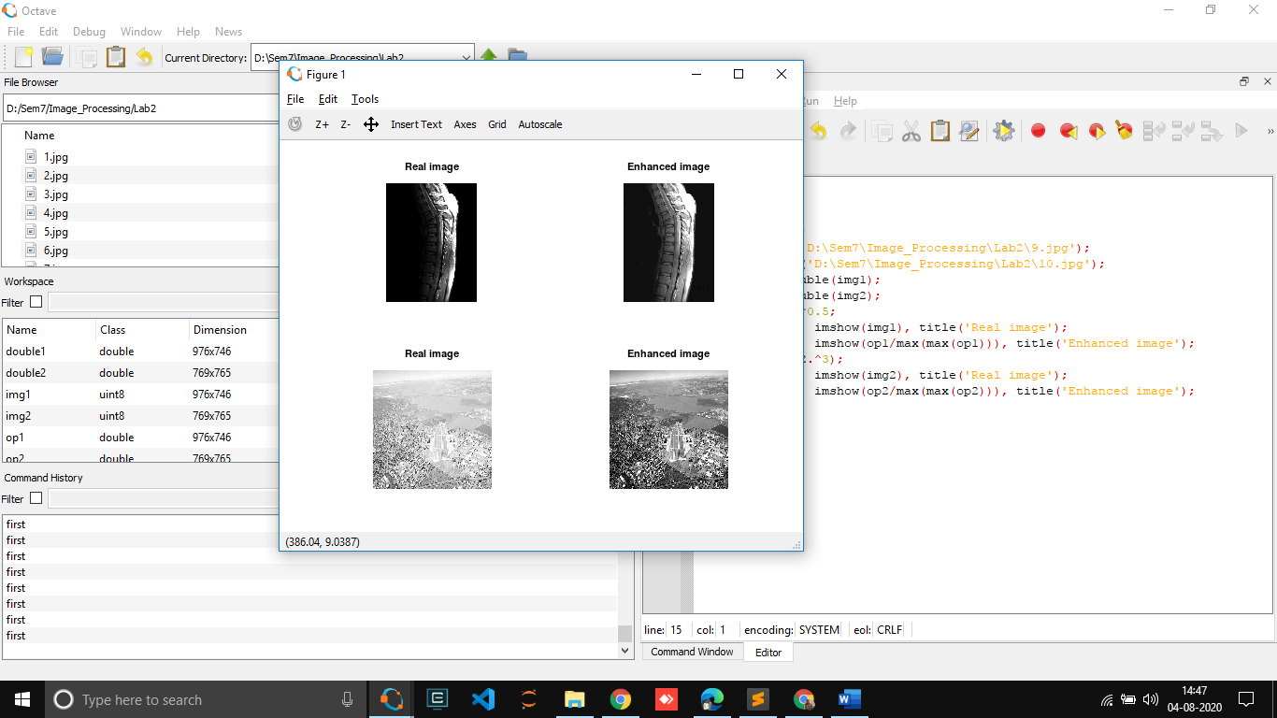  
  
  
  
  
  
  
  
  
  
  
  
  
  
  
  
  
  
  
  
  
  
  
  
  
  
  
  
  
  
  
  
  
  
  
  
  
  
  
  
  
  
7. Consider your over exposed photo (that you generated for assignment 1) and enhance it by power law transformation. Specify the value of gamma which is suitable for this enhancement.**

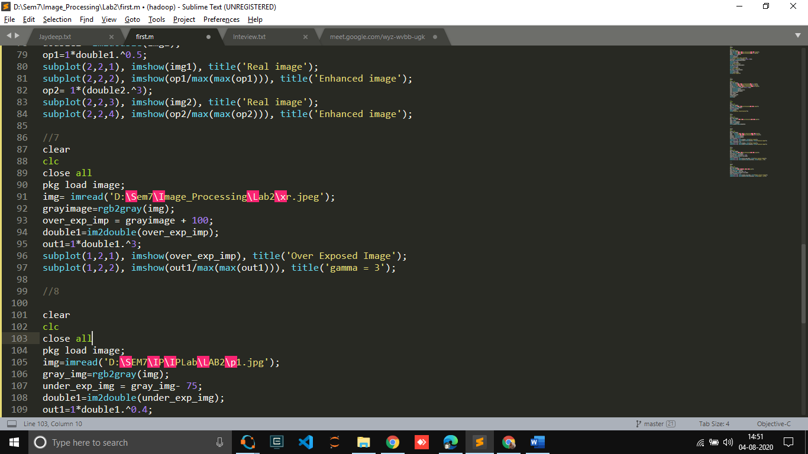

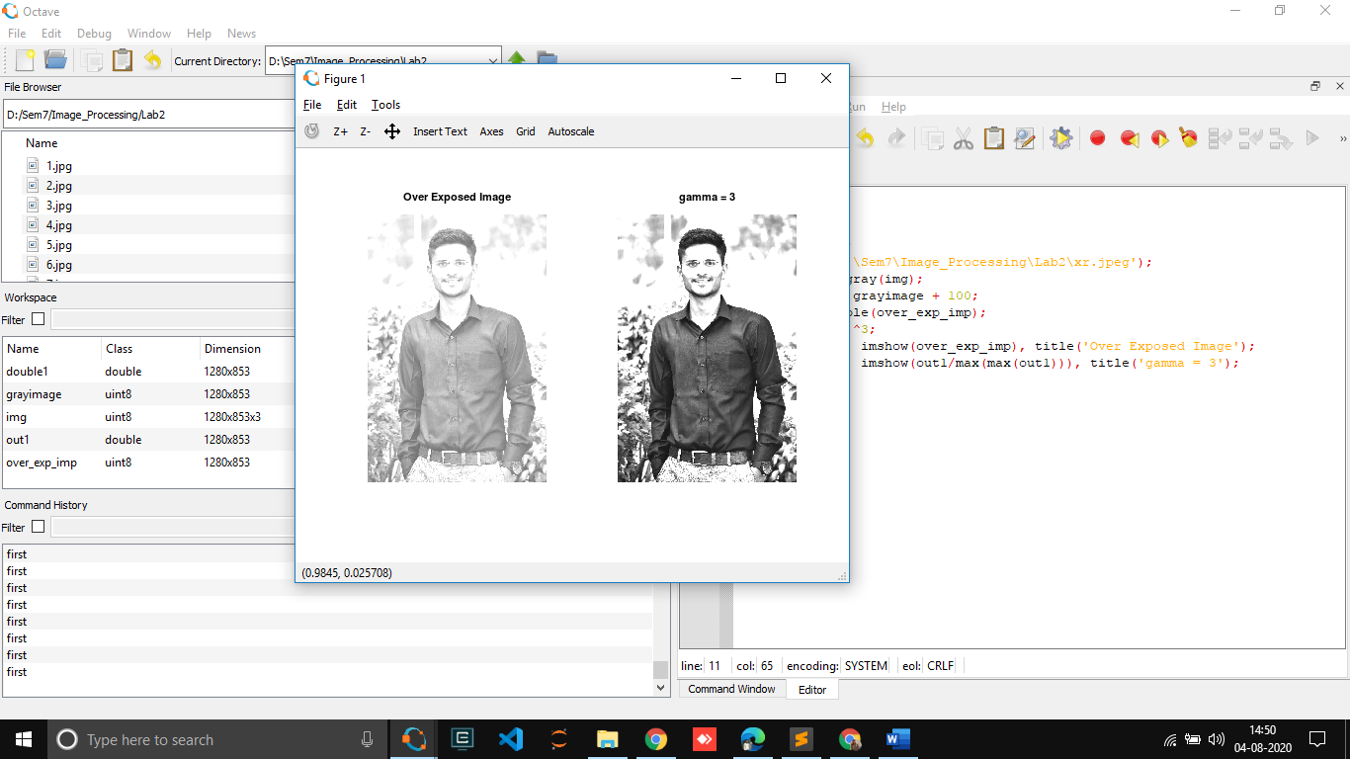

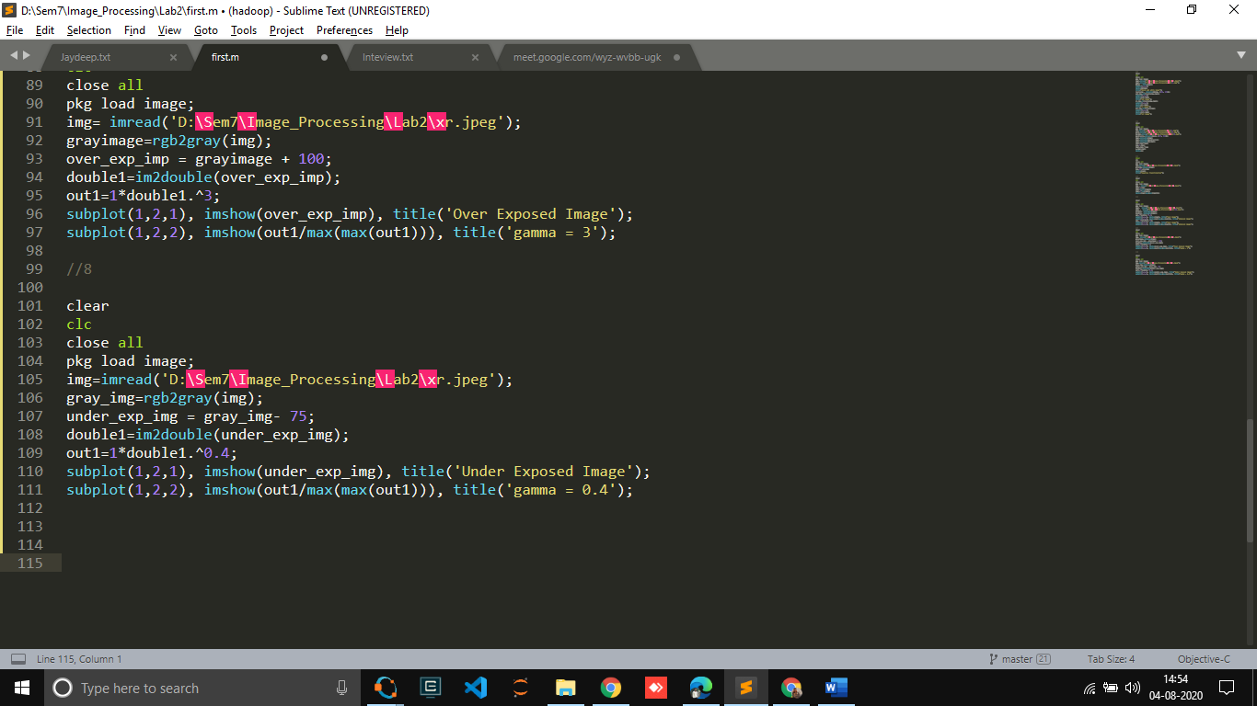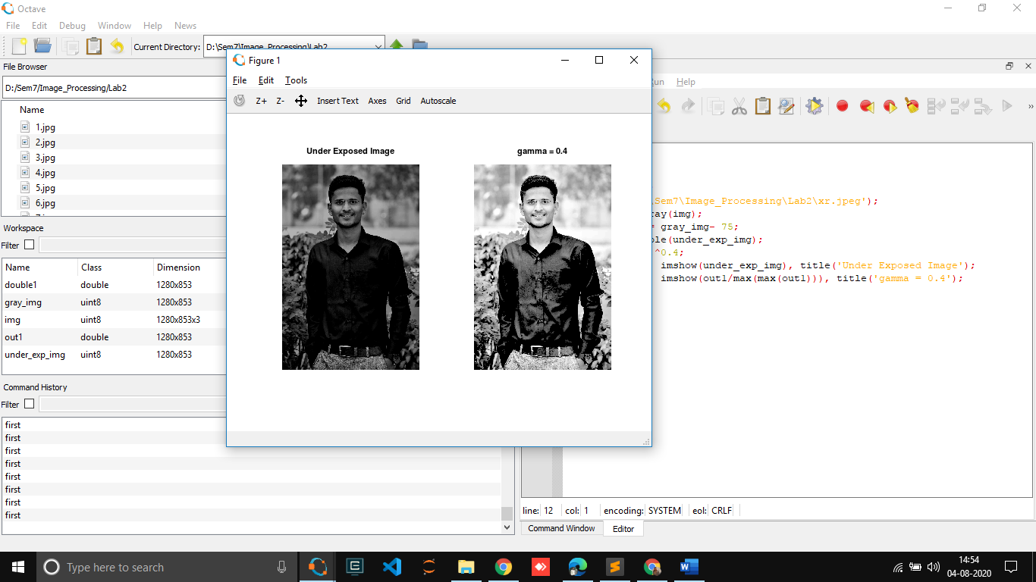**8. Consider your under exposed photo (that you generated for assignment 1) and enhance it by power law transformation. Specify the value of gamma which is suitable for this enhancement**