**LAB4**

**Aim: Write a map-reduce program to count the books from distributed.**

**Steps:**

**1.** Create a text file pages.txt and store page numbers line by line in that file.

**2.** Copy that file to hdfs from local storage and we can see content of file using cat command.

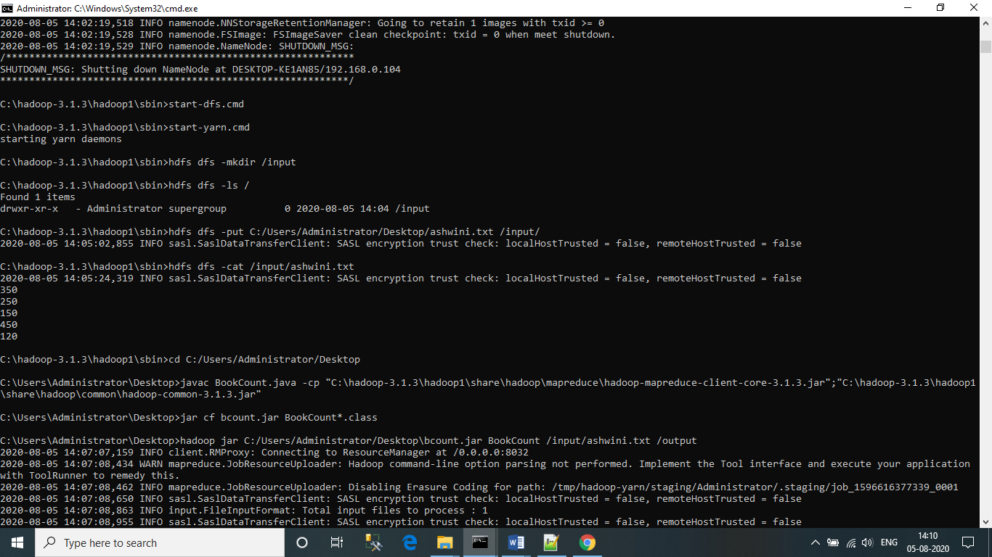

**3.** Create Bookcount.java class file which contains the mapper and reducer class for the particular problem statement.

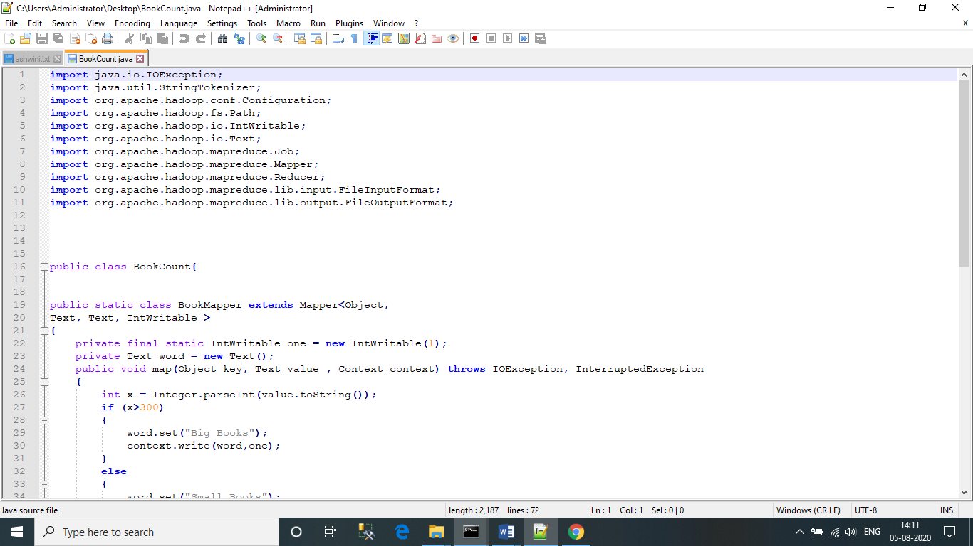

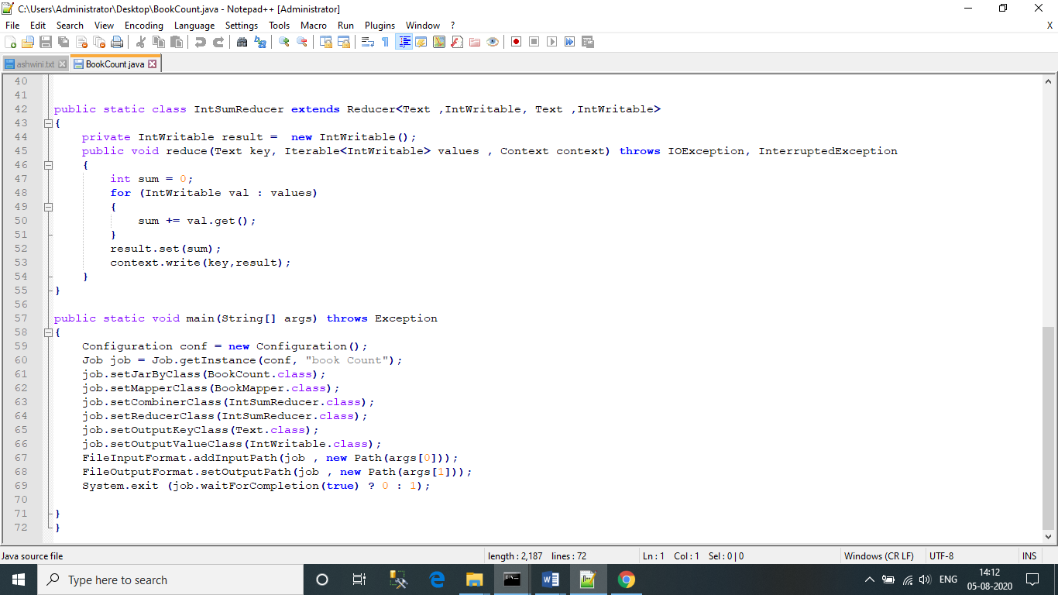

**4.** Compile and create the jar file bc.jar of MapReduce java file.

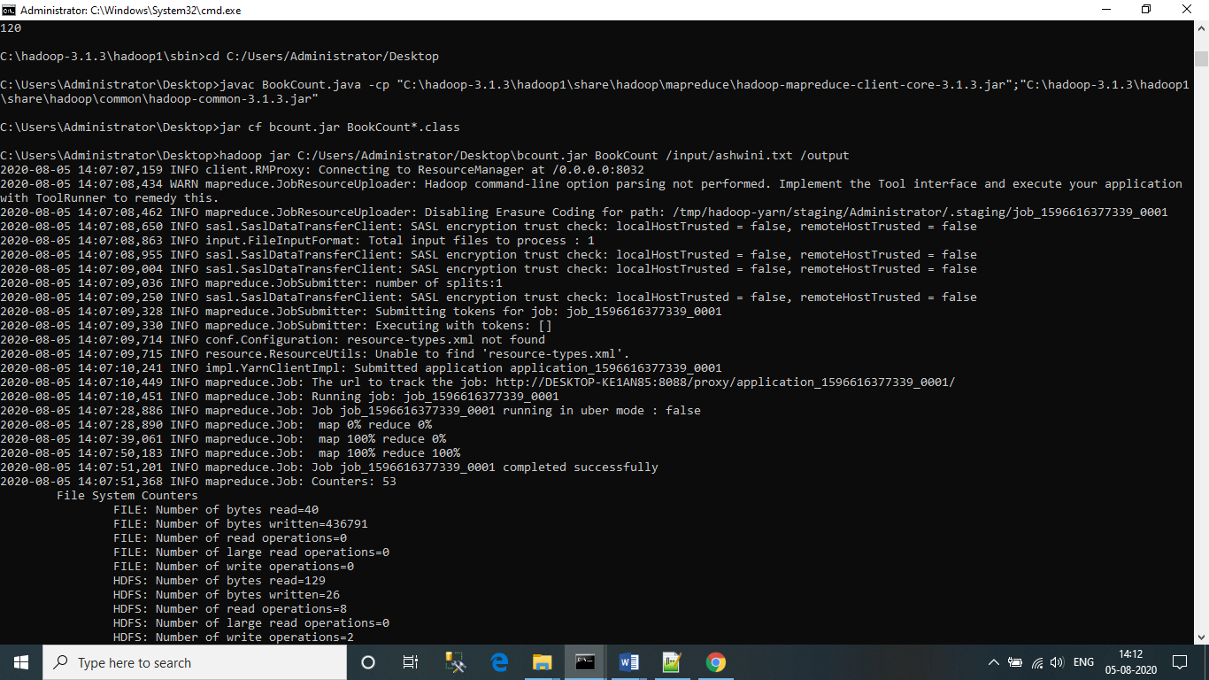

**5.** Now, by using “hadoop jar” command we can execute our program:

