**Practical : 01**

**Aim :** Basics concept- Introduction to Linux Operating system, Basic command in Linux and writing shell script in Vi editor.

# Theory:Linux distribution is an operating system that is made up of a collection of software based on Linux kernel or you can say distribution contains the Linux kernel and supporting libraries and software

**Architecture of Linux**

Linux architecture has the following components:

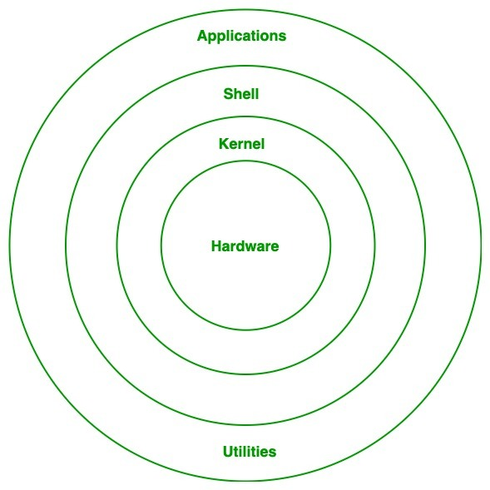

Fig:01 Linux architecture

**Kernel:**Kernel is the core of the Linux based operating system. It virtualizes the common hardware resources of the computer to provide each process with its virtual resources. The kernel is also responsible for preventing and mitigating conflicts between different processes. Different types of the kernel are:

1. Monolithic Kernel
2. Hybrid kernels
3. Exo kernels
4. Micro kernels
5. **System Library:**This is the special types of functions that are used to implement the functionality of the operating system.
6. **Shell:**It is an interface to the kernel which hides the complexity of the kernel’s functions from the users. It takes commands from the user and executes the kernel’s functions.
7. **Hardware Layer:**This layer consists all peripheral devices like RAM/ HDD/ CPU etc.
8. **System Utility:**It provides the functionalities of an operating system to the user.

**Advantages of Linux :**

1. The main advantage of Linux, is it is an open-source operating system. This means the source code is easily available for everyone and you are allowed to contribute, modify and distribute the code to anyone without any permissions.

1. In terms of security, Linux is more secure than any other operating system. It does not mean that Linux is 100 percent secure it has some malware for it but is less vulnerable than any other operating system. So, it does not require any anti-virus software.
2. The software updates in Linux are easy and frequent.
3. Various Linux distributions are available so that you can use them according to your taste.
4. Linux is freely available to use on the internet.
5. It has large community support.

**Disadvantages of Linux :**

1. It is not very user-friendly. So, it may be confusing for beginners.
2. It has small peripheral hardware drivers as compared to windows.

**Basic Commands**

**1. pwd** **:** When you first open the terminal, you are in the home directory of your user. To know which directory you are in, you can use the **“pwd”** command. It gives us the absolute path, which means the path that starts from the root. The root is the base of the Linux file system. It is denoted by a forward slash( / ). The user directory is usually something like "/home/username".

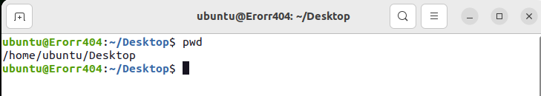

**2. ls :** Use the **"ls"** command to know what files are in the directory you are in. You can see all the hidden files by using the command **“ls -a”**.

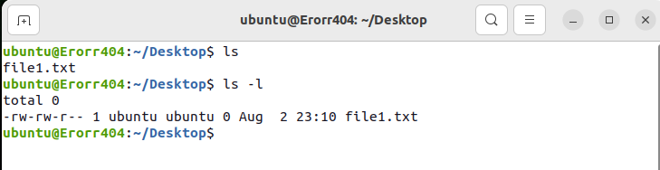

**3. cd** **:** Use the **"cd"** command to go to a directory. For example, if you are in the home folder, and you want to go to the downloads folder, then you can type in **“cd Downloads”**. Remember, this command is case sensitive, and you have to type in the name of the folder exactly as it is. If you just type **“cd”** and press enter, it takes you to the home directory. To go back from a folder to the folder before that, you can type “**cd** ..” . The two dots represent back.

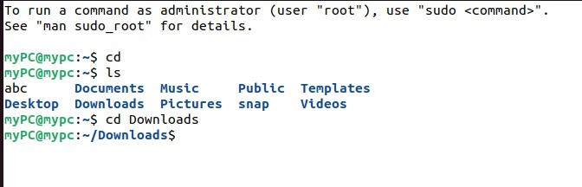

**4. mkdir  :** Use the **mkdir** command when you need to create a folder or a directory. For example, if you want to make a directory called “DIY”, then

you can type **“mkdir DIY**”.

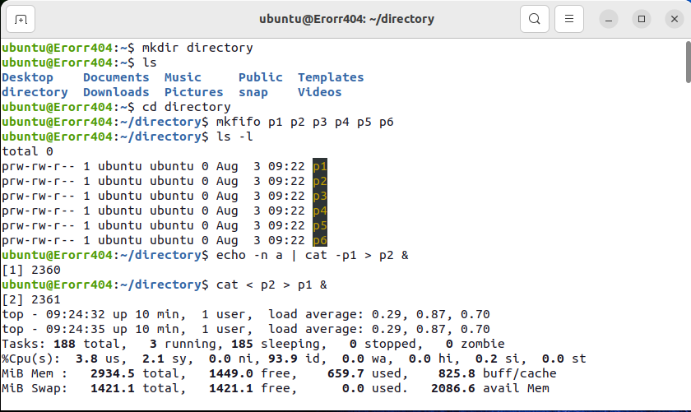

**5. rm** **:** Use the **rm** command to delete files and directories.  Use "**rm -r**" to delete just the directory. It deletes both the folder and the files it contains when using only the **rm** command.

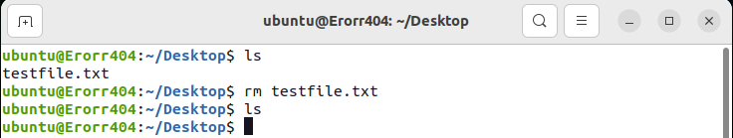

**6. touch** **:** The**touch** command is used to create a file. It can be anything, from an empty txt file to an empty zip file. For example, “**touch new.txt**”.

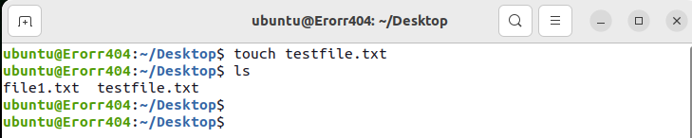

**7. man & --help** **:** To know more about a command and how to use it, use the **man** command. It shows the manual pages of the command. For example, “**man cd**” shows the manual pages of the **cd**command. Typing in the command name and the argument helps it show which ways the command can be used (e.g., **cd –help**).

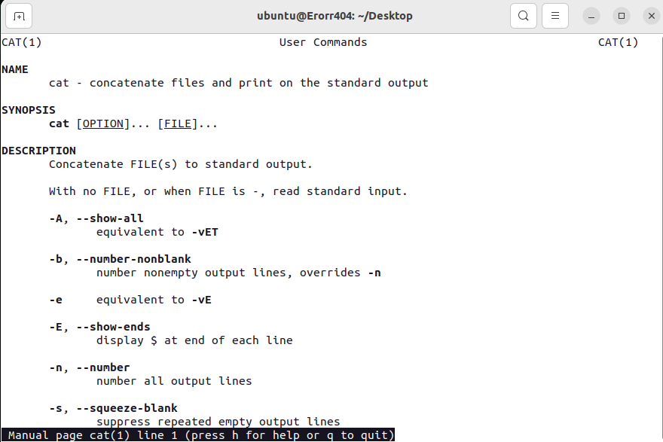

**8. cp** **:** Use the **cp**command to copy files through the command line. It takes two arguments: The first is the location of the file to be copied, the second is where to copy.

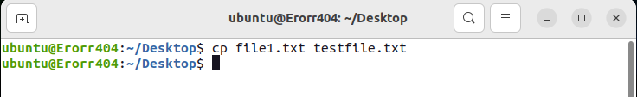

**9. mv** **:** Use the **mv** command to move files through the command line. We can also use the **mv** command to rename a file. For example, if we want to rename the file “**text**” to “**new**”, we can use “**mv text new**”. It takes the two arguments, just like the**cp** command

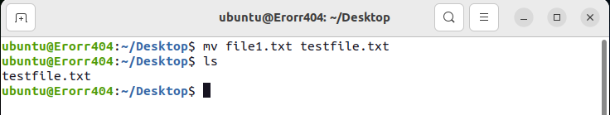

**Intermediate Commands**

1. **echo :** The "**echo**" command helps us move some data, usually text into a file. For example, if you want to create a new text file or add to an already made text file, you just need to type in, “**echo hello, my name is alok >> new.txt**”. You do not need to separate the spaces by using the backward slash here, because we put in two triangular brackets when we finish what we need to write.

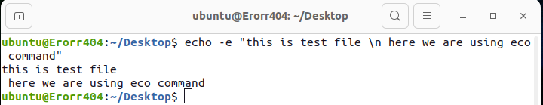

**2. cat :** Use the **cat** command to display the contents of a file. It is usually used to easily view programs.

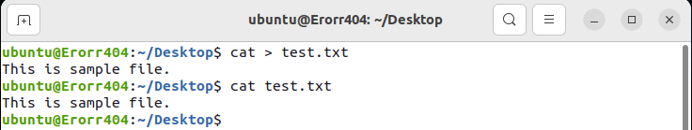

1. **du** **:** Use **du** to know the disk usage of a file in your system. If you want to know the disk usage for a particular folder or file in Linux, you can type in the command **df** and the name of the folder or file. For example, if you want to know the disk space used by the documents folder in Linux, you can use the command “**du Documents**”. You can also use the command “**ls -lah**” to view the file sizes of all the files in a folder.

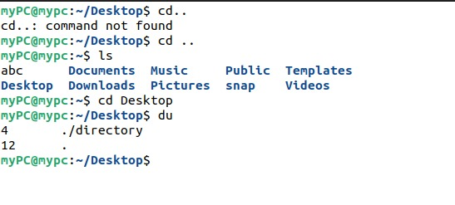

**4. reboot command** **:** It may be used to [halt, power-off or reboot a system](https://www.tecmint.com/shutdown-poweroff-halt-and-reboot-commands-in-linux/" \t "_blank) as follows.

1. **[sudo command](https://www.tecmint.com/sudoers-configurations-for-setting-sudo-in-linux/" \t "_blank) :**  allows a permitted system user to run a command as root or another user, as defined by the security policy such as sudo users

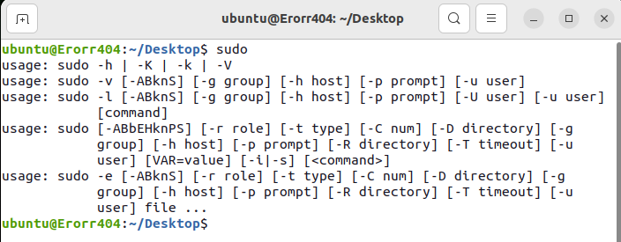

1. **[uname command](https://www.tecmint.com/find-linux-kernel-version-distribution-name-version-number/" \t "_blank)** **:**displays system information such as operating system, network node hostname kernel name, version and release etc.

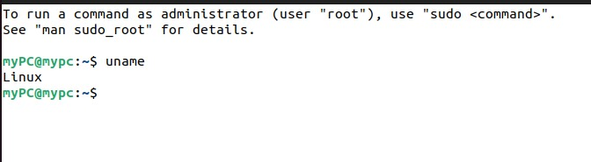

**Conclusion**: Thus, We have studied the Linux operating systems and the basic command of Linux. And I have implemented some basic command of Linux successfully.