**Practical : 4**

**AIM:** Disk partitions

1. Use fdisk -l to display existing partitions and sizes.
2. Use df -h to display existing partitions and sizes.
3. Compare the output of fdisk and df.
4. Create a 200MB primary partition on a small disk.
5. Create a 400MB primary partition and two 300MB logical drives on a big disk.
6. Use df - h and fdisk -l to verify your work.
7. Compare the output again of fdisk and df. Do both commands display the new partitions?
8. Create a backup with dd of the mbr that contains your 200MB primary partition.
9. Take a backup of the partition table containing your 400MB primary and 300MB logical drives. Make sure the logical drives are in the backup.
10. Remove all your partitions with fdisk. Then restore your backups.

**Theory:**

Disk partitioning is one step of [disk formatting](https://www.partitionwizard.com/help/what-is-disk-formatting.html" \t "_blank). It is the process of dividing a disk into one or more regions, the so called partitions. If a partition is created, the disk will store the information about thelocation and size of partitions in [partition table](https://www.minitool.com/lib/partition-table.html" \t "_blank) that is usually located in the first sector of a disk.

With the partition table, each partition can appear to the operating system as a logical disk and users can read and write dataon disk. And each partition can be managed separately.

Why we need it?

* To upgrade Hard Disk (to incorporate new Hrd Disk to the system)
* Dual Booting(Multiple operating systems on the same system)
* Efficient disk management
* Ensure backup and security
* Work with different File systems using the same system

**Commands use in disk partition:**

* **fdisk** : The fdisk is a Linux command called fixed disk/format disk and is used with the Linux/Unix-based systems for command-line-based disk manipulation process.

It is used to create and organize space for new partitions or new drives, rearrange old drives, and move and copy information to new disks. In your system, you can create as many partitions as you want, and you can extend the partitions using fdisk commands.

**Syntax-** fdisk [options] device

* **df command**: The df command (short for disk free), is used to display information related to file systems about total space and available space. df [OPTION]... [FILE]... If no file name is given, it displays the space available on all currently mounted file systems.

Syntax: df [OPTION]... [FILE]..

**Partition a Disk Using fdisk Command:**

Follow the steps below to partition a disk in Linux by using the fdisk command.

Step 1: List Existing Partitions

sudo fdisk -l

Step 2: Select Storage Disk

Select the storage disk you want to create partitions on by running the following

command: sudo fdisk /dev/sdb

Step 3: Create a New Partition

1. Run the n command to create a new partition.
2. Select the partition number by typing the default number (2).
3. After that, you are asked for the starting and ending sector of your hard drive. It is best to type the default number in this section (3622912).
4. The last prompt is related to the size of the partition. You can choose to have several sectors or to set the size in megabytes or gigabytes. Type +2GB to set the size of the partition to 2GB.

A message appears confirming that the partition is created.

Step 4: Write on Disk

The system created the partition, but the changes are not written on the disk.

1. To write the changes on disk, run the w command:
2. Verify that the partition is created by running the following command: Sudofdisk -l

# Disk partition

1. Use fdisk -l to display existing partitions and sizes.

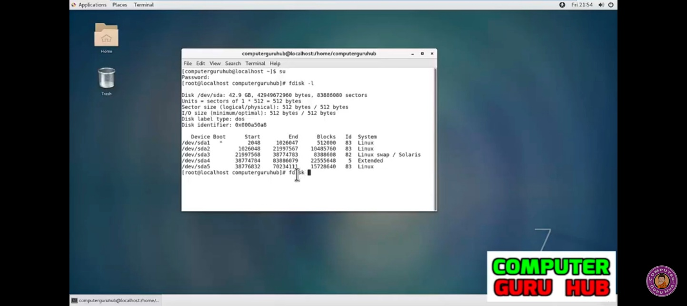

1. Use df -h to display existing partitions and sizes.
2. Compare the output of fdisk and df.

Some partitions will be listed in both outputs (maybe /dev/sda1 or /dev/hda1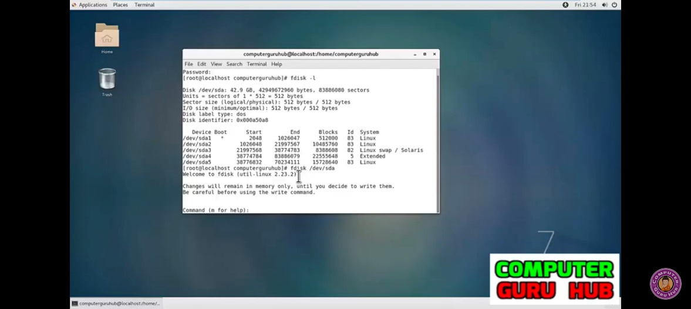

1. Create a 200MB primary partition on a small disk.

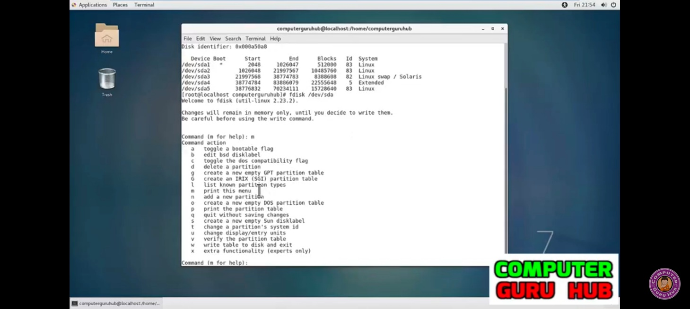

1. Create a 400MB primary partition and two 300MB logical drives on a big disk.

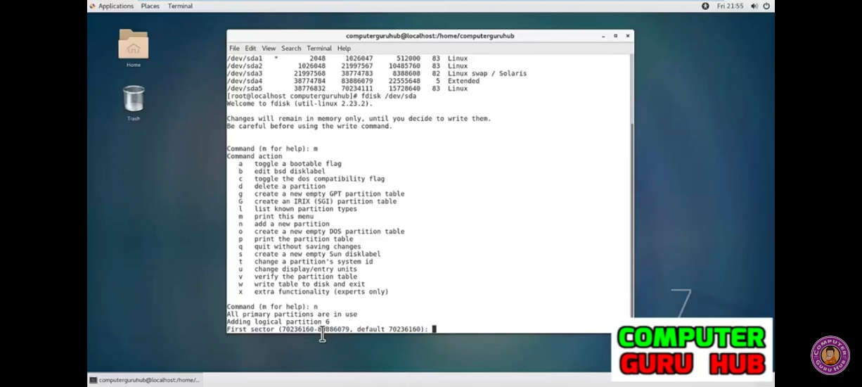

1. Use df -h and fdisk -l to verify your work

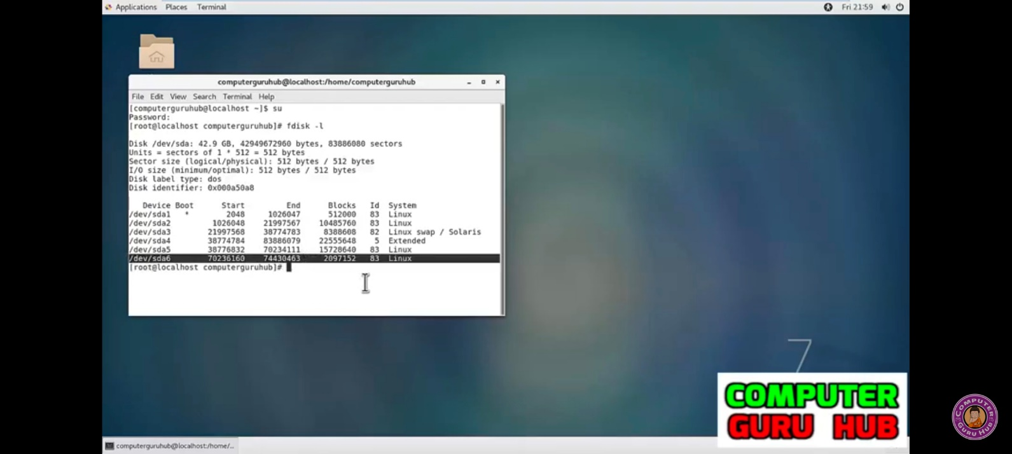

1. Remove all your partitions with fdisk. Then restore your backups. To backup /dev/sda partition table, enter:

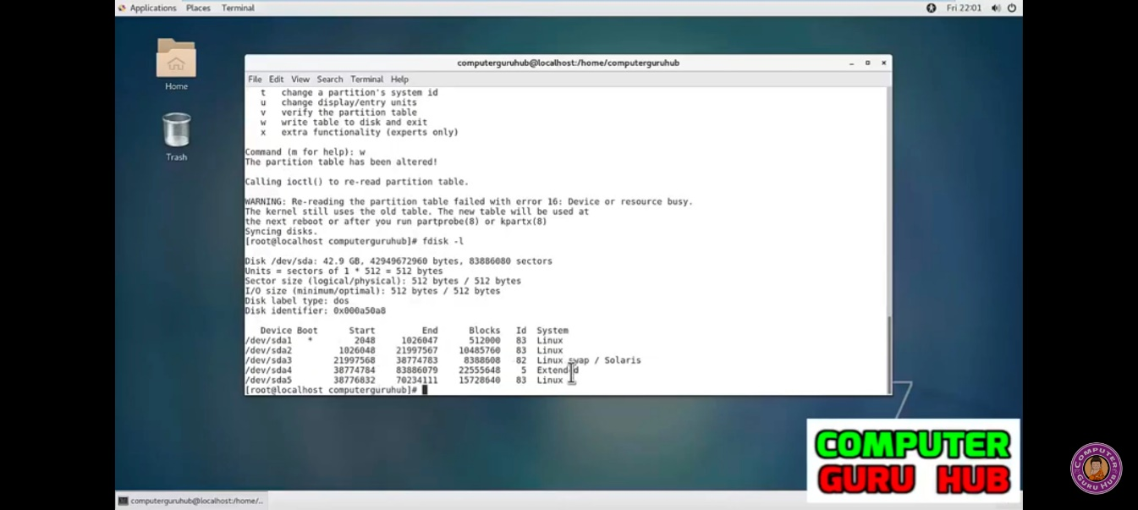

# Conclusion:Thus, we have successfully understood how to partition a disk and also perform various operations on it.