### PRACTICAL 6

**AIM:** File System

* 1. List the file systems that are known by yoursystems.
  2. Create an ext2 file systems on the 200MBpartition.
  3. Create an ext3 file systems on one of the 300MB logicaldrives.
  4. Create an ext4 on the 400MB partition.
  5. Set the reserved space for root on the ext3 file system to 0percent.
  6. Verify your work with fdisk anddf.
  7. Perform a file system check on all the new filesystems.

### Theory:

A file system is a way of organizing files on your partition. Besides file-based storage, file systems usually include directories and access control, and contain meta information about files like access times, modification times and file ownership.

A Linux file system is a structured collection of files on a disk drive or a partition. A partition is a segment of memory and contains some specific data. In our machine, there can be various partitions of the memory. Generally, every partition contains a file system.

The general-purpose computer system needs to store data systematically so that we can easily access the files in less time. It stores the data on hard disks (HDD) or

some equivalent storage type. There may be below reasons for maintaining the file system:

* Primarily the computer saves data to the RAM storage; it may lose the data if it gets turned off. However, there is non-volatile RAM (Flash RAM and SSD) that is available to maintain the data after the powerinterruption.
* Data storage is preferred on hard drives as compared to standard RAMas RAM costs more than disk space. The hard disks costs are dropping gradually comparatively the RAM.

Linux file system contains two-part file system software implementation architecture. Consider the below image:

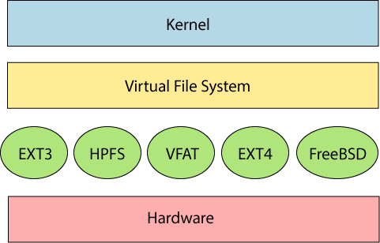

**Types of Linux File System**

When we install the Linux operating system, Linux offers many file systems such as **Ext, Ext2, Ext3, Ext4, JFS, ReiserFS, XFS, btrfs,** and **swap**.

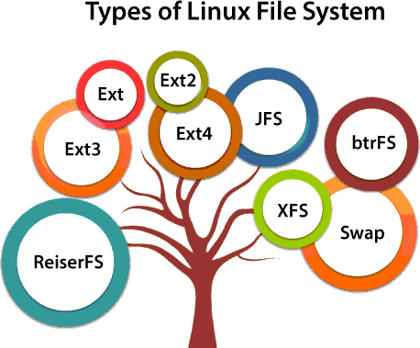

Let's understand each of these file systems in detail:

1. **Ext, Ext2, Ext3 and Ext4 filesystem**

The file system Ext stands for **Extended File System**. It was primarily developed for **MINIX OS**. The Ext file system is an older version, and is no longer useddue to somelimitations.

**Ext2** is the first Linux file system that allows managing two terabytes of data.Ext3 is developed through Ext2; it is an upgraded version of Ext2 and contains backward compatibility. The major drawback of Ext3 is that it does not support servers because this file system does not support file recovery and disksnapshot.

**Ext4** file system is the faster file system among all the Ext file systems. It is a very compatible option for the SSD (solid-state drive) disks, and it is the default file system in Linux distribution.

1. **JFS FileSystem**

JFS stands for **Journaled File System**, and it is developed by **IBM for AIX Unix**. It is an alternative to the Ext file system. It can also be used in place of Ext4, where stability is needed with few resources. It is a handy file system when [CPU](https://www.javatpoint.com/cpu-full-form) power is limited.

1. **XFS FileSystem**

XFS file system was considered as high-speed JFS, which is developed for parallel I/O processing. NASA still using this file system with its high storage server (300+ Terabyte server).

1. **Swap FileSystem**

The swap file system is used for memory paging in Linux operating system during the system hibernation. A system that never goes in hibernate state is required to have swap space equal to its [RAM](https://www.javatpoint.com/ram-full-form) size.

**Commands for file systems:-**

**File System Outputs:-**

1. **List the filesystems that are known by yoursystem.**

man fs

cat /proc/filesystems

cat /etc/filesystems (not on all Linux distributions)

1. **Create an ext2 filesystem on the 200MBpartition.**

mke2fs /dev/sdc1 (replace sdc1 with the correct partition)

1. **Create an ext3 filesystem on one of the 300MB logicaldrives.**

mke2fs -j /dev/sdb5 (replace sdb5 with the correct partition)

1. **Create an ext4 on the 400MBpartition.**

mkfs.ext4 /dev/sdb1 (replace sdb1 with the correct partition)

1. **Set the reserved space for root on the ext3 filesystem to 0percent.**

tune2fs -m 0 /dev/sdb5

1. **Verify your work with fdisk anddf.**

mkfs (mke2fs) makes no difference in the output of these commands

The big change is in the next topic: mounting

1. **Perform a file system check on all the new filesystems.**

fsck /dev/sdb1 fsck /dev/sdc1 fsck /dev/sdb5

**IMAGE OUTPUT(P.T.O):**

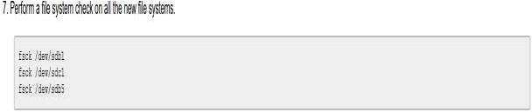0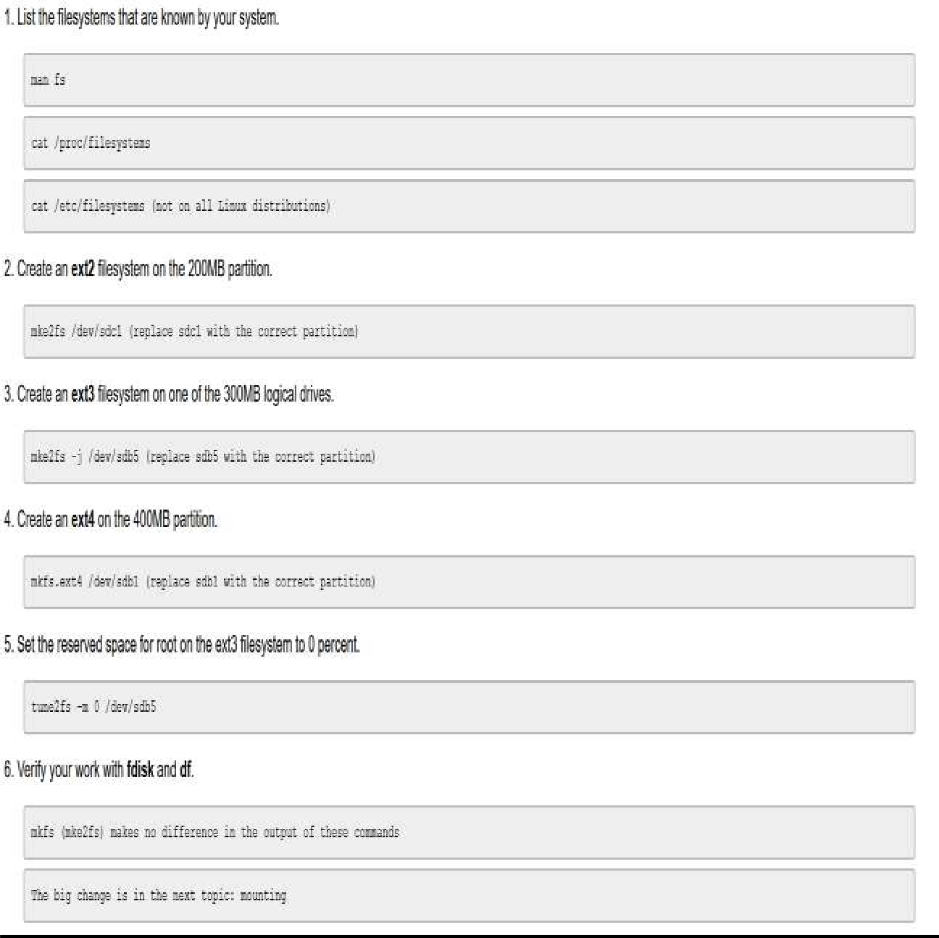

### CONCLUSION:

We have successfully studied about file system in linux and executed command in linux.