**PRACTICAL 7**

**PRACTICAL 7**

**AIM:-**

1. Schedule two jobs with at , display the at queue and remove thejob
2. As normal user , use crontab –e to schedule a script to run every four minutes
3. As ,root display the crontab file of normaluser
4. As a normal user again remove our crontabfile
5. Take a Look at the cron files and directories in /etc and understand them what is the runparts commanddoing

### THEORY:-

The **crontab** is a list of commands that you want to run on a regular schedule, and also the name of the command used to manage that list. Crontab standsfor―crontable,‖becauseitusesthejobscheduler*cron*toexecutetasks; *cron*itselfisnamedafter―chronos,‖theGreekwordfortime.*cron*isthesystem process which will automatically perform tasks for you according to a set schedule. The schedule is called the crontab, which is also the name of the program used to edit that schedule.

**Linux Crontab Format**

MIN HOUR DOM MON DOW CMD

**Crontab Fields and Allowed Ranges (Linux Crontab Syntax)**

|  |  |  |
| --- | --- | --- |
| **Field**  MIN | **Description**  Minute field | **Allowed Value**  0 to 59 |
| HOUR | Hour field | 0 to 23 |
| DOM | Day of Month | 1-31 |
| MON | Month field | 1-12 |
| DOW | Day Of Week | 0-6 |
| CMD | Command | Any command to be executed. |

**What does the crontab command do?**

On Unix-like operating systems, the **crontab command** opens the **cron** table for editing. The **cron** table is the list of tasks scheduled to run at regular timeintervals

on the system. The daemon which reads the **crontab** and executes the **commands**

at the right time is called **cron.**

### Why Use Cron Jobs?

Server admins have been using cron jobs for a long time. But since the target audience of this article is web developers, let's look at a few use cases of cron jobs that are relevant in this area:

* + If you have a membership site, where accounts have expiration dates, you can schedule cron jobs to regularly deactivate or delete accounts that are past their expiration dates.
  + You can send out daily newslettere-mails.
  + If you have summary tables (or materialized views) in your database, they can be regularly updated with a cron job. For example you may store every web page hit in a table, but another summary table may contain daily traffic summaries.
  + You can expire and erase cached data files in a certaininterval.
  + You can auto-check your website content for broken links and have a report e-mailed to yourselfregularly.
  + You can schedule long-running tasks to run from a command line script, rather than running it from a web script. Like encoding videos, or sending out masse-mails.
  + You can even perform something as simple as fetching your most recent Tweets, to be cached in a textfile.

These are all the directories in the folder /etc. The directories related to cron are:

1. cron.d
2. cron.daily
3. cron.hourly
4. cron.monthly
5. cron.weekly
6. Crontab

**Output:**



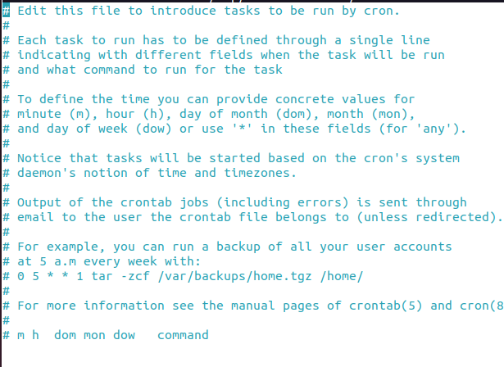

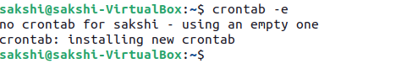

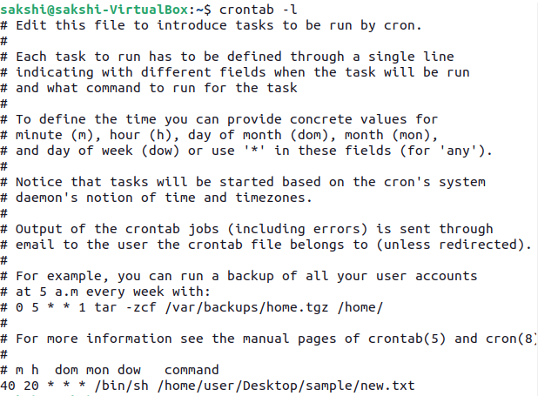

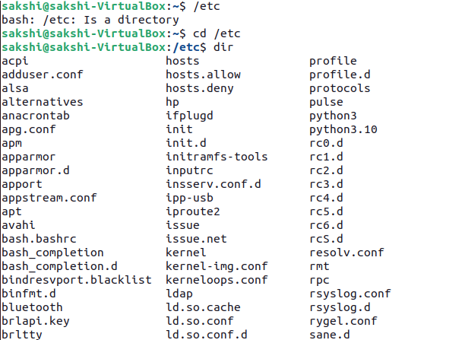

### CONCLUSION:

We have successfully used cron command to schedule a job and thus we know how to schedule any job in linux.