# 2.3 Exercises

Given the following diagrams, create the relational schema for each diagram. Note: the diagrams may not be normalized

1. Bank

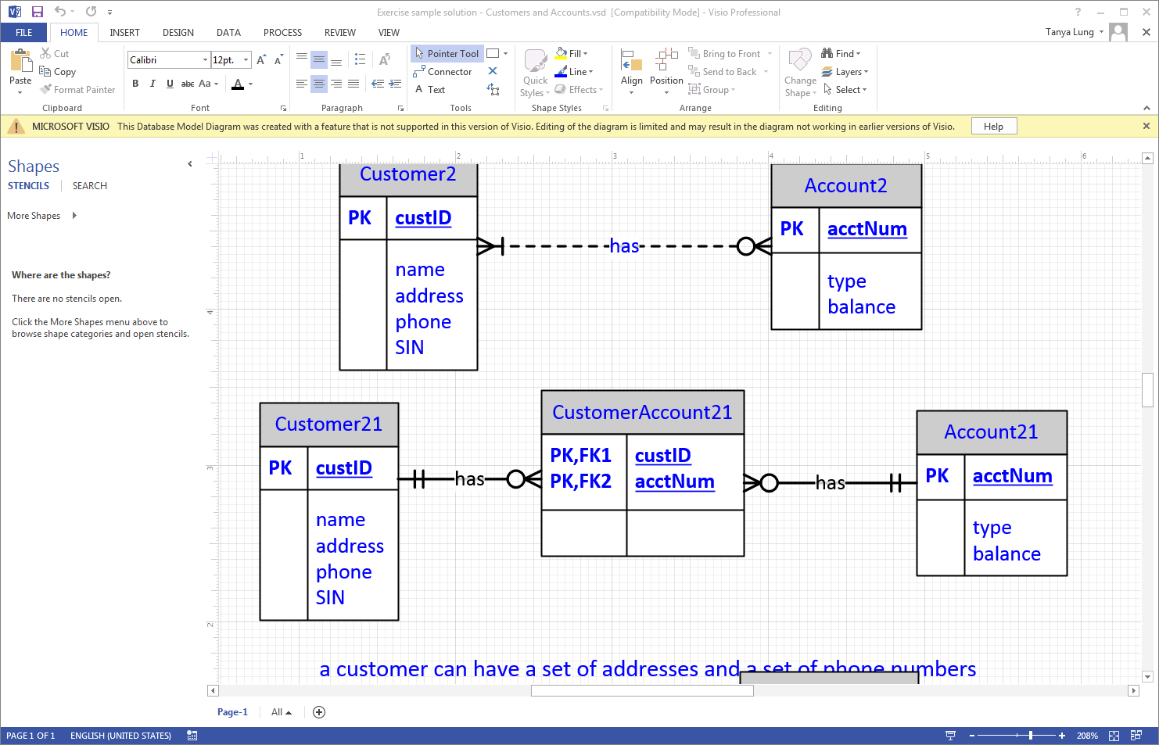

1. Farm

