Analyzing the updateability of a join view

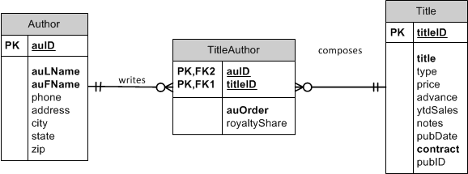

Consider this view:

CREATE OR REPLACE VIEW Oaklanders

AS

SELECT auFName AS First, auLName AS Last, t.titleID, title

FROM Author a JOIN TitleAuthor ta ON a.auID = ta.auID

JOIN Title t ON ta.titleID = t.titleID

WHERE city = 'Oakland'

AND state = 'CA';

|  |  |  |  |  |
| --- | --- | --- | --- | --- |
|  | |  |  | |
|  |  |  |  |  |

Is this view updateable?

How Do you know?

Try it!

* Delete statement

DELETE FROM Oaklanders

WHERE titleID = 'BU1032';

*ROLLBACK;*

Consider this view:

CREATE OR REPLACE VIEW Oaklanders

AS

SELECT auFName AS First, auLName AS Last, ta.titleID, title

FROM Author a JOIN TitleAuthor ta ON a.auID = ta.auID

JOIN Title t ON ta.titleID = t.titleID

WHERE city = 'Oakland'

AND state = 'CA';

|  |  |  |  |
| --- | --- | --- | --- |
|  | |  |  |
|  |  |  |  |

Is this view updateable?

Why and how?

Try it!

* Update statement

UPDATE Oaklanders

SET titleID = 'BU7832'

WHERE titleID = 'BU1032';

*ROLLBACK;*

* What happened?
* Insert a record so we can update our view

Insert into title (titleID, title, contract) values ('TL1111','DB is the best',1);

* Now update

UPDATE Oaklanders

SET titleID = 'TL1111'

WHERE titleID = 'BU7832';

* Check that our new row is there.

SELECT *

FROM TitleAuthor

WHERE titleID IN ('BU7832', 'TL1111');

*ROLLBACK;*

* Delete statement

DELETE FROM Oaklanders

WHERE titleID = 'BU1032';

*ROLLBACK;*

Consider this view:

CREATE OR REPLACE VIEW Oaklanders

AS

SELECT ta.auID, auFName AS First, auLName AS Last, ta.titleID, title, ta.auOrder

FROM Author a JOIN TitleAuthor ta ON a.auID = ta.auID

JOIN Title t ON ta.titleID = t.titleID

WHERE city = 'Oakland'

AND state = 'CA';

|  |  |  |  |  |  |
| --- | --- | --- | --- | --- | --- |
|  | |  | | |  |
|  |  |  |  |  |  |

Is this view updateable?

Why and how?

Try it!

* INSERT

INSERT INTO Oaklanders (auID, titleID, auOrder)

VALUES ('213-46-8915', 'BU1111', 3);

*ROLLBACK;*

* INSERT

UPDATE Oaklanders

SET titleID = 'BU7832'

WHERE titleID = 'TL1111';

*ROLLBACK;*

* Delete statement

DELETE FROM Oaklanders

WHERE titleID = 'BU1032';

*ROLLBACK;*

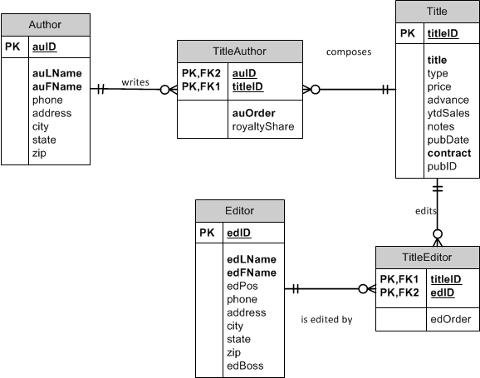

Consider this view:

CREATE OR REPLACE VIEW CompleteBookInfo

AS

SELECT a.auID, auLName AS AuthorLast, auOrder, t.titleID, title, e.edID, edLName AS EditorLast, edOrder

FROM Author a JOIN TitleAuthor ta ON a.auID = ta.auID

JOIN Title t ON ta.titleID = t.titleID

JOIN TitleEditor te ON t.titleID = te.titleID

JOIN Editor e ON te.edID = e.edID;

|  |  |  |  |  |  |  |  |
| --- | --- | --- | --- | --- | --- | --- | --- |
|  | |  |  | |  | |  |
|  |  |  |  |  |  |  |  |

Is this view updateable?

Why?