# Create data reports

8.1 Determine steps to create a report.

8.2 Describe the parts of a report.

8.3 Create a report with no grouping.

8.4 Create advanced reports using formatting options.

8.5 Create a multilevel grouping report with calculated controls.

8.6 Adding presentation quality to reports.

8.7 Incorporate subreports.

## Introduction

In the previous outcomes, we have created queries and forms, which can be printed. However, the output is usually not ideal for printing.

Access reports are used to combine data in tables, queries and forms to produce a result that will be printed in an effective manner. Reports are created in a similar manner as forms, where objects are laid out on a report design grid, positioned, and formatted

Differences between forms and reports:

* Reports are intended for printing and usually aren’t designed for display on Windows
* You can’t change the underlying data through a report
* Reports do not have a Datasheet view
* In multicolumn reports, the number of columns, the column width, and the column spacing are controlled by Printer Setup settings

Access provides several ways to create reports:

* Report tool – Creates a basic report based on the selected table OR query
* Report Wizard – Tools to help us create simple, customized reports
* Blank Report – Creates a new, blank report in Layout View
* Report Design – Creates a new, blank report in Design View
* Labels – Launches the label wizard.

Initially, we will create reports using the Report Wizard. Other tools will be examined later.

## 8.1 Steps to create a report

Whether creating simple or complex reports, the process is similar:

1. Describe the layout of the report (Requirements)
2. Determine (and create, if necessary) the source of the data
3. Create the report (Report Wizard or Report Design)
4. Print or view the report

### Create a basic report

The following steps will create a report to display data from the Order and Order Detail tables, using the Report Wizard.

The report's purpose is to convey information about the orders that have been placed. Using **grouping**, each order will be displayed separately, and within each order, the individual products ordered will be listed in the details section. Each order will look similar to a sales receipt.

#### Step 1: Describe the Layout

The basic layout of the report can be sketched out by hand. The layout describes:

* What information is to appear the report – relate this information to fields in the database
* Where the information will be located on the page
* How the information is to be grouped
* Any summary information (total of the order, count of the products)
* (Optional) Styles to apply.

This layout is a rough draft – no artistic ability required!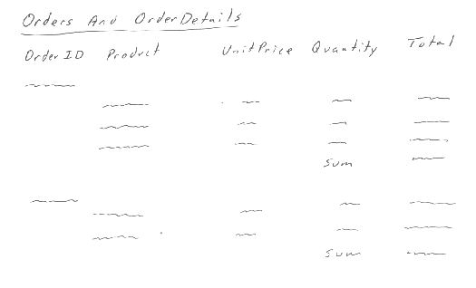

#### Step 2: Determine (and create, if necessary) the source of the data

A report can be based on a single table or query. Queries can draw their data from single or multiple tables. In Access, a report that uses a multi-table query treats the query as a single table – each record is processed separately.

The data needed for a report is separated from the report’s design. The report design will specify the location and formatting of the fields from the data source.

Let’s create a query to gather our data needed for the Order / Order Details report:

1. Create query: **qryOrderDetailsReport**
   1. Tables: [Order], [Order Detail]
   2. Fields:
      1. From [Order]: OrderID
      2. From [Order Detail]: ProductID, UnitPrice, Quantity
      3. Calculated fields:
         1. Extended Price: [UnitPrice]*[Quantity]*(1-[Discount])
   3. Criteria: OrderID Between 10248 And 10300
2. Run query, save, and close

#### Step 3: Create the Report

For this report, we will use the Report Wizard.

1. Optional: Click on the **qryOrderDetailsReport** in the Navigation Pane, Create Tab, Report Wizard
2. Select the data source (if selected in (1), then it should already be showing)
   1. Select all fields
   2. Next
3. Set type of grouping – by Order or by Order Detail – see difference in the preview window.
   1. Select By Order
   2. Next
4. Set any additional grouping (none required in this case)
   1. Next
5. Set the sorting – up to 4 levels
   1. Select ProductID
6. Click Summary Options (** NOT NEXT!!! **) – only visible if report has one or more numeric fields in the Detail section
7. Summary Options dialog box allows you to specify what types of summarization:
   1. Extended Price: Check Sum checkbox
   2. Show: Click Detail and Summary – this show the Extended price in the detail section as well as a total for the group.
   3. Ok
8. Next
9. Layout – Stepped
   1. Orientation – Portrait
   2. Adjust Field Width – checked
   3. Next
10. Title for the report: Northwind Traders Order Details
11. Preview the report and Finish

#### Step 4: Print or view the Report

The resulting report should appear in print-preview.

1. Notice that the report needs some additional formatting – The Extended Price and Totals should use a Currency Format, and some columns should be aligned better.
   1. Let’s spend some time doing these changes
2. Close the report
3. In the Navigation Pane, find the report and rename it to **rptOrderDetails**

## 8.2 Describe the parts of a report

Open the report you just created in Design View to review the parts of the report.

The report is divided into multiple sections. The sections that appear in a report will vary based on how it is designed. Later on, we’ll see how we can add different sections according to custom groups that we set up.

In this report, we can see the following sections:

* Report header – the report header appears at the top of the first page of the report but does not appear on subsequent pages
* Page Header – the page header appears at the top of every page in the report, including the first page; on the first page, the page header appears after the report header
* OrderID Header – the OrderID header appears every time a new OrderID is displayed and contains information about the order – **this appears because the report was grouped by OrderID**
* Detail Section – each record in the data set shows up in the detail section. Think of this as looping through record in the M of a 1-M relationship
* OrderID Footer – the OrderID footer appears at the end of every Order; the summary information for this order is displayed here.
* Page Footer – the page footer is displayed at the bottom of every page, often used for displaying the date, page number, document name, etc
* Report Footer – the report footer is displayed once, at the bottom of the last page, and typically contains summary information.

**Notes:**

* All headers have an associated footer
* Headers and footers are nested around the details section
* You can add/remove group headers and footers as required – the only section you cannot delete is the detail section.
* The report can only have one detail section. If multiple detail sections are required, you need to use a **subreport**

### Parts of a report (generally)

* Sections
* Group sections
* Controls
* Subreports

### Practice

Create a report to display the inventory by category. Save as **rptInventoryByCategory**

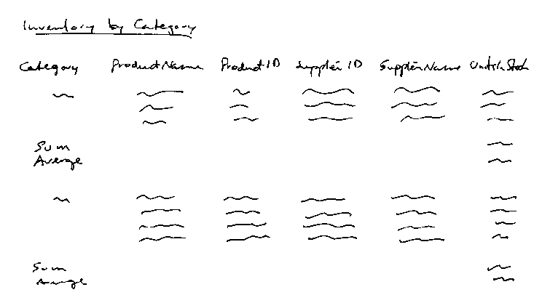

Our Query:

Experiment: within category, group by supplier

### Types of reports

* Tabular reports
  + One column for each field of the records, records in rows under column headers
* Single-column reports
  + One long column of text boxes for each record
  + Not used often as it wastes paper
* Multicolumn reports
  + Single-column reports in a snaking column (like newspaper columns)
  + Less wasteful compared to single-column reports but layout usually not suitable
* Groups/totals reports
  + Summarizes data for groups of records and adds grand totals at the end of the report
  + Most common type of report
* Mailing labels
  + Special kind of multi-column report for mailing labels or other multi-field data
  + Number of columns and rows determined by the type of labels used
* Unbound reports
  + Has subreports based on unrelated data sources

## 8.3 Create a report with no grouping

Reports with no groupings are usually designed to display information on a single theme or single table.

The following report will display information about the products offered by the Northwind Traders Company

1. Click on the Product table, and start the Report Wizard
2. Select the following fields: ProductID, ProductName, CategoryID, UnitPrice, UnitsInStock, UnitsOnOrder, ReorderLevel. Next
3. Grouping: By default, Access will apply grouping levels based on the relationships created in the database. For the fields we selected, there is 1:N relationship between Category and Product, so Access suggests grouping by CategoryID. Since no grouping is required, click the “<” to move the CategoryID back – this will remove the grouping. Next
4. Sort ascending by ProductName
5. Layout: tabular, Orientation: portrait. Next
6. Title: **rptProducts**, preview and finish

### Examine parts of the report in print preview

1. In Print Preview, scroll between the pages and note the parts that are the same on each page and what is different on each page.
   1. Report header
   2. Page header
   3. Detail section
   4. Page footer
   5. Report footer (none in this case)

### Examine the report in design view

1. Close Print Preview and switch to Design View
2. Notes the regions:
   1. Report header – label with the text of the report's title
   2. Page header – label controls, one for each field in the detail section
   3. Detail section – text box controls, bound to each field  
      Resize these controls as needed
   4. Page footer – text boxes bound to calculated fields
      1. Display the current date  
         =Now()
      2. Display the current page number and total number of pages  
         ="Page " & [Page] & " of " & [Pages]
   5. Report footer – closed

## 8.4 Create advanced reports

A report should present data in an efficient and pleasant manner. The visual appeal of a report can be enhanced with many formatting options.

The next steps will create a report to display information about suppliers and products, according to the following criteria:

* A report title and picture will appear at the top of the first page of the report
* The top of each page will show the supplier information.
* The product information will be displayed for each supplier, sorted by ProductID
* If a supplier has too many products to fit on a page, the rest of the products will appear on the next page.

# Step 1: Describe the Layout

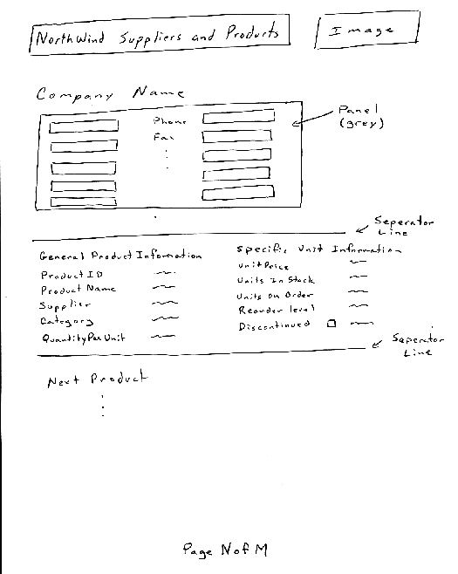

# Step 2: Determine (and create, if necessary) the source of the data

The data for this report will come from the Supplier and Product tables. We will create a multi-table query that selects all field (*) from both tables. Save as **qrySuppliersAndProductsReport**

Sorting can be applied in the query, but the report makes the ultimate determination.

# Step 3: Create the Report

While the Report Wizard is suitable for quick and simple reports, when more complex formatting is required, the wizard is not as useful. This report will be created using the Report Design tool.

When using Report Design, we will follow a series of steps:

1. Layout the data fields in the correct report position
2. Add grouping and sorting
3. Apply formatting to make the report presentable
4. Add calculated controls

**3.1 Layout the data fields**

1. Click Create tab, Report Design button
2. Set the data source for the report: Report object selected, Record Source property, qrySuppliersAndProductsReport.
3. Save the report as rptSuppliersAndProducts.
4. From the Page Setup tab:
   1. Left and right margins: 0.75” (1.905 cm)
   2. Top and Bottom margins: 1” (2.54 cm)
   3. Orientation: Portrait
5. Set the width to 7” (18.78 cm) by dragging on the right edge of the report or via the Width property for the form:
   1. Note: 7” (report width) + (2 * 0.75”) (left and right margins) = 8.5”, standard paper width. If the form is wider than the paper, each page of the report will print on two or more pieces of paper.
6. Add the fields to the report (in the same way fields are added to forms)
   1. Design tab: Add Existing Fields
   2. Select fields from Supplier: SupplierID through HomePage. Drag to the Page Header (the header will expand)
   3. Select fields from Product: ProductID through Discontinued. Drag to the Detail section
7. Display the Report Header and Footer sections:
   1. Right click on any of the dividers and choose Report Header/Footer.
8. Create a Title in the Report Header:
   1. Caption: Northwind Suppliers and Products
   2. Font Size: 22
   3. Font Weight: Bold
   4. Size to fit
9. Add the logo, Logo.bmp, to the Report Header
10. Adjust the layout:
    1. Logo and title:
    2. 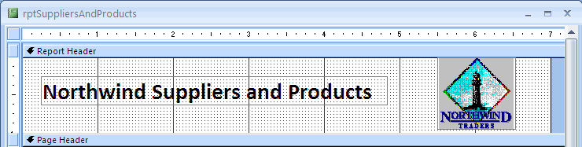
    3. Adjust the Height of Report Header to remove unwanted white space
11. View the report in Print Preview. Notice the page header sections
12. Rearrange the Page Header:
    1. Delete the SupplierID field
    2. Delete labels for Company name, City, Region, Country, and Postal Code
    3. Format the Company Name field:
       1. Font size: 16
       2. Font weight: bold
       3. Font italic: yes
    4. Arrange the text boxes into two columns as shown:
    5. Table

       Description automatically generated
    6. Switch between print preview and design view and adjust field widths as needed
    7. **Table

       Description automatically generated**
13. Rearrange the Detail section:
    1. Add labels for column titles, as shown below
       1. Font size: 14
       2. Weight: bold
    2. Left align text boxes
    3. Add spaces to label captions and adjust size to fit, if necessary
    4. Change the layout as below:
    5. Graphical user interface, application

       Description automatically generated
14. Add the page number to the page footer
    1. Add a text box to the Page Footer and delete its label
    2. Click on the Control Source property and open the Expression Builder
    3. In the first column, click “Common Expressions”
       1. In the second column, click “Page N of M”
    4. Go to the Print Preview and check
15. Center the page footer text
    1. Stretch the text box from left margin to right margin
    2. Set Text Align to Center
16. Save the report

**3.2 Add Report Grouping and Sorting**

Add a group header for the supplier’s company

1. Click the Sorting and Grouping Button
2. Add a group: choose Company Name
   1. Click “More ….” To see options – note should say “with a header section”
3. Close the Sorting and Grouping box
4. Change the CompanyName header property
   1. Force New Page: Before Section
5. Collapse the CompanyName header
6. Print preview and save the report

**3.3 Apply Formatting**

***Create a text shadow***

1. Select the label control in the report header – make sure the Back Style is transparent
2. Copy the label and paste a copy into the report header
3. Change the copy’s font color to a light gray
4. Move the copy to be slightly right and upward of the original – may nee to turn off “snap to grid” option
5. Send to back

**Add lines, rectangles, and shading**

Shading:

1. Select Page Header
2. Set Back Color to light shade of gray

Rectangle:

1. Draw a rectangle control in the report header
2. Resize it to cover the logo and labels
3. Set Back Color to same shade of gray
4. Send to Back
5. Adjust the shadow label color if necessary
   1. Select the label control
   2. Press Tab to cycle through the rest of the controls until the desired label is selected
   3. Use a dark shade of gray

Caution: Black Colors should be used sparingly as they can consume a lot of toner / ink if the report is printed

Lines:

1. Draw a line at the top of the Details section – hold Shift to get a straight line
2. Set Border Width to 2pt
3. Preview – note border is not applied at the bottom of the last product
4. Experiment with ways to fix it …
   1. Move line to bottom of the details section
   2. Add another line to the bottom of the page header section

**Use Special Effect**

Create a sunken look for controls in the page header:

1. Select all text box controls in the page header section
2. Set Special Effects property to Sunken

Hide Empty Fields:

1. Select Region field
2. Set the “Can Shrink” property to Yes
3. Preview
   1. **Add Calculated Controls**

This section will add some calculated controls to enhance the report

**Option Group with a Calculated Control**

Rather than display the homepage as text, we will create a control to display whether a homepage exists or not.

Create the option group

1. Make sure wizard is enable for our controls
2. Option Group tool, drag into the page header
3. In the wizard,
   1. Enter two label names: “Yes” and “No”, next
   2. Select “No, I don’t want a default”, Next
   3. The Values of 1 for Yes and 2 for No are good, next
   4. Select the “Save the value for later use” next
   5. Select the “Option Buttons” and “Sunken” style, next
   6. Set caption to “Has Homepage”, Finish

Add an expression

1. Select the option group frame
2. Change the Control Source:
   1. =IIF(IsNull([HomePage]), “2”, “1”)
   2. The Immediate If will set the option group to 2 (No) if the home page value is null; if it is not null, the value is set to 1 (Yes).

Preview the report, If it is working, delete the homepage text box and remove any extra space at the bottom of the page header section.

**Data Lookups**

Report shows the CategoryID, but the Category Name would be better.

Options:

* We could alter the query to include the Category table
* We could create a lookup, similar to what was done in forms. We look at two ways:
  + Use a combo box
  + Use the DLookup function

**Combo box lookups:**

1. Right-click on the CategoryID text box
2. “Change To” > “Combo Box”
3. Add the lookup to the Row Source property
   1. Category table
   2. CategoryID and CategoryName fields
   3. Close and Save
4. Bound Column: 1
   1. Column Count: 2
   2. Column Widths: 0”
5. Preview and adjust field width as needed

**DLookup Function.**

You can use the DLookup function to get the value of a particular field from a specified set of records (a domain). You can use the DLookup function to display the value of a field that isn’t in the record source for your form or report.

Syntax:

DLookup(Expr, Domain, Criteria)

1. Change the CategoryID combo box back to a text box
2. The value being looked up, CategoryID, must exist on the report somewhere. We will add another (soon to be invisible) text box to hold the category id.
   1. Drop a text box in an empty space in the Details section
   2. Delete the associated label
   3. Adjust the properties as follows:
      1. Name: txtCategoryID
      2. Control Source: CategoryID
3. Add the DLookup function to the old CategoryID text box
   1. Change the Control Source by either entering the following formula or use the Expression Builder:
      1. =DLookup(“[CategoryName]”, “Category”, “[CategoryID]=[txtCategoryID]”)
         1. If you use the Expression Builder, the DLookup function is listed under the Built-in Functions, Domain Aggregate category
         2. Parts of the DLookup function:
            1. “[CategoryName]” – the name of the field in the table to lookup and display in the text box
            2. “Category” – the name of the table/query where the 1st parameter can be found
            3. “[CategoryID]=”[txtCategoryID]” – is the equivalent WHERE clause
4. View the report in Print Preview
5. Compare the value in the look up field with txtCategoryID field
6. Change the txtCategoryID’s Visible property to No
7. Save

**Step 4: Print or View the report**

After viewing and scrolling through some pages, save and close the report. If you have a PDF printer installed, you may with to experiment with printing the report to PDF.

## 8.5 Create a multilevel grouping with calculated controls

Report grouping levels are based on relationships between tables, specifically one-to-many relationships:

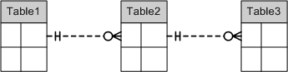

We’ll have the following Grouping levels:  
Grouping

Table1

Table2

Table3

In this example, we want to show the order details for each order placed by a customer:

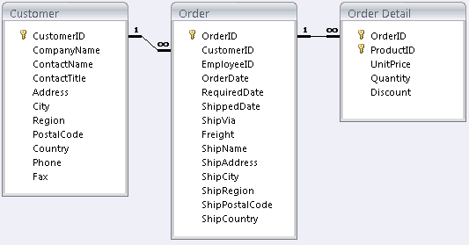

Only the orders within a date range given when the report is run will be shown.

Follow the four-step process.

### Step 1: Describe the layout

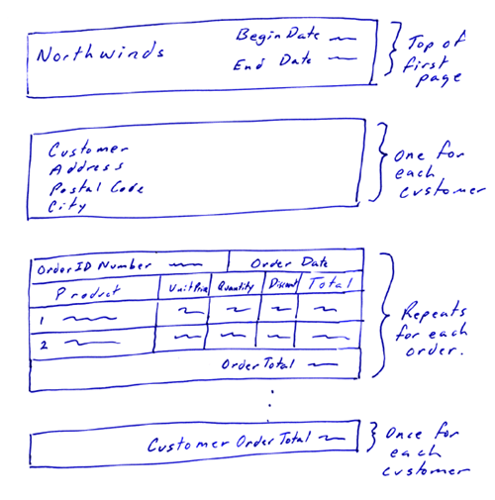

### Step 2: Determine (and create, if necessary) the source of the data

The query will draw from the Customer (*), Order (*), and Order Detail (*) tables, and have a calculated field for the Extended Price:  
Extended Price: [UnitPrice]*[Quantity]*(1-[Discount])

Save the query as **qryCustomerOrderDetailsReport**.

### Step 3: Create the report

Use the Report Design window

Save the report as **rptCustomerOrderDetails**.

Make Edits.

Take as many notes here as you think you need:

1. Report properties:
   1. Record Source: qryCustomerOrderDetailsReport
   2. Width: 5.5”
   3. Left and right margins: 1.5”
   4. Top and bottom margins: 1”
2. Add grouping and sorting
   1. OrderDate – ascending order, no header or footer (notice this changes from a Group On to a Sort By)
   2. Customer.CustomerID – ascending order, with both header and footer
   3. Order.OrderID – ascending order, both header and footer
   4. Text

      Description automatically generated
3. Add text boxes to the Detail section:
   1. Bring the ProductID, UnitPrice, Quantity, Discount, and Extended Price fields into the detail section
   2. Set font size for labels and text boxes to 8pt. Right-align the UnitPrice, Quantity, Discount, and Extended Price fields
   3. Arrange > Tabular
   4. Select the labels in the Page Header and drag into the OrderID header.
   5. Change the ProductID field to a Combo Box that draws its information from the Product table.
      1. Row source: a query that grabs ProductID and ProductName from Product Table
      2. Properties:
         1. Bound Column: 1
         2. Column Count: 2
         3. Column Widths: 0”
   6. Adjust the widths of the fields so all data fits in the 5.5”
      1. Note: Jack’s New England Clam Chowder is the longest product name
   7. Preview and save
4. Add information to the OrderID header section
   1. Make some room in the header section and move the detail labels down.
   2. Add a text box (no label) to the top left corner of the OrderID header section:
      1. Control Source: =”Order ID Number: “ & [Order.OrderID]
      2. Font Size: 14pt
      3. Font Weight: Bold
      4. Text Align: Left
   3. Add a text box (no label) to the top right corner of the OrderID header section:
      1. Control Source: OrderDate
      2. Font Size: 8pt
      3. Font Weight: Bold
      4. Text Align: Right
   4. For both of these text boxes:
      1. Font color: White
      2. Back Color: Black
      3. Size the text boxes so they have the same height and touch (creates a black border)
   5. Edit labels:
      1. ProductID label – Caption: Product
      2. Extended Price label – Caption: Total
      3. For these two labels:
         1. Font Size: 12
         2. Font Weight: Bold
         3. Text Align: Center
         4. Back Color: a shade of light gray
5. Add information to the OrderID footer section
   1. Add a text box (no label)
   2. Properties:
      1. Control Source: =”Order Total: “ & FormatCurrency(Sum([Extended Price]))
      2. Height: same as ProductID label
      3. Font size: 8pt, Weight: Bold
      4. Text Align: Right
      5. Back Color: same shade of gray as for labels.
   3. View and Save
6. To prevent orders from splitting:
   1. Group, Sort, and Total area, OrderID group, More > “keep whole group together on one page” is selected.
7. Add information to the CustomerID header section
   1. Add the CompanyName, Address, City, and PostalCode fields
   2. Delete the labels
   3. Format:
      1. Weight: 12
      2. Back Style: Transparanet
   4. Add a rectangle
      1. Special Effect: Shadowed
      2. Back Color: light Gray
   5. Format:
      1. 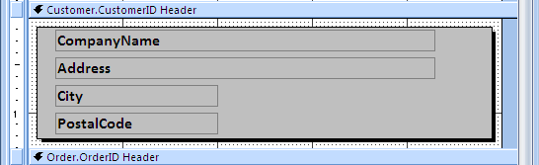
8. Add information to the CustomerID footer
   1. Add a text box (no label)
   2. Properties
      1. Control Source: =”Customer Order Total: “ & FormatCurrency(Sum[Extended Price]))
      2. Height: same as the ProductID label
      3. Font Weight: Bold
      4. Text Align: Right
      5. Back Color: same shade of gray as the labels
      6. Special Effect: Shadowed
   3. View – Note each customer has only one order – this is because the grouping ordered by OrderDate first
9. To fix ordering:
   1. In the Group, Sort, and Total section, move the Order Date to be between the CustomerID and OrderID
   2. Graphical user interface, text, application

      Description automatically generated
   3. View and save
10. Add date parameters to the query criteria
    1. Add the OrderDate field to the query
    2. Set the Criteria to be “Between [Please enter the Begin Date] And [Please enter the End Date]”
    3. Do not show the OrderDate field
    4. Graphical user interface, application, table

       Description automatically generated
    5. Graphical user interface, text, application

       Description automatically generated
    6. Save and close the query
    7. View the report.
11. Edit the form
    1. Add a report header
    2. Add a label to the header
       1. Caption: Northwind Customer’s Orders
       2. Font Size: 14
       3. Font Weight: Bold
    3. Add two text boxes to the header (no labels)
       1. Text box with the start date
          1. Control source: =”Start Date: “ & [Please enter the Begin Date]
       2. Text box with the end date
          1. Control source: =”End Date: “ & [Please enter the End Date]
       3. For both:
          1. Font size: 8
          2. Text align: Right
12. Collapse the Report Footer, Page Header, and Page Footer regions
13. View the report with Begin Date of 1/1/1997 and End Date of 6/30/1998
    1. Note that some customer total values are separated onto the next page
14. Change the Customer.CustomerID group to “Keep whole group together on one page”.
15. Save Changes
16. Make it pretty

Save the report.

### Step 4: Print or view the report

View the report. Save and close.

## 8.6 Presentation quality

Throughout this learning outcome, we have explored several methods to make quality reports

Some tips to keep in mind:

* Make sure that all data in each field is visible.
* Don't use large amounts of white space as it will cause the report to be printed on more pages than is required.
* If you have groupings, use some method of making the information in the groups standout as a group.
* Make sure the text or numbers in the columns line up.
* Make sure the background colour leaves the text readable.
* To save printer ink or toner, use black or dark colours sparingly.
* Use colour only if the report will be viewed on a computer monitor or printed on a colour printer.
* For readability, use only one or two fonts per report. Serif fonts are easier to read.

## 8.7 Subreports

A subreport is a report that is inserted in another main report. When you combine reports, one of them must serve as the main report that contains the other report object. A main report is either bound or unbound.

You can have:

1. An unbound main report with unrelated subreports would be used to combine unrelated subreports.
2. A main report and subreport that are bound to the same record source to show detail records in the main report, and show summary information in the subreport.
3. A main report and a subreport that are bound to related record sources would be used if you wanted a main report that contained data common to one or more subreports.

### Linking a report to a subreport

When you insert a subreport that contains information that is related to data in the main report, the subreport control must be linked to the main report. The link ensures that the records displayed in the subreport correspond correctly to the records printed in the main report.

Access may automatically link the subreport to the main report:

* You create the subreport by using a wizard or by dragging an object from the Navigation Pane to a report AND EITHER:
  + You've already defined relationships for the tables you selected, or you've defined relationships for the tables underlying the queries you selected. OR
  + The main report is based on a table with a primary key, and the subreport is based on a table that contains a field with the same name as that primary key and has the same or a compatible data type. If you select a query or queries as the record source of a subreport, the underlying tables in the query or queries must meet the same conditions.

### Create the main report

The main report will display the total value of inventory for each product category. It will include information on the total value of each product's current inventory and the total value of all inventory items in each product group.

#### Create the query

* Save as **qryProductsOnHandReport**
* Tables: Product
* Fields: *
* Criteria: Discontinued = False
* Graphical user interface, application, table

  Description automatically generated

**Create the main report with the Report Wizard**

* We already have the main report available in our database.
* Take a look at it and notice the grouping, the calculated fields, etc.
* Also notice the big whitespace in our CategoryID footer, this is where we’ll put in our subreport

### Create the subreport

We will create a report to display the total value of inventory for each product category compared to the total monthly sales for that category. Comparing the monthly sales to the inventory level of a category allows the report's user to estimate inventory turnover rates.

We will create the subreport from the main report, but we could have created the subreport as a regular report first and then inserted it as a subreport into the main report later. Either method is acceptable and is usually a personal preference. Try creating it as a report first and then link it to the main report for practice.

#### Create the Subreport's Data Source (CrossTab query)

Create the following crosstab query:

* Tables: Product, Order, Order Details
* Date column Field value:
  + Date: Format([OrderDate],”mmm”)
* Sales column Field value:
  + Sales: Sum([Order Detail].[Quantity] * [Order Detail].[UnitPrice])
* Open the Query Property Sheet. In the column headings property order the months as shown:
  + Graphical user interface, application, table

    Description automatically generated
* Save as **qry1997MonthlyCategorySales**

#### Create the Subreport object within the Main Report

We want to add the total sales per month information to the Product Inventory by Category report already constructed. We need to create the subreport so that each category’s total sales per month will be correctly added to the matching category in the main report

* With Control Wizards enabled, click the Subform/Subreport tool and place in CategoryID footer area.
* From the first window select Use existing Tables and Queries
* We will use the crosstab query we created. Select all the fields from the query to appear the subreport
* Name the object subRptProductInventory.
* Note the Link Child Fields and Link Master Fields are set to CategoryID. The wizard completed this for us.
* Detailed Edits (minor).
* Save Edits.