Entity Relationship Diagram

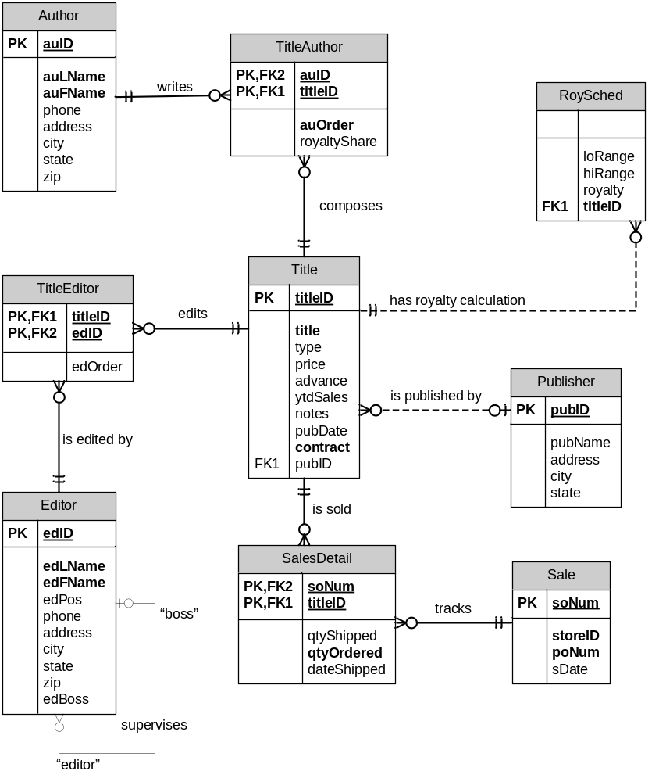
Sample Data

Author
AUID | AULNAME | AUFNAME | PHONE | ADDRESS | CITY | STATE | ZIP
409-56-7008 | Bennet | Abraham | 415 658-9932 | 6223 Bateman St. | Berkeley | CA | 94705
213-46-8915 | Green | Marjorie | 415 986-7020 | 309 63rd St. #411 | Oakland | CA | 94618
238-95-7766 | Carson | Cheryl | 415 548-7723 | 589 Darwin Ln. | Berkeley | CA | 94705
998-72-3567 | Ringer | Albert | 801 826-0752 | 67 Seventh Av. | Salt Lake City | UT | 84152
899-46-2035 | Ringer | Anne | 801 826-0752 | 67 Seventh Av. | Salt Lake City | UT | 84152
722-51-5454 | DeFrance | Michel | 219 547-9982 | 3 Balding Pl. | Gary | IN | 46403
807-91-6654 | Panteley | Sylvia | 301 946-8853 | 1956 Arlington Pl. | Rockville | MD | 20853
893-72-1158 | McBadden | Heather | 707 448-4982 | 301 Putnam | Vacaville | CA | 95688
724-08-9931 | Stringer | Dirk | 415 843-2991 | 5420 Telegraph Av. | Oakland | CA | 94609
274-80-9391 | Straight | Dick | 415 834-2919 | 5420 College Av. | Oakland | CA | 94609
756-30-7391 | Karsen | Livia | 415 534-9219 | 5720 McAuley St. | Oakland | CA | 94609
724-80-9391 | MacFeather | Stearns | 415 354-7128 | 44 Upland Hts. | Oakland | CA | 94612
427-17-2319 | Dull | Ann | 415 836-7128 | 3410 Blonde St. | Palo Alto | CA | 94301
672-71-3249 | Yokomoto | Akiko | 415 935-4228 | 3 Silver Ct. | Walnut Creek | CA | 94595
267-41-2394 | O'Leary | Michael | 408 286-2428 | 22 Cleveland Av. #14 | San Jose | CA | 95128
472-27-2349 | Gringlesby | Burt | 707 938-6445 | PO Box 792 | Covelo | CA | 95428
527-72-3246 | Greene | Morningstar | 615 297-2723 | 22 Graybar Rd. | Nashville | TN | 37215
172-32-1176 | White | Johnson | 408 496-7223 | 10932 Bigge Rd. | Menlo Park | CA | 94025
712-45-1867 | del Castillo | Innes | 615 996-8275 | 2286 Cram Pl. #86 | Ann Arbor | MI | 48105
846-92-7186 | Hunter | Sheryl | 415 836-7128 | 3410 Blonde St. | Palo Alto | CA | 94301
486-29-1786 | Locksley | Chastity | 415 585-4620 | 18 Broadway Av. | San Francisco | CA | 94130
648-92-1872 | Blotchet-Halls | Reginald | 503 745-6402 | 55 Hillsdale Bl. | Corvallis | OR | 97330
341-22-1782 | Smith | Meander | 913 843-0462 | 10 Misisipi Dr. | Lawrence | KS | 66044

Editor
EDID | EDLNAME | EDFNAME | EDPOS | PHONE | ADDRESS | CITY | STATE | ZIP | EDBOSS
993-86-0420 | McCann | Dennis | acquisition | 301 468-3909 | 32 Rockbill Pike | Rockbill | MD | 20852
943-88-7920 | Kaspchek | Christof | acquisition | 415 549-3909 | 18 Severe Rd. | Berkeley | CA | 94710
321-55-8906 | DeLongue | Martinella | project | 415 843-2222 | 3000 6th St. | Berkeley | CA | 94710 | 993-86-0420
826-11-9034 | Himmel | Eleanore | project | 617 423-0552 | 97 Bleaker | Boston | MA | 02210 | 993-86-0420
527-72-3246 | Greene | Morningstar | copy | 615 297-2723 | 22 Graybar House Rd. | Nashville | TN | 37215 | 826-11-9034
712-45-1867 | del Castillo | Innes | copy | 615 996-8275 | 2286 Cram Pl. #86 | Ann Arbor | MI | 48105 | 826-11-9034
777-02-9831 | Samuelson | Bernard | project | 415 843-6990 | 27 Yosemite | Oakland | CA | 94609 | 993-86-0420
777-66-9902 | Almond | Alfred | copy | 312 699-4177 | 1010 E. Devon | Chicago | IL | 60018 | 826-11-9034
885-23-9140 | Rutherford-Hayes | Hannah | project | 301 468-3909 | 32 Rockbill Pike | Rockbill | MD | 20852 | 993-86-0420

Publisher
PUBID | PUBNAME | ADDRESS | CITY | STATE
0736 | New Age Books | 1 1st St | Boston | MA
0877 | Binnet & Hardley | 2 2nd Ave. | Washington | DC
1389 | Algodata Infosystems | 3 3rd Dr. | Berkeley | CA

RoySched
TITLEID | LORANGE | HIRANGE | ROYALTY
BU1032 | 0 | 5000 | 0.1
BU1032 | 5001 | 50000 | 0.12
PC1035 | 0 | 2000 | 0.1
PC1035 | 2001 | 4000 | 0.12
PC1035 | 4001 | 50000 | 0.16
BU2075 | 0 | 1000 | 0.1
BU2075 | 1001 | 5000 | 0.12
BU2075 | 5001 | 7000 | 0.16
BU2075 | 7001 | 50000 | 0.18
PS2091 | 0 | 1000 | 0.1
PS2091 | 1001 | 5000 | 0.12
PS2091 | 5001 | 50000 | 0.14
PS2106 | 0 | 2000 | 0.1
PS2106 | 2001 | 5000 | 0.12
PS2106 | 5001 | 50000 | 0.14
MC3021 | 0 | 1000 | 0.1
MC3021 | 1001 | 2000 | 0.12
MC3021 | 2001 | 6000 | 0.14
MC3021 | 6001 | 8000 | 0.18
MC3021 | 8001 | 50000 | 0.2
TC3218 | 0 | 2000 | 0.1
TC3218 | 2001 | 6000 | 0.12
TC3218 | 6001 | 8000 | 0.16
TC3218 | 8001 | 50000 | 0.16
PC8888 | 0 | 5000 | 0.1
PC8888 | 5001 | 50000 | 0.12
PS7777 | 0 | 5000 | 0.1
PS7777 | 5001 | 50000 | 0.12
PS3333 | 0 | 5000 | 0.1
PS3333 | 5001 | 50000 | 0.12
MC3026 | 0 | 1000 | 0.1
MC3026 | 1001 | 2000 | 0.12
MC3026 | 2001 | 6000 | 0.14
MC3026 | 6001 | 8000 | 0.18
MC3026 | 8001 | 50000 | 0.2
BU1111 | 0 | 4000 | 0.1
BU1111 | 4001 | 8000 | 0.12
BU1111 | 8001 | 50000 | 0.14
MC2222 | 0 | 2000 | 0.1
MC2222 | 2001 | 4000 | 0.12
MC2222 | 4001 | 8000 | 0.14
MC2222 | 8001 | 12000 | 0.16
TC7777 | 0 | 5000 | 0.1
TC7777 | 5001 | 15000 | 0.12
TC4203 | 0 | 2000 | 0.1
TC4203 | 2001 | 8000 | 0.12
TC4203 | 8001 | 16000 | 0.14
BU7832 | 0 | 5000 | 0.1
BU7832 | 5001 | 50000 | 0.12
PS1372 | 0 | 50000 | 0.1

Sale
SONUM | STOREID | PONUM | SALEDATE
1 | 7066 | QA7442.3 | 13-Sep-1998
2 | 7067 | D4482 | 14-Sep-1998
3 | 7131 | N914008 | 14-Sep-1998
4 | 7131 | N914014 | 14-Sep-1998
5 | 8042 | 423LL922 | 14-Sep-1998
6 | 8042 | 423LL930 | 14-Sep-1998
7 | 6380 | 722a | 13-Sep-1998
8 | 6380 | 6871 | 14-Sep-1998
9 | 8042 | P723 | 11-Mar-2001
19 | 7896 | X999 | 21-Feb-2001
10 | 7896 | QQ2299 | 28-Oct-2000
11 | 7896 | TQ456 | 12-Dec-2000
12 | 8042 | QA879.1 | 22-May-2000
13 | 7066 | A2976 | 24-May-2000
14 | 7131 | P3087a | 29-May-2000
15 | 7067 | P2121 | 15-Jun-2000

SalesDetail
SONUM | QTYORDERED | QTYSHIPPED | TITLEID | DATESHIPPED
1 | 75 | 75 | PS2091 | 15-Sep-1998
2 | 10 | 10 | PS2091 | 15-Sep-1998
3 | 20 | 720 | PS2091 | 18-Sep-1998
4 | 25 | 20 | MC3021 | 18-Sep-1998
5 | 15 | 15 | MC3021 | 14-Sep-1998
6 | 10 | 3 | BU1032 | 22-Sep-1998
7 | 3 | 3 | PS2091 | 20-Sep-1998
8 | 5 | 5 | BU1032 | 14-Sep-1998
9 | 25 | 5 | BU1111 | 28-Mar-2001
19 | 35 | 35 | BU2075 | 15-Mar-2001
10 | 15 | 15 | BU7832 | 29-Oct-2000
11 | 10 | 10 | MC2222 | 12-Jan-2001
12 | 30 | 30 | PC1035 | 24-May-2000
13 | 50 | 50 | PC8888 | 24-May-2000
14 | 20 | 20 | PS1372 | 29-May-2000
14 | 25 | 25 | PS2106 | 29-Apr-2000
14 | 15 | 10 | PS3333 | 29-May-2000
14 | 25 | 25 | PS7777 | 13-Jun-2000
15 | 40 | 40 | TC3218 | 15-Jun-2000
15 | 20 | 20 | TC4203 | 30-May-2000
15 | 20 | 10 | TC7777 | 17-Jun-2000

TitleAuthor
AUID | TITLEID | AUORD | ROYALTYSHARE
409-56-7008 | BU1032 | 1 | 0.6
486-29-1786 | PS7777 | 1 | 1
486-29-1786 | PC9999 | 1 | 1
712-45-1867 | MC2222 | 1 | 1
172-32-1176 | PS3333 | 1 | 1
213-46-8915 | BU1032 | 2 | 0.4
238-95-7766 | PC1035 | 1 | 1
213-46-8915 | BU2075 | 1 | 1
998-72-3567 | PS2091 | 1 | 0.5
899-46-2035 | PS2091 | 2 | 0.5
998-72-3567 | PS2106 | 1 | 1
722-51-5454 | MC3021 | 1 | 0.75
899-46-2035 | MC3021 | 2 | 0.25
807-91-6654 | TC3218 | 1 | 1
274-80-9391 | BU7832 | 1 | 1
427-17-2319 | PC8888 | 1 | 0.5
846-92-7186 | PC8888 | 2 | 0.5
756-30-7391 | PS1372 | 1 | 0.75
724-80-9391 | PS1372 | 2 | 0.25
724-80-9391 | BU1111 | 1 | 0.6
267-41-2394 | BU1111 | 2 | 0.4
672-71-3249 | TC7777 | 1 | 0.4
267-41-2394 | TC7777 | 2 | 0.3
472-27-2349 | TC7777 | 3 | 0.3
648-92-1872 | TC4203 | 1 | 1

TitleEditor
EDID | TITLEID | EDORD
826-11-9034 | BU2075 | 2
826-11-9034 | PS2091 | 2
826-11-9034 | PS2106 | 2
826-11-9034 | PS3333 | 2
826-11-9034 | PS7777 | 2
826-11-9034 | PS1372 | 2
885-23-9140 | MC2222 | 2
885-23-9140 | MC3021 | 2
885-23-9140 | TC3218 | 2
885-23-9140 | TC4203 | 2
885-23-9140 | TC7777 | 2
321-55-8906 | BU1032 | 2
321-55-8906 | BU1111 | 2
321-55-8906 | BU7832 | 2
321-55-8906 | PC1035 | 2
321-55-8906 | PC8888 | 2
321-55-8906 | BU2075 | 3
777-02-9831 | PC1035 | 3
777-02-9831 | PC8888 | 3
943-88-7920 | BU1032 | 1
943-88-7920 | BU1111 | 1
943-88-7920 | BU2075 | 1
943-88-7920 | BU7832 | 1
943-88-7920 | PC1035 | 1
943-88-7920 | PC8888 | 1
993-86-0420 | PS1372 | 1
993-86-0420 | PS2091 | 1
993-86-0420 | PS2106 | 1
993-86-0420 | PS3333 | 1
993-86-0420 | PS7777 | 1
993-86-0420 | MC2222 | 1
993-86-0420 | MC3021 | 1
993-86-0420 | TC3218 | 1
993-86-0420 | TC4203 | 1
993-86-0420 | TC7777 | 1

Title
TITLEID | TITLE | TYPE | PUBID | PRICE | ADVANCE | YTDSALES | CONTRACT | NOTES | PUBDATE
PC8888 | Secrets of Silicon Valley | popular_comp | 1389 | 40 | 8000 | 4095 | 1 | Muckraking reporting on the world's largest computer hardware and software manufacturers. | 12-Jun-1998
BU1032 | The Busy Executive's Database Guide | business | 1389 | 29.99 | 5000 | 4095 | 1 | An overview of available database systems with emphasis on common business applications. Illustrated. | 12-Jun-1998
PS7777 | Emotional Security: A New Algorithm | psychology | 0736 | 17.99 | 4000 | 3336 | 1 | Protecting yourself and your loved ones from undue emotional stress in the modern world. Use of computer and nutritional aids emphasized. | 12-Jun-1998
PS3333 | Prolonged Data Deprivation: Four Case Studies | psychology | 0736 | 29.99 | 2000 | 4072 | 1 | What happens when the data runs dry? Searching evaluations of information-shortage effects. | 12-Jun-1998
BU1111 | Cooking with Computers: Surreptitious Balance Sheets | business | 1389 | 21.95 | 5000 | 3876 | 1 | Helpful hints on how to use your electronic resources to the best advantage. | 09-Jun-1998
MC2222 | Silicon Valley Gastronomic Treats | mod_cook | 0877 | 29.99 | 0 | 2032 | 1 | Favorite recipes for quick, easy, and elegant meals tried and tested by people who never have time to eat, let alone cook. | 09-Jun-1998
TC7777 | Sushi, Anyone? | trad_cook | 0877 | 29.99 | 8000 | 4095 | 1 | Detailed instructions on improving your position in life by learning how to make authentic Japanese sushi in your spare time. 5-10% increase in number of friends per recipe reported from beta test. | 12-Jun-1998
TC4203 | Fifty Years in Buckingham Palace Kitchens | trad_cook | 0877 | 21.95 | 4000 | 15096 | 1 | More anecdotes from the Queen's favorite cook describing life among English royalty. Recipes, techniques, tender vignettes. | 12-Jun-1998
PC1035 | But Is It User Friendly? | popular_comp | 1389 | 42.95 | 7000 | 8780 | 1 | A survey of software for the naive user, focusing on the 'friendliness' of each. | 30-Jun-1998
BU2075 | You Can Combat Computer Stress! | business | 0736 | 12.99 | 10125 | 18722 | 1 | The latest medical and psychological techniques for living with the electronic office. Easy-to-understand explanations. | 30-Jun-1998
PS2091 | Is Anger the Enemy? | psychology | 0736 | 21.95 | 2275 | 2045 | 1 | Carefully researched study of the effects of strong emotions on the body. Metabolic charts included. | 15-Jun-1998
PS2106 | Life Without Fear | psychology | 0736 | 17 | 6000 | 111 | 1 | New exercise, meditation, and nutritional techniques that can reduce the shock of daily interactions. Popular audience. Sample menus included, exercise video available separately. | 05-Oct-1998
MC3021 | The Gourmet Microwave | mod_cook | 0877 | 12.99 | 15000 | 22246 | 1 | Traditional French gourmet recipes adapted for modern microwave cooking. | 18-Jun-1998
TC3218 | Onions, Leeks, and Garlic: Cooking Secrets of the Mediterranean | trad_cook | 0877 | 40.95 | 7000 | 375 | 1 | Profusely illustrated in color, this makes a wonderful gift book for a cuisine-oriented friend. | 21-Oct-1998
MC3026 | The Psychology of Computer Cooking |  | 0877 |  |  |  | 0
BU7832 | Straight Talk About Computers | business | 1389 | 29.99 | 5000 | 4095 | 1 | Annotated analysis of what computers can do for you: a no-hype guide for the critical user. | 22-Jun-1998
PS1372 | Computer Phobic and Non-Phobic Individuals: Behavior Variations | psychology | 0736 | 41.59 | 7000 | 375 | 1 | A must for the specialist, this book examines the difference between those who hate and fear computers and those who think they are swell. | 21-Oct-1998
PC9999 | Net Etiquette | popular_comp | 1389 |  |  |  | 0 | A must-read for computer conferencing debutantes!.

