
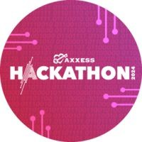
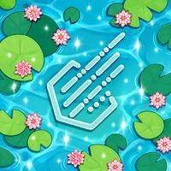

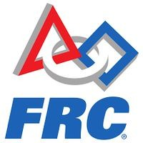


JAYDEN BOOMER
Software Engineer | Embedded Systems | Web Development
+1 (682) 262-0947
jaboomer02@gmail.com
linkedin.com/in/jaydenboomer/
jaydenboomer.com
Richardson, Texas 75080
WORK EXPERIENCE
SUMMARY
Store Associate
Designer Shoe Warehouse
Proactive and goal-oriented professional with excellent time management and problem-solving skills. Known for reliability and adaptability, with swift capacity to learn and apply new skills. Committed to leveraging these qualities to drive team success and contribute to organizational growth
08/2025 - Present
Southlake, Texas
•
Provided excellent customer service by greeting shoppers, assisting with product selection, processing transactions, promoting the DSW loyalty program, providing personalized assistance, matching products to customers' needs, and answering product-related questions
Maintained a clean, organized, and safe environment by clearing aisles, returning shoes to their proper locations, and maintaining common areas
Received inbound freight, placed merchandise on the sales floor according to DSW standards, completed online orders, and completed markdowns
•
EDUCATION
•
Bachelor of Science: Software Engineering
The University of Texas at Dallas, Erik Jonsson School of Engineering and
Computer Science
GPA
3.539 / 4.000
PROJECTS & ACTIVITIES
Programmer & Team Lead
Axxess Hackathon
24-hour Hackathon focusing on Healthcare Innovation.
02/2025
KEY ACHIEVEMENTS
- Developed QuickCare, an AI chatbot that can perform quick diagnosis and provide feedback on users' health q
AI Chatbot Development
Developed QuickCare, an AI chatbot for rapid health-related feedback, during a 24-hour healthcare innovation hackathon.
Programmer & Team Lead
HackUTD: Ripple Effect
11/2024
Team Leadership
Led a team of 4 in organizing store layout, boosting customer flow efficiency by 25%.
The largest 24-hour hackathon in the US. Explored how small innovative ideas can create massive, lasting impacts.
- Developed CelestiFi, which offers intuitive file organization w/ visual clustering by size and relevance.
Robotics & Electronics
Participated in VEXU Robotics software and electronics projects, collaborating on hands-on robotics development and problem-solving.
Programmer
VEXU Robotics - Comet Robotics
09/2024 - Present
A student-run organization that promotes robotics through hands-on projects, community outreach, and competitive events
- Attend weekly meetings to work on software and electronics
Employee Training
Trained 5 new employees, reducing onboarding time by 30% within 1 quarter.
Secretary & Lead Programmer
FIRST Robotics - Keller Fusion
An international robotics competition where teams of students build industrial-sized robots to play a difficult game in a sports-like tournament.
- Highlight your accomplishments, using numbers if possible.
08/2021 - 05/2023
SKILLS
Technical Skills
Java
C++
C#
HTML CSS
TypeScript
Python
Git
Arduino UNO R3
INTERESTS
CAD
PTC OnShape
MS Office Suite
Machine Learning
Engineering
Skills
Project Management
Robotics
Art
Piano
Hiking
Problem Solving
Energy & Enthusiasm
Patience and empathy
CERTIFICATIONS & AWARDS
Cleanliness and hygiene
NOCTI Cert. - Engineering Technology Foundations
2022
AP Scholar
2022
ADDITIONAL INFORMATION
Work Eligibility
Eligible to work in the U.S. with no restrictions
www.jaydenboomer.com

