Jayden Briffa, Vodafone

PRogramming fundamentals- Assignment 2 (DN4MD001)

Contents
1. Introduction 2
2. Application design 3
2.1. Requirements 3
2.1.1. Functional requirements 3
2.1.2. Non-functional requirements 3
2.1.3. Out-of-scope 4
2.2. High level flow 4
2.3. Planned functions and modules 4
2.4. Interface 5
3. Implementation 5
4. Testing 5
4.1. Test strategy 5
4.2. Key issues in development 6
5. Reflection 6
7. Future developments 6
8. Conclusion 6
9. References 6
10. Appendix 7
Appendix 1: Planned functions and schemas 7
Appendix 2: Interface notes 8
Appendix 3: Flow diagram 9
Appendix 4: Testing table 10

1. Introduction
When working on a project, a developer may need to make a note of a subtask within a project or schedule some time for a ticket they are working on. This may require adding comment to the codebase like “TODO: x”, cluttering the codebase, or updating an external ticket tracker or calendar, breaking their flow. Therefore, a small terminal-based task tracking system would be useful to allow developers to make quick personal notes without leaving their editor.

2. Application design

2.1. Requirements

2.1.1. Functional requirements

FR1 Allow the user to perform CRUD operations on tasks
Users must be able to create new tasks and update existing tasks so they are not forced to retype all of a task’s information to make a small change, improving User Experience (UX). Deleting specific tasks allows users to remove now-unnecessary tasks from view. Lastly, users must be able to view truncated details for all tasks at once, or full details for a single task by inputting its id.

FR2 Allow tasks to be sorted into categories
Tasks must have a category property which lets users logically group tasks together. Task categories must be reflected in read operations, offering a significant UX benefit by allowing the user to focus on similar tasks together without forcing them to create singular huge tasks which discourage decomposition.

FR3 Store tasks and retrieve tasks locally
Tasks should be saved to a local file after create, read, or update operations, and when the user requests to save. Storing program state locally will allow users quick access to their tasks without configuring external storage solutions and ensure that users’ tasks are safe if the program crashes. This will reduce frustration in users and offer them flexibility with how long to run the program at any one time.

2.1.2. Non-functional requirements

NFR1 IO should be understandable and actionable for a technical audience
Terminal users are likely to be familiar with data and programming concepts such as task IDs, json, etc. Therefore, this application should offers users visibility into the program’s data management to improve visibility for the user if they make any input errors, or the application runs into unexpected errors. However, outputs must also be clear and actionable to ensure a smooth user experience.

NFR2 Must handle unexpected errors gracefully without crashing
The program must catch expected and unexpected errors, offering the user guidance where appropriate and informing the user of unrecoverable errors, while ensuring the program does not stop running because of those errors. Additionally, users should only be asked to re-enter invalid fields, rather than needing to also re-enter valid information. This will prevent user frustration if they make a mistake while entering task information.

NFR3 Reading tasks by category or id, and adding tasks, must not take longer than 0.5s
A key theme of this tool is to be lightweight and easy to run to ensure developer flow is not broken and to ensure it can perform on already-strained machines. Key operations must be optimised to offer a smooth, responsive interface and limit the time a developer must spend focussing on adding their new task.

2.1.3. Out-of-scope
Customisation for styling, bulk deletion, or retrieving full details for multiple tasks would improve UX. However, this is not necessary for the prototype stage, which is focussed on core functionalities and experience.
This application is intended as a personal productivity tool rather than a team coordination tool. Therefore, external storage options are not required to allow remote access by others, although future updates may offer options for backing up, versioning, or personal remote access to improve availability and portability.

2.2. High level flow
Appendix 3: Flow diagram

2.3. Planned functions and modules
There are 3 core hashmaps with different purposes. They are implemented to improve scalability, maintain performance, and allow for future flexibility:
- tasksById- Holds actual task data accessible if you know the task’s id
- tasksIdsByCategory- Holds references to tasks for efficient categorisation
- taskIdsByName- Allows lookups of task ids by current name, so users can identify tasks by, and change, the name field

Other languages like Go or C would allow pointers to be passed instead of needing to retrieve an ID, then retrieve the data. However, the impact of the hash calculations is not significant in an application of this scope.
Appendix 1: Planned functions and schemas

2.4. Interface
Appendix 2: Interface notes

3. Implementation
Python was chosen for this application for its simple file handling and maintainability. Its near-english syntax offers a simpler development process now and for future development. Additionally, over 55% of developers know python (Statista, 2025), so new developers are more likely to have the skills to develop the application. Go was considered as an alternative for its high readability and portability. However, fewer developers know Go, and development time could be increased from the constraints Go places on development including its forced verbosity in error handling etc. Additionally, the performance benefits from compilation and Go’s superior concurrency are unlikely to affect a program of this scope.

4. Testing

4.1. Test strategy
Prior to development, a test table was developed to capture unit and End-To-End (E2E) tests for this application (see Appendix 4: Testing table). Functional tests consisted primarily of end-to-end tests covering the main menu options presented to the user on program execution. Normal data was used to test the happy path, invalid data to test error messages and error handling, and boundary data to test validation functions.
Each test linked to at least 1 requirement. Keeping most of the functional tests E2E rather than smaller unit tests helped ensure that multiple requirements were verified while saving development time. Some unit tests were performed for core, self-contained processes like loading and saving tasks. Bugs in these functions are likely to manifest in costly, complex, bugs later in development due to the rest of the program depending on them. Non functional tests were developed to cover performance and resilience requirements, ensuring that the program performs under expected load and handles unexpected errors gracefully.
While less efficient in the long-term than automated tests, these manual tests cover all the program’s requirements. Additionally, this ensures time is wasted writing tests that are likely to be obsolescent past the prototype phase. Therefore, manual testing is suitable for a prototype of this scope.

4.2. Key issues in development

5. Reflection

7. Future developments
- Allow bulk-deletion and view multiple tasks by their ID
- Allow backups and versioning
- Integrate with common ticketing systems like JIRA to import tasks

8. Conclusion

9. References
Statista (2025), Most used programming languages among developers worldwide as of 2025. Available at https://www.statista.com/statistics/793628/worldwide-developer-survey-mostused-languages/ (Accessed: 6 June 2026)

10. Appendix

Appendix 1: Planned functions and schemas
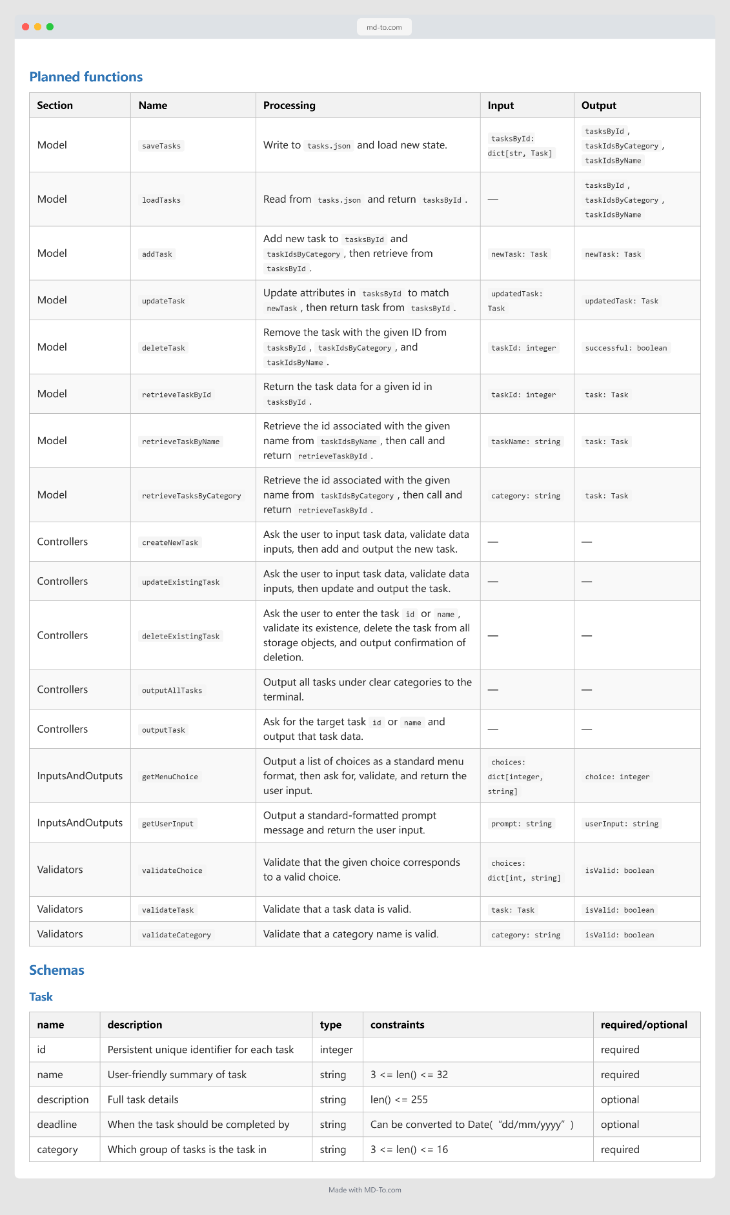

Appendix 2: Interface notes
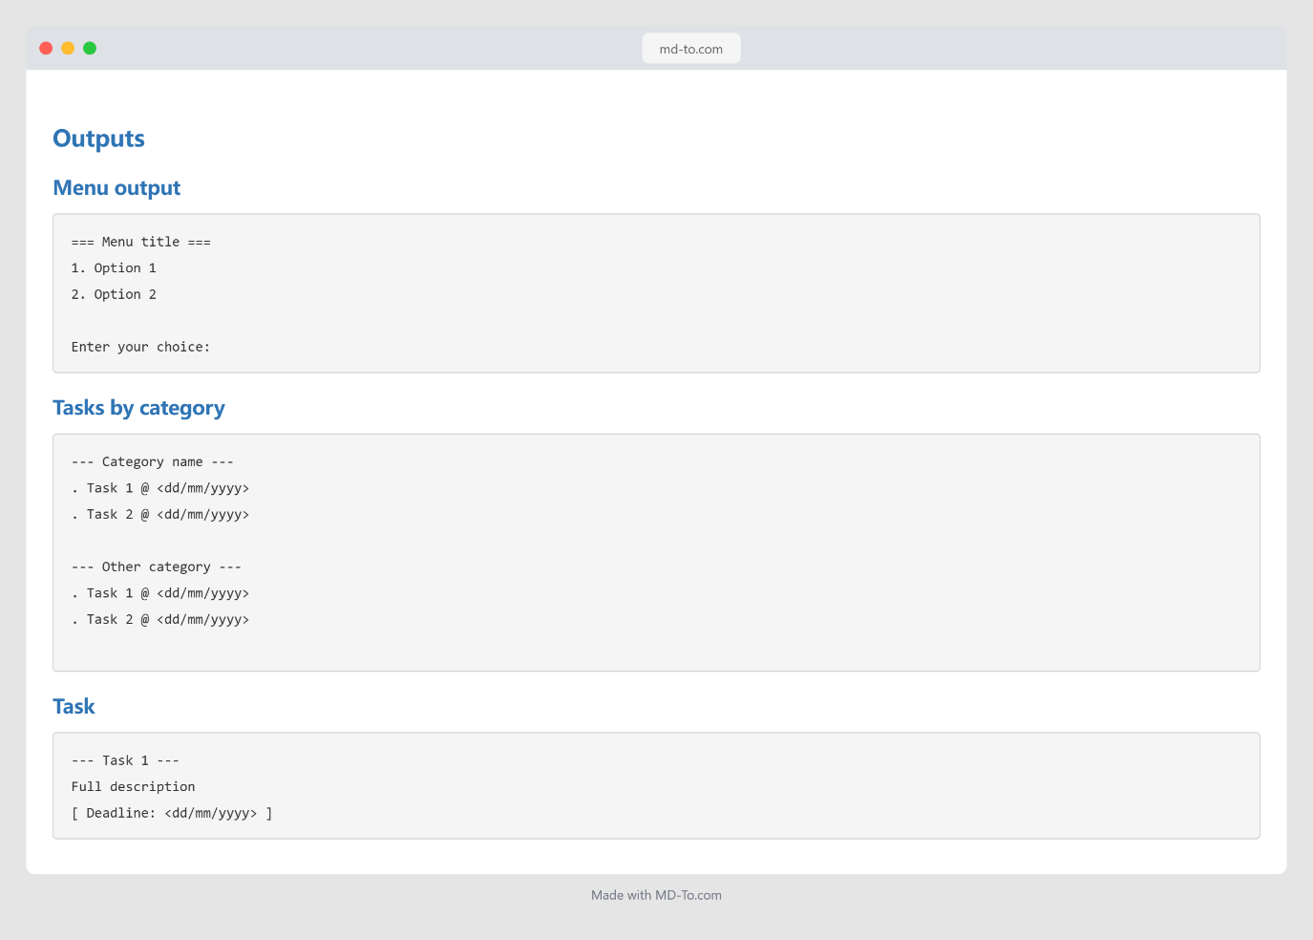

Appendix 3: Flow diagram
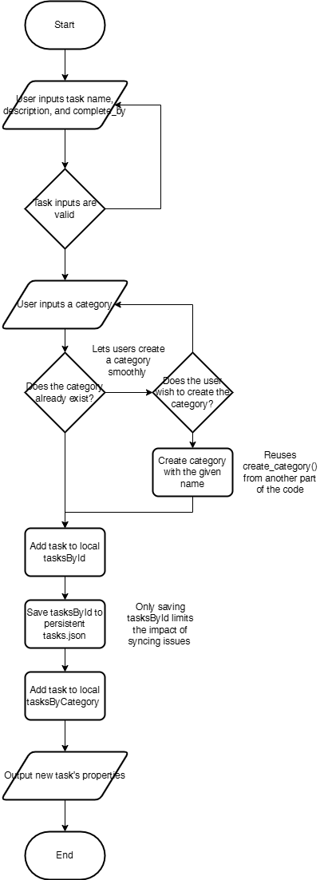

Appendix 4: Testing table

