# Week 13 Practical

# Duties of a DBA 10%

## Examine each of these carefully, screen captures and notes can be used as proof of completion. Perform any additional setup as required to complete these tasks.

* **Check the previous night’s SQL Server database and transaction log backups and SQL Server Agent jobs for errors.**

Container permissions do not allow us to view SQL server agent because it’s now set using an environment variable. To prevent this in the future you can add --env MSSQL_AGENT_ENABLED=True in the start up script



* **Check all databases to make sure all are up and not marked as suspect. Check previous DBCC CHECKDB for errors.**

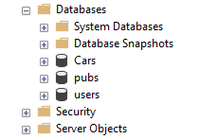 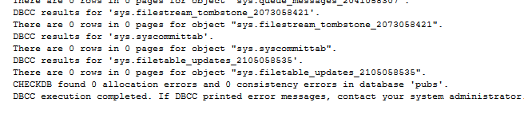

No databases marked as suspect and 0 errors using CHECKDB

* **Check SQL Server Log File entries for warnings and errors and determine if any entries warrant further investigation. Export and save the current log file.**

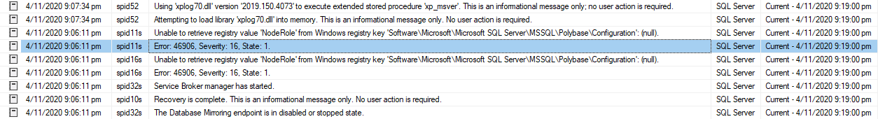

After re-creating a WSFC cluster, disable and then re-enable AlwaysOn on every cluster node on which an instance of SQL Server is enabled for AlwaysOn. You can use the SQL Server Configuration Manager for this task.

* **Look for any security policy violations. Look for resources on the server, such as file sizes and disk space, and audit growth for long-term projections.**

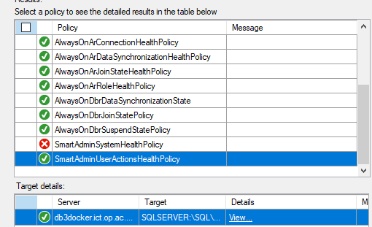

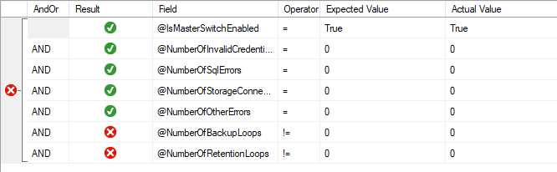

* **Explore using long-running queries or tasks, Perfmon, etc. to generate data. Set up a sensible logging report to monitor disk and memory usage.**

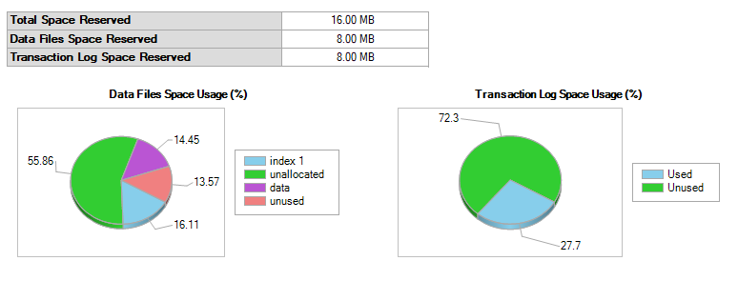

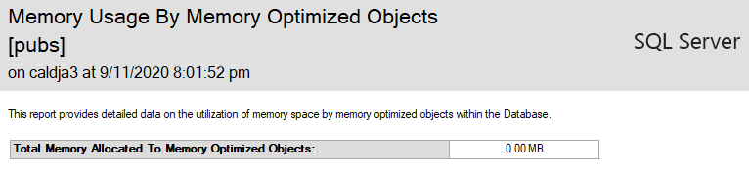

* **What about your Container? What sort of usage data can you extract.**

### Use your pubs database

DBA task

Create a new database named “temp_backup”

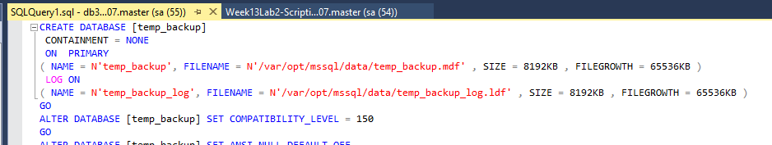

Restore pubs database to temp_backup

USE [master]

BACKUP LOG [pubs] TO DISK = N'/var/opt/mssql/data/pubs_LogBackup_2020-11-11_22-09-06.bak'

WITH NOFORMAT, NOINIT, NAME = N'pubs_LogBackup_2020-11-11_22-09-06',

NOSKIP, NOREWIND, NOUNLOAD, NORECOVERY , STATS = 5

RESTORE DATABASE [temp_database] FROM DISK = N'/var/opt/mssql/data/pubs.bak'

WITH FILE = 4, MOVE N'pubs' TO N'/var/opt/mssql/data/temp_database.mdf',

MOVE N'pubs_log' TO N'/var/opt/mssql/data/temp_database_log.ldf',

NOUNLOAD, STATS = 5

GO

Insert the data from backup to production that is missing

use [pubs]

insert into roysched (title_id, lorange, hirange, royalty)

select * from [temp_backup].[dbo].[roysched] tr

where not exists (select * from roysched r where tr.title_id = r.title_id)

Delete the table and create a new one and grab the data from backup then insert to target table

drop table roysched

CREATE TABLE roysched

(

title_id varchar(6) NOT NULL

REFERENCES titles(title_id),

lorange int NULL,

hirange int NULL,

royalty int NULL

)

GO

insert into roysched (title_id, lorange, hirange, royalty)

select * from [temp_backup].[dbo].[roysched]