
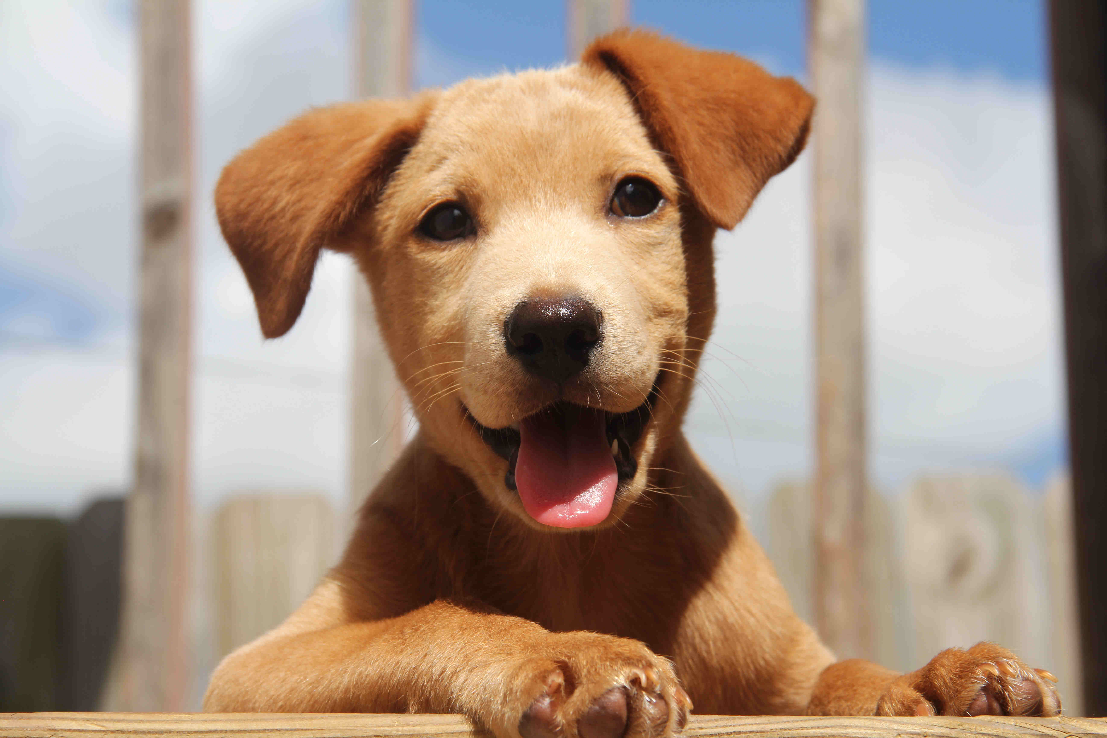
The Complete Puppy Guide!

Table of Contents
Care of a New Puppy 1
Going Home 1
Feeding 1
Accommodation 1
Training 2
Exercise 2
Health Care 2
Vaccination 2
Worming 2
Fleas 3
Teething 3
Grooming 3
Registration 3


Care of a New Puppy

Going Home
The day you collect your puppy from the breeder is an exciting one for you but for them it is an anxious time facing a strange new world without the company of their litter mates and the comforting presence of their mother. It is now that the all important bond between both you and your pup should be forged. Their future well being depends largely upon the measure of your reassurance to them. They are still very young and it should be remembered that they need good nourishing food, plenty of sleep, they have little control of their bodily functions, and during the wakeful hours, they need companionship.

Feeding
This is perhaps the most important aspect of care for your puppy and the key to their future health. A good balanced diet is essential to provide the necessary vitamins, minerals and a balance of carbohydrate, protein and fat required for growth.

A puppy up to 12 weeks of age should receive 4 small meals a day (rather than 1-2 large ones). As they get older you can start reducing the number of feeds, especially if they are getting too heavy or they don’t want to eat as much.

The easiest way to ensure your pup is getting the best diet possible is to feed a commercially designed ‘complete and balanced’ puppy ration (these have been specially designed for growing puppies as they have different dietary requirements than adults and consequently they have a lot of trouble efficiently digesting and utilising adult food).

Supplementing the diet with calcium/phosphorus etc. is not necessary as long as a complete and balanced ration is used in the recommended amounts. In fact too much calcium can do just as much harm as too little.

Table scraps should not make up more than 30% of the diet eg. gravy, vegetables, rice, etc.

Bones should form part of the diet as they provide good dental exercise, however take them away once they start to chew them up - this will help avoid splinters and internal blockages. Brisket bones are food for small dogs. Large canon bones are best fed to medium - large dogs. NEVER feed cooked bones.

Milk is not necessary if a balanced ration is fed. It can cause diarrhoea in some individuals. It is important, however, that there is ad lib water available at all times.

Accommodation
Your puppy should have a place of it’s own and a cardboard box, with one side cut out for easy access, is quite adequate. Remember that it may be all very well for a young puppy to cuddle up beside you on the couch or on your bed but this is not so acceptable in a large muddy dog and rule changes are hard for them to understand. START AS YOU MEAN TO GO ON.

Dog owners are required by law to confine their dogs to their own premises unless they are out on supervised exercise, and so either a fenced section, or a kennel and run are essential. Chaining a dog is not a good idea and the boredom that ensues brings the tendency to bark.

Training
- The basis of training a puppy is to use a regular routine so that the puppy learns to know what to expect each day. Their clock is mainly their stomach so regular meals are important. Your number one priority will be house training so your vigilance here in putting your puppy out on the lawn on waking and after meals is the first step towards cleanliness. It is a good idea to use a command when they do go to the toilet - this will help them to understand what you want as they get older.

- Try to anticipate your puppies actions and don't leave your shoes or toys laying around to be chewed. They do not easily differentiate your old sneakers from your brand new leather shoes. Give them their own toys and encourage them to play with these.

- The most welcome words to your puppies ears are ‘GOOD DOG’ and if they do misbehave remember that their natural mother would not beat them but would growl and perhaps shake them gently by the scruff of the neck. You own tones of disapproval should be enough.

Exercise
A young puppy does not need to be lead walked. In fact, the larger the breed of dog, the more careful you need to be with exercise. Don't let them jump up and down lots of steps or in and out of cars without assistance and try to minimise the amount of running around they do.* All of these actions will add extra strain to growing bones and may cause irreversible damage.

Health Care

Vaccination
Distemper, Hepatitis, Parvovirus and Kennel Cough vaccines should be given at 8, 12 and 16 weeks of age. Leptospirosis should be added in at 12 and 16 weeks of age. Puppies should be confined to their home environment until 10 days after the final vaccination. Boosters are given annually.

Worming
Treat for roundworms at 2 week intervals from 1-2 weeks through to 12 weeks of age. Once over 3 months, they need a combination of roundworm and tapeworm treatment every 3months.

Fleas
Flea Control | Fleas are very common in warm climates like Auckland, especially in the summer months. Thus, flea allergy dermatitis is one of the most common skin conditions encountered by veterinarians.
Flea Treatment | It is important to keep up with flea treatment in ALL ages but with pups and kittens less than 5 months of age care should be taken to use only products registered for this age. Once past 5 months use some form of regular flea control such as flea collars, weekly rinses o monthly flea sterilisation tablets etc.

Teething
Baby teeth are generally lost and replaced by adult teeth between 4-6 months of age. Breeds with pricked ears will often have their ears drop during this stage for a temporary period.

Grooming
This is important in all breeds of dogs. It serves the dual function of removing excess hair and knots and helps remove fleas. Regular grooming also helps you notice any abnormal lumps, cuts, scratches etc. that you may otherwise miss. It is also important to check ears, eyes and teeth. Getting them familiar and comfortable with this will help the vet when doing regular check ups.

Registration
Registration of dogs is compulsory in New Zealand and must be done before the dog reaches 3 months of age. This can be done through the offices of your local council.

Local bylaws must be obeyed and users of public places should be respected and not be annoyed by your dog running wild. Its important that faeces are removed from public places so take adequate precautions against this or be prepared to clean up after your pet. Remember that if all dog owners act responsibly we shall not be further burdened with restrictions.

PLEASE CONTACT US IF YOU HAVE ANY QUERIES OR PROBLEMS.

You can exhaust your puppy

