

No E-Mail submissions will be accepted.  
Submission formats and file naming:

File name : firstName_lastName_lab_1

File format: pdf or MS Word format

e.g. Jim_Carrey_lab_1.pdf

**1.** Consider the following C code (*main.c*) and answer/complete the following questions/tasks:

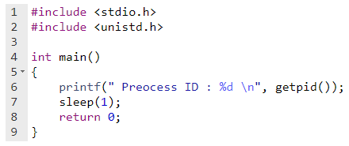

A) Use the online C compiler <https://www.onlinegdb.com/online_c_compiler> and run your code. Attach a screenshot of your output.

B) Use your Linux environment and run your code. Attach a screenshot of your output.

Hint:

|  |
| --- |
| Compilation |
|  |
| *gcc main.c -o main.out* |
| ./main.out |

C) In your code change the sleeping time from **1s** to **30s**, recompile your code and in the Linux terminal run the following commands (in the same terminal):

I) *./main.out &*

(Enter the command and then press the enter key two times)

II) *pstree –p -T* (or *pstree* *–pT*)

and answer following questions:

C.1) Did you get the same process ID for *main.out* in both part I and II (Yes/No)? Attach a screenshot of your output.

C.2) What does “*pstree –p –T”* mean?

Hint: Use “*man pstree”* command to answer this question.

C.3) What does *./main.out &*  mean?

D) Make sure the sleeping time is 30s and then open two Linux terminals, in the first terminal run *./main.out* and in the second terminal run *pstree –pT*. Are you still getting the same process ID for *./main.out* in both terminals (Yes/No)? Attach a screenshot of your output.

Use your Linux environment and answer the following questions.

**2.** Run lscpu command and complete the following table:

|  |  |
| --- | --- |
| Architecture |  |
| CPU op-mode(s) |  |
| Address sizes |  |
| Byte Order |  |

Attach a screenshot of your output.

**3.** Run lscpu | grep cachecommand in your terminal and attach a screenshot of your output. What does | grep cachemean?