

No E-Mail submissions will be accepted.  
Submission formats and file naming:

File name: firstName_lastName_lab_3

File format: pdf or MS Word format

e.g. Jim_Carrey_lab_3.pdf

**1.** Given the following details about a file:

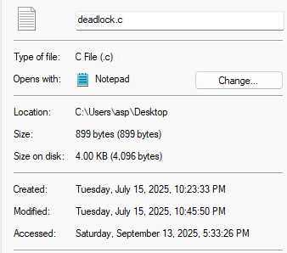

1. What is the actual size of the file?
2. How many disk blocks does the file occupy?
3. Is there any unused space in the last disk block (Y/N)? Explain your answer.
4. What is the size of each disk block?

Using the information above, calculate:

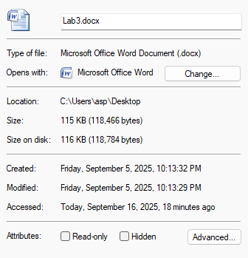

1. The total number of disk blocks used by the file.
2. The amount of wasted space in the last disk block.

Hint: 1 KB = 210

2. In a multiprogramming operating system, processes are scheduled using a fixed time quantum of 50 milliseconds. The system timer is driven by a clock with a tick interval of 2 nanoseconds.

Tasks:

1. Calculate the duration of the time quantum in clock ticks.
2. Determine the value that must be loaded into a 32-bit timer register to represent a 50 millisecond time quantum.

Assume the timer register counts down in units of clock ticks and triggers a context switch when it reaches zero.

**3.** Use the online Linux emulator available at:

<https://bellard.org/jslinux/>

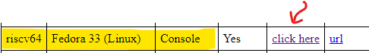

a) Compile the file hello.c to generate the a.out executable. Then, complete the table below.

|  |  |  |
| --- | --- | --- |
|  | i-number | File permissions (in Octal format) |
| hello.c |  |  |
| bench.py |  |  |
| a.out |  |  |

b) Take a screenshot clearly showing the terminal output where you retrieved the above information and **attach it** as part of your submission.

c) Execute the following command in the terminal: chmod -x a.out, then attempt to run a.out. Were you able to run a.out (yes/no)? Provide an explanation for your answer.

**4.** Given a clock with a frequency of 100 Hz, calculate the clock period in milliseconds (ms) and then fill out the following table.

|  |  |  |  |
| --- | --- | --- | --- |
| **Clock register # of Bits** | **Max**  **register value** | **New clock period**  **(in second) generated by counter** | **New clock frequency (Hz)** |
| 4 |  |  |  |
| 16 |  |  |  |