# Overview Entries for Debugging

## Entry 1: 15th of April 2015

Convert operation still non-functional, Conversion methods in place, execution code not written.

Switch toggle functional, no issues.

Convert button would look more ergonomic in the bottom right, recommend changing.

Recommend changing temperature unit representations to more obvious units, either Celsius and Fahrenheit or C° or F° to make the unit more obvious. Caution to be taken in implementing conversions regarding these units and the other units.

Miles not yet visible in the Imperial unit combo box, please add to list as soon as possible.

Wording for rounding value "Maximum Fraction digits" unclear, please change to Decimal places or significant figures to clarify whether its each point after the decimal or the number of place values respectively.

Textbox only accepts numerical values and defaults to zero, good move to avoid errors due to invalid input however the ability to induce negative numbers may need to be revised, team discretion, not essential.

For the presentation, it’s recommended capitalising the first letter of the imperial units. Same for metric if full names are used. Do not capatalise cm, m or km if displayed in this format.

Retain format between imperial and metric units, use full name or abbreviations for both, and avoid alternating. For the imperial units the accepted abbreviations are In, Ft, yd and mi for each, inch, feet yard and mile respectably

## Entry 2: 21st of April 2015

Conversion app is fully functional, Unit calculations Reversible by toggle, selection VIA combo box.

The variable selection of decimal places, now rounds from 1 to 9 decimal places.

Bug fixer notes, renamed "fraction digits" in display to read "decimal places" to clarify term.

There is some decimal rounding issue with some conversions. If the decimal place value is too low it will result in automatically showing a conversion of 0.0, however this can only be noted. Ensure client is aware of this while using Converter application.

Converter auto pairs temperature units on selection. This should help avoid mixing distance with temperature. There is now an error prompt in place in case the mistake still occurs, does not crash program.

All the conversions are functional.

Display is simple and easy to recognise.

Issue with default value as "0.0" can cause input to be out by a factor of ten.

Minor issue, mistake easy to spot and correct by user, can be avoided by clicking between ‘0’ and the ‘.’

Converter appears fully operational at present.

ADDENDUM

Added defaulting feature to distance-temperature conversions, switching from a temperature conversion will default to a conversion to feet or metres.

Added issue with rounding resetting values to 0.0, changing the value will redo the conversion using the new decimal places. This works both ways.

## Entry 3 - Wrap up: 22nd of April 2015

Initial appearance of the conversion program, long before it was functional was vastly different from the final product, taking on a more Horizontal look and felt a lot messier in general. While most aspects remained in the final design the presentation was a lot tidier in the later models

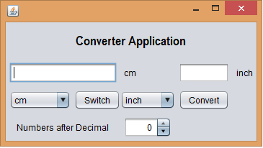

The next stage evolved quickly into the format that was retained though to the final design, while not initially functional the interface was operational and only the calculations themselves were missing. These calculations HAD been written, however without code calling the calculations to the interface, the Convert button was the only thing that didn’t work.

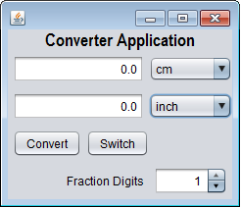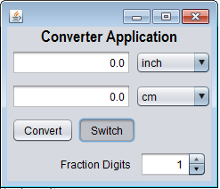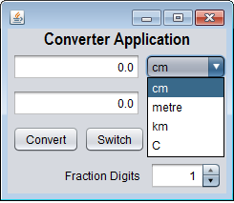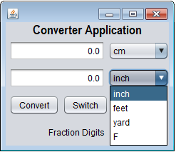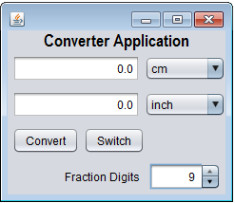

Once the final coding was done for the Convert button, the application was deemed complete, with only minor tweaks and bug fixes put in place to smooth things out. With each conversion and potential error checked and polished the application was deemed complete.

