[1st SEMESTER From April to May]

Kyaw Za Yan Naing (ID: 10238699)

Date of Submission: 12/5/2022

Problem Solving

Diploma In Information Technology

Project report.

The purpose of this application is to maintain a centralized database of swimmers’ timing from Singapore Swimming Association (SSA). Currently, the coaches are recording and submitting the swimmers’ timings manually using the paper. Thus, we design a mini application that will help to auto mate recording and submitting process. The overall view of the program is it will acquire user input for registration process and registered users can submit their swimmers’ record as many as they want, and these records will be posted or remain unposted based on user’s decision.

First of all, we decided to create a raw form of program first which can eventually be developed into a fully functional version which can interact with user can store users’ information in a real database. we used an offline database called pickle which is built in python module and can also be considered as mockup database. That can store data in a text file, and we can draw them out in anytime and can mutate them in our favor. For registration process, we acquire three user inputs, user’s name, gender, and date of birth. The reason we use date of birth instead of age is we will calculate the age based on the date and it is apparently more reliable and standardized. Next thing is we put the user’s status as active which is default value for newly registered user. The following step is to delete registered users. In order to delete user, we must check if the user does exist in our database in the first place. If the user does exist and its status is active, we updated the status to inactive. We can active the user again through the registration for new user process. we put a condition that if the user’s name is already existed in our database and status is active, we inform the user that he or she is already in the database and status is also active. After user registered in our program, he now can record his swimmer’s timing. In this step, the program will acquire inputs such as name, event type, timing and meet or competition location. One user can record more than one swim timing and initially the program will ask him or her that he or she wants to post their timing on the database.

For the final step, we implemented a function that users can search back their records by name or name and event type, and they can either post or unposted these filtered results. We also implemented validations functions to improve user experience even though not as much precise as we expect it to be. If I had more time, I could have designed a graphical structure and real database which will be much more promising than this version of the application. With more time, I could bring this application to be launched in the real world. You could check out the flowchart of the program down below.

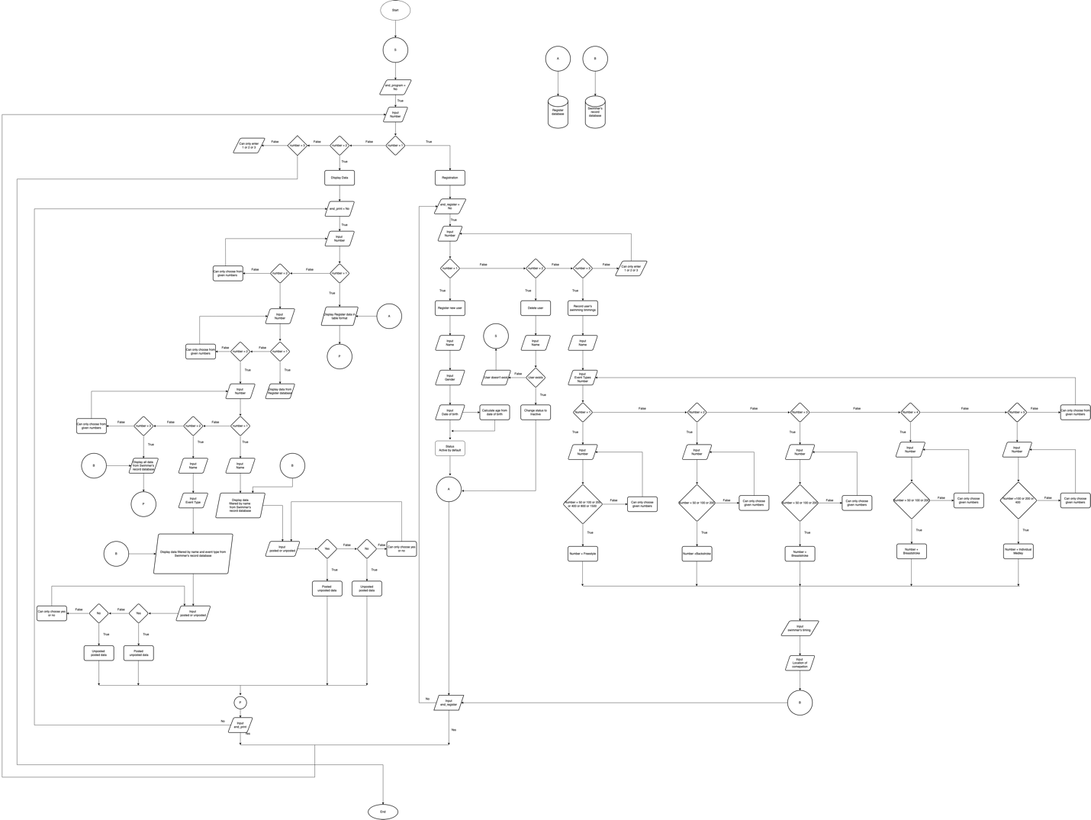Flowchart

Noted: I also added the PNG file of the flowchart in the project folder in which you can have a better view of the program.

User manual guide:

This is what you will see when you first run the application. There is three simple options that user can choose.

First of all, let’s register a user first. Enter 1 for that.

There will more three clear options of asking you what you want to do. We want to register new user, so, enter 1 for that.