Date of Submission: 12/5/2022

[1st SEMESTER FROM April to May]

Kyaw Za Yan Naing (ID:10238699)

User’s manual guide

Problem Solving

Diploma In Inforamtion Technology

This is how it will look like once you run the application.

Enter one for registration.

In this you can either create, delete or record swimmer’s timings.

First create a user

You can now either end the reistration process or continue.

In this case I will continue. Which will bring back to second photo.

Now, let’s delete user.

Enter 2 to delete user and it will ask your name. You can enter the name you want to delete. For now, let’s try delete a user. I created users in advance for testing. So, enter Kyaw Za Yan Naing.

As we can see, user’s status is now updated to inactive. Let’s move to next step, which step is to record swimmer timing for the user we created. So, enter “no” to keep the register process and enter 3 to record swimmers timing. Enter the input that program ask you.

Let’s now move on to data display process. Thus, enter yes to end the registration process. It will again ask you do you want to end the program. Enter “no” to continue the program.

After that, the program will lead you back to the first photo in which program ask you that do you want to register or print data. To print data, enter 2.

Now, program will ask you that do you want to print register data or print the recorded even data. Firstly, let’s see what is inside the register. To see that, enter 1.

We can see the user Jayden Core we register earlier along with the information we put, and status is active. Nonetheless we can see the user Kyaw Za Yan Naing that we deleted, and his status is inactive. Let’s continue the printing process. In order to do that, enter “no” for now.

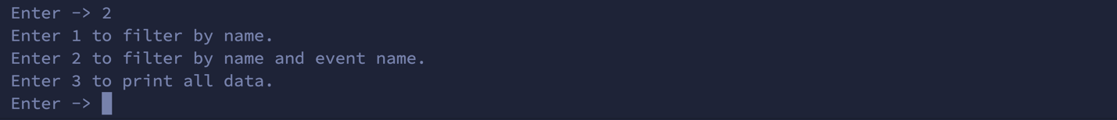Let’s move on to the event data. Enter 2 for that.

Now, we can see three options. We can search by name, name and event name and just print all data inside the database. Let’s see all the data first. Enter 3 for that.

There are all the data I have added for testing, and we can see the data Jayden Core information and it is unposted because we chose not to post. Now, let’s try search method. For that, enter “no” to continue printing process. Enter 2 to print event data and enter 1 to filter by name. Let’s try with name Kyaw Za Yan Naing.

We can see two records that are unposted listed, and that program ask you that you want to post or not. I entered “Yes” so the program posted those events and return back the data along with a message. Enter “no” again to test filter by name and event name function. Enter 2 to print event data and enter 2 again to test that function.

As shown in the picture above, I searched with the name Mg Mg and event name 1500 Freestyle. There are two data with different timing and location. I entered yes to post all two of them. Unfortunately, it’s pretty much all about the program. You can try doing other options and test as many as you want to. To quit the program, enter yes to end printing process and yes again to end the program.