**TOURISM WEBSITE**

**END TERM REPORT**

***by***

**Pujan Talukder(Section:K19FG, Roll No:02)**

**Gopal Sharma(Section:K19FG,Roll No:01)**

**Abhishek Tripathi(Section:K19FG,Roll No:03)**



**Department of Intelligent Systems**

**School of Computer Science Engineering**

**Lovely Professional University, Jalandhar**

**Year 2019-2020**

**DECLARATION**

**This is to declare that this report has been written by us. No part of the report is copied from other sources. All information included from other sources have been acknowledged. We aver that if any part of the report is found to be copied, we shall take full responsibility for it.**

**Pujan Talukder(Roll No:02)**

**Gopal Sharma(Roll No:01)**

**Abhishek Tripathi(Roll No:03)**

**Date : 10/04/2020**

**CONTENTS**

**TITLE PAGE**

|  |  |
| --- | --- |
| BACKGROUND AND OBJECTIVES OF PROJECT |  |
| DESCRIPTION OF PROJECT |  |
| DESCRIPTION OF WORK DEVISION |  |
| IMPLEMENTATION OF PROJECT |  |
| TECHNOLOGIES AND FRAMEWORK |  |
| SWOT ANALYSIS |  |

BONAFIED CERTIFICATE

Certified that the project report “TOURISM WEBPAGE” is the bona fide work of “Gopal Sharma, Pujan Talukder, Abhishek Tripathi” who carried out the project work under my supervision.

Ms. Nikita Kaushik

Id-25821

Department of intelligent systems

School of Computer Science and

Engineering

**Introduction**

The Trip Tok is a web based application. The main purpose of “Trip Tok” is to provide a convenient way for a customer to chose places to travel and also book hotels for tour purposes. The objective of this project is to develop a system that automates the processes and activities of a travel agency. In this project, We will make an easier task of searching places and for booking hotels and tour packages. In the present system a customer has to approach various agencies to find details of places and to book tickets. This often requires a lot of time and effort. We provide approach skills to critically examine how a tourist visits and its ability to operate in an appropriate way when dealing with the consequences of tourism, locally, regionally, and nationally including visitor security and ecological influences. It is tedious for a customer to plan a particular journey and have it executed properly. The project ‘Trip Tok’ is developed to replace the currently existing system, which helps in keeping records of the customer details of destination as well as payment received.

**Objectives**

This application is develop to provide best travelling services to the customers and travel agents. We have developed Trip Tok to provide a search platform where a tourist can find their tour places according to their choices. This system also helps to promote responsible and interesting tourism so that people can enjoy their holidays at their favorable places. This system also helps to develop tourism with different cultures so that they enrich the tourism experience and build pride. We develop this system to create and promote forms of tourism that provide healthy interaction opportunities for tourists and locals and increase better understanding of different cultures, customs, lifestyles, traditional knowledge and believes.   
  
This system also gives tours related information like which places are tourist attractions, cities, and provinces. Our website will provide the user with the best deals for their tour. Tourist can also book hotels through our website “Trip Tok”. This system also keeps a history of visited places of its users and also take their valuable reviews and comments. We provide the experience of our users so that a new user can get some references.

**Goals**

Our goal is to provide our user a simple but interactive interface that can be handled easily. Through our web application an user can easily choose tour packages as per their choice in a convenient way, thus it will reduce their effort of a user for finding deals and comparing. Trip Tok web application also has the feature to book hotels through the booking portal.

The major goal for making this web application is to provide best travelling services to the customers and travel agents. We have developed Trip Tok to provide a search platform where a tourist can find their tour places according to their choices.

**Work Division and Responsibilities**

Planning of design and structure of the webpage by Pujan Talukder and Gopal Sharma.

* Gopal Sharma, worked on the the structure and the format of the webpage, Coding through HTML5 and scripting of the web page through java script.
* Pujan Talukder, worked on the styling of the elements of the webpage, Coding through CSS3.
* Abhishek Tripathi, debuging the source code and finding more references for the project.

**Implementation**

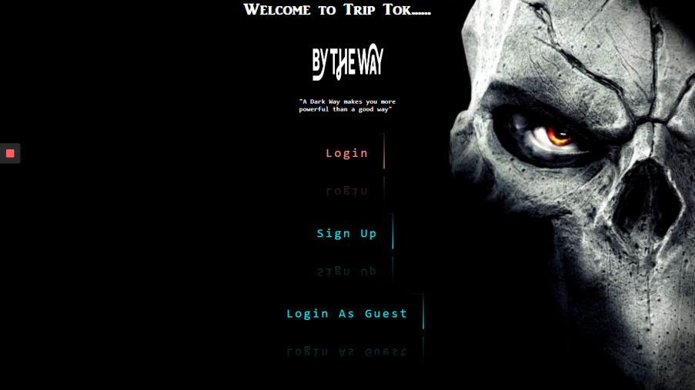

The above screen shot is the welcome page of our website. Here the user will come across some navigations. On clicking the login and sign up link it will be directed to the login page and by clicking the login as guest link it will be directed toward home page of our website. Followings are the screen shot of the login page.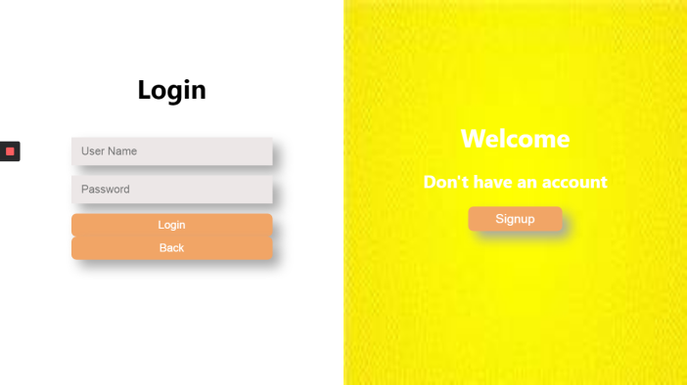

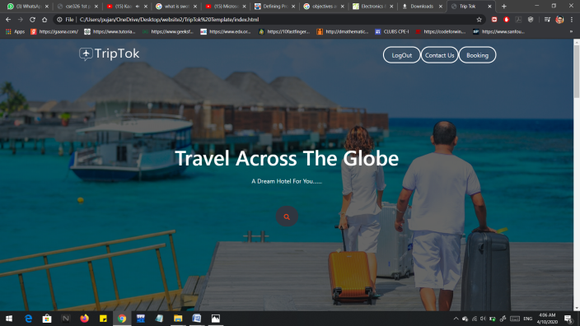

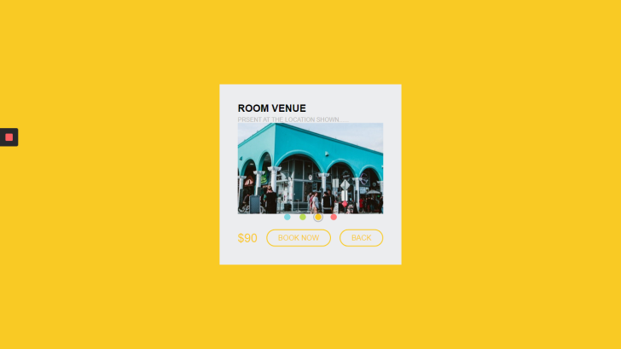In the home page there is booking navigation, contact us navigation and log out navigation.By clicking the booking link the page will be directed to the hotel booking interface.

In home page user can see the travelling gallery and user reviews also.

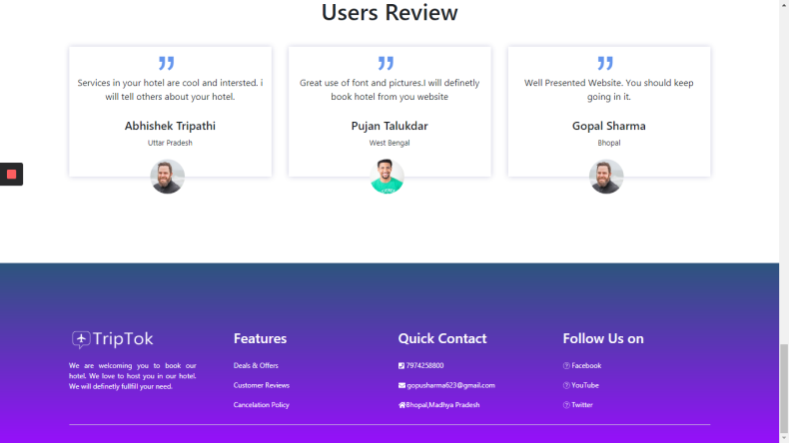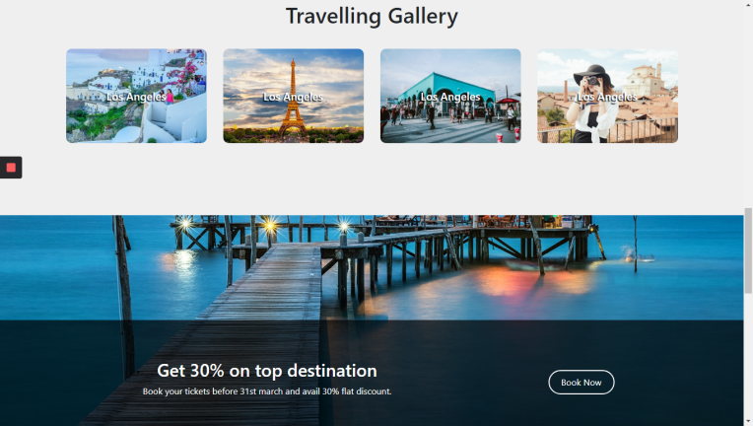**Visual Code Viewer is used as text editor in our project.**

**SWOT Analysis**

Strengths- A very ‘user friendly’ website that gives ten different categories of types of traveling that are available at the bottom of the welcome screen. The technology that is utilized is not only up to date but is conveniently interactive to link the welcome screen to a variety of different sectors of tourism. “Accommodations”. Offers vivid pictures of locations around world.

Weaknesses- Although the technology is up to date, the overall format that is used to transfer from site to site within the main welcome screen could be to basic and does not tackle enough visual senses quickly enough. Even though galleries, and videos are available, it takes to many clicks to view them. Too much simplicity of the website.

Opportunities- There is a great opportunity to expand it’s market towards other types of travelers in the areas of shopping, heritage. Expand further on existing green tourism practices. Continue to drive tourism numbers through innovation. Over a larger variety of vacation package to tailor different target markets.

Threats- Actually the project is not linked with mysql or any kind of database.