Lab-13-MappingData.R

jaydenbrown

2022-04-28

## Lab 13: Mapping Data in R  
## J. Brown  
## 2022-04-29  
  
#load libraries  
library(dplyr)

##   
## Attaching package: 'dplyr'

## The following objects are masked from 'package:stats':  
##   
## filter, lag

## The following objects are masked from 'package:base':  
##   
## intersect, setdiff, setequal, union

library(readr)  
library(ggplot2)  
library(maps)  
library(mapdata)  
  
#Create a dataframe from the "state" boundry file  
Bndry <- map_data("state")  
  
#Create an object with a basic map  
map1 <- ggplot(data = Bndry) +   
 geom_polygon(aes(x = long, y = lat, group = group),  
 color = "black",   
 fill = "purple") +   
 coord_fixed(1.3)  
map1

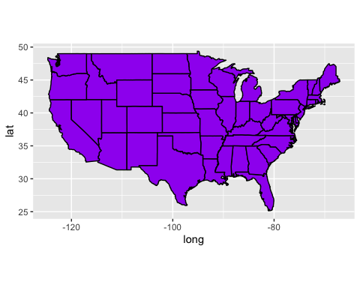

#Create a theme to clean up the map  
ditch_the_axes <- theme(axis.text = element_blank(),  
 axis.line = element_blank(),  
 axis.ticks = element_blank(),  
 panel.border = element_blank(),  
 panel.grid = element_blank(),  
 axis.title = element_blank(),  
 panel.background = element_blank())  
  
#Print the cleaned up map  
map1 + ditch_the_axes + ggtitle("This is the Title of My Map")

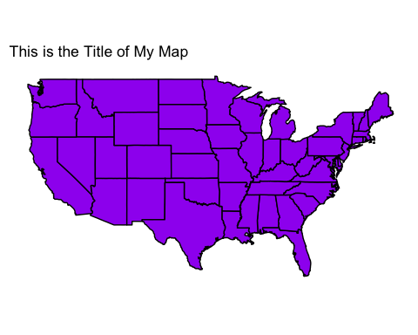

##Read in the .csv file with the data  
infmort <- read_csv("~/Downloads/InfantMortality2017.csv")

## Rows: 49 Columns: 8

## ── Column specification ────────────────────────────────────────────────────────  
## Delimiter: ","  
## chr (3): state, postal.code, region  
## dbl (4): south, poverty.pct, white.pct, inf.mort  
##   
## ℹ Use `spec()` to retrieve the full column specification for this data.  
## ℹ Specify the column types or set `show_col_types = FALSE` to quiet this message.

#Classify the infant mortality into a set of ranges for the colors  
infmort$classify <- NA  
infmort$classify[infmort$inf.mort > 0.0 & infmort$inf.mort <= 4.6] <- "0-4.6"  
infmort$classify[infmort$inf.mort > 4.6 & infmort$inf.mort <= 5.8] <- "4.6-5.8"  
infmort$classify[infmort$inf.mort > 5.8 & infmort$inf.mort <= 6.2] <- "5.8-6.2"  
infmort$classify[infmort$inf.mort > 6.2 & infmort$inf.mort <= 7.1] <- "6.2-7.1"  
infmort$classify[infmort$inf.mort > 7.1 & infmort$inf.mort <= 8.7] <- "7.1-8.7"  
  
infantmap <- inner_join(Bndry, infmort, by = "region")  
  
#Create map of infant mortality  
map2 <- ggplot(data = infantmap) +   
 geom_polygon(aes(x = long, y = lat, group = group, fill = classify),  
 color = "white")  
  
#Add the maps together, clean up the axes, and color code the states.  
map2 + ditch_the_axes + ggtitle("Infant Mortality in the U.S., 2017") +  
 scale_fill_manual(values = c("#26456D", "#2D7CB4", "#CACACA", "#D8392C", "#9B0724"),  
 guide_legend(title = " "))

