**CMPT 275 Assignment 3 Test Case pdf**

**Test case 1:** When a shape is selected, the parameter(s) for that shape are shown and set to a default value. The area and circumference are also updated using those default values.

Figure : Correct side length parameter is shown for Equilateral triangle

Figure : Correct height and width parameters are shown for the rectangle

Figure : Parameters for the ellipse are shown after user selects the ellipse shape

Figure : Correct parameter of side length for a square is shown

Figure : Circle default parameter shown

**Test Case 2:** Demonstrate circumference and area calculation for each shape

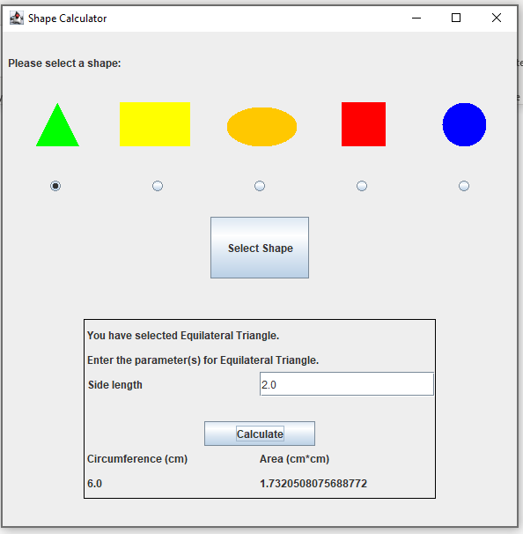

Figure : Triangle area and circumference recalculated with user inputs

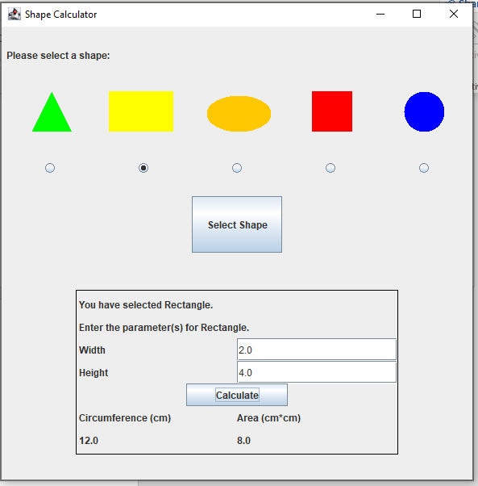

Figure : Rectangle area and circumference calculated based on user inputs

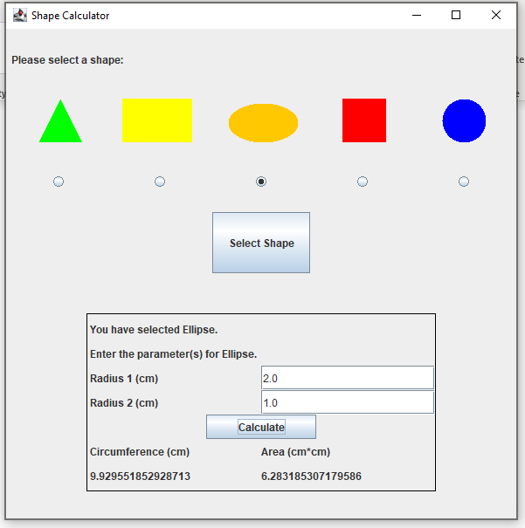

Figure : Ellipse recalculated area and circumference with user radii inputs

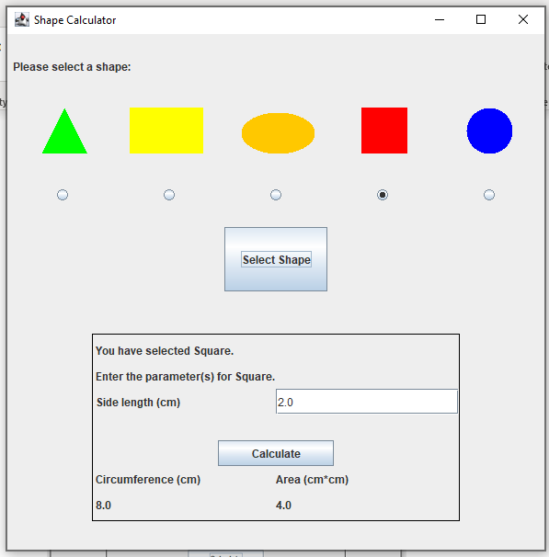

Figure : Square area and circumference using user inputted side length value

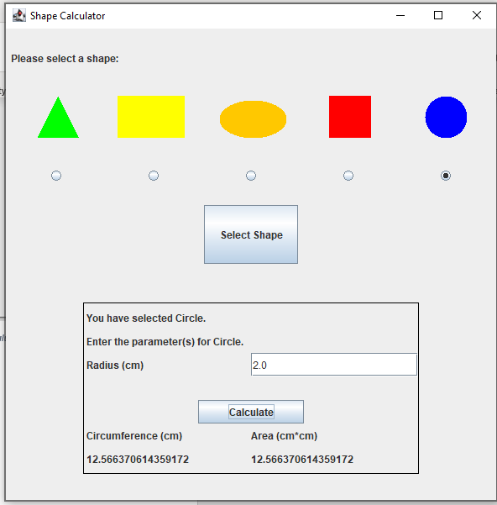

Figure : Circle area and circumference with user inputted values

**Test Case 3:** Validations on inputs that they must be doubles

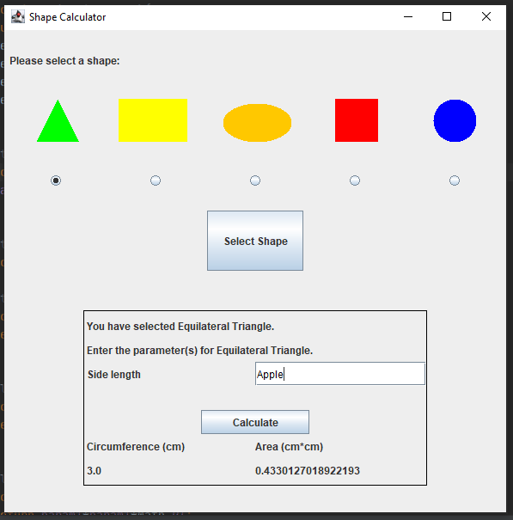

Figure : User about to calculate with string in input

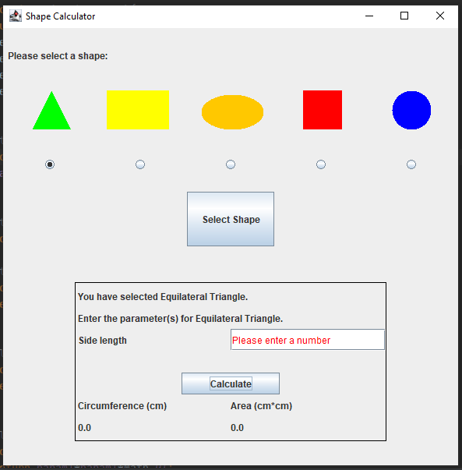

Figure : Error message for an invalid input

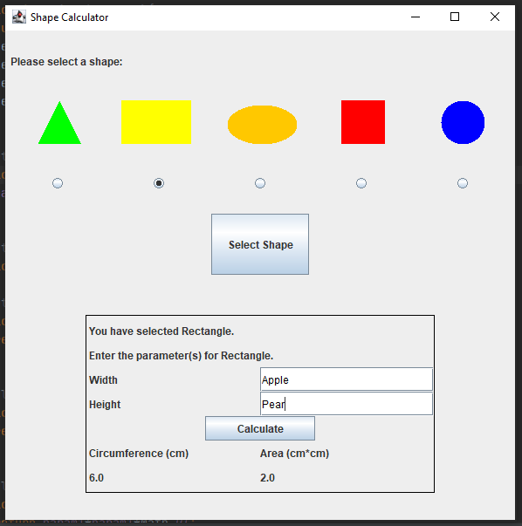

Figure : User inputting strings to both parameters for the rectangle

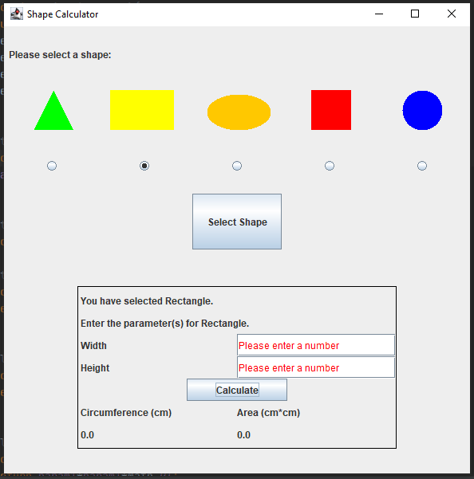

Figure : Program can detect the errors in the inputs and informs the user