Jayden Rios

00325523

Networking

**Ubuntu NETWORK DOC:**

Current default network settings:

**COMMAND IFCONFIG:**

Ifconfig: (interface configuration)

This is a network management tool. It is used to configure and view the status of the network interfaces in Linux operating systems. With ifconfig, you can assign IP addresses, enable, or disable interfaces, manage ARP cache, routes, and more.

**COMMAND: ip addr**

The Ip addr command can show us the addresses of all links configured on the network. We can see here under “inet” our ip address which is 192.168.159.128/24. This is a unique identifying number assigned to our device.

**COMMAND:hostname**

Hostname is a command that can show you the hostname of your network.



**COMMAND: tracepath**

Tracepath is a command that can show you the path used from the origin to the destination. Tracepath has many options to choose from. The are listed here with their purpose.

**COMMAND: networkctl**

Networkctl is a command used to view available network devices.

Networkctl status can be used to show the current status of your network.

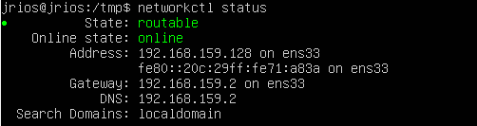

**COMMAND: ss**

The ss command (socket statistics) can be used to get a list of all sockets. A socket is connected to a port number so the tcp can properly identify the location of a device that data is being sent to. Here is an example of some listed when using the command.

**COMMAND: ping “ip address” -c3**

The ping command can be used to test the reachability of a host on a network. Here we will use ping -c 3 to send 3 messages to the host ip address. Ping can also be a helpful tool to show if your server is connected to the internet.

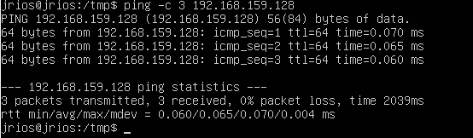

Here you can see 3 64 byte packets of data sent to the user and the speed it took to do so, (2039ms).

**COMMAND: apt list**

apt list is a command that will list all the installs on your system. Here is an example of some installs the command is used.

**CentOS NETWORK DOC:**

Current Default Network Settings

In order to use certain networking tools on CentOS, you must first update the yum repository. You can do this by using the command sudo yum update.

Type “y” and hit enter to allow updates and installations. This can take a few mins.

Once this step is complete and all repos have been updated you must install net-tools. This is a package that enables the user to use many important networking commands on the command line such as ifconfig, netstat, route and many more useful tools.

Type **sudo yum install net-tools -y**

You now have access to new networking tools.

**COMMAND: Ifconifig**

Ifconfig: (interface configuration)

This is a network management tool. It is used to configure and view the status of the network interfaces in Linux operating systems. With ifconfig, you can assign IP addresses, enable, or disable interfaces, manage ARP cache, routes, and more.

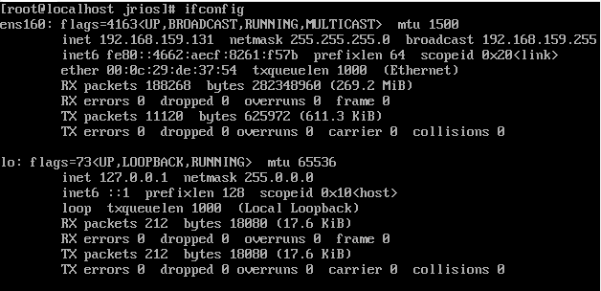

**COMMAND: ip addr**

The Ip addr command can show us the addresses of all links configured on the network. We can see here under “inet” our ip address which is 192.168.159.128/24. This is a unique identifying number assigned to our device.

**COMMAND: Hostname**

Hostname is a command that can show you the hostname of your network.



**COMMAND:Tracepath**

Tracepath is a command that can show you the path used from the origin to the destination. Tracepath has many options to choose from. The are listed here with their purpose.



**COMMAND:networkctl**

Networkctl can be used to view available network devices. Can also be used to view current network status. In order to use this tool you must install its package to your server. To do this use the command yum install systemd-networkd.

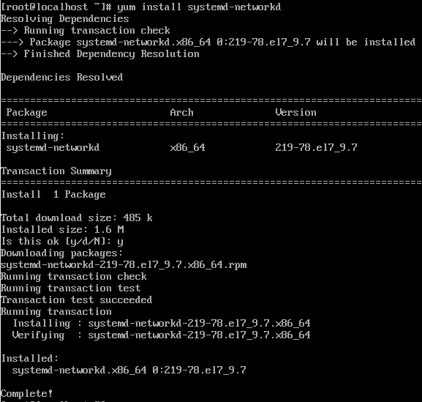

You can then type networkctl on your command line.

**COMMAND:ss**

The ss command (socket statistics) can be used to get a list of all sockets. A socket is connected to a port number so the tcp can properly identify the location of a device that data is being sent to. Here is an example of some listed when using the command.

**COMMAND: ping google.com -c3**

The ping command can be used to test the reachability of a host on a network. Here we will use ping -c 3 to send 3 messages to google.com. Ping can also be a helpful tool to show if your server is connected to the internet.

To show current repolist, use the **command yum repolist**.

**SCRIPTS FOR BOTH SERVERS DOC**

**Script for network dump UBUNTU**

In order to create this script you must create a file. I named this one Networkinfo.sh

You must then allow read,write, execute permissions with chmod +rwx to allow editing to this file.

Then use the vi editor by entering vi networkinfo.sh

Script being ran results UBUNTU

To run this script you would **enter ./networkinfo.sh in the directory it was created in.**

All information added to the script will proceed to be shown on the commandline as well as placed in a new file named networkinfo_”DATE” as shown in the script**. This file can be found by enter ls in the working directory.**

**Script for network dump CENTOS**

In order to create this script you must create a file. I named this one Networkinfo.sh

You must then allow read,write, execute permissions with **chmod +rwx** to allow editing to this file.

Then use the vi editor by entering **vi networkinfo.sh**

**Script Results CENTOS**

To run this script you would enter **./networkinfo.sh in the directory it was created in.**

All information added to the script will proceed to be shown on the commandline as well as placed in a new file named networkinfo_”DATE” as shown in the script**. This file can be found by enter ls in the working directory.**

**1 PAGE SCRIPT EXPLANATION DOC**

By default, networking on servers works by being connected to a network over the internet or locally. Most servers have a NIC or Network Interface Card which allows it to send and receive packets of data. When a server receives packets, it can process them by many methods such as executing commands, reading scripts, or creating files. Servers can send responses to these data packets through protocols over the networks such as TCP/IP which can ensure reliability in packet delivery. By default, networks can use many other protocols such as http for website communications, ftp for file transfers or ssh for secure remote accessing. Admins can configure networks to better suit them for purpose. As stated, before scripts can be an important part of configuring or working within a network. My script created above named “networkinfo_”DATE”.txt, is a txt file that dumps important information about the current networks info and the date it was created on. The first thing I decided to show was ifconfig. This command is very useful. It can be used to view many aspects of your network including ip addresses, statistics, packet transmissions and many more. You can also use it to manually configure and troubleshoot your network. I then decided to include the ip addr command to show the current ip address. This is important because ip addresses allow the network to communicate and give each other proper destinations to send and receive data. After this I included DNS or (Domain Server Name). These are used to translate human language domain names into Ip Addresses, which allows users to access websites, send and receive emails and use other network services. I then included the open ports command. When a port is open it means that the network is ready to receive incoming network connections from other devices. Therefore, opening particular ports and showing which ports are open is crucial for receiving communications from different devices or services. Lastly, I decided to use the Ping command in the script. Ping is an important tool within the network. It allows the user to test the connectivity and time responses of communications between your server and another network. Ping can help to show how fast your network is sending and receiving data packets, it can connect to host networks and can tell you if your service is connected to the internet or not. I felt that these were all very important features to include in the script. They can all show a variety of networking information throughout the servers, help you make configurations, or show you what services are up and ready for communication. The results of the script can be shown on the command line and in the txt file. Screenshots of this have been included above. All research articles have been sourced and pasted below as well.

**How networking is done by default UBUNTU:**

By default, Ubuntu Linux uses the IP (internet protocol) network for communications. It relies on dynamic host configuration protocol (dhcp) for automatic ip address assignment and network configurations. When you connect Ubuntu to a network it will send a request to receive ip address, subnet mask, gateway, and dns server info. Once connected, it will then proceed to use various protocols, tools, and services to manage connections. Linux Ubuntu is a very flexible network that allows for effortless connectivity.

**How networking is done by default CentOS:**

Similar to Ubuntu, Linux CentOS which is based on Red Hat Enterprise (RHEL), uses the IP (internet protocol) network for communications. It relies on dynamic host configuration protocol (dhcp) for automatic ip address assignment and network configurations. When you connect Ubuntu to a network it will send a request to receive ip address, subnet mask, gateway, and dns server info. Once connected, it will then proceed to use various protocols, tools, and services to manage connections. Linux Ubuntu is a very flexible network that allows for effortless connectivity. Centos also uses systemd-networkd which is a service that is responsible for network configurations.

Sources for network research:

Allenvrousemcse, et al. “Understand the Role of Scripting in Network Administration.” *TechRepublic*, 8 June 2007, www.techrepublic.com/article/understand-the-role-of-scripting-in-network-administration/#:~:text=Scripting%20lets%20you%20automate%20various%20network%20administration%20tasks%2C,based%20on%20certain%20conditions%2C%20such%20as%20group%20membership.

Dancuk, Milica. “Linux Network Commands Cheat Sheet: Phoenixnap KB.” *Knowledge Base by phoenixNAP*, 20 Nov. 2023, phoenixnap.com/kb/linux-network-commands.

*Networking*, www.aholdengouveia.name/LinuxAdmin/networking.html. Accessed 3 Dec. 2023.

Saive, Ravi, et al. “Ravi Saive.” *13 Linux Network Configuration and Troubleshooting Commands*, 13 July 2023, www.tecmint.com/linux-network-configuration-and-troubleshooting-commands/.

GitHub link for script: <https://github.com/JaydenRios/JaydenRios>

As of 12/3/2023 both servers have been updated using:

**Sudo apt-get update -UBUNTU**

**Yum update -CENTOS**