LOK NATYA

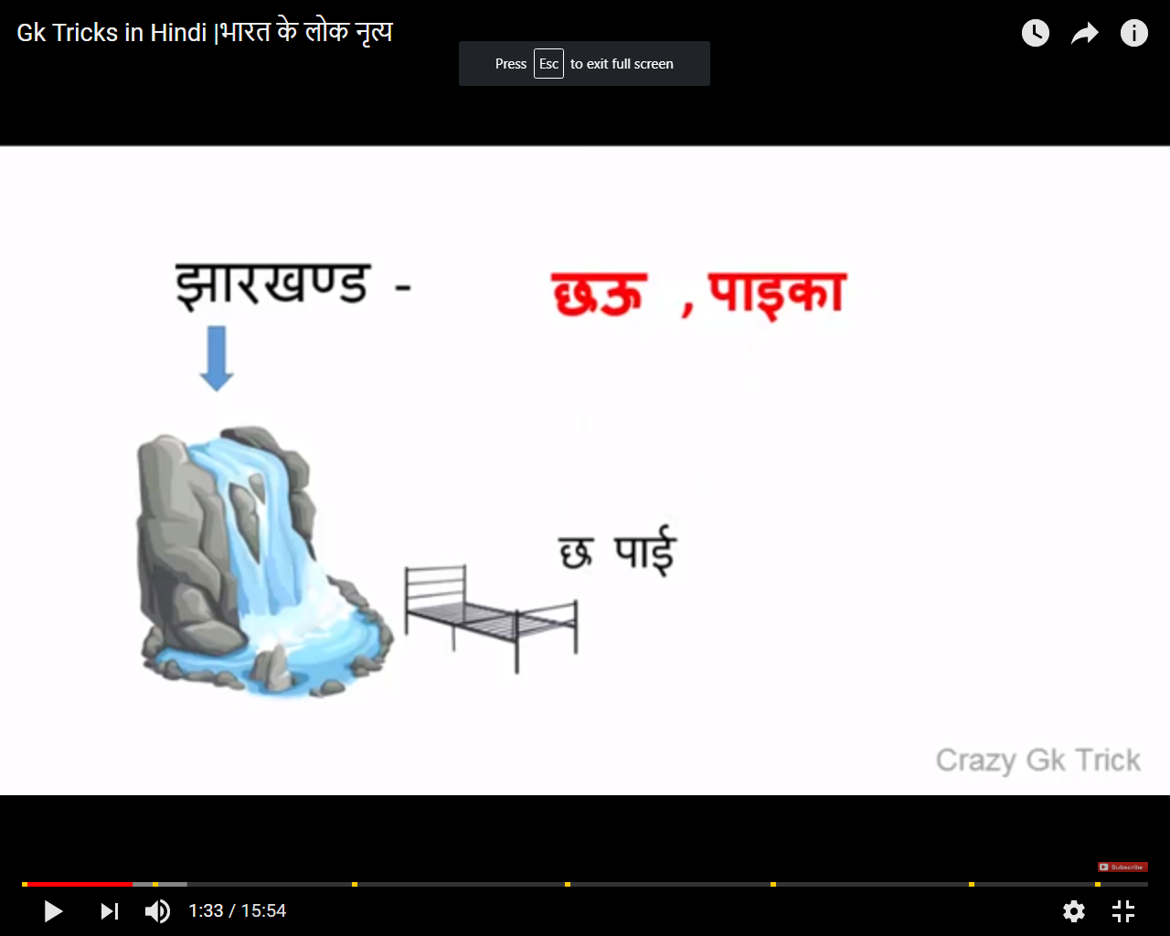 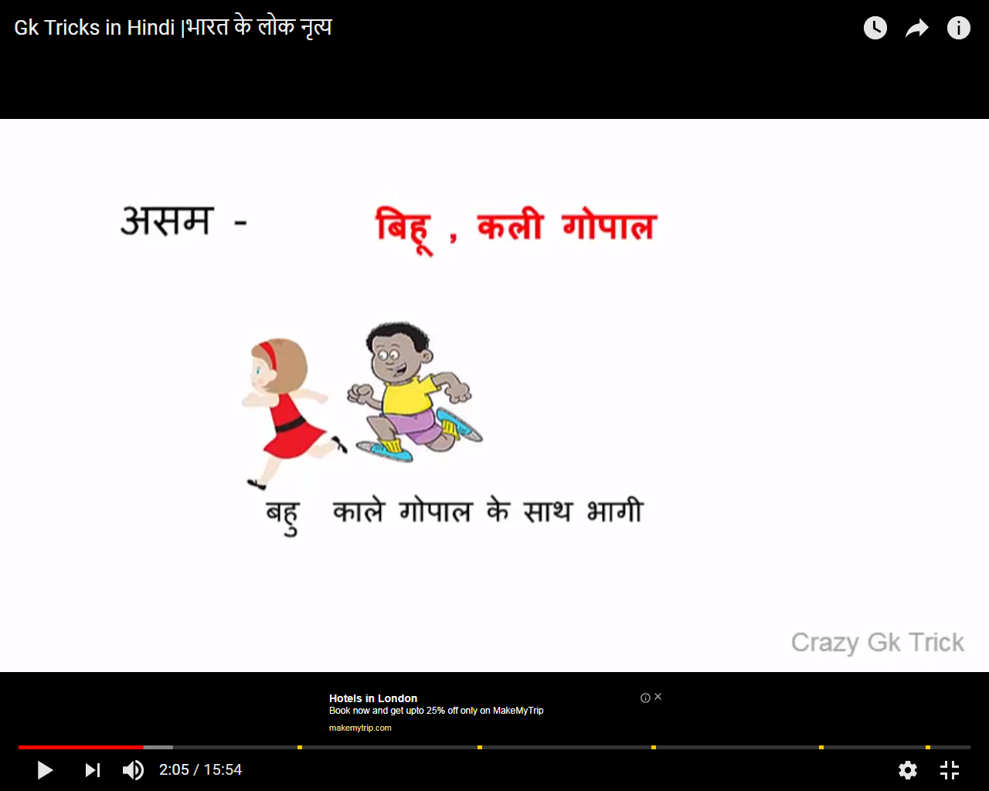

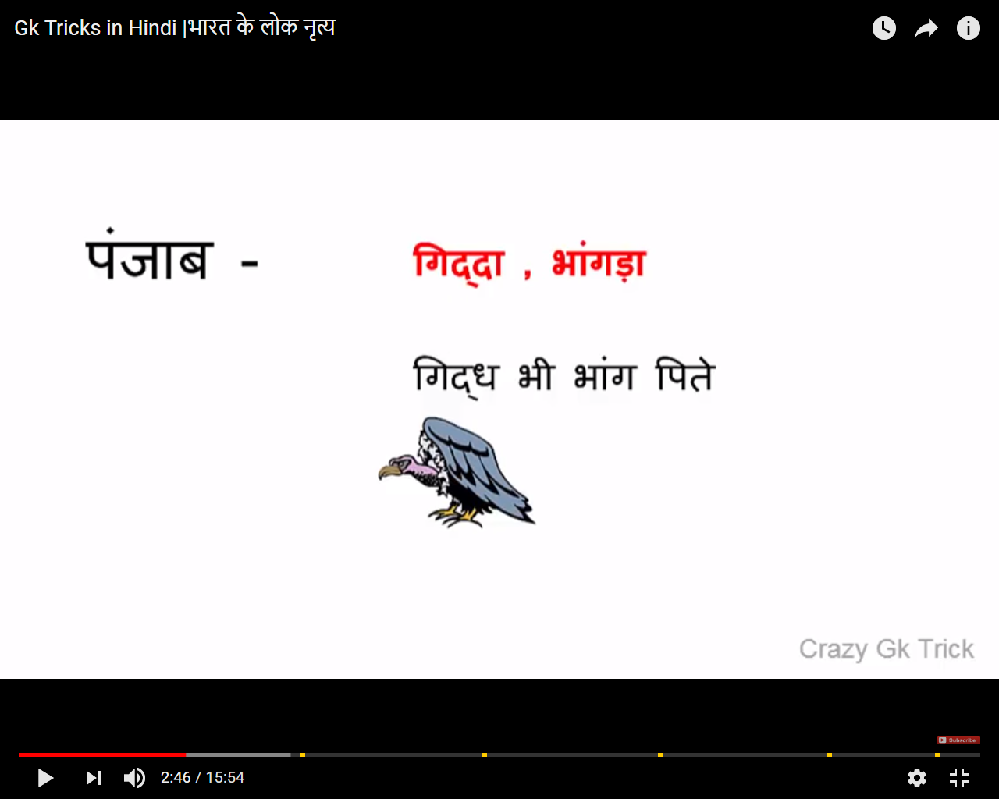

Main kathputali dance dekne gaya rajasthan,gurmi itni thi jaise sue chuubhe.

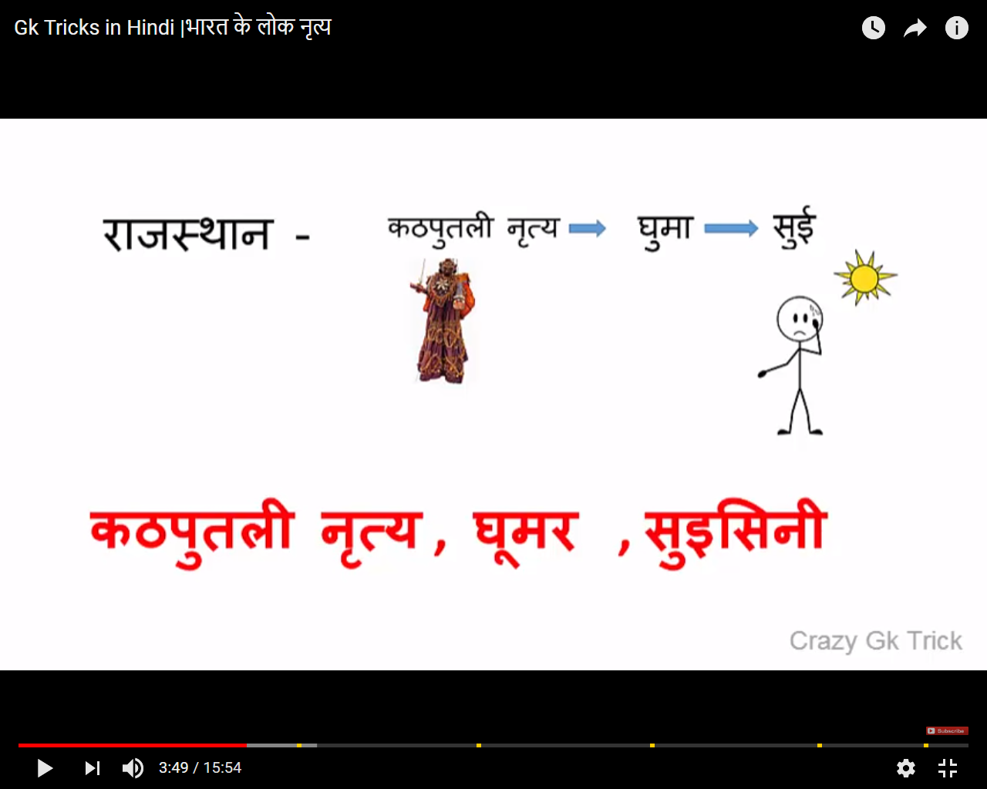

Naag ki choch labi hoti hai

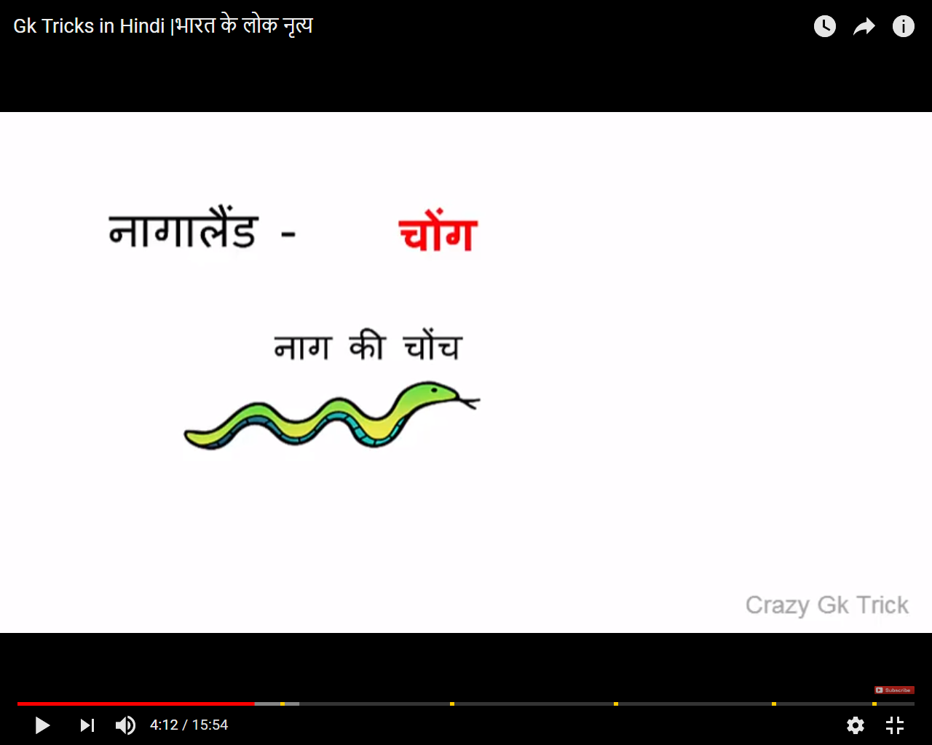

GOA-Dharu-Dhakkan ki mandi

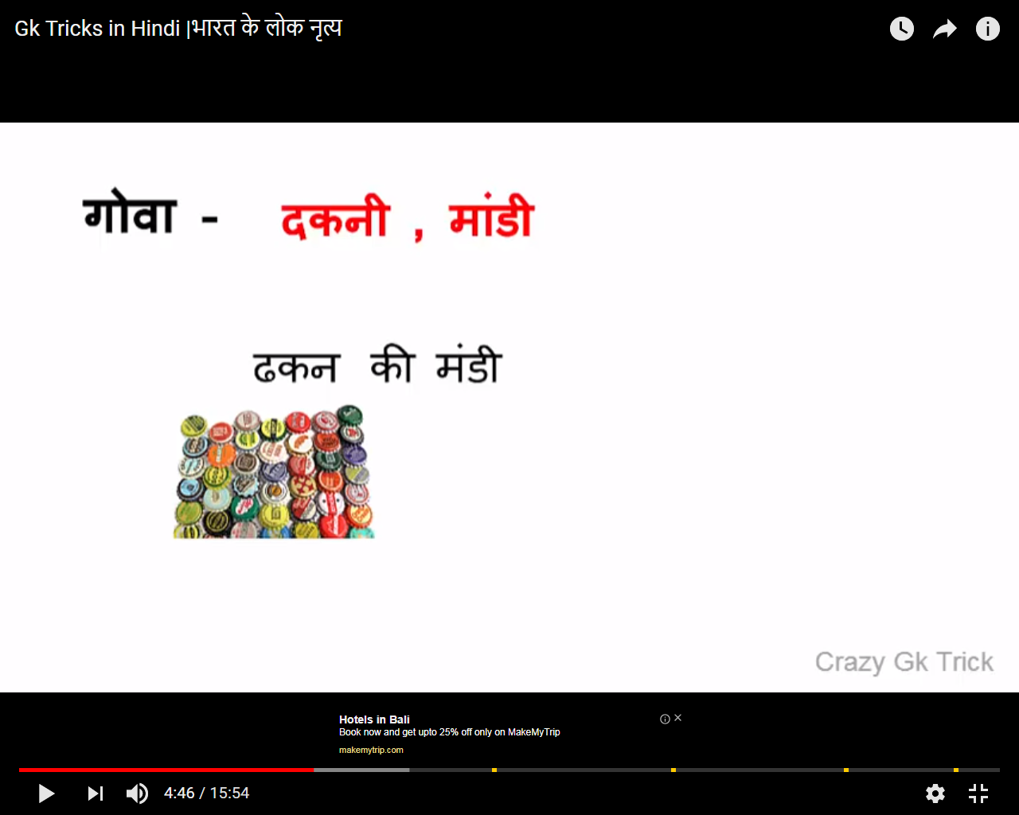

Arunachal-Arun aisa ladka hai ,apne chehre pe mukhauta pahen kr yudh ladne chala

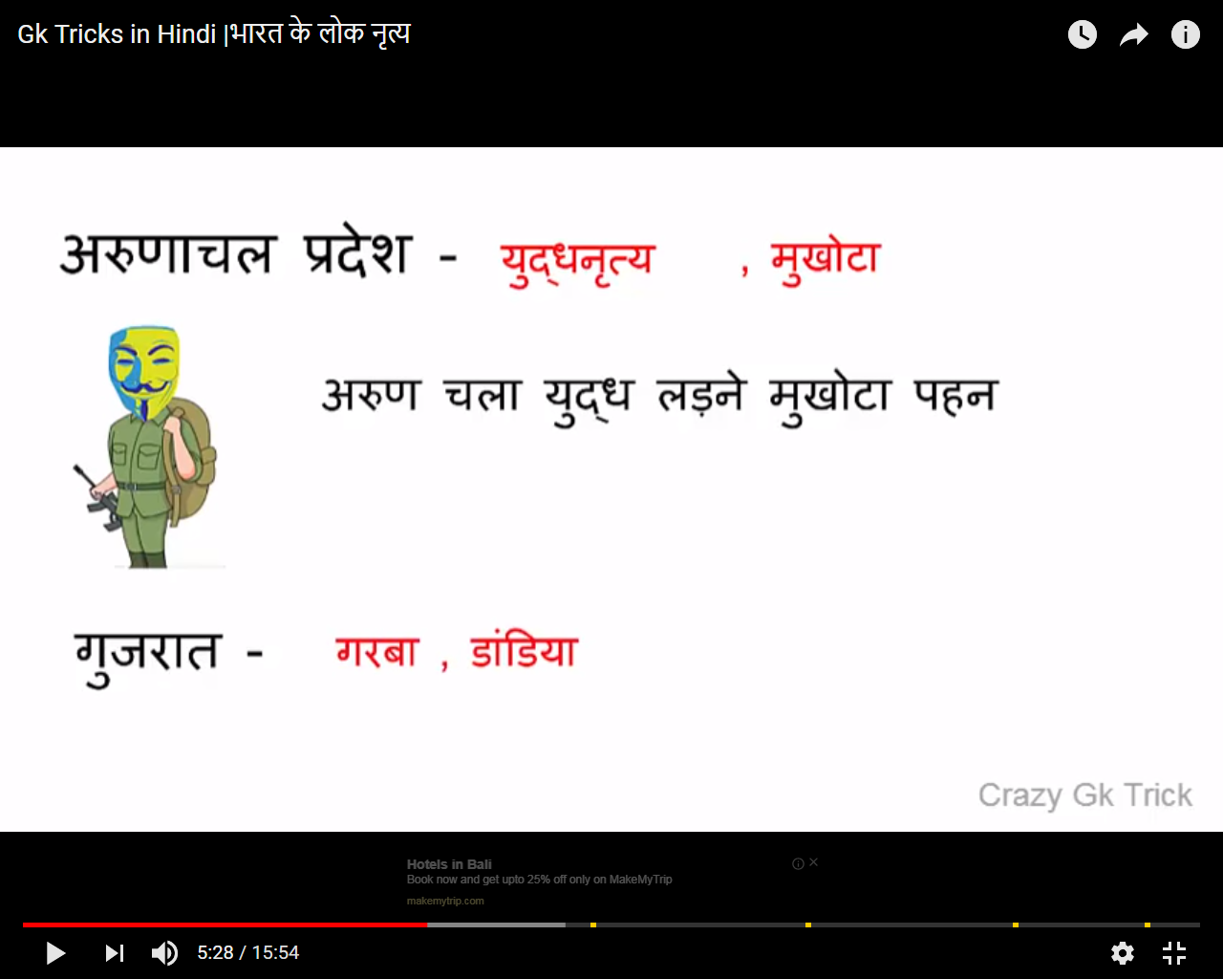

Uttarakand -many river-nadiyo ka gadh

Kashmir-thand ki wajh se ooff niklta hai

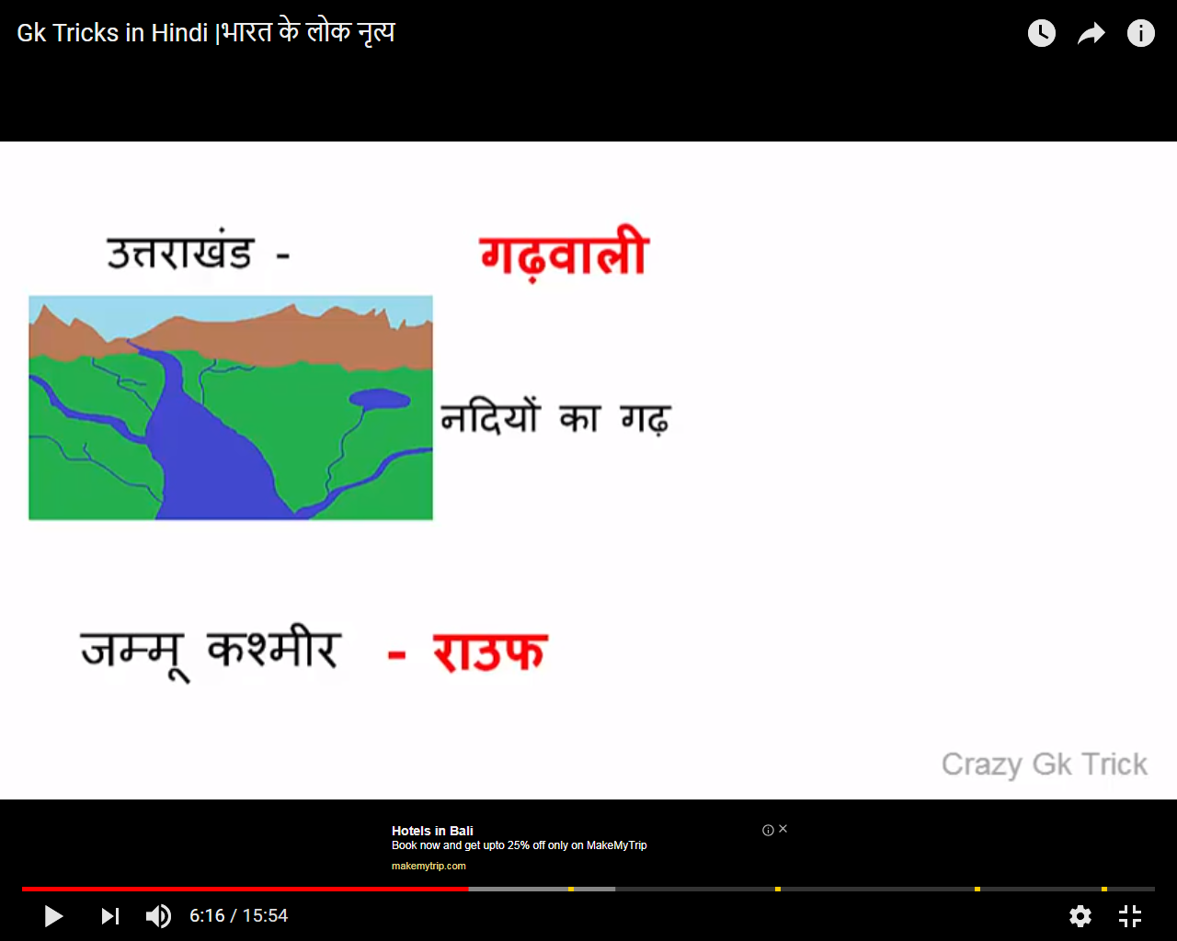

Himachal-Him- burf -chappal pahen kr+tanda aur naao

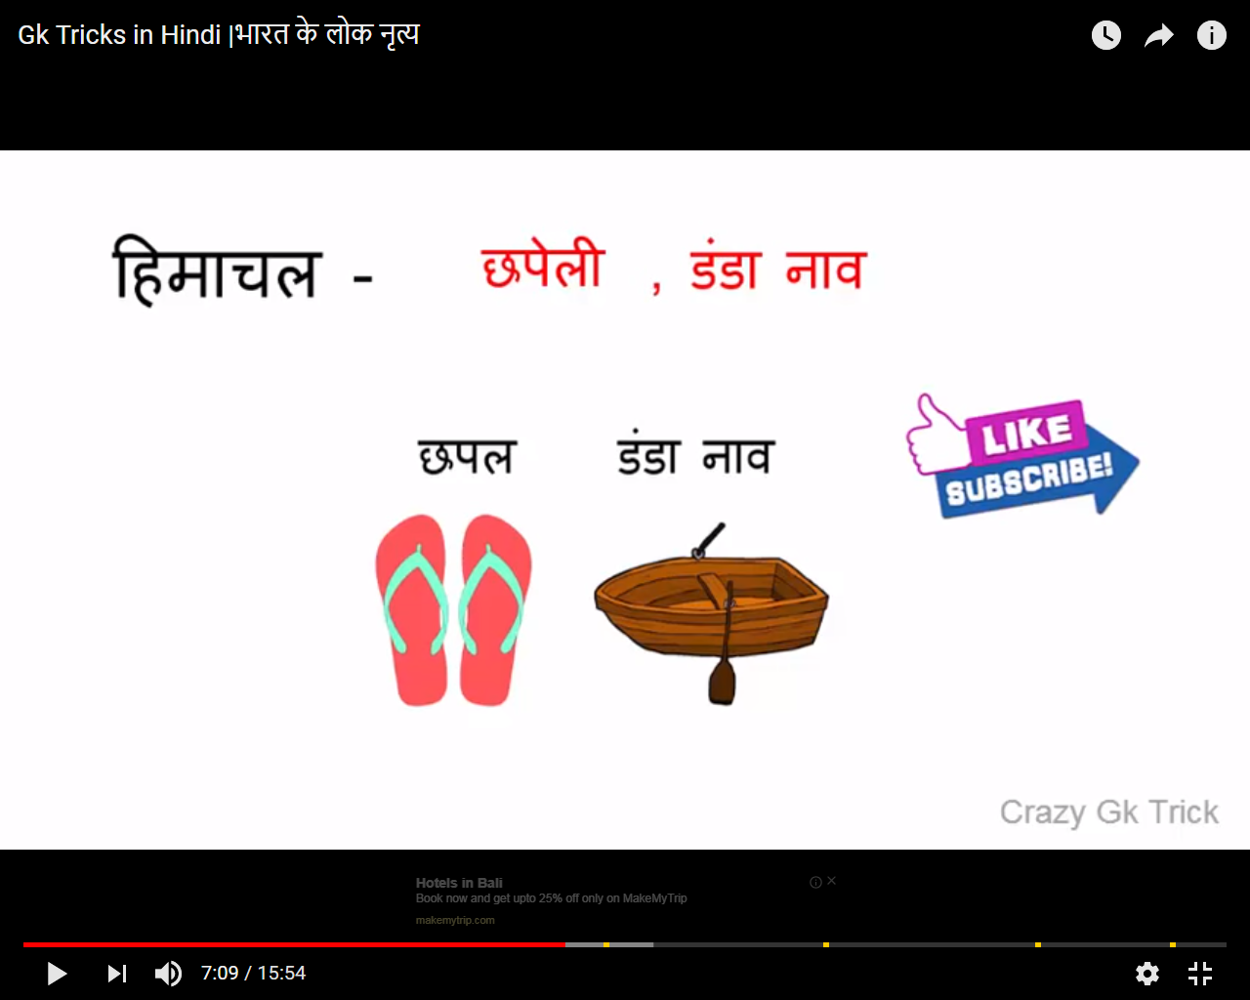

Chattisgarh-36 gadi

Odisha-Odessi

Maharastra-maharastra lao-Loudi

Meghalay-itni barrish ki gale tk paani aa gaya

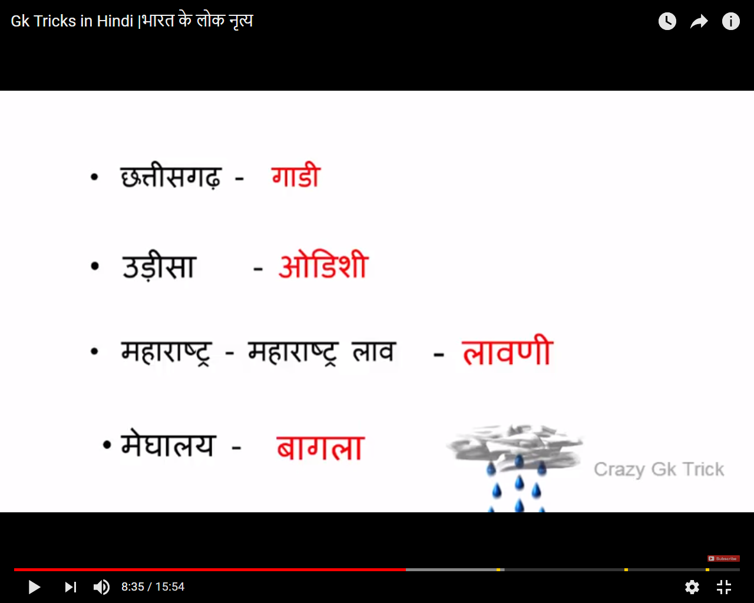

Uttarpardesh-bharat ke uttar me ek ladki hai jo raas lila dikhati hai,chore log nautaki dekne gaye.

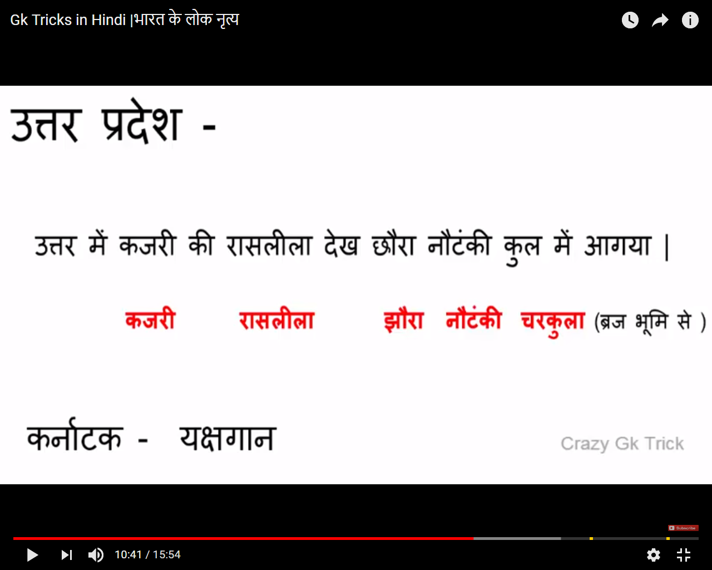

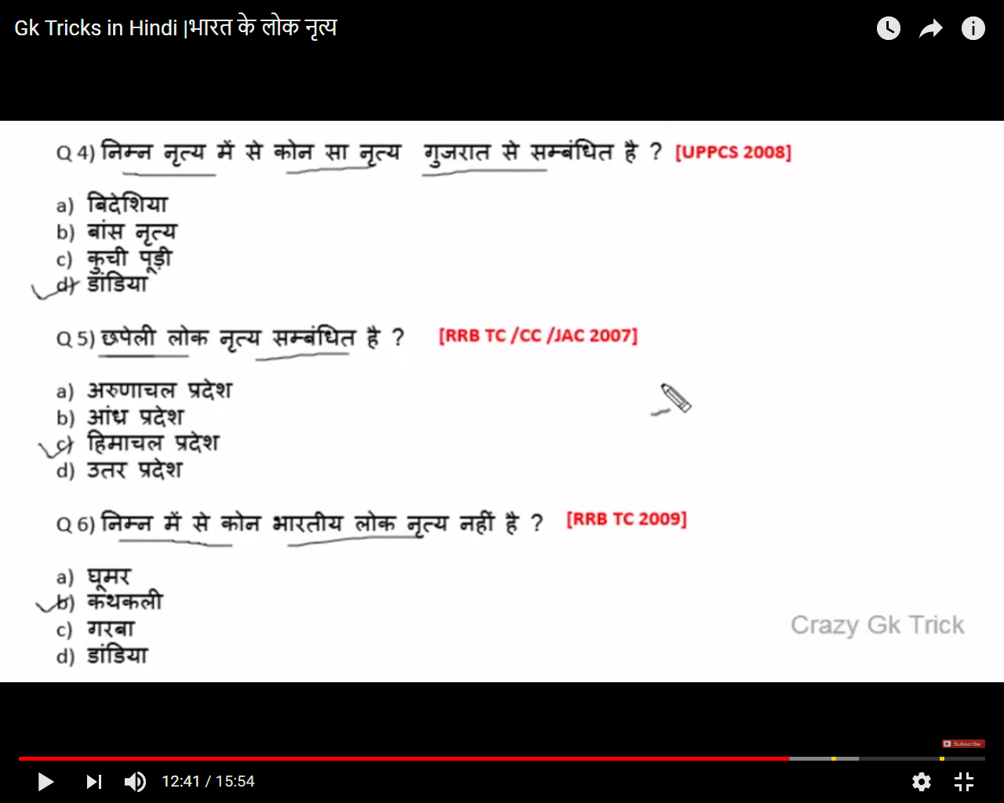

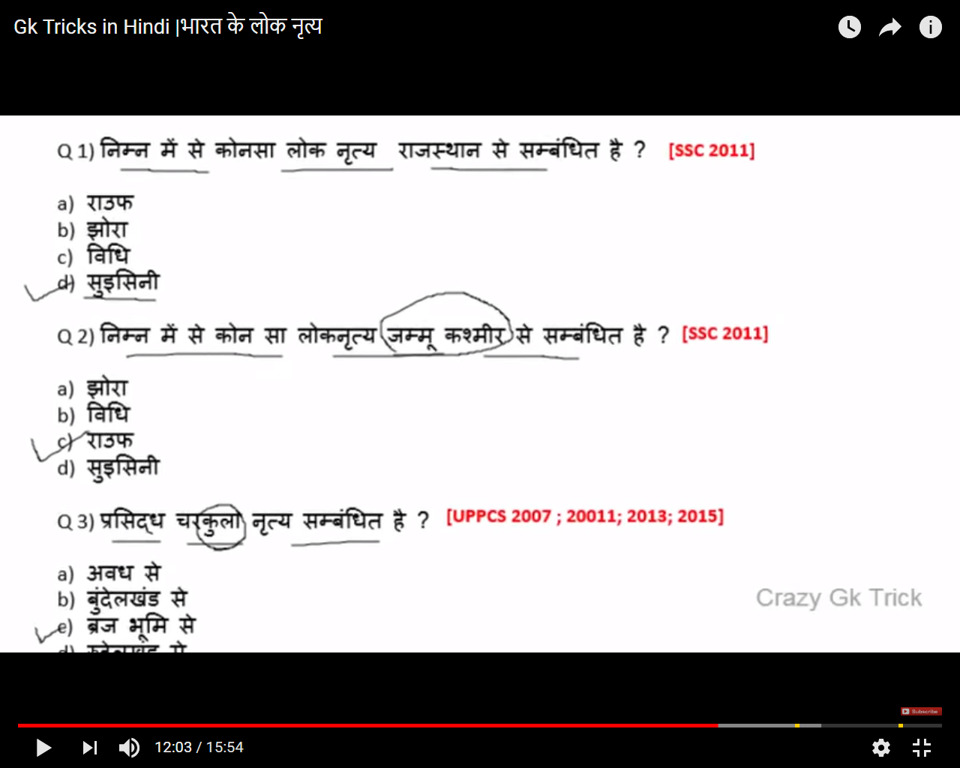

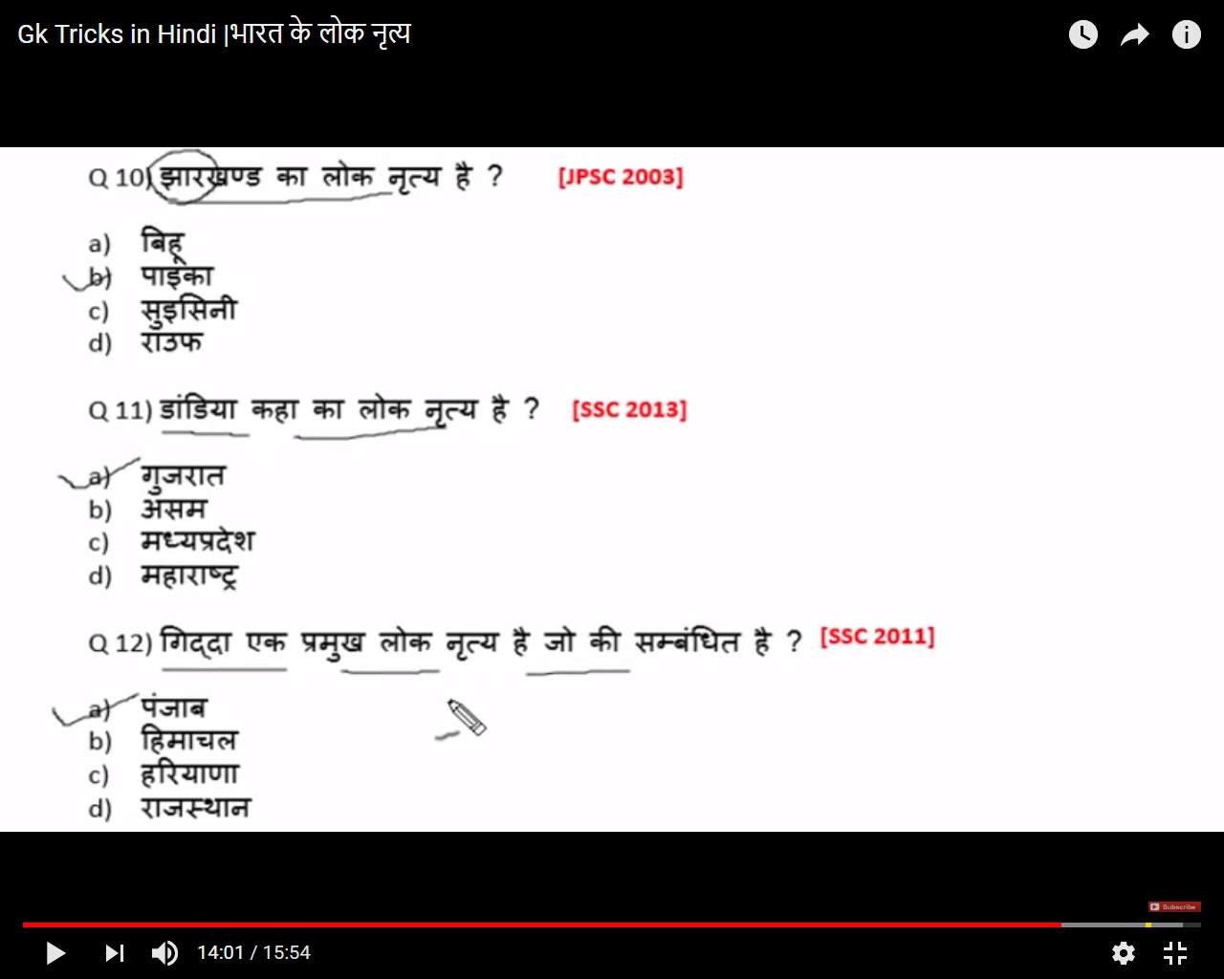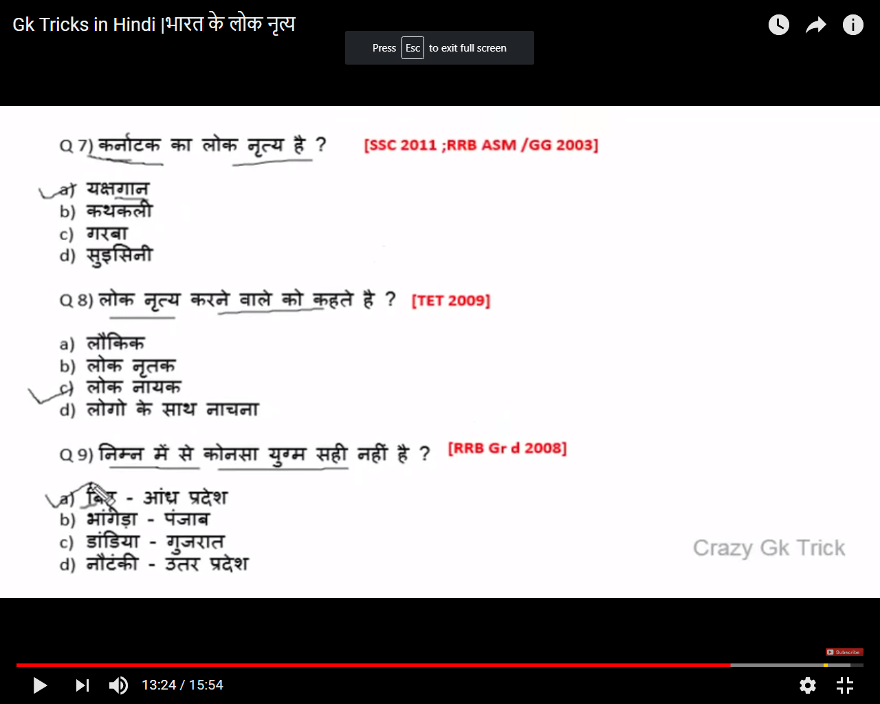

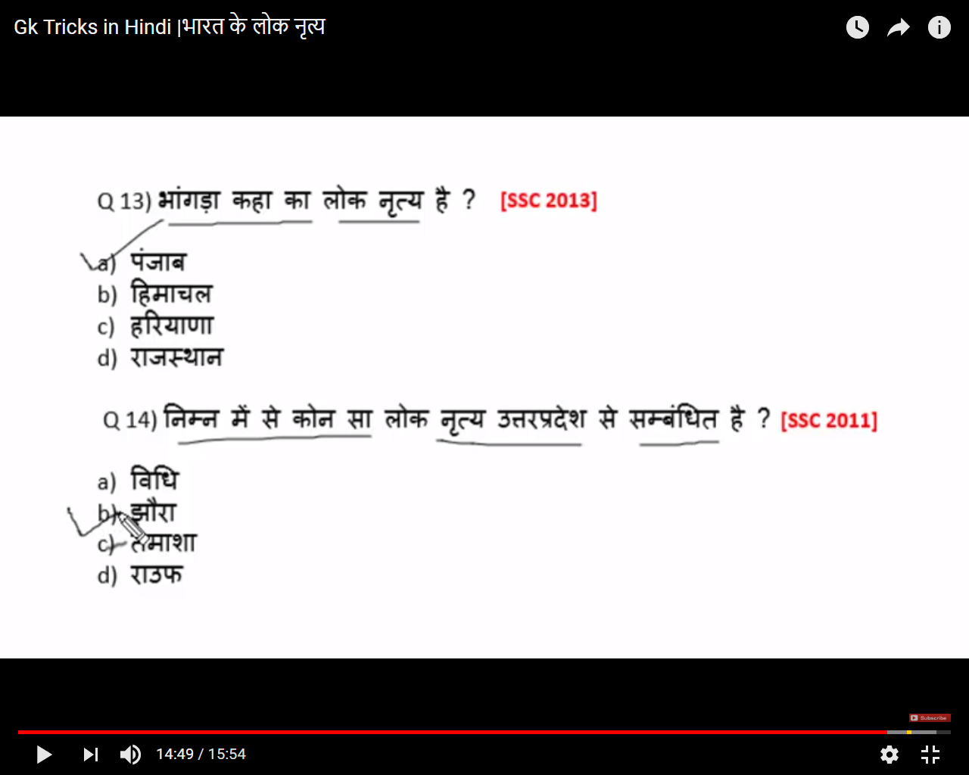

Shastri Dance.Natya

Bhrt Nadu ne gaan krke adhi poodi khake kathak mein uttar Diya

Kuchipudi -Dev Natya (pudi bhagawan ko chadhate hai)

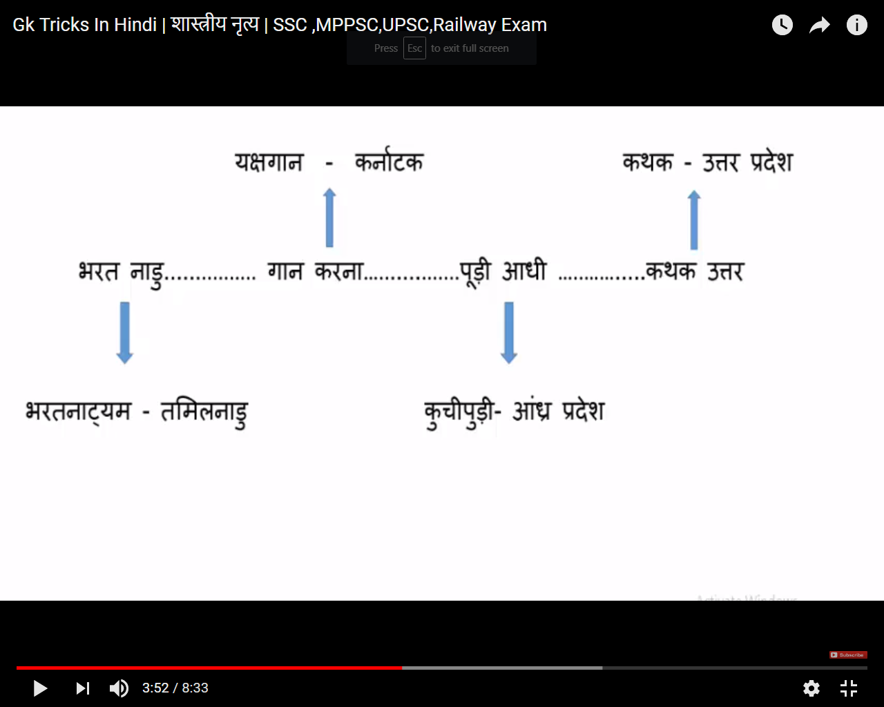

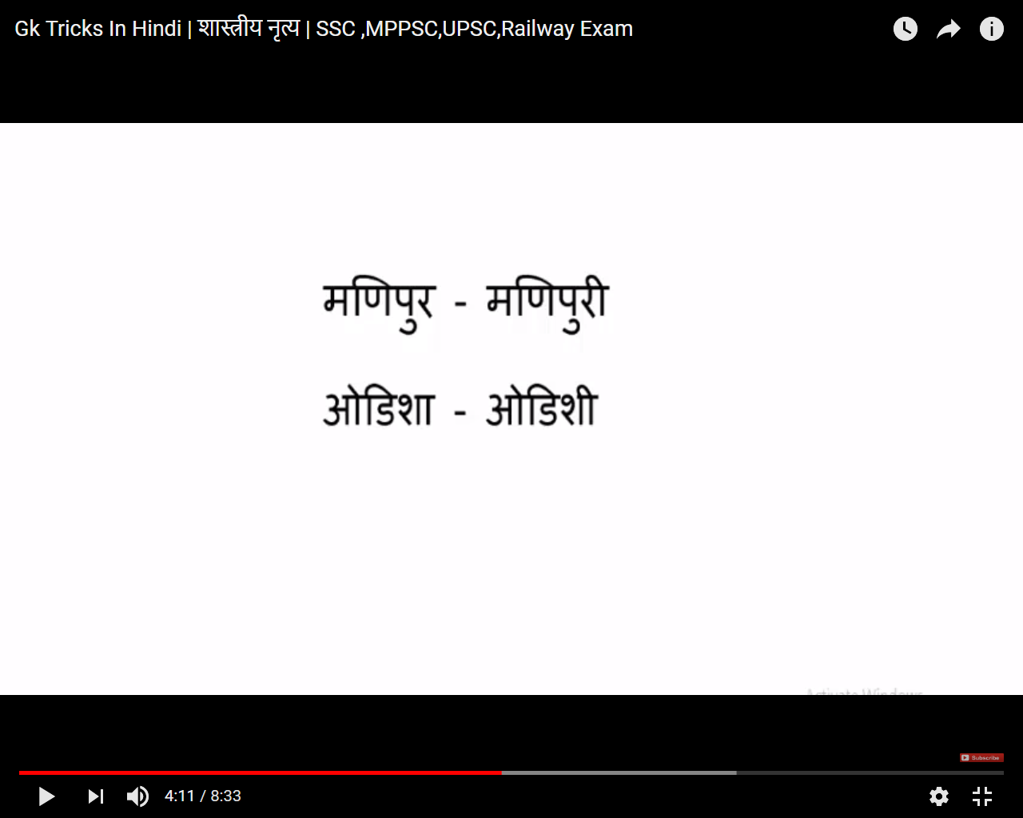

Keral->phool kali dulahan baalo me lagati hai

