WaterFalls

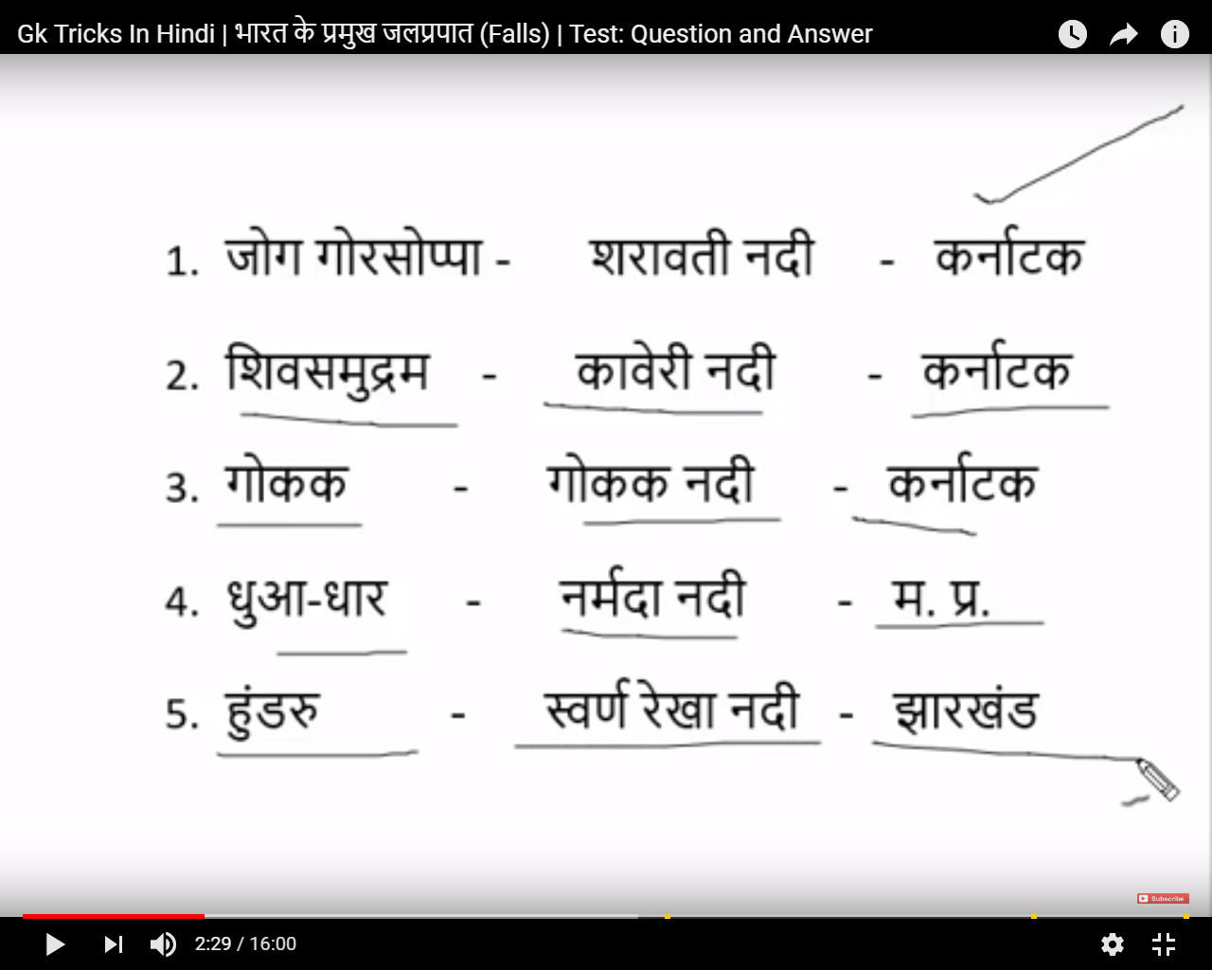

#jog ek sarabhi ko chipak gaya.Sarabi natak kr raha hai

Joga Falls Or Gerosoppa Falls - Sharavathi river -Karnataka

Highest water fall in india-Jog fal

Jog Fall-  [Mahatma Gandhi](https://en.wikipedia.org/wiki/Mahatma_Gandhi) Hydro-electric Project.

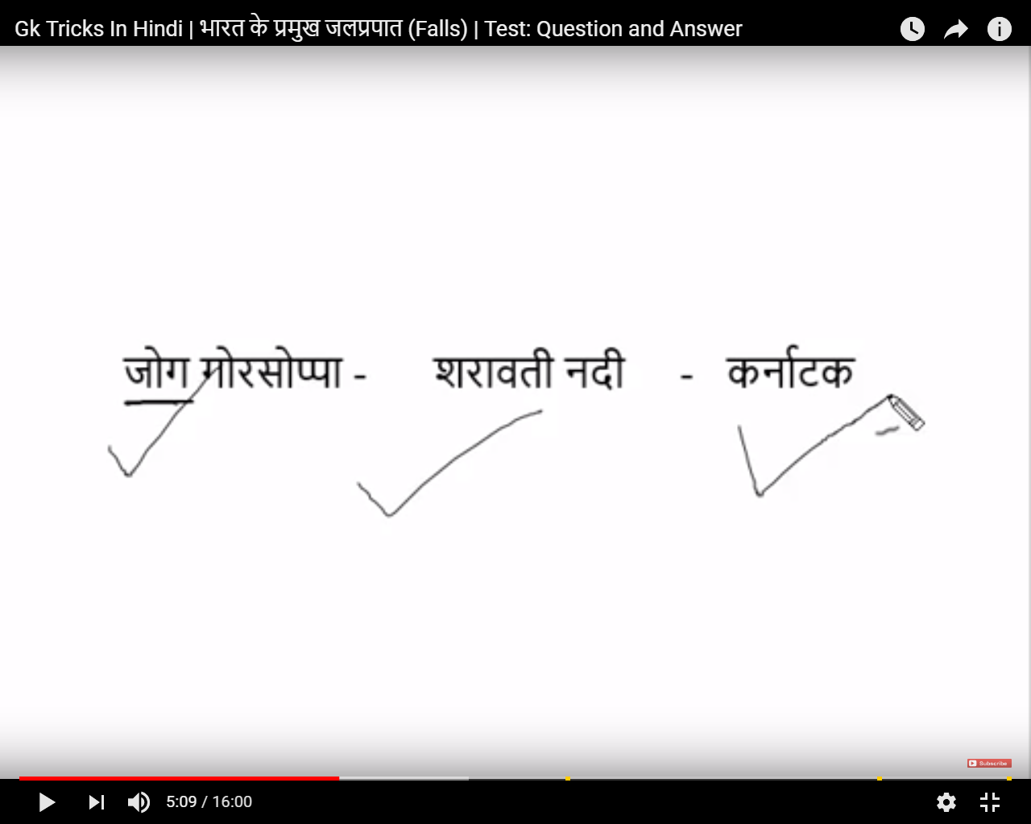

Shiv Samudra-samudra ka aaster varies (change) kr rha hai.

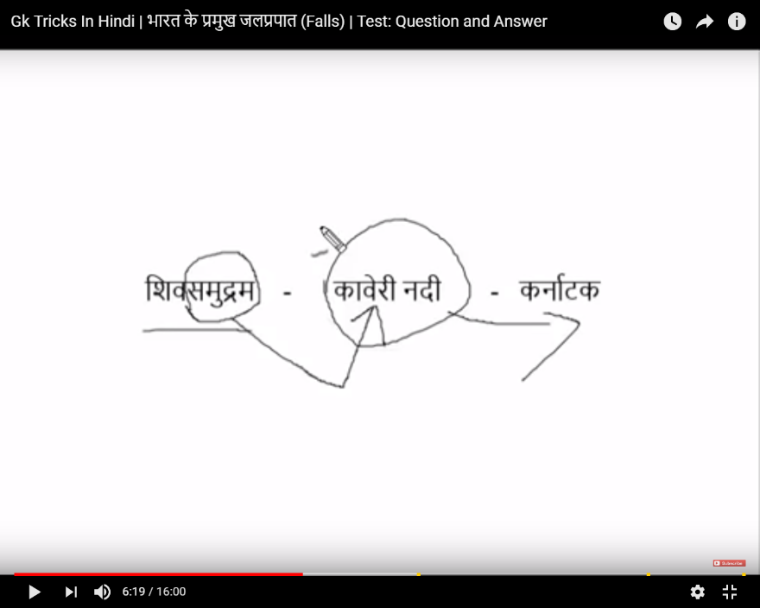

Dua Dhar -Dhar ek paani ki dhar jamin pe padi ,aapas ki lakdiya gilla ho gaya,ab lakadi naram hogaye.ab usme aag lagaya to duaa duaa ho gayaa.

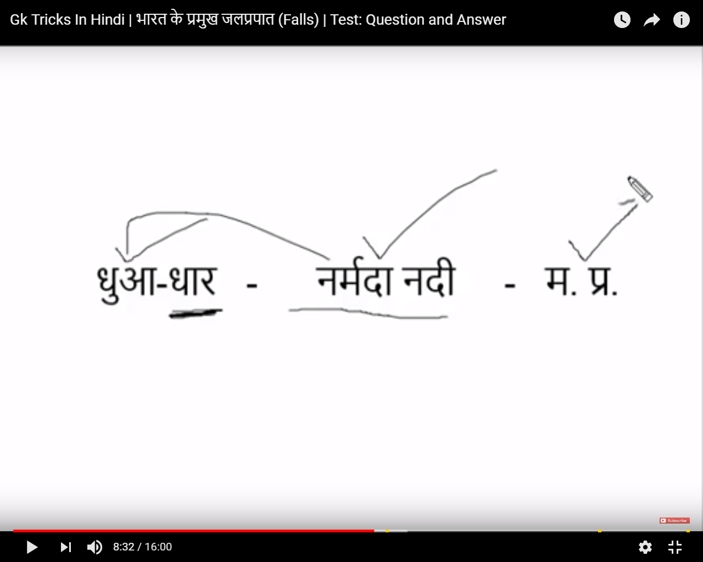

Hundru-hund related sund -hathi ki sund (sabse bada ).hathi ne sudh me paani bhara aur paani upper feka to jaran jaisa .sone kaa hathi jarane me ayaa.

Hundru -Rachi Jharkand

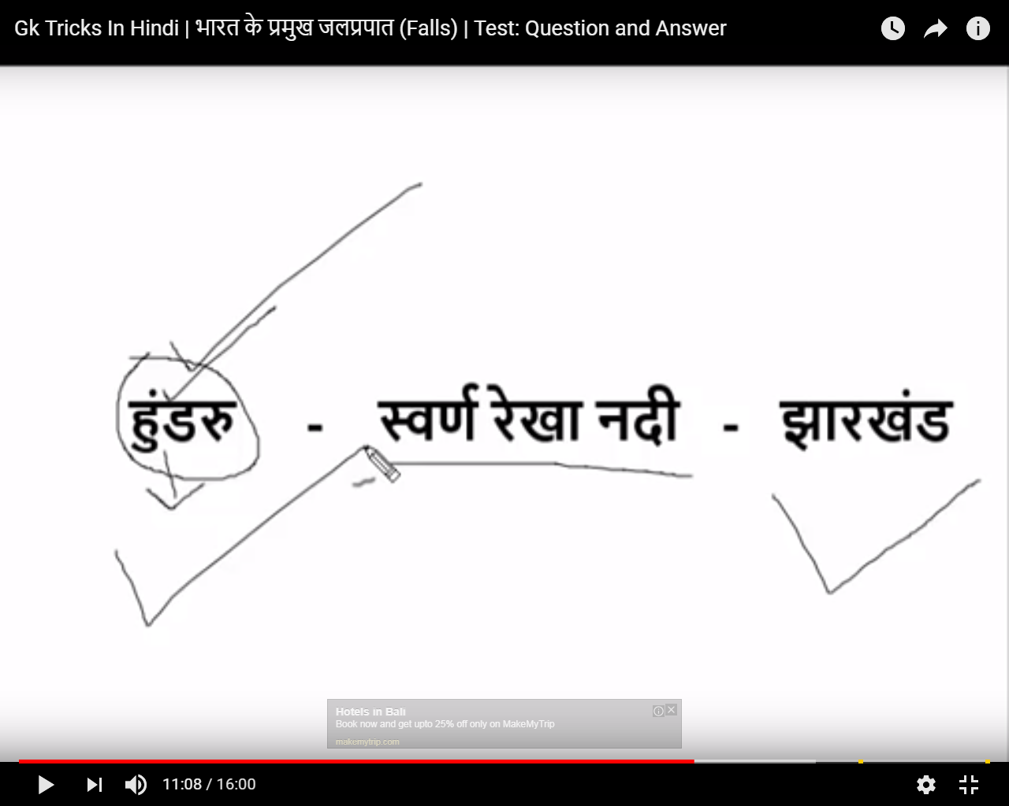

GOKAK-karnataka

