**Practical – 2**

**Aim:** Analyse effect of below given spatial domain techniques.

1. Histogram Matching
2. Logical operations on two images
3. Arithmetic operation on two images
4. **Aim:** Histogram Matching

**Code:**

clc

clear all

% read input image using imread() function

inImg1 = imread('Images\e12.tif');

inImg2 = imread('Images\e13.tif');

%Create matrix of 256*1 of all zeros

A = zeros(256,1,'uint8');

% Genrate histogram of both images

histImg1 = imhist(inImg1);

histImg2 = imhist(inImg2);

% Calculate S for all no. of pixel of histogram

S1 = cumsum(histImg1) / numel(inImg1);

S2 = cumsum(histImg2) / numel(inImg2);

for i = 1 : 256

[~,ind] = min(abs(S1(i) - S2)); %Calculate diff between each element of both image

A(i) = ind-1; %Assign value to created matrix

end

%Genrate Output Image

outImg = A(double(inImg1)+1);

subplot(2,3,1),imshow(inImg1);title('Input Image-1');

subplot(2,3,2),imshow(inImg2);title('Input Image-2');

subplot(2,3,3),imshow(outImg);title('Histogram matched Image');

subplot(2,3,4),imhist(inImg1);title('Histogram of Image-1');

subplot(2,3,5),imhist(inImg2);title('Histogram of Image-2');

subplot(2,3,6),imhist(outImg);title('Histogram of matched image');

**Input - Output:**

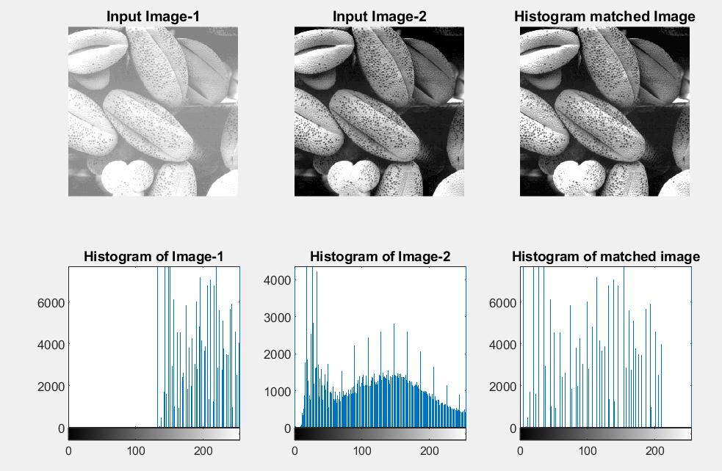

**Observation:**

Here we can see that through histogram matching we unify the contrast level of given two input images and generated histogram matched image.

1. **Aim:** Logical operations on two images

**Code:**

clc

clear all

% read input image using imread() function

inImg1 = imread('Images\Jaydip.jpg');

inImg2 = imread('Images\Jaydip1.jpg');

% Convert rgb image into gray

x = rgb2gray(inImg1);

y = rgb2gray(inImg2);

%Resize the image for bitwise operation

A = imresize(x,[256,256]);

B = imresize(y,[256,256]);

%Logical AND

and = bitand(A,B);

%Logical OR

or = bitor(A,B);

%Logical NOT

not1 = bitcmp(A);

not2 = bitcmp(B);

%Logical AND NOT

ans = bitand(A,not2);

%Logical AND XOR

xor = bitxor(A,B);

subplot(5,3,1),imshow(x);title('Input Image-1');

subplot(5,3,2),imshow(y);title('Input Image-2');

subplot(5,3,3),imshow(and);title('(Image-1) AND (Image-2)');

subplot(5,3,4),imshow(or);title('(Image-1) OR (Image-2)');

subplot(5,3,5),imshow(not1);title('NOT(Image-1)');

subplot(5,3,6),imshow(not2);title('NOT(Image-2)');

subplot(5,3,7),imshow(ans);title('(Image-1) AND (NOT(Image-2))');

subplot(5,3,8),imshow(xor);title('(Image-1) xor (Image-2)');

**Input - Output:**

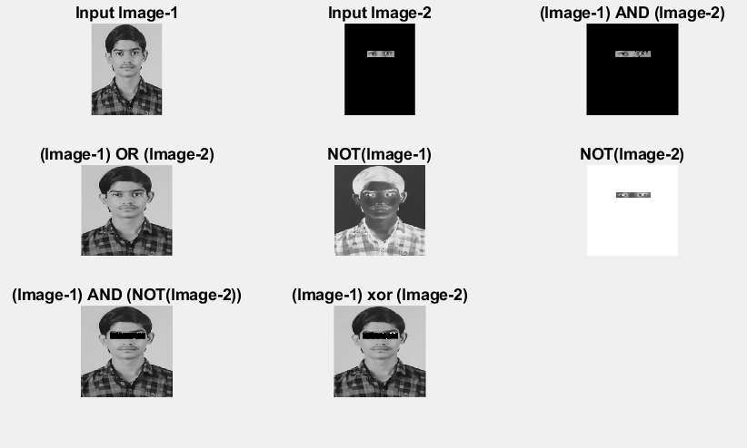

**Observation:**

Here we can see that by applying logical AND operation, common bright pixels of both images remains as it is and remaining pixel become dark. In logical OR operation both images brighter pixel merge. In Logical NOT operation bright pixels become dark and visa-versa. In logical XOR operation both images common bright pixels become dark and rest remain as it is.

1. **Aim:** Arithmetic operations on two images

**Code:**

clc

clear all

% read input image using imread() function

inImg1 = imread('Images\Jaydip.jpg');

inImg2 = imread('Images\Jaydip1.jpg');

% Convert rgb image into gray

x = rgb2gray(inImg1);

y = rgb2gray(inImg2);

%Resize the image for bitwise operation

A = imresize(x,[256,256]);

B = imresize(y,[256,256]);

%Addition

add = imadd(A,B);

%Subtraction

sub1 = imsubtract(A,B);

sub2 = imsubtract(B,A);

%Multiplication

A1 = im2double(A);

B1 = im2double(B);

mul = immultiply(A1,B1);

%Division

div1 = imdivide(A1,B1);

div2 = imdivide(B1,A1);

subplot(5,3,1),imshow(x);title('Input Image-1');

subplot(5,3,2),imshow(y);title('Input Image-2');

subplot(5,3,3),imshow(add);title('Image-1 + Image-2');

subplot(5,3,4),imshow(sub1);title('Image-1 - Image-2');

subplot(5,3,5),imshow(sub2);title('Image-2 - Image-1');

subplot(5,3,6),imshow(mul);title('Image-1 * Image-2');

subplot(5,3,7),imshow(div1);title('Image-1 / Image-2');

subplot(5,3,8),imshow(div2);title('Image-2 / Image-1');

**Input - Output:**

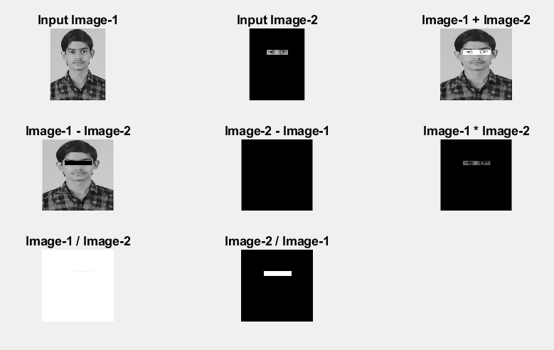

**Observation:**

Here we can see that after applying Add operation, eye part of second image overlaps in first parts eye part. In Subtract operation, common part of both images subtracted. In Multiplication NOT operation, common part of both images becomes little bit darker. In division operation, both images common part of both images become brighter.