**Practical – 6**

**Aim:** Read few noise images. Identify the noise present in them. Compare the result of image restoration on them.

**Code:**

clc;

clear all;

% read input image using imread() function

inImg = imread('Images\e25.tif');

%appling image restoration using Median filter

outImg = medfilt2(inImg);

subplot(3,2,1), imshow(inImg), title('Input Image');

%ploting histogram of input image

subplot(3,2,2), imhist(inImg), title('Input Image Histogram');

subplot(3,2,3), imshow(outImg), title('Image Restoration using Median Filter');

%ploting histogram of output image

subplot(3,2,4), imhist(outImg), title('Output Image Histogram');

**Output:**

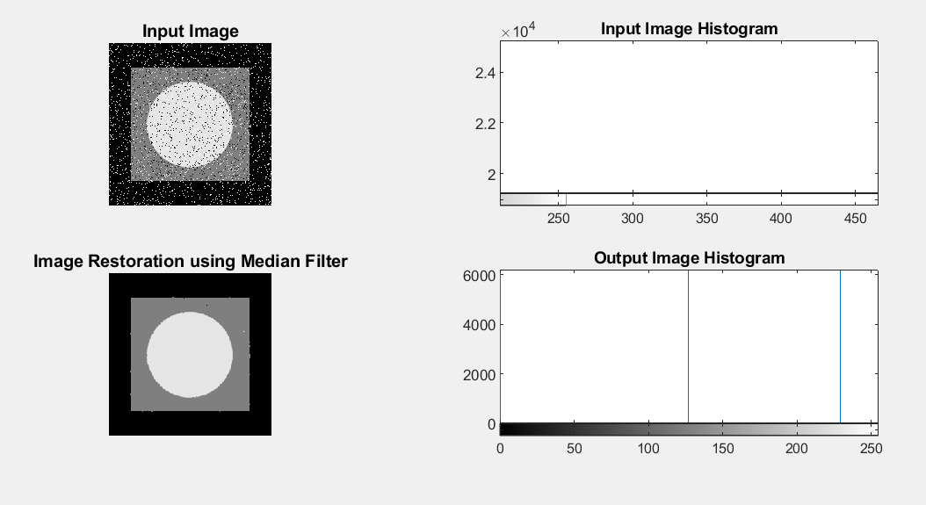

**Conclusion:**

By Performing this practical we get to know about different types of noise available in image and different technique to remove the noise from the image.