**Practical – 7**

**Aim:** Read RGB image and interchange blue and yellow colour (Colour image processing).

**Code:**

from matplotlib import pyplot as plt

from PIL import Image

import numpy as np

outputImg = Image.open("D:\\Study\\6th Sem\\DIP\\Practicals\\Images\\e6.png")

pix = outputImg.load()

n, m = outputImg.size

for i in range(1,n):

    for j in range(1,m):

        r, g, b, a = pix[i, j]

        # Check if blue colour pixel found then convert its pixel value to yellow color

        if r < 95 and g < 189 and b > 146:

            pix[i, j] = (225, 255, 0, a)

        # Check if yellow colour pixel found then convert its pixel value to blue color

        if r > 200 and g > 174 and b < 128:

            pix[i, j] = (0, 0, 255, a)

img1 = Image.open("D:\\Study\\6th Sem\\DIP\\Practicals\\Images\\e6.png")

img2 = outputImg

# I.show()

w = 10

h = 10

fig = plt.figure(figsize=(8, 8))

columns = 2

rows = 1

# for i in range(1, columns*rows +1):

# img = np.random.randint(10, size=(h,w))

# show input plot

fig.add_subplot(rows, columns, 1)

plt.imshow(img1)

plt.axis('off')

plt.title('Input Image')

# show output plot

fig.add_subplot(rows, columns, 2)

plt.imshow(img2)

plt.axis('off')

plt.title('Output Image')

plt.show()

**Output:**

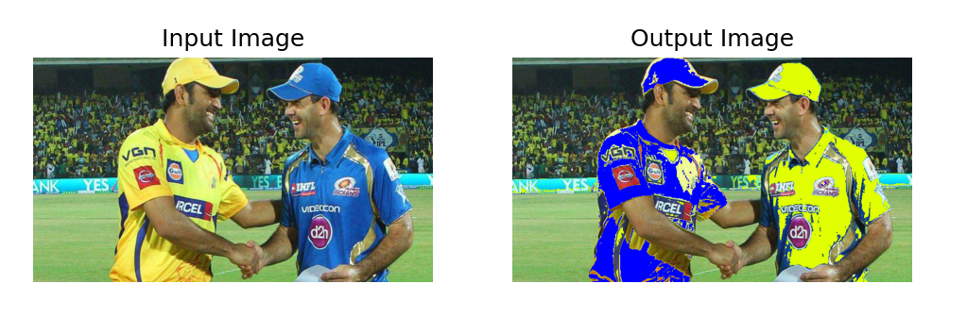

**Conclusion:**

By Performing this practical we get to know how we can process colour image using different libraries in python.