**Practical – 8**

**Aim:** Implement colour-based image classification. (Minimum three classes and minimum three classification algorithms have to use.) Compare the result of applied classification algorithms.

**Code:**

clc;

clear;

res = zeros(40,4);

% Processing Grape Images

for a = 1:20

path = strcat('images/grapes',string(a),'.jpg');

img = imread(path);

[m,n,k] = size(img);

% Calculate average of pixel value

for i = 1:k

sum = 0;

for j = 1:m

for k = 1:n

sum = sum + double(img(j,k,i));

end

end

sum = sum/(n*m);

res(a,i) = sum;

end

res(a,4) = 0;

end

% Processing apple Images

for a = 21:40

path = strcat('images/apples',string(a-20),'.jpg');

img = imread(path);

[m,n,k] = size(img);

% Calculate average of pixel value for each plane

for i = 1:k

sum = 0;

for j = 1:m

for k = 1:n

sum = sum + double(img(j,k,i));

end

end

sum = sum/(n*m);

res(a,i) = sum;

end

% Classifying Apples as 1

res(a,4) = 1;

end

% Writing table to worksheet

writematrix(res,"data.xlsx");

Classes: 0 = Grapes, 1 = Apples

Features: Red, Green, Blue (Average pixel value for each plane)

**Output:**

* **Selected Images**

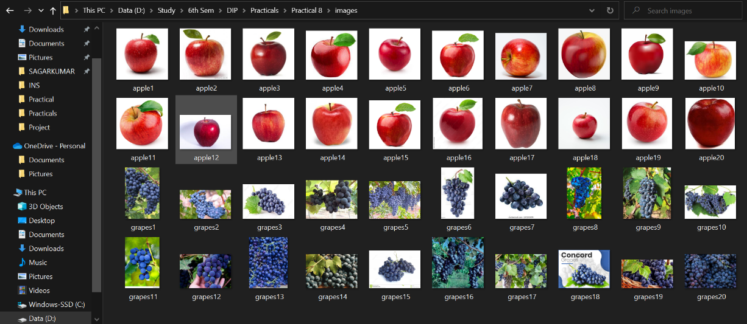

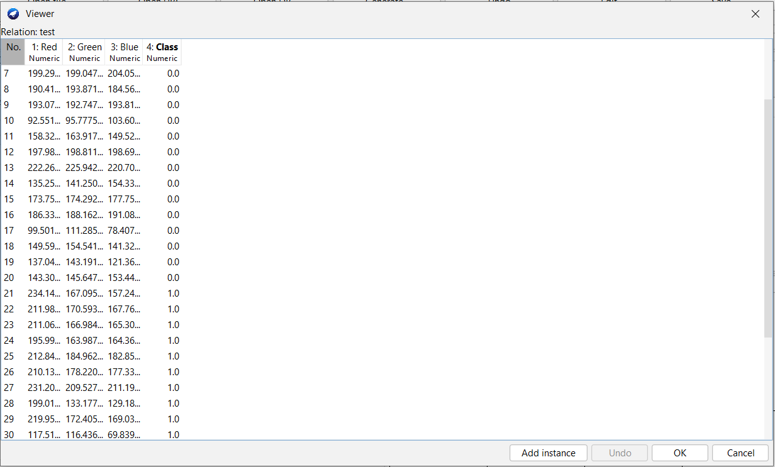

* **Selected Test Images:**

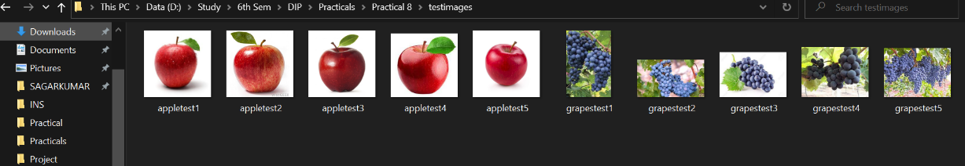

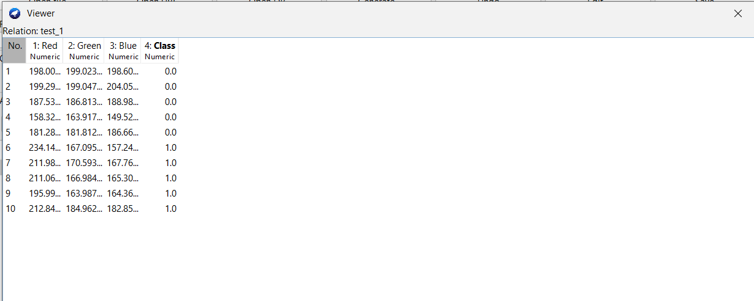

* **Weka Pre-processing (Load CSV File)**

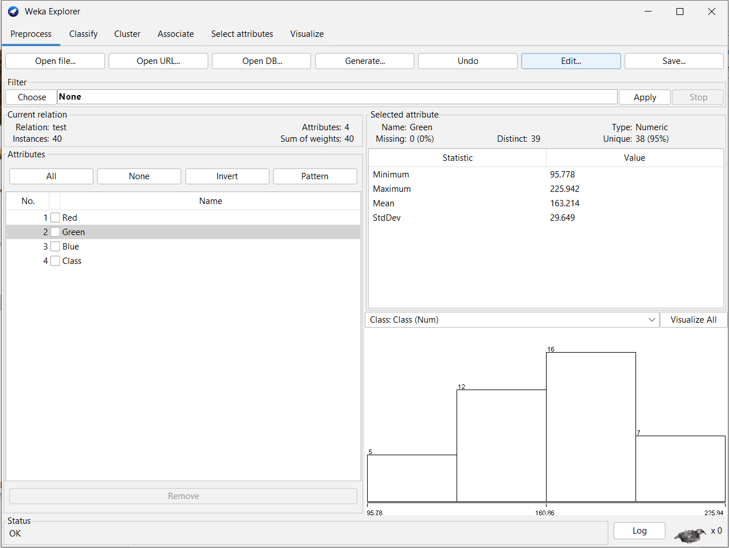

* **Random Tree Algorithm for Classification**

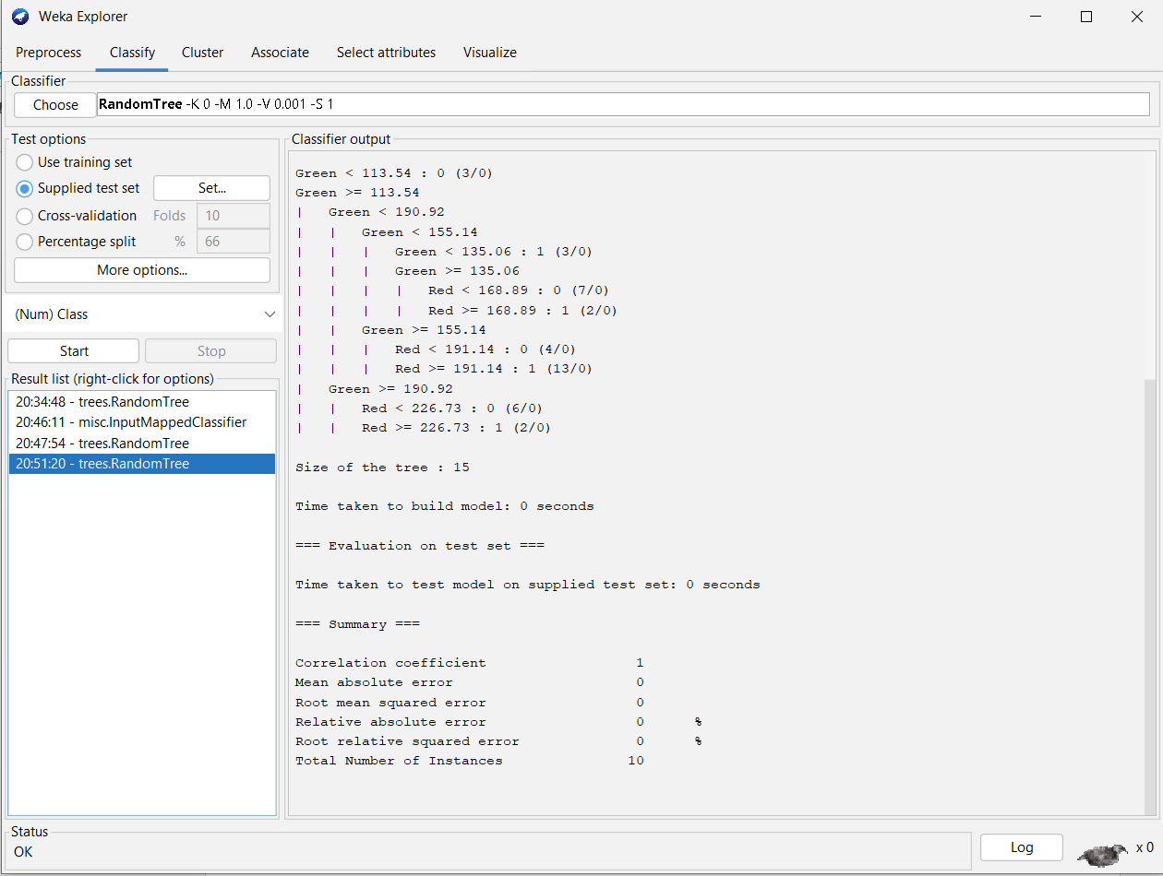

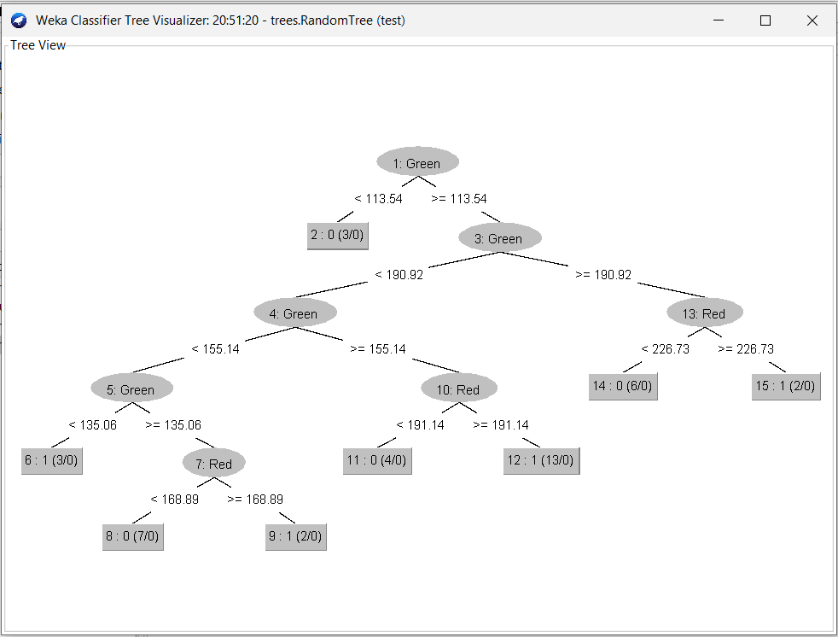

* **Linear Regression Algorithm for Classification**

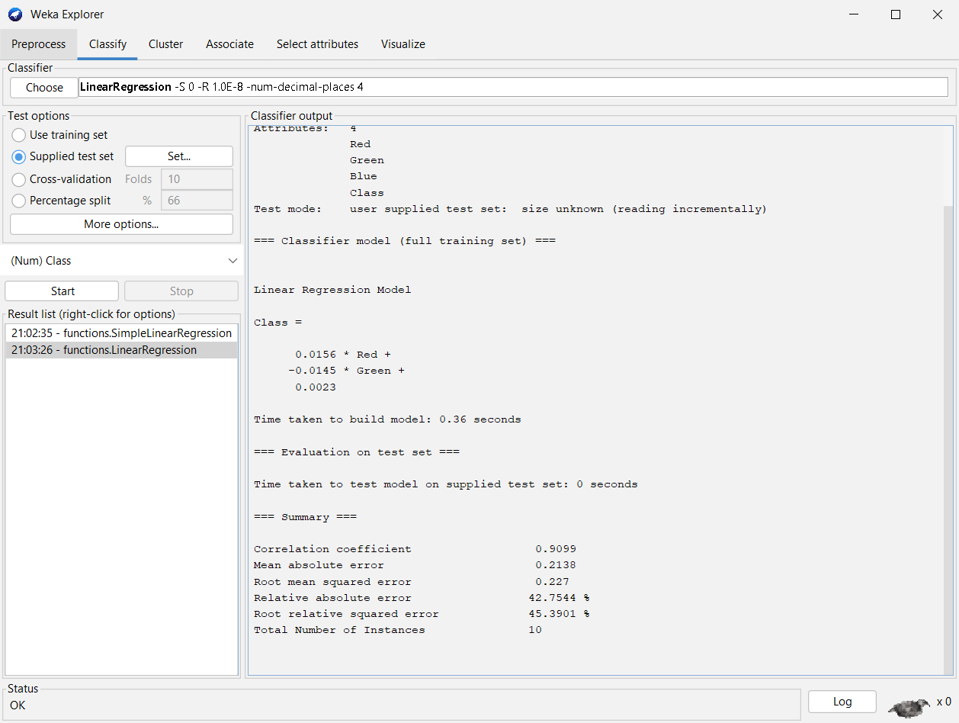

**Conclusion:**

By Performing this practical we get to know how we can implement colour-based image classification using average pixel value of images.