**Practical – 5**

**Aim:** Implement RLE (Run length Encoding) Algorithm**.**

**Encoding:**

clc

clear all;

inImg = imread("Images\prac5.bmp");

[row,col] = size(inImg);

rle = [];

rle(1) = row;

rle(2) = col;

Intensity = inImg(1,1);

k = 3;

count = 0;

for j = 1:col

for i = 1:row

if inImg(i,j) == Intensity

count = count + 1;

else

rle(k) = Intensity;

Intensity = inImg(i,j);

rle(k+1) = count;

count = 1;

k = k+2;

end

end

end

rle(k) = Intensity;

rle(k+1) = count;

save("prac5Comp");

**Decoding:**

close all;

clc;

clear all;

load("prac5Comp.mat");

row = rle(1);

col = rle(2);

outImg = zeros(row, col);

Intensity = rle(3);

count = rle(4);

k = 3;

[x,y] = size(rle);

for j = 1:col

for i = 1:row

outImg(i,j) = Intensity;

count = count - 1;

if count == 0

k = k+2;

if k > y

break;

end

Intensity = rle(k);

count = rle(k+1);

end

end

end

outImg = uint8(outImg);

subplot(1,2,1),imshow(inImg),title("Input");

subplot(1,2,2),imshow(outImg),title("Output");

**Input - Output:**

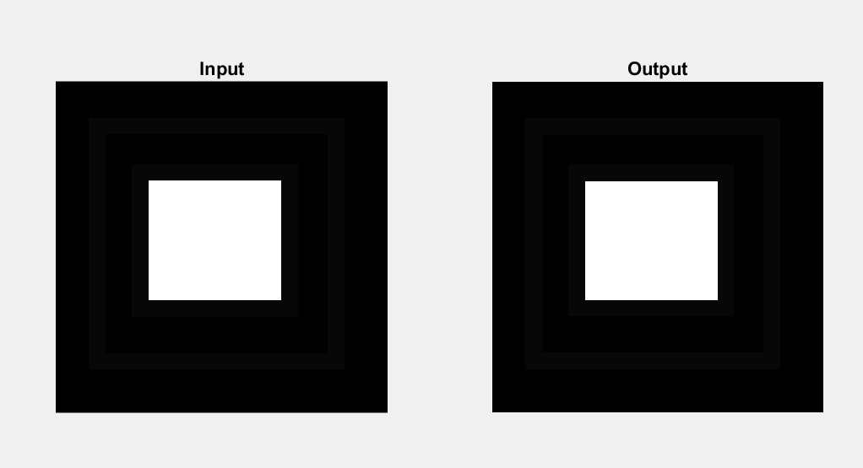

**Observation:**

By performing this practical we can see that after RLE encoding algorithm applying on image we get the compressed image of input image without any loss of data of input image and by applying decoding algorithm we get exact same image of input image.