COMP 141: Haskell — Part 2

*Instructions:* In this exercise, we are going to review a bunch of Haskell structures.

1. Use !! to define function second that returns the second item of the input list.

1. Use head and tail to define function second1 that returns the second item of the input list.

1. Use !! to define function fourth that returns the fourth item of the input list.

1. Use head and tail to define function fourth1 that returns the fourth item of the input list.

1. Define function secondFromLast that receives a list and returns the second element from last. Use !! infix operator and length function.

1. Define function secondFromLast1 that receives a list and returns the second element from last. Use last and init functions.

1. Use !! and length to define function nthFromLast that receives a number n and a list, and returns nth item of the list from last. For example, nthFromLast 3 [1..7] must return 5.

1. Define function secondHalf that receives a list, cuts it in half, and returns the second half. For example, if the input is [1,2,3,4], then the output would be [3,4].

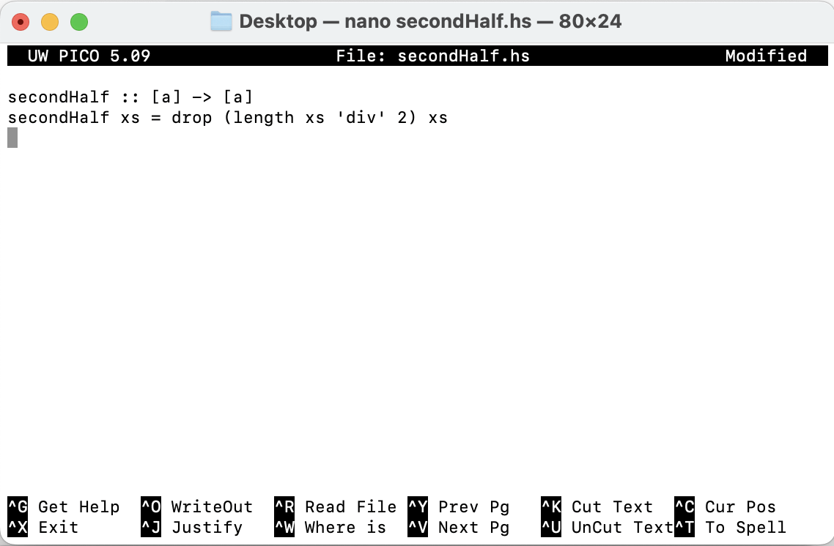

1. Remember that xs !! n returns the nth element of list xs. Let’s define our own version of operator

!!, called atIndex, e.g., atIndex 3 [1,2,3,4,5,6] must return 4. Use take and last functions to define atIndex function.

1. Define function trimList that receives a list and removes the first and last elements of that list. For example, if the input is "abcdef", then the output is "bcde". Define the function, using take and drop functions.

1. Use take and length to define function firstQ that receives a list as input and returns the first quarter of it. For example, if the input is [1..20] then the output would be [1,2,3,4,5].

