<country>
<language of test>
CCC Questionnaire

School Name
Student ID
Student Name
Family Name
Given Name
Date of Birth
/ / 198
Day
Month
Year
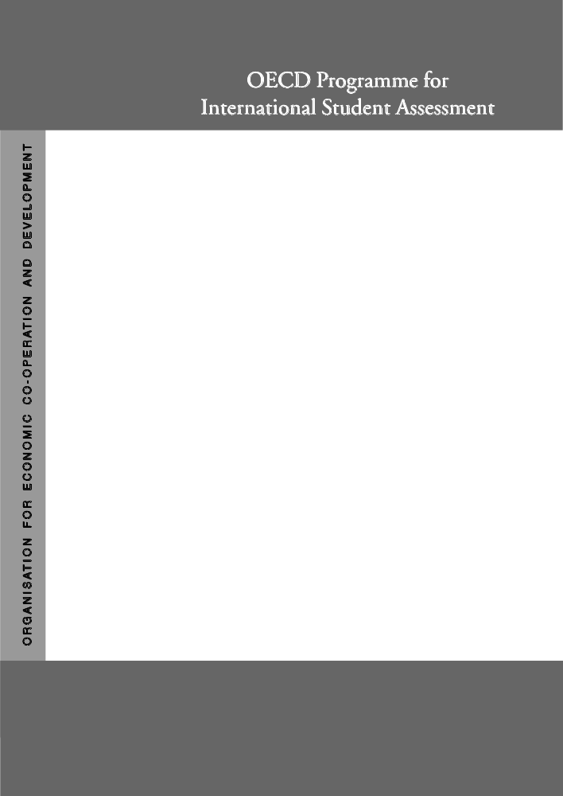

Project Consortium:
Australian Council for Educational Research (ACER)
Netherlands National Institute for Educational Measurement (CITO)
Educational Testing Service (ETS, USA)
National Institute for Educational Research (NIER, Japan)
Westat (USA)

CC01Q01  CC01Q02  CC01Q03  CC01Q04  CC01Q05  CC01Q06  CC01Q07  CC01Q08  CC01Q09  CC01Q10  CC01Q11  CC01Q12  CC11Q13  CC11Q14  CC01Q15  CC01Q16  CC01Q17  CC01Q18 | Q1 How often do these things apply to you?  (Please <tick> only one box on each row.)  Almost Almost  Never Sometimes Often always  - When I study, I try to memorise everything  that might be covered. ₁ ₂ ₃ ₄  - I’m certain I can understand the most difficult  material presented in texts. ₁ ₂ ₃ ₄  - When I study, I start by figuring out exactly  what I need to learn. ₁ ₂ ₃ ₄  - When I sit myself down to learn something  really difficult, I can learn it. ₁ ₂ ₃ ₄  - When I study, I memorise as much as possible. ₁ ₂ ₃ ₄  - I study to increase my job opportunities. ₁ ₂ ₃ ₄  - When studying, I work as hard as possible. ₁ ₂ ₃ ₄  - I’m confident I can understand the most  complex material presented by the teacher. ₁ ₂ ₃ ₄  - When I study, I try to relate new material to  things I have learned in other subjects. ₁ ₂ ₃ ₄  - When I study, I memorise all new material  so that I can recite it. ₁ ₂ ₃ ₄  - If I decide not to get any bad grades, I can  really do it. ₁ ₂ ₃ ₄  - When studying, I keep working even if the  material is difficult. ₁ ₂ ₃ ₄  - When I study, I force myself to check to see  if I remember what I have learned. ₁ ₂ ₃ ₄  - I study to ensure that my future will be  financially secure. ₁ ₂ ₃ ₄  - When I study, I practise by saying the  material to myself over and over. ₁ ₂ ₃ ₄  - If I decide not to get any problems wrong,  I can really do it. ₁ ₂ ₃ ₄  - When I study, I figure out how the  information might be useful in the real world. ₁ ₂ ₃ ₄  - I’m confident I can do an excellent job on  assignments and tests. ₁ ₂ ₃ ₄

CC01Q19  CC01Q20  CC01Q21  CC01Q22  CC01Q23  CC01Q24  CC01Q25  CC01Q26  CC01Q27  CC01Q28 | Almost Almost  Never Sometimes Often always  - When I study, I try to figure out which  concepts I still haven’t really understood. ₁ ₂ ₃ ₄  - When studying, I try to do my best to acquire  the knowledge and skills taught. ₁ ₂ ₃ ₄  - When I study, I try to understand the material  better by relating it to things I already know. ₁ ₂ ₃ ₄  - I study to get a good job. ₁ ₂ ₃ ₄  - When I study, I make sure that I remember  the most important things. ₁ ₂ ₃ ₄  - If I want to learn something well, I can. ₁ ₂ ₃ ₄  - When I study, I figure out how the material  fits in with what I have already learned. ₁ ₂ ₃ ₄  - I’m certain I can master the skills being taught. ₁ ₂ ₃ ₄  - When I study, and I don’t understand something  I look for additional information to clarify this. ₁ ₂ ₃ ₄  - When studying, I put forth my best effort. ₁ ₂ ₃ ₄

CC02Q01  CC02Q02  CC02Q03  CC02Q04  CC02Q05  CC02Q06  CC02Q07  CC02Q08  CC02Q09  CC02Q10 | Q2 How much do you disagree or agree with each of the following?  (Please <tick> only one box on each row.)  Disagree Agree  Disagree Somewhat Somewhat Agree  - When I do mathematics, I sometimes get totally  absorbed. ₁ ₂ ₃ ₄  - I like to work with other students. ₁ ₂ ₃ ₄  - I learn things quickly in most school subjects. ₁ ₂ ₃ ₄  - I like to try to be better than other students. ₁ ₂ ₃ ₄  - I’m hopeless in <test language> classes. ₁ ₂ ₃ ₄  - Because reading is fun, I wouldn’t want to  give it up. ₁ ₂ ₃ ₄  - I’m good at most school subjects. ₁ ₂ ₃ ₄  - I learn most when I work with other students. ₁ ₂ ₃ ₄  - I learn things quickly in <test language> class. ₁ ₂ ₃ ₄  - Because doing mathematics is fun, I wouldn’t  want to give it up. ₁ ₂ ₃ ₄

CC02Q11  CC02Q12  CC02Q13  CC02Q14  CC02Q15  CC02Q16  CC02Q17  CC02Q18  CC02Q19  CC02Q20  CC02Q21  CC02Q22  CC02Q23  CC02Q24 | Disagree Agree  Disagree Somewhat Somewhat Agree  - Trying to be better than others makes me  work well. ₁ ₂ ₃ ₄  - I get good marks in mathematics. ₁ ₂ ₃ ₄  - I read in my spare time. ₁ ₂ ₃ ₄  - I do my best work when I work with other  students. ₁ ₂ ₃ ₄  - Mathematics is one of my best subjects. ₁ ₂ ₃ ₄  - I would like to be the best at something. ₁ ₂ ₃ ₄  - When I read, I sometimes get totally absorbed. ₁ ₂ ₃ ₄  - I have always done well in mathematics. ₁ ₂ ₃ ₄  - I like to help other people do well in a group. ₁ ₂ ₃ ₄  - I do well in tests in most school subjects. ₁ ₂ ₃ ₄  - Mathematics is important to me personally. ₁ ₂ ₃ ₄  - It is helpful to put together everyone’s  ideas when working on a project. ₁ ₂ ₃ ₄  - I get good marks in <test language>. ₁ ₂ ₃ ₄  - I learn faster if I’m trying to do better  than the others. ₁ ₂ ₃ ₄

