**Create Project and Up the Server**

**Step0:**

Go to your working directory (QABD_REST_API folder) and run all steps here.

**Step1:**

Have to create virtual environment for this backend project, CMD:

pip install pipenv

pipenv shell

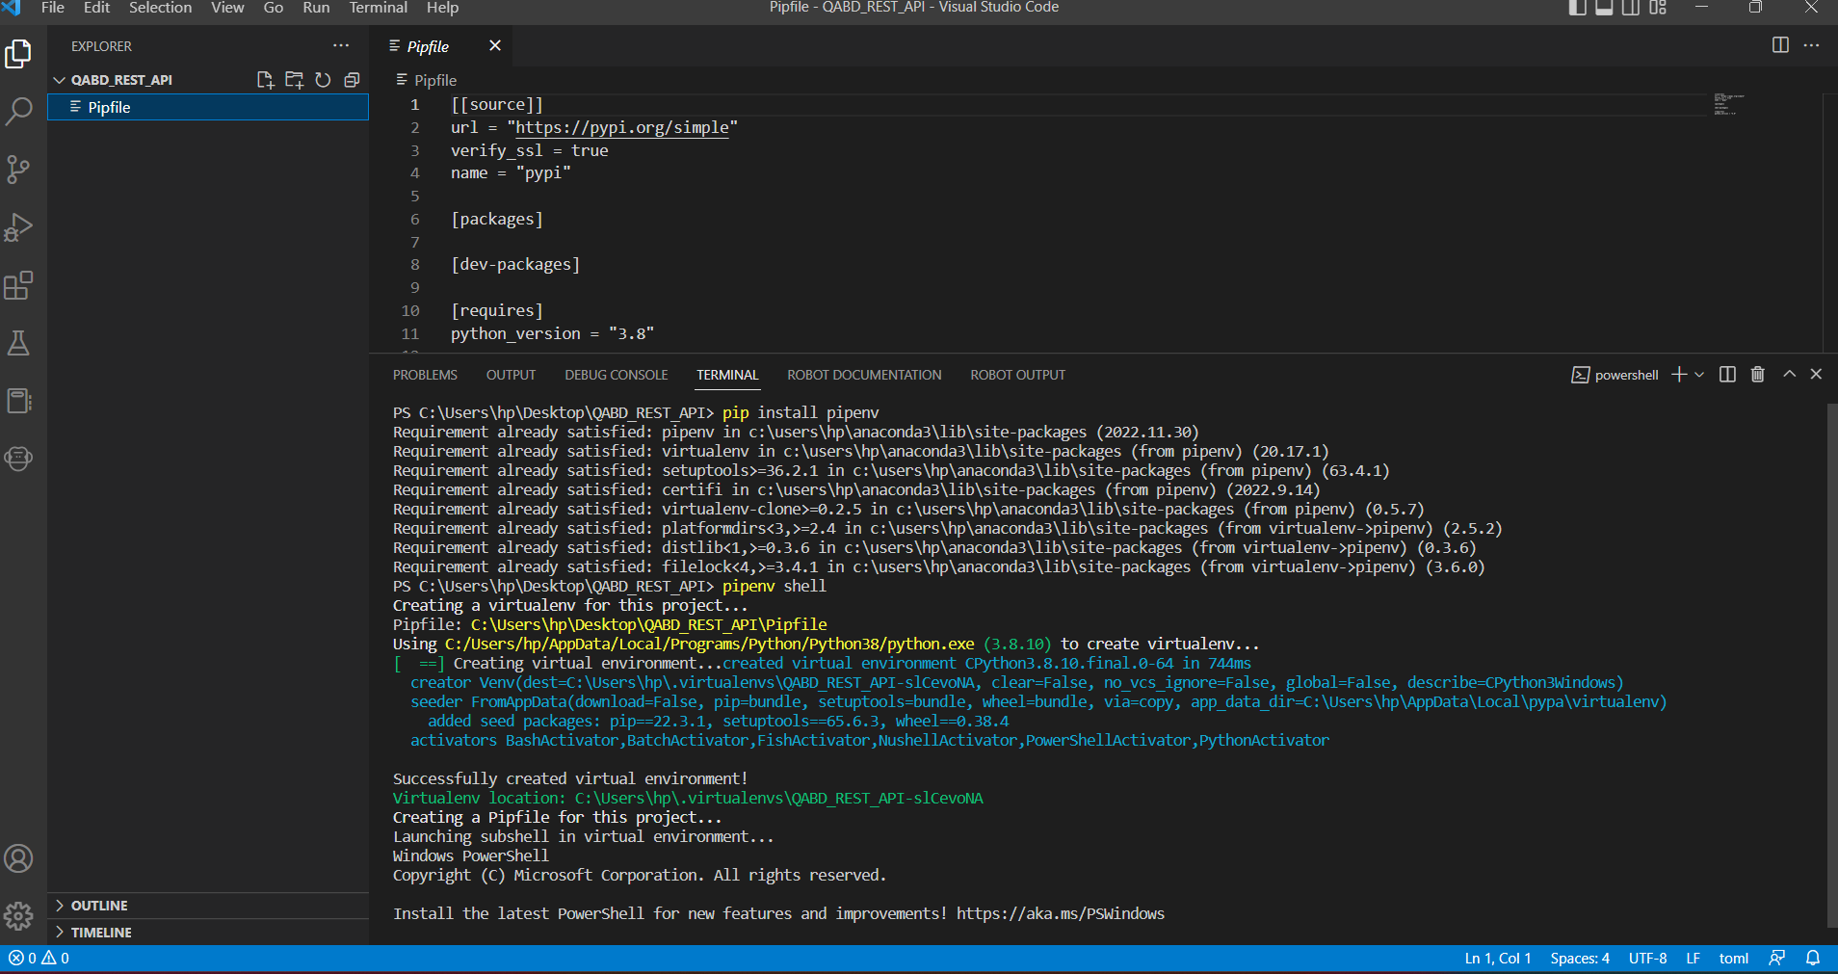

**Step2:**

Open Pipfile and verify the python version

[requires]

python_version = "3.8"

**Step3:** CMD:

pipenv install django djangorestframework

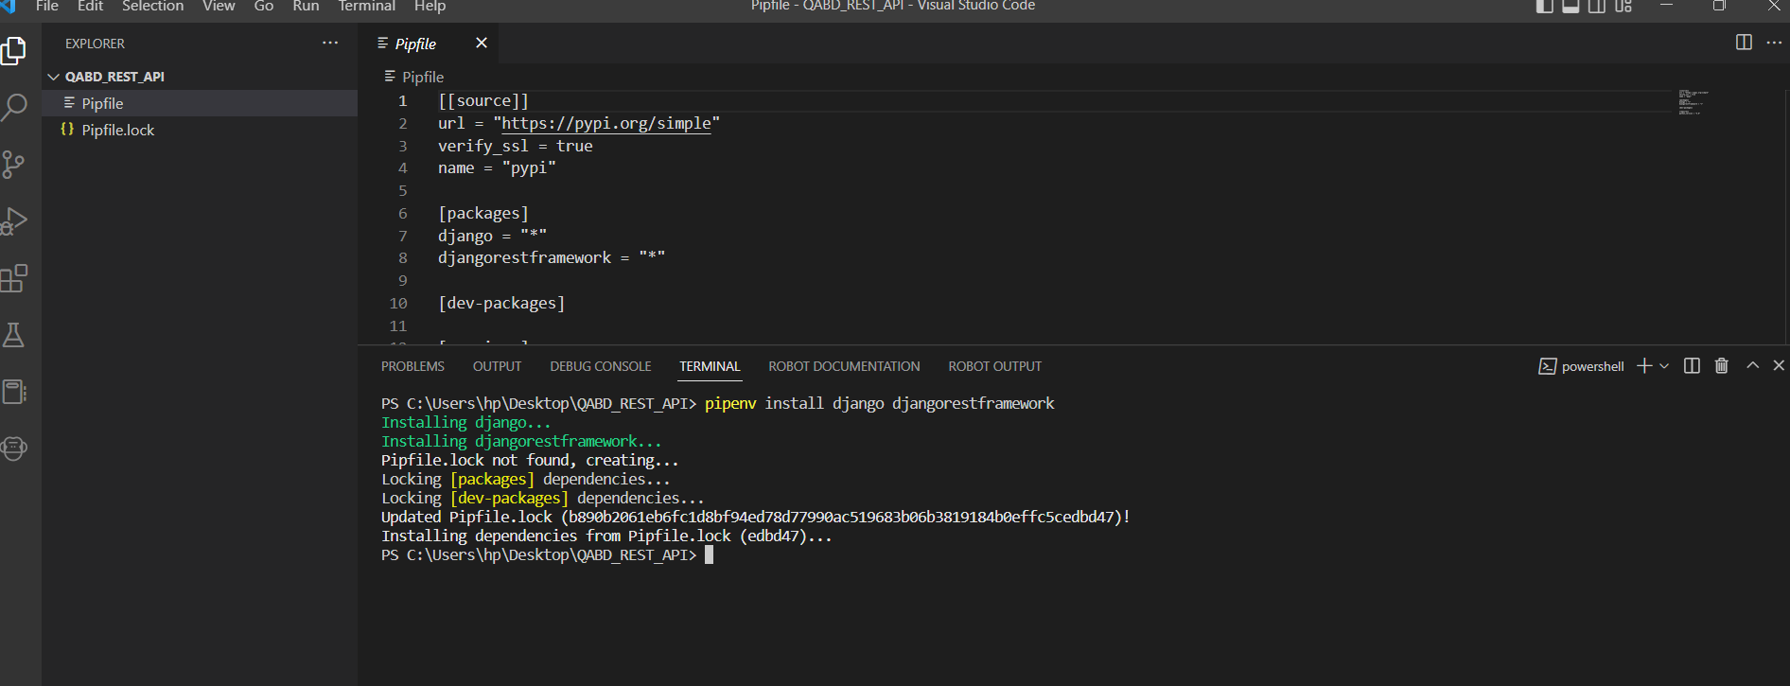

**Step4:** Create Project and Create App

django-admin startproject qabd_api .

[Note: here dot means current directory]

python manage.py startapp users

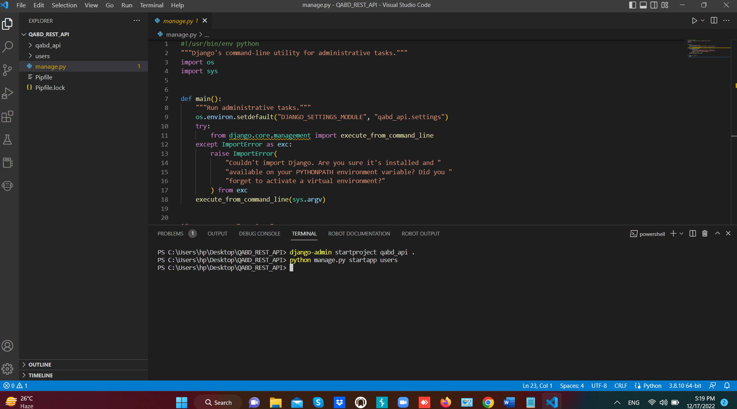

**Step5:**

Problem: Import "rest_framework" could not be resolved.

Solution: If you are using VSCode, Ctrl + Shift + P -> Type and select 'Python: Select Interpreter' and enter into your projects virtual environment. Select your pipenv with your directory name.

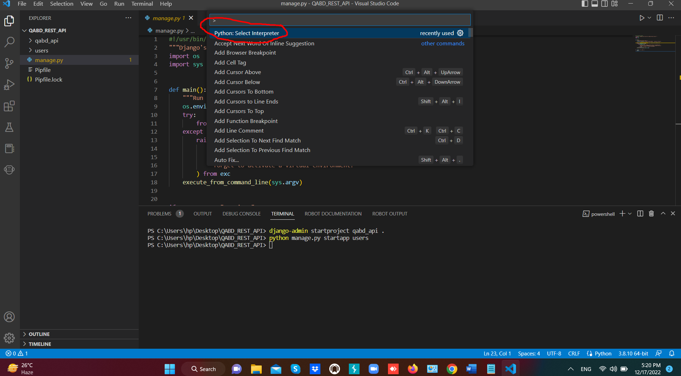

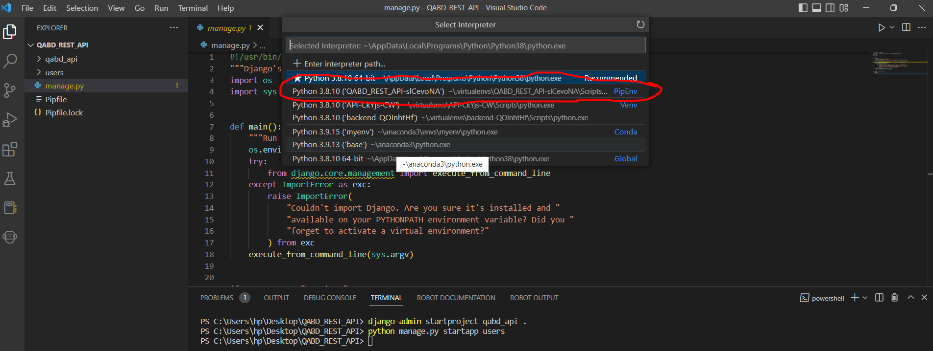

**Step6:** Go qabdbackend/qabdbackend/setting.py

INSTALLED_APPS = [

"django.contrib.admin",

"django.contrib.auth",

"django.contrib.contenttypes",

"django.contrib.sessions",

"django.contrib.messages",

"django.contrib.staticfiles",

"rest_framework",

"users",

]

and add in the last line:

REST_FRAMEWORK = {

"DEFAULT_PAGINATION_CLASS": "rest_framework.pagination.PageNumberPagination",

"PAGE_SIZE": 10

}

**Step7:** Go qabd_api/urls.py and edit the file:

from django.urls import path, include

urlpatterns = [

path("admin/", admin.site.urls),

path("api-auth/", include("rest_framework.urls", namespace="rest_framework")),

]

**Step8:** Now Migrate the database with below commands:

python manage.py makemigrations

python manage.py migrate

**Step9:** Run the Server: CMD:

python manage.py runserver

**Step10:** Now you can browse:

<http://127.0.0.1:8000>

