1. What is a Kubernetes cluster?

The fundamental behind Kubernetes is that we can enforce the desired state management, by which I mean that we can feed the cluster services of a specific configuration, and it will be up to the cluster services to go out and run that configuration in the infrastructure.

So, as you can see in the above diagram, the deployment file will have all the configurations required to be fed into the cluster services. Now, the deployment file will be fed to the API and then it will be up to the cluster services to figure out how to schedule these pods in the environment and make sure that the right number of pods are running.

So, the API which sits in front of services, the worker nodes & the Kubelet process that the nodes run, all together make up the Kubernetes Cluster.

1. What are the different parts of the Kubernetes architecture?

The [Kubernetes Architecture](https://www.edureka.co/blog/kubernetes-architecture/" \t "_blank) has mainly 2 components – the master node and the worker node. As you can see in the below diagram, the master and the worker nodes have many inbuilt components within them. The master node has the kube-controller-manager, kube-apiserver, kube-scheduler, etcd. Whereas the worker node has kubelet and kube-proxy running on each node.

1. What exactly do you mean by "container orchestration"?

Consider a scenario where you have 5-6 microservices for an application. Now, these microservices are put in individual containers, but won’t be able to communicate without container orchestration. So, as orchestration means the amalgamation of all instruments playing together in harmony in music, similarly container orchestration means all the services in individual containers working together to fulfill the needs of a single server.

1. What are the various features of Kubernetes?

The features of Kubernetes, are as follows:

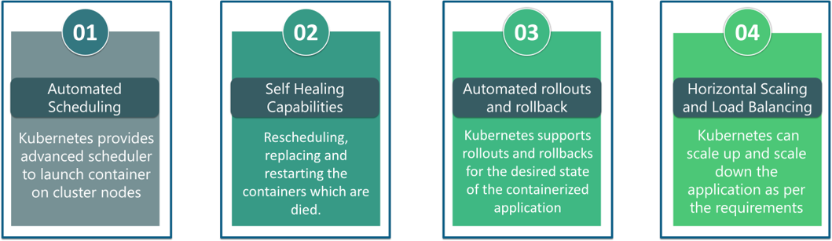

1. Explain the relationship between Kubernetes and Docker?

It’s a known fact that Docker provides the lifecycle management of containers and a Docker image builds the runtime containers. But, since these individual containers have to communicate, Kubernetes is used. So, Docker builds the containers and these containers communicate with each other via Kubernetes. So, containers running on multiple hosts can be manually linked and orchestrated using Kubernetes.