1. How well do you understand Kube-proxy?

Kube-proxy is an implementation of both a network proxy and a load balancer. It is used to support service abstraction used with other networking operations. It is responsible for directing traffic to the container depend on IP and the port number.

1. What does Kubernetes controller manager imply?

Multiple controller processes run on the master node but are compiled together to run as a single process which is the Kubernetes Controller Manager. So, Controller Manager is a daemon that embeds controllers and does namespace creation and garbage collection. It owns the responsibility and communicates with the API server to manage the end-points.

So, the different types of controller manager running on the master node are :  
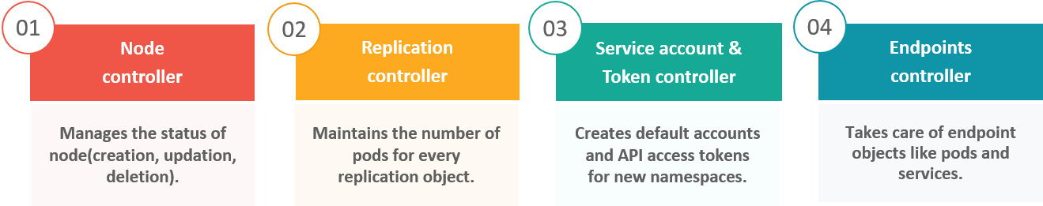

1. What exactly do you mean by ETCD?

Etcd is written in [Go programming language](https://www.edureka.co/blog/golang-tutorial/) and is a distributed key-value store used for coordinating distributed work. So, Etcd stores the configuration data of the Kubernetes cluster, representing the state of the cluster at any given point in time.

1. What does "control resource monitoring" imply?

As for users, it is really important to understand the performance of the application and resource utilization at all the different abstraction layer, Kubernetes factored the management of the cluster by creating abstraction at different levels like container, pods, services and whole cluster. Now, each level can be monitored and this is nothing but Container resource monitoring.

The various container resource monitoring tools are as follows:

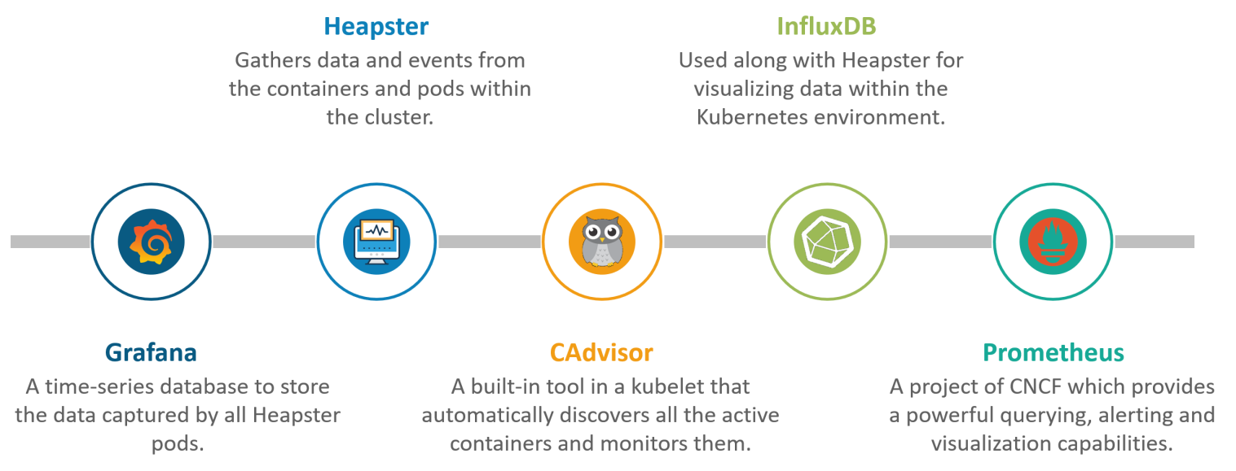

1. What are federated clusters and how do they work?

Multiple Kubernetes clusters can be managed as a single cluster with the help of federated clusters. So, you can create multiple Kubernetes clusters within a data center/cloud and use federation to control/manage them all at one place.

The federated clusters can achieve this by doing the following two things. Refer to the below diagram