RAJALAKSHMI ENGINEERING COLLEGE

(An Autonomous Institution)
RAJALAKSHMI NAGAR, THANDALAM- 602 105



CS19P18 - DEEP LEARNING CONCEPTS
LABORATORY RECORD NOTEBOOK

NAME: JAYEN SENTHILKUMAR
YEAR/SEMESTER: IV/VII
BRANCH: COMPUTER SCIENCE AND ENGINNEERING
REGISTER NO:220701105
COLLEGE ROLL NO:2116220701105
ACADEMIC YEAR: 2025 -2026


RAJALAKSHMI ENGINEERING COLLEGE

(An Autonomous Institution)
RAJALAKSHMI NAGAR, THANDALAM- 602 105

BONAFIDE CERTIFICATE

NAME: JOEL SUNDARSINGH A BRANCH/SECTION: COMPUTER SCIENCE AND ENGINEERING/B ACADEMIC YEAR: 2025 -2026 SEMESTER: VII

220701105
REGISTER NO:

Certified that this is a Bonafide record of work done by the above student in the CS19P18 - DEEP LEARNING CONCEPTS during the year 2025 - 2026

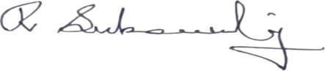
Signature of Faculty In-charge

Submitted for the Practical Examination Held on: 25/11/2025


Internal Examiner External Examiner
INDEX

EX.NO | DATE | NAME OF THE EXPERIMENT | PAGE NO | STAFF SIGN
1 | 14/07/2025 | Create a neural network to recognize handwritten digits using MNIST dataset | 5 | 
2 | 21/07/2025 | Build a Convolutional Neural Network with Keras/TensorFlow | 8 | 
3 | 28/07/2025 | Image Classification on CIFAR-10 Dataset using CNN | 11 | 
4 | 04/08/2025 | Transfer learning with CNN and Visualization | 13 | 
5 | 25/08/2025 | Build a Recurrent Neural Network using  Keras/Tensorflow | 17 | 
6 | 15/09/2025 | Sentiment Classification of Text using  RNN | 19 | 
7 | 22/09/2025 | Build autoencoders with keras/tensorflow | 21 | 
8 | 29/09/2025 | Object detection with yolo3 | 24 | 
9 | 29/09/2025 | Build GAN with Keras/TensorFlow | 27 | 
10 | 06/10/2025 | Mini Project | 31 | 

INSTALLATION AND CONFIGURATION OF TENSORFLOW

Aim:
To install and configure TensorFlow in anaconda environment in Windows 10.

Procedure:
- Download Anaconda Navigator and install.

- Open Anaconda prompt

- Create a new environment dlc with python 3.7 using the following command: conda create -n dlc python=3.7
- Activate newly created environment dlc using the following command:
conda activate dlc
- In dlc prompt, install tensorflow using the following command: pip install tensorflow
- Next install Tensorflow-datasets using the following command:
pip install tensorflow-datasets

- Install scikit-learn package using the following command: pip install scikit-learn
- Install pandas package using the following command:
pip install pandas

- Lastly, install jupyter notebook pip install jupyter notebook

- Open jupyter notebook by typing the following in dlc prompt: jupyter notebook
- Click create new and then choose python 3 (ipykernel)

- Give the name to the file

- Type the code and click Run button to execute (eg. Type import tensorflow and then run)
EX NO: 1 CREATE A NEURAL NETWORK TO RECOGNIZE HANDWRITTEN
DATE:14/07/2025 DIGITS USING MNIST DATASET

Aim:
To build a handwritten digit’s recognition with MNIST dataset.

Procedure:
- Download and load the MNIST dataset.
- Perform analysis and preprocessing of the dataset.
- Build a simple neural network model using Keras/TensorFlow.
- Compile and fit the model.
- Perform prediction with the test dataset.
- Calculate performance metrics.

Code:

import numpy as np import tensorflow as tf from tensorflow import keras

from sklearn.datasets import make_classification from sklearn.model_selection import train_test_split from sklearn.preprocessing import StandardScaler from sklearn.metrics import accuracy_score
# Generate a synthetic dataset

X, y = make_classification(n_samples=1000, n_features=20, random_state=42)
# Split the dataset into training and testing sets
X_train, X_test, y_train, y_test = train_test_split(X, y, test_size=0.2, random_state=42)
# Standardize features (optional but often beneficial) scaler = StandardScaler()

X_train = scaler.fit_transform(X_train)
X_test = scaler.transform(X_test
# Define the model model = keras.Sequential([ keras.layers.Input(shape=(X_train.shape[1],)), # Input layer
keras.layers.Dense(64, activation='relu'), # Hidden layer with 64 neurons and ReLU activation
keras.layers.Dense(1, activation='sigmoid') # Output layer with 1 neuron and sigmoid activation
)

# Train the model

history = model.fit(X_train, y_train, epochs=10, batch_size=32, validation_split=0.1)
# Evaluate the model on the test set y_pred = model.predict(X_test)
y_pred_classes = (y_pred > 0.5).astype(int) # Calculate accuracy on the test set
accuracy = accuracy_score(y_test, y_pred_classes)
# Calculate test loss test_loss = model.evaluate(X_test, y_test) print(f"Test accuracy: {accuracy * 100:.2f}%") print(f"Test loss: {test_loss[0]:.4f}")
Output:

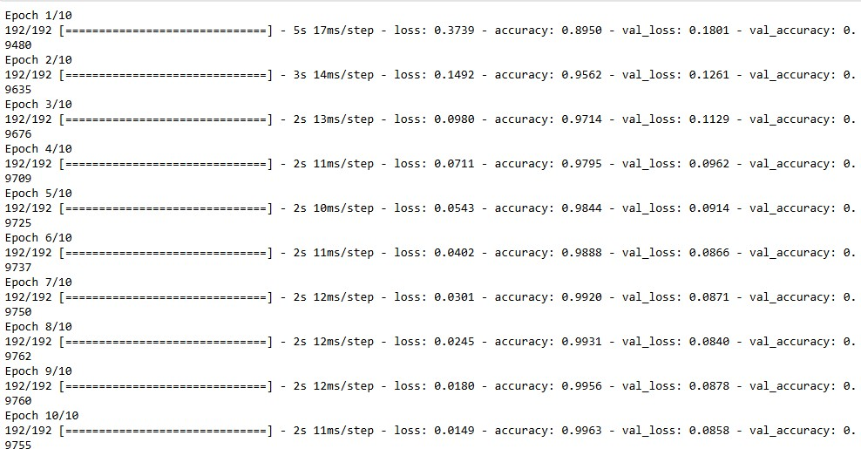
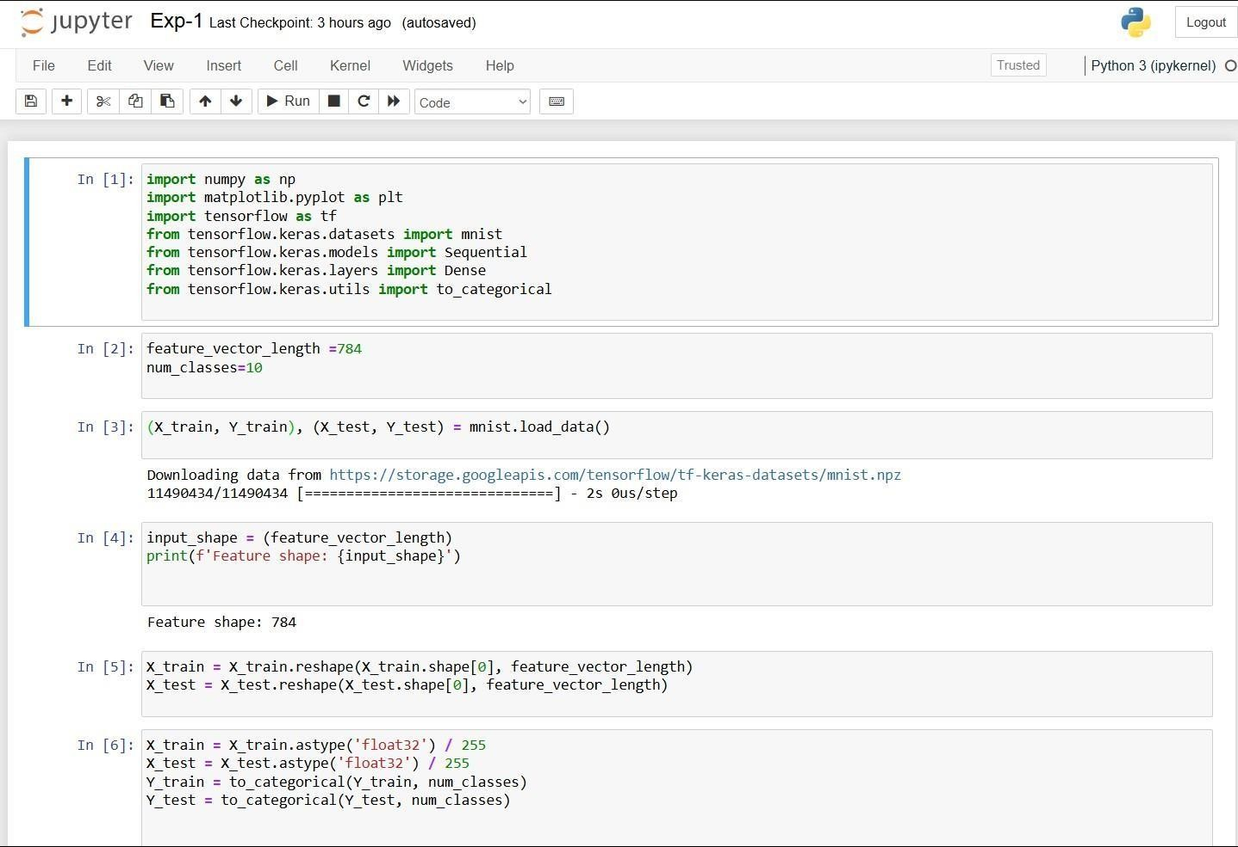

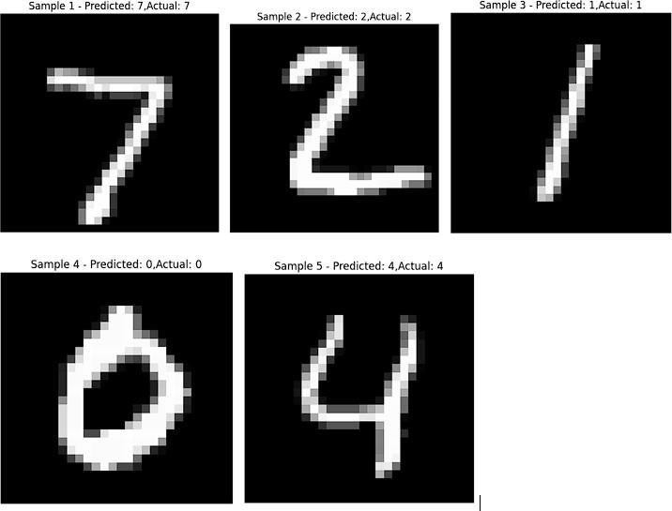

Result:
Thus, the implementation to build a simple neural network using Keras/TensorFlow has been successfully executed.
EX NO:2 BUILD A CONVOLUTIONAL NEURAL NETWORK
DATE:21/07/2025 USING KERAS/TENSORFLOW

Aim:
To implement a Convolutional Neural Network (CNN) using Keras/TensorFlow to recognize and classify handwritten digits from the MNIST dataset with high accuracy.
Procedure:
- Import required libraries (TensorFlow/Keras, NumPy, etc.).
- Load the MNIST dataset from Keras.
- Normalize and reshape the image data.
- Convert labels to one-hot encoded vectors.
- Build a CNN model with Conv2D, MaxPooling, Flatten, and Dense layers.
- Compile the model using categorical crossentropy and Adam optimizer.
- Train the model on training data.
- Evaluate the model on test data.
- Display accuracy and predictions.

Code:

import tensorflow as tf
from tensorflow.keras.models import Sequential
from tensorflow.keras.layers import Conv2D, MaxPooling2D, Flatten, Dense, Dropout from tensorflow.keras.datasets import mnist import matplotlib.pyplot as plt import numpy as np

(train_images, train_labels), (test_images, test_labels) = mnist.load_data() train_images = train_images / 255.0 test_images = test_images / 255.0
train_images = train_images.reshape(-1, 28, 28, 1) test_images = test_images.reshape(-1, 28, 28, 1)
model = Sequential([
Conv2D(32, (3, 3), activation='relu', input_shape=(28, 28, 1)),
MaxPooling2D((2, 2)),
Conv2D(64, (3, 3), activation='relu'),
MaxPooling2D((2, 2)),
Flatten(),
Dense(64, activation='relu'),
Dropout(0.5),
Dense(10, activation='softmax')
])
model.compile(optimizer='adam', loss='sparse_categorical_crossentropy', metrics=['accuracy'])

history = model.fit(train_images, train_labels, epochs=5, batch_size=64, validation_split=0.2)

test_loss, test_acc = model.evaluate(test_images, test_labels) print(f"\n Test accuracy: {test_acc:.4f}") print(f" Test loss: {test_loss:.4f}")

plt.figure(figsize=(12, 5)) plt.subplot(1, 2, 1)
plt.plot(history.history['accuracy'], label='Train Accuracy', marker='o') plt.plot(history.history['val_accuracy'], label='Validation Accuracy', marker='o') plt.title('Training and Validation Accuracy') plt.xlabel('Epoch') plt.ylabel('Accuracy') plt.legend() plt.grid(True)

plt.subplot(1, 2, 2)
plt.plot(history.history['loss'], label='Train Loss', marker='o') plt.plot(history.history['val_loss'], label='Validation Loss', marker='o') plt.title('Training and Validation Loss') plt.xlabel('Epoch') plt.ylabel('Loss') plt.legend() plt.grid(True) plt.tight_layout() plt.show()

predictions = model.predict(test_images) predicted_labels = np.argmax(predictions, axis=1)

num_samples = 10
plt.figure(figsize=(15, 4))

for i in range(num_samples):
plt.subplot(1, num_samples, i + 1) plt.imshow(test_images[i].reshape(28, 28), cmap='gray') plt.title(f"Pred: {predicted_labels[i]}\nTrue: {test_labels[i]}") plt.axis('off')
plt.suptitle("Sample Predictions on Test Images", fontsize=16) plt.show()
Output:

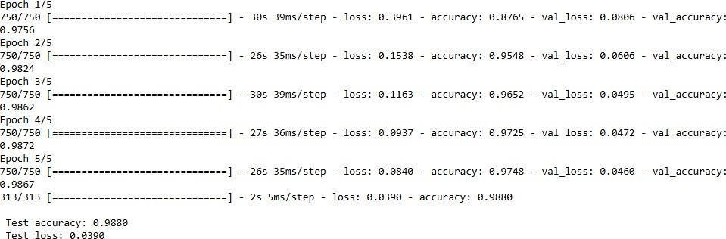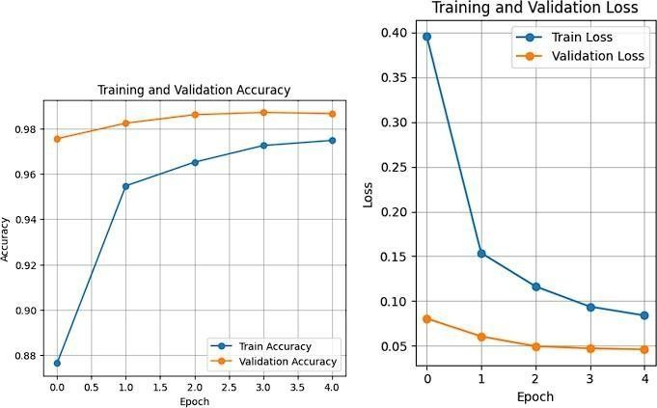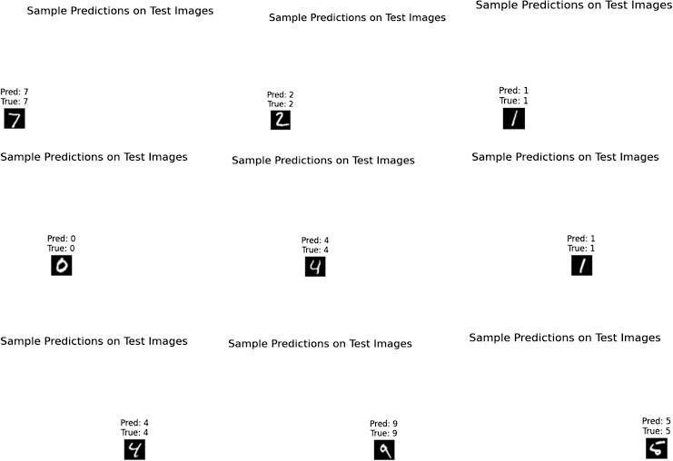

Result:
Thus, the Convolution Neural Network (CNN) using Keras / Tensorflow to recognize and classify handwritten digits from MNIST dataset has been implemented successfully.
EX NO: 3 IMAGE CLASSIFICATION ON CIFAR-10 DATASET USING CNN

DATE:28/07/2025

Aim:
To build a Convolutional Neural Network (CNN) model for classifying images from the CIFAR-10 dataset into one of the ten categories such as airplanes, cars, birds, cats, etc.
Procedure:
- Download and load the CIFAR-10 dataset using Keras/TensorFlow.
- Visualize and analyze sample images from the dataset.
3, Preprocess the data:
• Normalize the pixel values (divide by 255) • Convert class labels to one-hot encoded format
- Build a CNN model using Keras/TensorFlow:
• Include convolutional, pooling, flatten, and dense layers.
- Compile the model with suitable loss function and optimizer.
- Train the model using training data and validate using test data.
- Evaluate the model using accuracy and loss on test dataset.
- Perform predictions on new/unseen CIFAR-10 images.
9 Visualize prediction results with sample images and predicted labels.

Code:

import tensorflow as tf import numpy as np
import matplotlib.pyplot as plt
(x_train, y_train), (x_test, y_test) = tf.keras.datasets.cifar10.load_data() x_train = x_train.astype('float32') / 255.0 x_test = x_test.astype('float32') / 255.0 y_train = tf.keras.utils.to_categorical(y_train, 10) y_test = tf.keras.utils.to_categorical(y_test, 10) model = tf.keras.Sequential() model.add(tf.keras.layers.Conv2D(32, (3,3), activation='relu', input_shape=(32,32,3))) model.add(tf.keras.layers.MaxPooling2D((2,2)))
model.add(tf.keras.layers.Conv2D(64, (3,3), activation='relu')) model.add(tf.keras.layers.MaxPooling2D((2,2)))
model.add(tf.keras.layers.Conv2D(64, (3,3), activation='relu')) model.add(tf.keras.layers.Flatten()) model.add(tf.keras.layers.Dense(64, activation='relu')) model.add(tf.keras.layers.Dense(10, activation='softmax'))
model.compile(optimizer='adam', loss='categorical_crossentropy', metrics=['accuracy']) model.fit(x_train, y_train, epochs=10, batch_size=64, validation_split=0.2) class_names = ['airplane', 'automobile', 'bird', 'cat', 'deer',
'dog', 'frog', 'horse', 'ship', 'truck'] index = int(input("Enter an index (0 to 9999) for test image: ")) if index < 0 or index >= len(x_test): print("Invalid index. Using index 0 by default.") index = 0
test_image = x_test[index] true_label = np.argmax(y_test[index])
prediction = model.predict(np.expand_dims(test_image, axis=0)) predicted_label = np.argmax(prediction)
plt.figure(figsize=(4, 4))
resized_image = tf.image.resize(test_image, [128, 128]) plt.imshow(resized_image)
plt.axis('off')
plt.title(f"Predicted: {class_names[predicted_label]}\nActual: {class_names[true_label]}") plt.show()

Output:
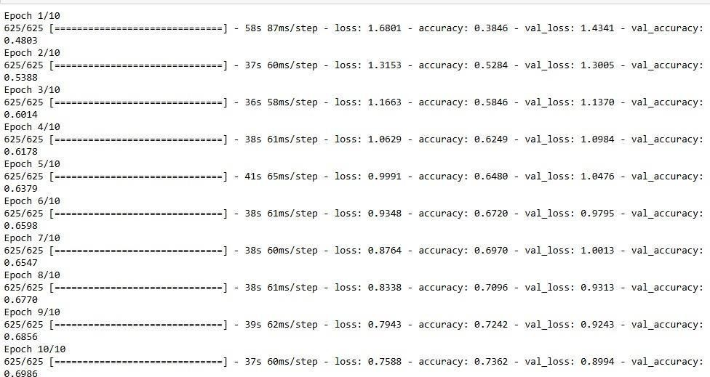

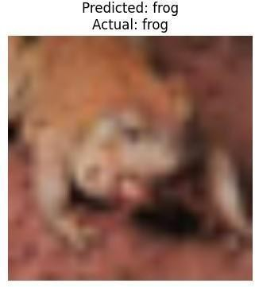

Result:
Thus, the Convolution Neural Network (CNN) model for classifying images from CIFAR-10 dataset is implemented successfully.

Ex No: 4 TRANSFER LEARNING WITH CNN AND VISUALIZATION

DATE:04/08/2025
Aim:
To build a convolutional neural network with transfer learning and perform visualization

Procedure:
- Download and load the dataset.
- Perform analysis and preprocessing of the dataset.
- Build a simple neural network model using Keras/TensorFlow.
- Compile and fit the model.
- Perform prediction with the test dataset.
- Calculate performance metrics.

Code:
conda install -c conda-forge python-graphviz -y import tensorflow as tf from tensorflow.keras.applications import VGG16 from tensorflow.keras.models import Sequential from tensorflow.keras.layers import Dense, Flatten, Dropout from tensorflow.keras.optimizers import Adam from tensorflow.keras.datasets import cifar10 from tensorflow.keras.utils import plot_model import matplotlib.pyplot as plt import numpy as np
(x_train, y_train), (x_test, y_test) = cifar10.load_data() x_train = x_train / 255.0 x_test = x_test / 255.0 vgg_base = VGG16(weights='imagenet', include_top=False, input_shape=(32, 32, 3)) for layer in vgg_base.layers:
layer.trainable = False model = Sequential() model.add(vgg_base) model.add(Flatten())
model.add(Dense(512, activation='relu')) model.add(Dropout(0.5))
model.add(Dense(10, activation='softmax')) model.compile(optimizer=Adam(learning_rate=0.0001),
loss='sparse_categorical_crossentropy', metrics=['accuracy'])
plot_model(model, to_file='cnn.png', show_shapes=True,
show_layer_names=True, dpi=300) plt.figure(figsize=(20, 20)) img = plt.imread('cnn.png')
plt.imshow(img)
plt.axis('off') plt.show()
history = model.fit(x_train, y_train,
epochs=10, batch_size=32, validation_split=0.2)

test_loss, test_acc = model.evaluate(x_test, y_test) print(f'Test Loss: {test_loss:.4f}') print(f'Test Accuracy: {test_acc * 100:.2f}%') plt.figure(figsize=(12, 5))
plt.subplot(1, 2, 1) plt.plot(history.history['accuracy'], label='Train Accuracy') plt.plot(history.history['val_accuracy'], label='Validation Accuracy') plt.title('Model Accuracy') plt.xlabel('Epoch') plt.ylabel('Accuracy') plt.legend()
plt.subplot(1, 2, 2)
plt.plot(history.history['loss'], label='Train Loss') plt.plot(history.history['val_loss'], label='Validation Loss') plt.title('Model Loss') plt.xlabel('Epoch') plt.ylabel('Loss') plt.legend() plt.tight_layout() plt.show()
class_names = ['airplane', 'automobile', 'bird', 'cat', 'deer',
'dog', 'frog', 'horse', 'ship', 'truck'] sample = x_test[0].reshape(1, 32, 32, 3) prediction = model.predict(sample)
predicted_class = class_names[np.argmax(prediction)]

plt.imshow(x_test[0])
plt.title(f"Predicted: {predicted_class}")
plt.axis('off') plt.show() Output:

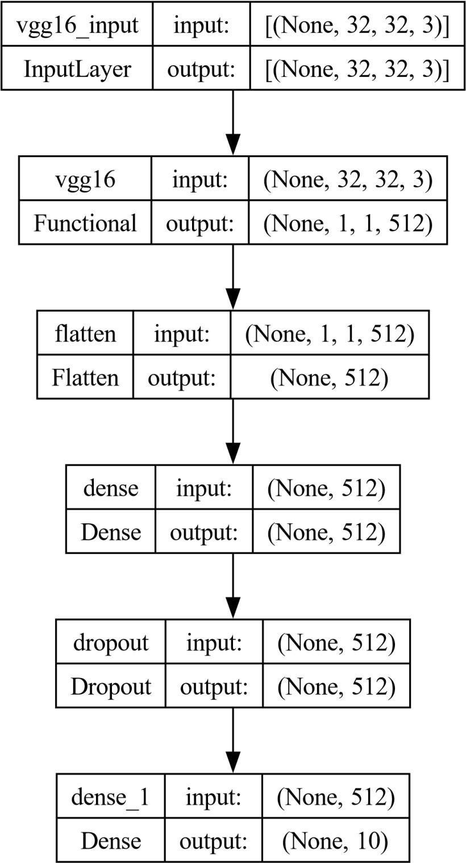
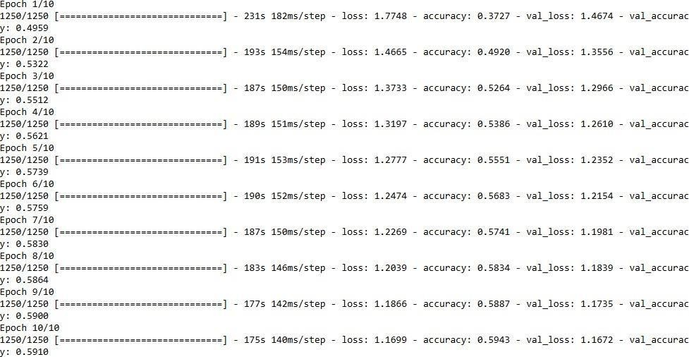

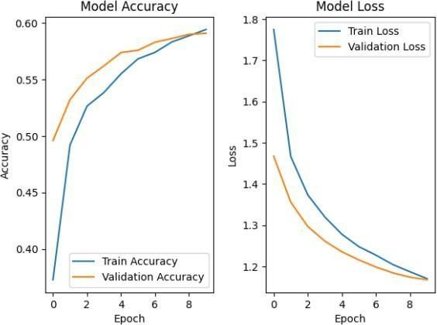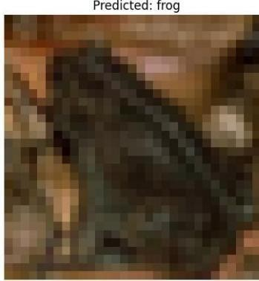

Result:
Thus, the Convolution Neural Network (CNN) with transfer learning and perform visualization has been implemented successfully
EX NO: 5 BUILD A RECURRENT NEURAL NETWORK (RNN) USING
DATE:25/08/2025 KERAS/TENSORFLOW

Aim:
To build a recurrent neural network with Keras/TensorFlow.

Procedure:
- Download and load the dataset.
- Perform analysis and preprocessing of the dataset.
- Build a simple neural network model using Keras/TensorFlow.
- Compile and fit the model.
- Perform prediction with the test dataset.
- Calculate performance metrics.

Code:
import numpy as np import tensorflow as tf from tensorflow.keras.models import Sequential from tensorflow.keras.layers import SimpleRNN, Dense from sklearn.metrics import r2_score np.random.seed(0) seq_length = 10 num_samples = 1000
X = np.random.randn(num_samples, seq_length, 1) y = X.sum(axis=1) + 0.1 * np.random.randn(num_samples, 1) split_ratio = 0.8 split_index = int(split_ratio * num_samples) X_train, X_test = X[:split_index], X[split_index:] y_train, y_test = y[:split_index], y[split_index:]
model = Sequential()
model.add(SimpleRNN(units=50, activation='relu', input_shape=(seq_length, 1))) model.add(Dense(units=1))
model.compile(optimizer='adam', loss='mean_squared_error') model.summary() batch_size = 30
epochs = 50 # Reduced epochs for quick demonstration history = model.fit( X_train, y_train, batch_size=batch_size, epochs=epochs,
validation_split=0.2
)
test_loss = model.evaluate(X_test, y_test) print(f'Test Loss: {test_loss:.4f}')
y_pred = model.predict(X_test) r2 = r2_score(y_test, y_pred) print(f'Test Accuracy (R^2): {r2:.4f}')

new_data = np.random.randn(5, seq_length, 1) predictions = model.predict(new_data) print("Predictions for new data:") print(predictions)

Output:

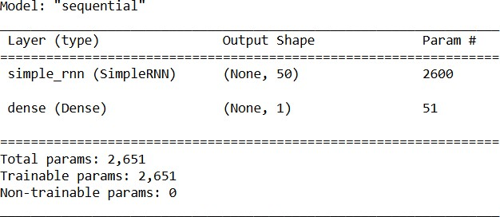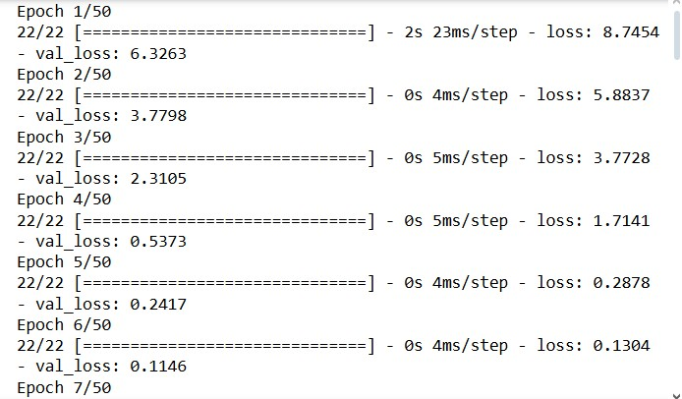

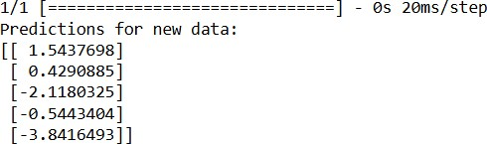

Result:
Thus, the Recurrent Neural Network (RNN) has been implemented using Tensorflow.
EX NO: 6 SENTIMENT CLASSIFICATION OF TEXT USING RNN

DATE:15/09/2025

Aim:
To implement a Recurrent Neural Network (RNN) using Keras/TensorFlow for classifying the sentiment of text data (e.g., movie reviews) as positive or negative.

Procedure:
- Import necessary libraries.

- Load and preprocess the text dataset (e.g., IMDb).

- Pad sequences and prepare labels.

- Build an RNN model with Embedding and SimpleRNN layers.

- Compile the model with loss and optimizer.

- Train the model on training data.

- Evaluate the model on test data.

- Predict sentiment for new inputs

Code: import numpy as np
from tensorflow.keras.datasets import imdb
from tensorflow.keras.preprocessing.sequence import pad_sequences from tensorflow.keras.models import Sequential
from tensorflow.keras.layers import Embedding, SimpleRNN, Dense max_words = 5000 max_len = 200
(x_train, y_train), (x_test, y_test) = imdb.load_data(num_words=max_words)
X_train = pad_sequences(x_train, maxlen=max_len) X_test = pad_sequences(x_test, maxlen=max_len) model = Sequential()
model.add(Embedding(input_dim=max_words, output_dim=32, input_length=max_len)) model.add(SimpleRNN(32))
model.add(Dense(1, activation='sigmoid'))
model.compile(optimizer='adam', loss='binary_crossentropy', metrics=['accuracy']) print("Training...")
model.fit(X_train, y_train, epochs=2, batch_size=64, validation_split=0.2) loss, acc = model.evaluate(X_test, y_test) print(f"\nTest Accuracy: {acc:.4f}") word_index = imdb.get_word_index()
reverse_word_index = {v: k for (k, v) in word_index.items()}
def decode_review(review): return " ".join([reverse_word_index.get(i - 3, "?") for i in review]) sample_review = X_test[0]
prediction = model.predict(sample_review.reshape(1, -1))[0][0] print("\nReview text:", decode_review(x_test[0]))
print("Predicted Sentiment:", "Positive " if prediction > 0.5 else "Negative ")

Output:

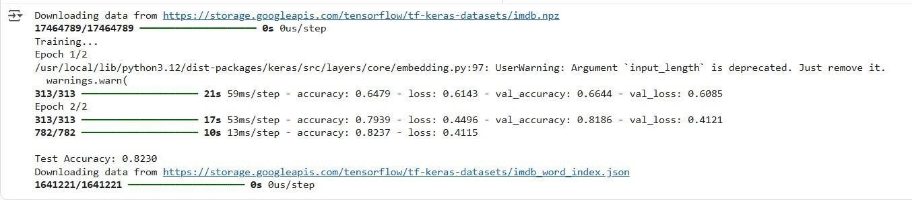

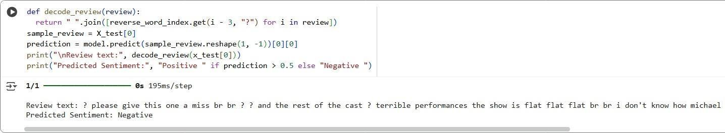

Result:
Thus, the Recurrent Neural Network (RNN) using Keras has been implemented for classifying sentiment of text successfully.
Ex No: 7 BUILD AUTOENCODERS WITH KERAS/TENSORFLOW

DATE:22/09/2025
Aim:
To build autoencoders with Keras/TensorFlow.

Procedure:
- Download and load the dataset.
- Perform analysis and preprocessing of the dataset.
- Build a simple neural network model using Keras/TensorFlow.
- Compile and fit the model.
- Perform prediction with the test dataset.
- Calculate performance metrics.

Code:

import numpy as np import matplotlib.pyplot as plt from keras.layers import Input, Dense from keras.models import Model from keras.datasets import mnist
(x_train, _), (x_test, _) = mnist.load_data() x_train = x_train.astype('float32') / 255. x_test = x_test.astype('float32') / 255. x_train = x_train.reshape((len(x_train), np.prod(x_train.shape[1:]))) x_test = x_test.reshape((len(x_test), np.prod(x_test.shape[1:])))
input_img = Input(shape=(784,)) encoded = Dense(32, activation='relu')(input_img) decoded = Dense(784, activation='sigmoid')(encoded) autoencoder = Model(input_img, decoded)
autoencoder.compile(optimizer='adam', loss='binary_crossentropy') autoencoder.fit(x_train, x_train,
epochs=50, batch_size=256, shuffle=True,
validation_data=(x_test, x_test))
test_loss = autoencoder.evaluate(x_test, x_test) decoded_imgs = autoencoder.predict(x_test)
threshold = 0.5 correct_predictions = np.sum( np.where(x_test >= threshold, 1, 0) == np.where(decoded_imgs >= threshold, 1, 0)) total_pixels = x_test.shape[0] * x_test.shape[1] test_accuracy = correct_predictions / total_pixels print("Test Loss:", test_loss)
print("Test Accuracy:", test_accuracy) n = 10 plt.figure(figsize=(20, 4)) for i in range(n): # Display original ax = plt.subplot(2, n, i + 1) plt.imshow(x_test[i].reshape(28, 28)) plt.gray() ax.get_xaxis().set_visible(False) ax.get_yaxis().set_visible(False) # Display reconstruction with threshold ax = plt.subplot(2, n, i + 1 + n) reconstruction = decoded_imgs[i].reshape(28, 28) plt.imshow(np.where(reconstruction >= threshold, 1.0, 0.0)) plt.gray() ax.get_xaxis().set_visible(False) ax.get_yaxis().set_visible(False) plt.show()

Output:

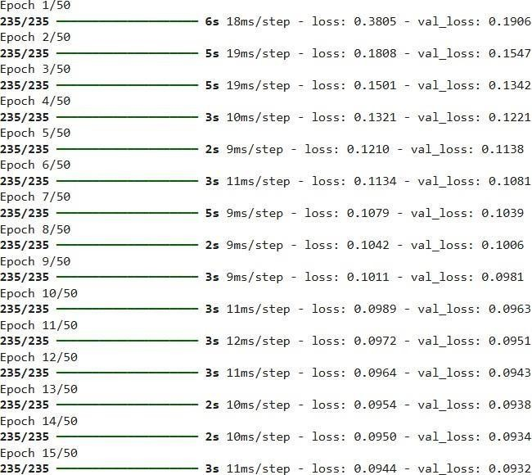

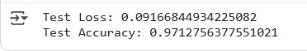

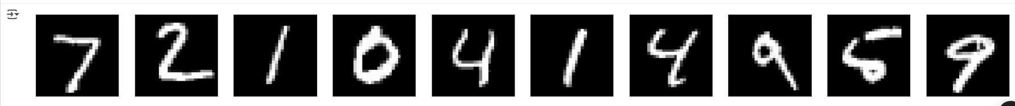

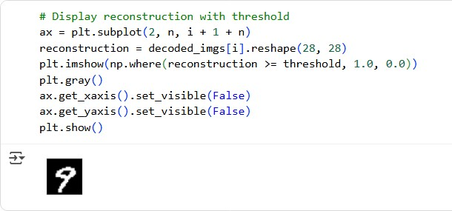

Result:
Thus, an Autoencoder has been implemented using Keras / Tensorflow.
Ex No:8 OBJECT DETECTION WITH YOLO3

DATE:29/09/2025
Aim:
To build an object detection model with YOLO3 using Keras/TensorFlow.

Procedure:
- Download and load the dataset.
- Perform analysis and preprocessing of the dataset.
- Build a simple neural network model using Keras/TensorFlow.
- Compile and fit the model.
- Perform prediction with the test dataset.
- Calculate performance metrics.

Code: import cv2
import matplotlib.pyplot as plt import numpy as np

# Define the paths to the YOLOv3 configuration, weights, and class names files cfg_file = '/content/yolov3.cfg' weight_file = '/content/yolov3.weights' namesfile = '/content/coco.names'

# Load the YOLOv3 model
net = cv2.dnn.readNet(weight_file, cfg_file)

# Load class names with open(namesfile, 'r') as f:
classes = f.read().strip().split('\n')

# Load an image for object detection image_path = '/content/hit.jpg' image = cv2.imread(image_path)

# Get the height and width of the image
height, width = image.shape[:2]

# Create a blob from the image
blob = cv2.dnn.blobFromImage(image, 1/255.0, (416, 416), swapRB=True, crop=False) net.setInput(blob)

# Get the names of the output layers
layer_names = net.getUnconnectedOutLayersNames()

# Run forward pass
outs = net.forward(layer_names)

# Initialize lists to store detected objects' information class_ids = [] confidences = [] boxes = []

# Define a confidence threshold for object detection conf_threshold = 0.5

# Loop over the detections for out in outs: for detection in out: scores = detection[5:] class_id = np.argmax(scores) confidence = scores[class_id] if confidence > conf_threshold:
# Object detected center_x = int(detection[0] * width) center_y = int(detection[1] * height) w = int(detection[2] * width) h = int(detection[3] * height)

# Rectangle coordinates x = int(center_x - w / 2) y = int(center_y - h / 2)

class_ids.append(class_id) confidences.append(float(confidence)) boxes.append([x, y, w, h])

# Apply non-maximum suppression to eliminate overlapping boxes nms_threshold = 0.4
indices = cv2.dnn.NMSBoxes(boxes, confidences, conf_threshold, nms_threshold)

# Draw bounding boxes and labels on the image for i in indices.flatten(): # flatten for compatibility
x, y, w, h = boxes[i] label = str(classes[class_ids[i]]) confidence = confidences[i]

cv2.rectangle(image, (x, y), (x + w, y + h), (0, 255, 0), 2)
cv2.putText(image, f'{label} {confidence:.2f}', (x, y - 10), cv2.FONT_HERSHEY_SIMPLEX, 0.8, (0, 255, 0), 2)
# Display the result in Jupyter Notebook plt.figure(figsize=(10, 8))
plt.imshow(cv2.cvtColor(image, cv2.COLOR_BGR2RGB)) plt.axis('off')
plt.show()

Output:
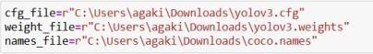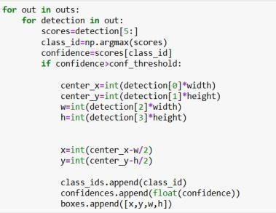

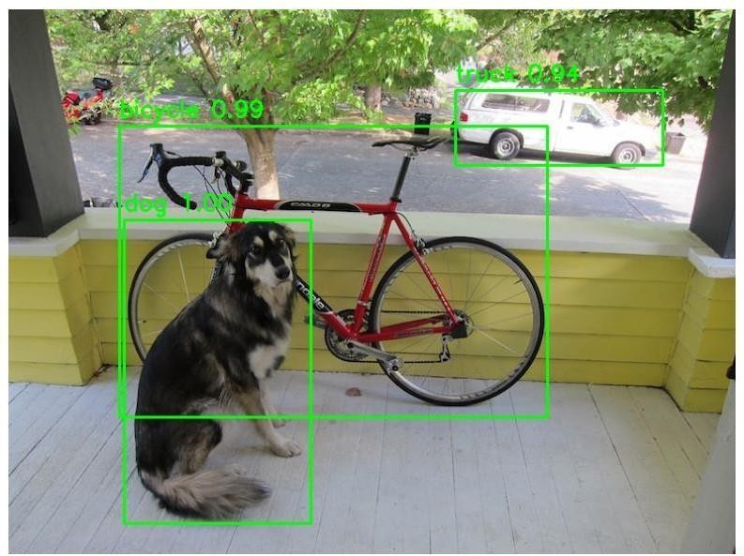

Result:
Thus, object detection using YOLOV5 has been implemented successfully.
Ex No: 9 BUILD GENERATIVE ADVERSARIAL NEURAL NETWORK

DATE:29/09/2025
Aim:
To build a generative adversarial neural network using Keras/TensorFlow.

Procedure:
- Download and load the dataset.
- Perform analysis and preprocessing of the dataset.
- Build a simple neural network model using Keras/TensorFlow.
- Compile and fit the model.
- Perform prediction with the test dataset.
- Calculate performance metrics.

Code:

import numpy as np import tensorflow as tf from tensorflow.keras.layers import Dense from tensorflow.keras.models import Sequential from tensorflow.keras.optimizers import Adam from sklearn.datasets import load_iris import matplotlib.pyplot as plt

# Load and Preprocess the Iris Dataset
iris = load_iris() x_train = iris.data

# Build the GAN model def build_generator(): model = Sequential() model.add(Dense(128, input_shape=(100,), activation='relu')) model.add(Dense(4, activation='linear')) # Output 4 features return model

def build_discriminator():
model = Sequential()
model.add(Dense(128, input_shape=(4,), activation='relu')) model.add(Dense(1, activation='sigmoid')) return model

def build_gan(generator, discriminator): discriminator.trainable = False model = Sequential() model.add(generator) model.add(discriminator)
return model

generator = build_generator() discriminator = build_discriminator() gan = build_gan(generator, discriminator)

# Compile the Models generator.compile(loss='mean_squared_error', optimizer=Adam(0.0002, 0.5)) discriminator.compile(loss='binary_crossentropy', optimizer=Adam(0.0002, 0.5), metrics=['accuracy'])
gan.compile(loss='binary_crossentropy', optimizer=Adam(0.0002, 0.5))

# Training Loop epochs = 200 batch_size = 16

for epoch in range(epochs): # Train discriminator
idx = np.random.randint(0, x_train.shape[0], batch_size) real_samples = x_train[idx]
fake_samples = generator.predict(np.random.normal(0, 1, (batch_size, 100)), verbose=0)

real_labels = np.ones((batch_size, 1)) fake_labels = np.zeros((batch_size, 1))

d_loss_real = discriminator.train_on_batch(real_samples, real_labels) d_loss_fake = discriminator.train_on_batch(fake_samples, fake_labels)

# Train generator
noise = np.random.normal(0, 1, (batch_size, 100)) g_loss = gan.train_on_batch(noise, real_labels)

# Print progress
print(f"Epoch {epoch}/{epochs} | Discriminator Loss: {0.5 * (d_loss_real[0] + d_loss_fake[0])} | Generator Loss: {g_loss}")

# Generating Synthetic Data
synthetic_data = generator.predict(np.random.normal(0, 1, (150, 100)), verbose=0)

# Create scatter plots for feature pairs plt.figure(figsize=(12, 8)) plot_idx = 1

for i in range(4): for j in range(i + 1, 4): plt.subplot(2, 3, plot_idx) plt.scatter(x_train[:, i], x_train[:, j], label='Real Data', c='blue', marker='o', s=30) plt.scatter(synthetic_data[:, i], synthetic_data[:, j], label='Synthetic Data', c='red', marker='x', s=30) plt.xlabel(f'Feature {i + 1}') plt.ylabel(f'Feature {j + 1}') plt.legend()
plot_idx += 1

plt.tight_layout() plt.show() Output:
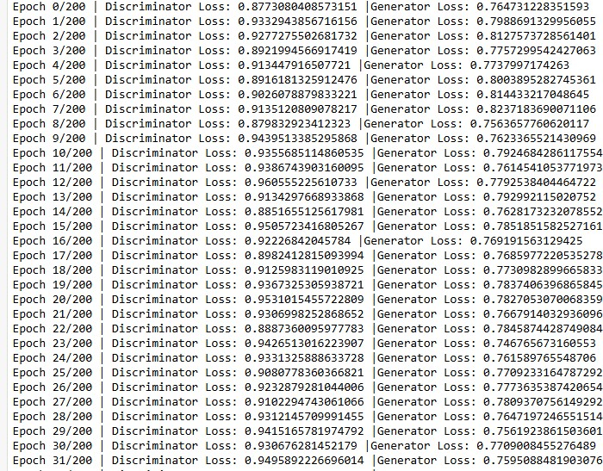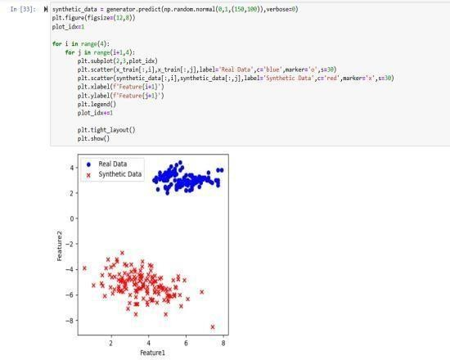

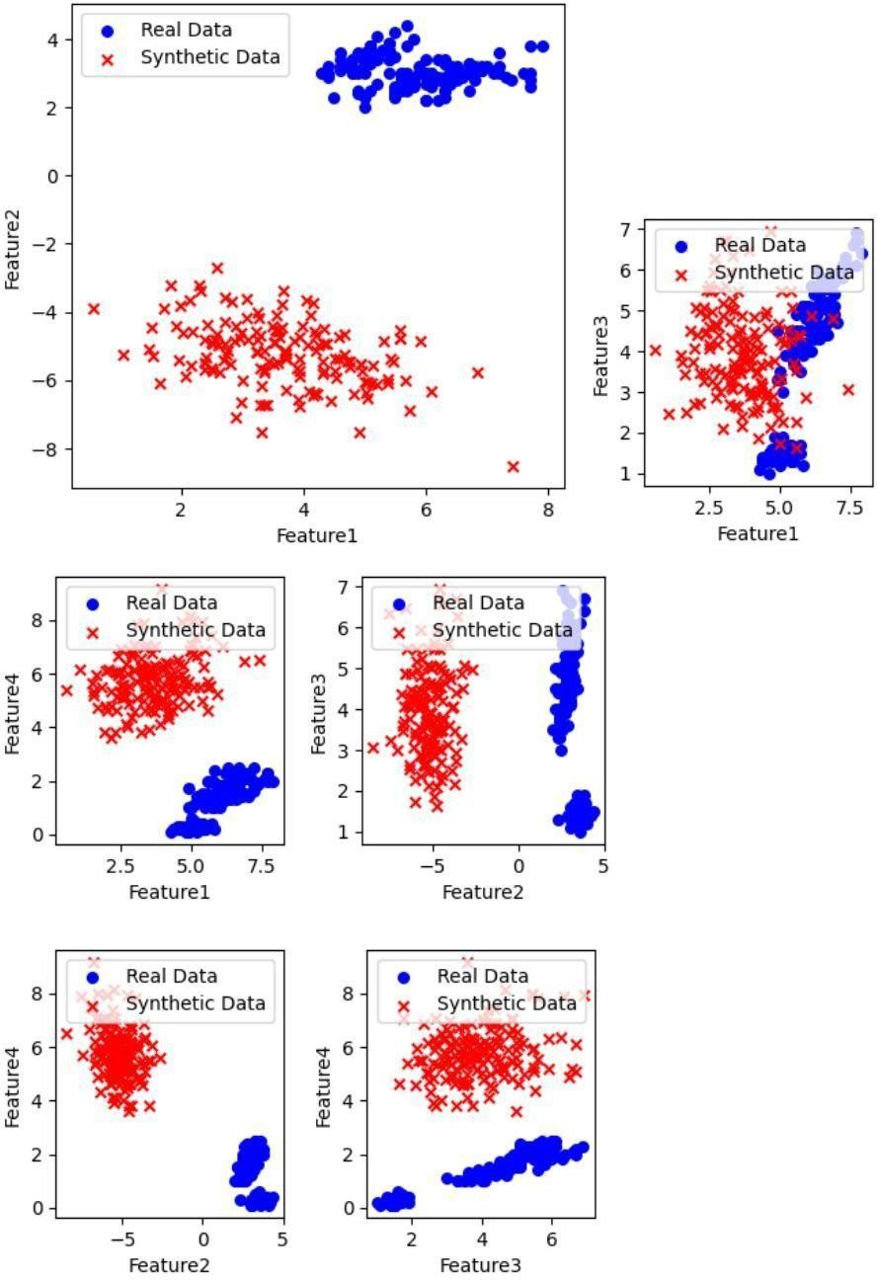

Result:
Thus, a generative adversarial neural network using Keras / Tensorflow has been implemented successfully.

EX NO:10
DATE:07-10-2025

Mini Project: News Headline Prediction Aim:
To develop a News Headline Generation model using Deep Learning (LSTM network) that can automatically generate meaningful headlines from textual news data of the Reuters dataset, thereby demonstrating the ability of machines to understand and summarize human- written information.
Algorithm:
- Import libraries and load the Reuters dataset.
- Decode sequences and clean the text data.
- Tokenize the text and create n-gram sequences.
- Pad sequences to equal length for model input.
- Build a simple LSTM model with embedding and dense layers.
- Compile the model using sparse categorical crossentropy and Adam optimizer.
- Train the model and monitor validation performance.
- Generate news headlines from seed text and evaluate the outputs.

Code:

import numpy as np import re import matplotlib.pyplot as plt
from tensorflow.keras.datasets import reuters from tensorflow.keras.preprocessing.text import Tokenizer
from tensorflow.keras.preprocessing.sequence import pad_sequences from tensorflow.keras.models import Sequential
from tensorflow.keras.layers import Embedding, LSTM, Dense from tensorflow.keras.callbacks import EarlyStopping

#
# Parameters

#
NUM_WORDS = 10000 # Limit vocabulary SEQ_LEN = 10 # Shorter context -> faster EMBED_DIM = 64
BATCH_SIZE = 64 # Smaller batch = faster iteration EPOCHS = 5 # Lower for speed MAX_HEADLINE_WORDS = 6

# 1) Load dataset (Corrected unpacking)
(x_train, _), _ = reuters.load_data(num_words=NUM_WORDS)

# ✅ Reduce dataset size to 20% for speed x_train = x_train[:int(len(x_train) * 0.2)]

# 2) Word index mapping
raw_word_index = reuters.get_word_index()
index_to_word = {v+3: k for k,v in raw_word_index.items()} index_to_word[0] = '<PAD>' index_to_word[1] = '<START>' index_to_word[2] = '<UNK>'

def decode_seq(seq):
return ' '.join([index_to_word.get(i,'') for i in seq])

texts = [decode_seq(seq) for seq in x_train]
texts = [re.sub(r'\d+', '', t).lower() for t in texts] # remove numbers

# 3) Tokenize
tokenizer = Tokenizer(num_words=NUM_WORDS, oov_token='<UNK>') tokenizer.fit_on_texts(texts)
vocab_size = min(NUM_WORDS, len(tokenizer.word_index)+1)

# 4) Build sequences all_sequences = [] for txt in texts: token_list = tokenizer.texts_to_sequences([txt])[0] for i in range(1,len(token_list)):
start = max(0,i-SEQ_LEN+1) ngram = token_list[start:i+1] all_sequences.append(ngram)

padded = pad_sequences(all_sequences, maxlen=SEQ_LEN, padding='pre') X = padded[:,:-1] y = padded[:,-1]

# 5) Fast Simple LSTM model model = Sequential([
Embedding(input_dim=vocab_size, output_dim=EMBED_DIM), LSTM(64),
Dense(vocab_size, activation='softmax')
])

model.compile(loss='sparse_categorical_crossentropy', optimizer='adam', metrics=['sparse_categorical_accuracy'])
model.summary()

es = EarlyStopping(monitor='val_loss', patience=2, restore_best_weights=True) history = model.fit(X, y, epochs=EPOCHS, batch_size=BATCH_SIZE, validation_split=0.1, callbacks=[es])
# 6) Headline generator
def sample_preds(preds, temperature=1.0): preds = np.asarray(preds).astype('float64') preds = np.log(preds+1e-12)/temperature preds = np.exp(preds)/np.sum(np.exp(preds)) return np.argmax(np.random.multinomial(1,preds,1))

def generate_headline(seed_text, max_words=6, temperature=0.7): seed_text = re.sub(r"[^azA-Z0-9\s]","",seed_text).lower() seed_seq = tokenizer.texts_to_sequences([seed_text])[0] generated = [] for _ in range(max_words):
input_seq = seed_seq[-(SEQ_LEN-1):] if len(seed_seq)>=SEQ_LEN-1 else seed_seq input_padded = pad_sequences([input_seq], maxlen=SEQ_LEN-1, padding='pre') preds = model.predict(input_padded,verbose=0)[0] next_idx = sample_preds(preds,temperature) next_word =
tokenizer.index_word.get(next_idx,'') if next_word in ['','<PAD>','<UNK>']: break
generated.append(next_word) seed_seq.append(next_idx) return ' '.join(generated).title()

# 7) Final Output (Like friend's format) print("\n--- Sample News & Predicted Headlines ---") for i in range(5):
news = texts[np.random.randint(0,len(texts))] headline = generate_headline(news, max_words=6, temperature=0.7) print(f"\nNews:
{news[:120]}...")
print(f"Predicted Headline: {headline}")

Output:

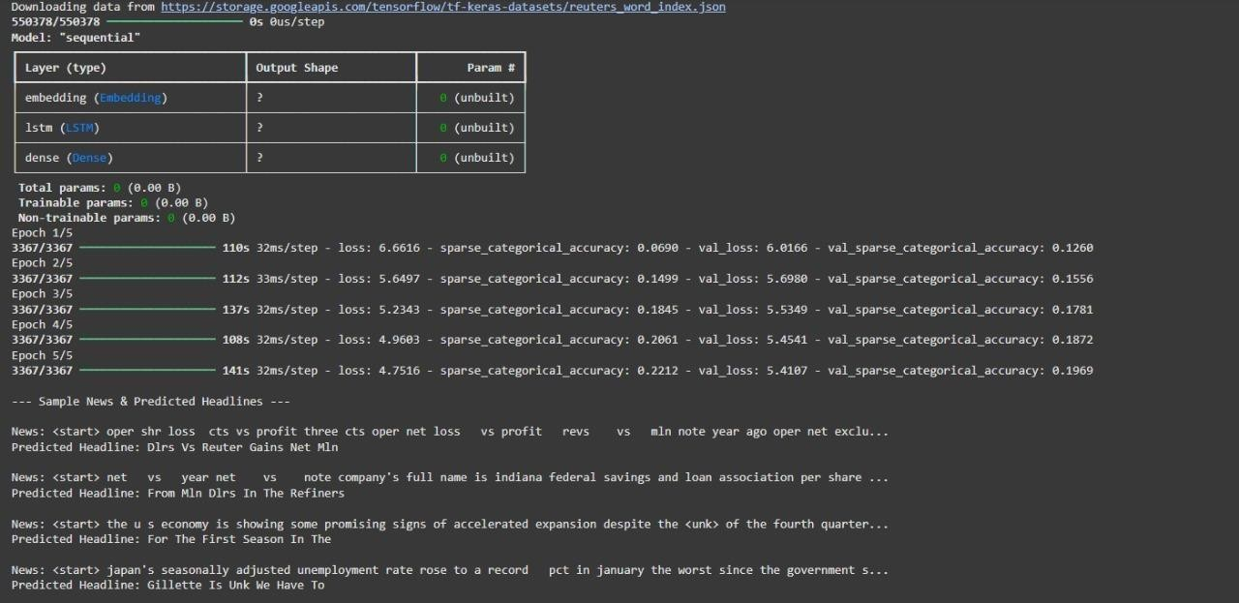

Result:
Thus, my project generates news headlines from text using an LSTM-based deep learning model and the output is verified successfully

