EDGE INTELLIGENCE
LAB-1
-JAYENTH KANNA V
25MML0056

Code:
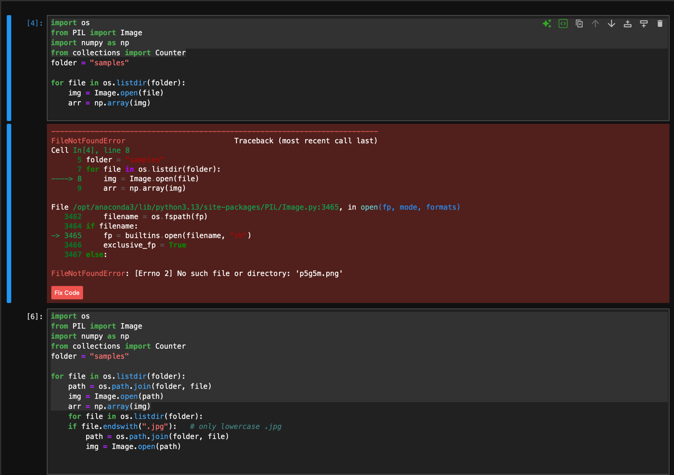
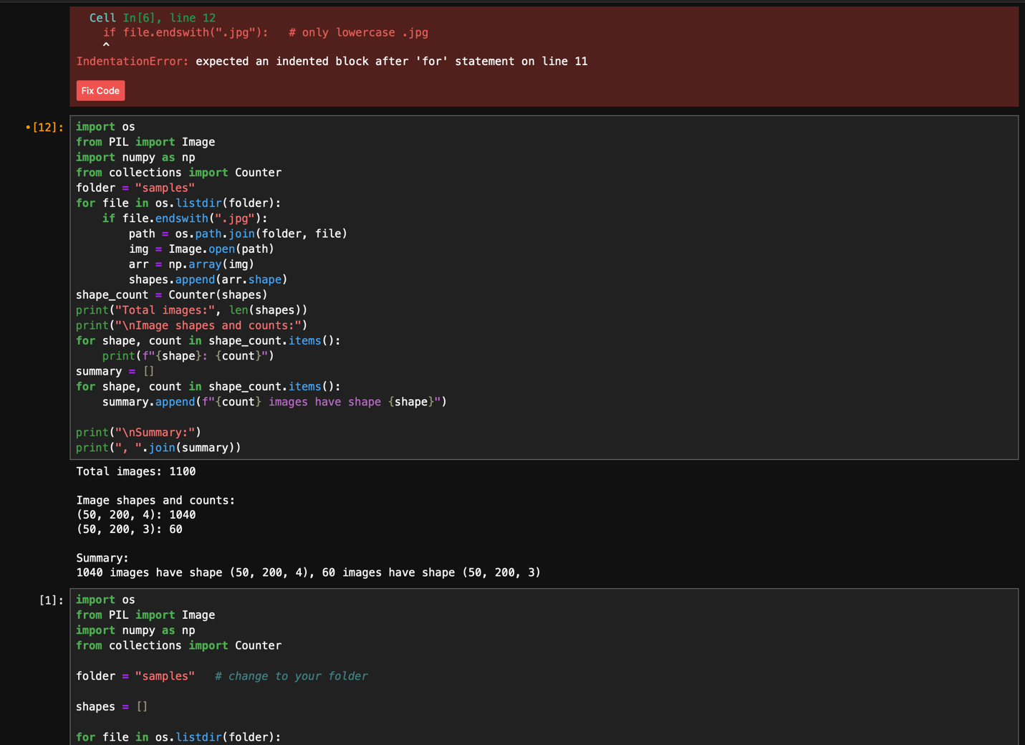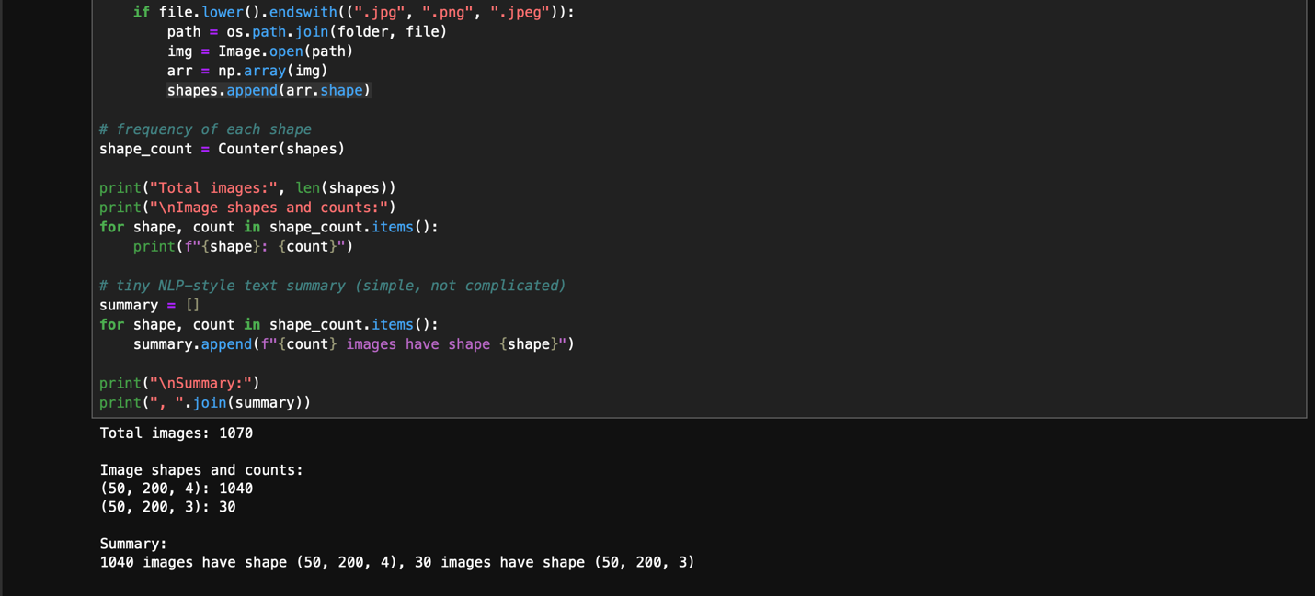

Summary:
So, I started writing this image-shape analysis script thinking everything would “just work,” but of course, Python had other plans. First, I confidently opened images without actually joining the folder path — because obviously the interpreter should magically know where my files are. That earned me a beautiful FileNotFoundError. Then I realised half my images weren’t opening because I only checked for .jpg, completely forgetting that .JPG, .PNG, .jpeg also exist. Lesson learned: computers are extremely picky.
Next, PIL decided to troll me with images coming in all kinds of random modes: grayscale, RGB, RGBA… basically everything except what I expected. The shapes were so inconsistent my script looked like it was reading data from three different planets. Fix? I forced everything into RGB — dictatorship solves problems.
I also found out that not closing images keeps the files “busy”, which is Python’s polite way of saying “you messed up again.” So I used with Image.open() to stop Python from judging me.
Finally, I wrapped everything in try/except like a responsible adult. After all these fixes, the script actually behaved and produced the correct shape summary.

