CSE-224
CA1 Jayesh Mandawara 12312683
Visual Implementation
Here is the code for XML: -
<?xml version="1.0" encoding="utf-8"?>
<androidx.appcompat.widget.LinearLayoutCompat xmlns:android="http://schemas.android.com/apk/res/android"
xmlns:app="http://schemas.android.com/apk/res-auto"
xmlns:tools="http://schemas.android.com/tools"
android:id="@+id/main"
android:layout_width="match_parent"
android:layout_height="match_parent"
android:orientation="vertical"
android:padding="30dp"
tools:context=".MainActivity">
<TextView
android:layout_width="wrap_content"
android:layout_height="wrap_content"
android:text="Jayesh Mandawara"
android:layout_gravity="center"
android:layout_marginTop="50dp"
/>
<TextView
android:layout_width="wrap_content"
android:layout_height="wrap_content"
android:text="12312683"
android:layout_gravity="center"
android:layout_marginTop="5dp"
/>
<ImageView
android:layout_width="350dp"
android:layout_height="90dp"
android:src="@drawable/mine"
android:layout_marginTop="20dp"/>
<TextView
android:layout_width="wrap_content"
android:layout_height="wrap_content"
android:text="Subject 1"
android:layout_marginLeft="30dp"
android:layout_marginTop="20dp"
/>
<EditText
android:layout_width="300dp"
android:layout_height="wrap_content"
android:layout_marginLeft="30dp"
android:id="@+id/ed1"
android:hint="Enter your marks obtained in Sub 1"
/>
<TextView
android:layout_width="wrap_content"
android:layout_height="wrap_content"
android:text="Subject 2"
android:layout_marginLeft="30dp"
android:layout_marginTop="20dp"
/>
<EditText
android:layout_width="300dp"
android:layout_height="wrap_content"
android:layout_marginLeft="30dp"
android:id="@+id/ed2"
android:hint="Enter your marks obtained in Sub 2"
/>
<TextView
android:layout_width="wrap_content"
android:layout_height="wrap_content"
android:text="Subject 3"
android:layout_marginLeft="30dp"
android:layout_marginTop="20dp"
/>
<EditText
android:layout_width="300dp"
android:layout_height="wrap_content"
android:layout_marginLeft="30dp"
android:id="@+id/ed3"
android:hint="Enter your marks obtained in Sub 3"
/>
<Button
android:layout_width="wrap_content"
android:layout_height="wrap_content"
android:layout_gravity="center"
android:layout_marginTop="20dp"
android:text="Calculate"
android:id="@+id/btn"
/>
<TextView
android:layout_width="wrap_content"
android:layout_height="wrap_content"
android:hint="Results in CGPA will be shown here..."
android:layout_marginTop="30dp"
android:id="@+id/tv1"
android:layout_marginLeft="30dp"
/>
</androidx.appcompat.widget.LinearLayoutCompat>

Here is the code for Kotlin: -
package com.example.ca1
import android.os.Bundle
import android.widget.Button
import android.widget.EditText
import android.widget.TextView
import androidx.activity.enableEdgeToEdge
import androidx.appcompat.app.AppCompatActivity
import androidx.core.view.ViewCompat
import androidx.core.view.WindowInsetsCompat
class MainActivity : AppCompatActivity() {
override fun onCreate(savedInstanceState: Bundle?) {
super.onCreate(savedInstanceState)
enableEdgeToEdge()
setContentView(R.layout.activity_main)
var ed1 = findViewById<EditText>(R.id.ed1)
var ed2 = findViewById<EditText>(R.id.ed2)
var ed3 = findViewById<EditText>(R.id.ed3)
var btn = findViewById<Button>(R.id.btn)
var tv1 = findViewById<TextView>(R.id.tv1)
btn.setOnClickListener {
var a = ed1.text.toString()
var b = ed2.text.toString()
var c = ed3.text.toString()
if (a.isEmpty() || b.isEmpty() || c.isEmpty()) {
tv1.text = "Please enter all the values"
}
var res = ((a.toDouble() + b.toDouble() + c.toDouble()) / 300.0) * 100.0
var percent = res / 10.0
tv1.text = String.format("%.2f", percent)
}
}
}

Here are the output images: -
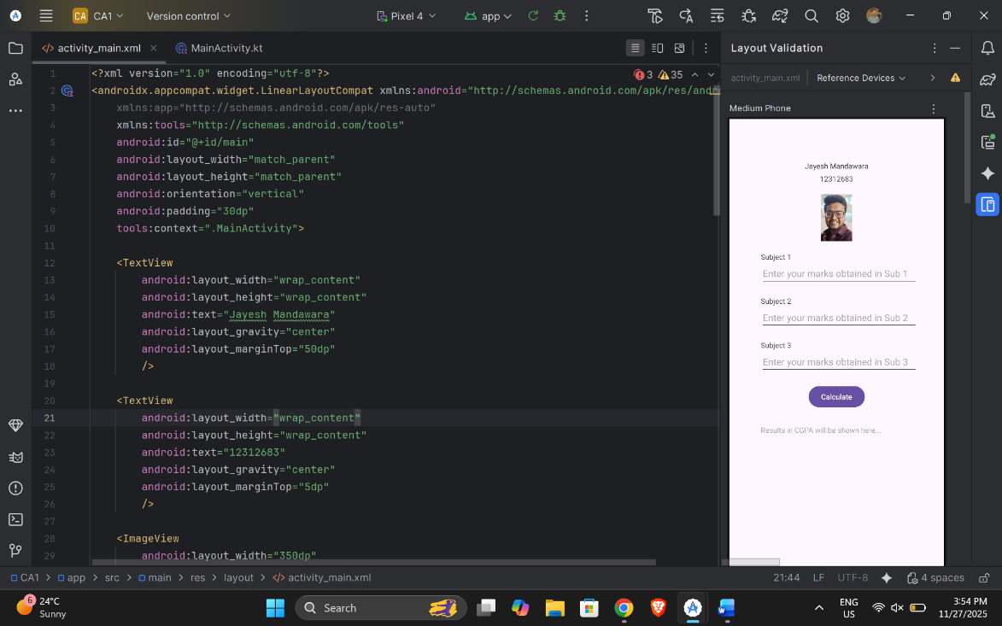

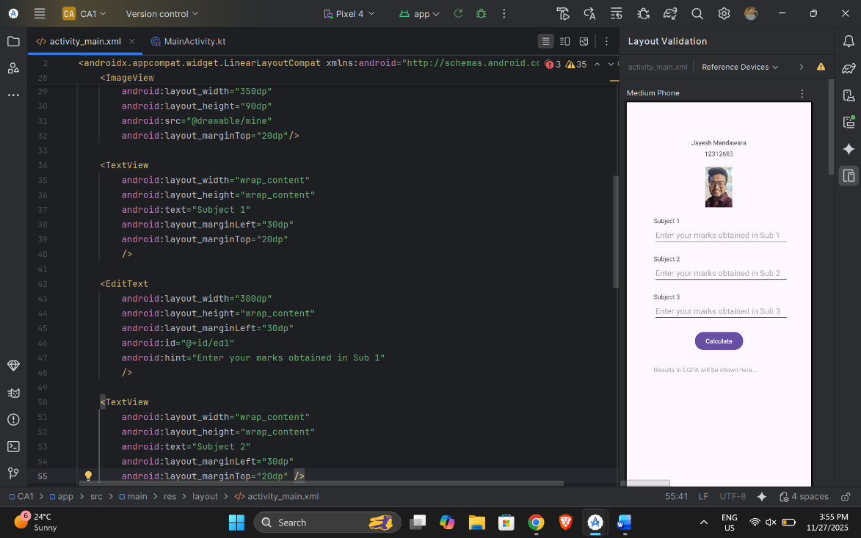

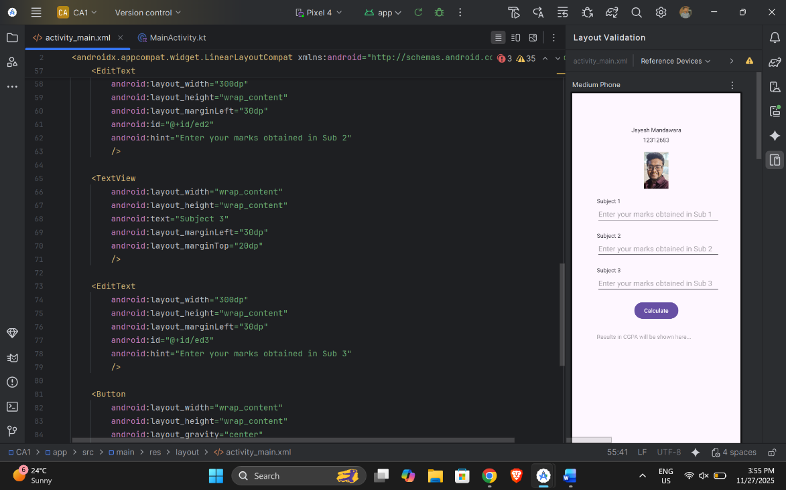

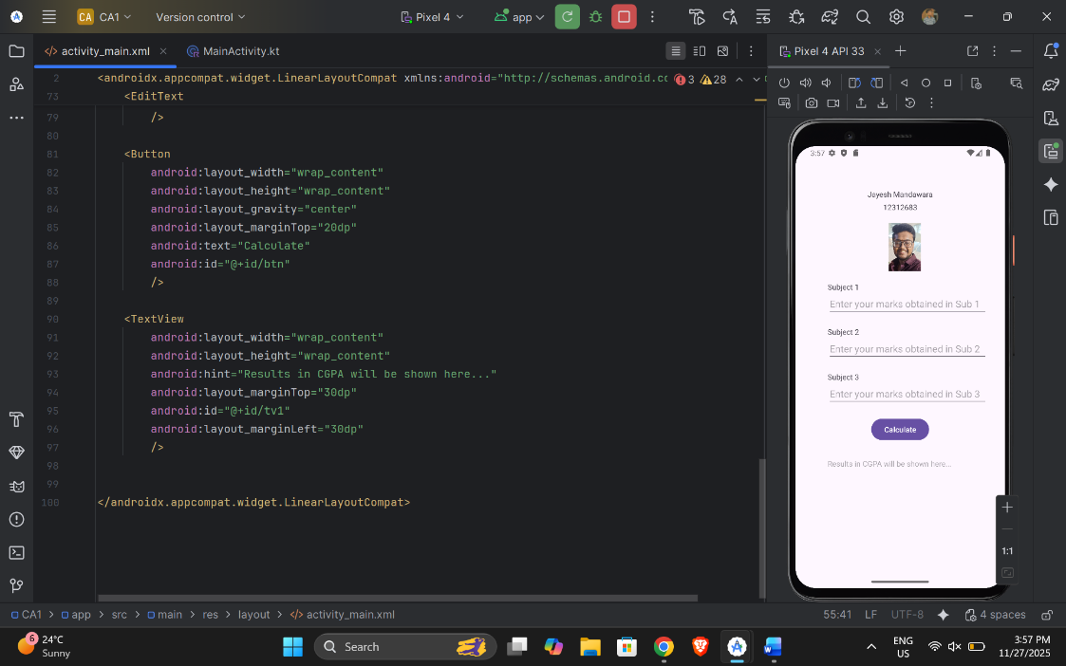

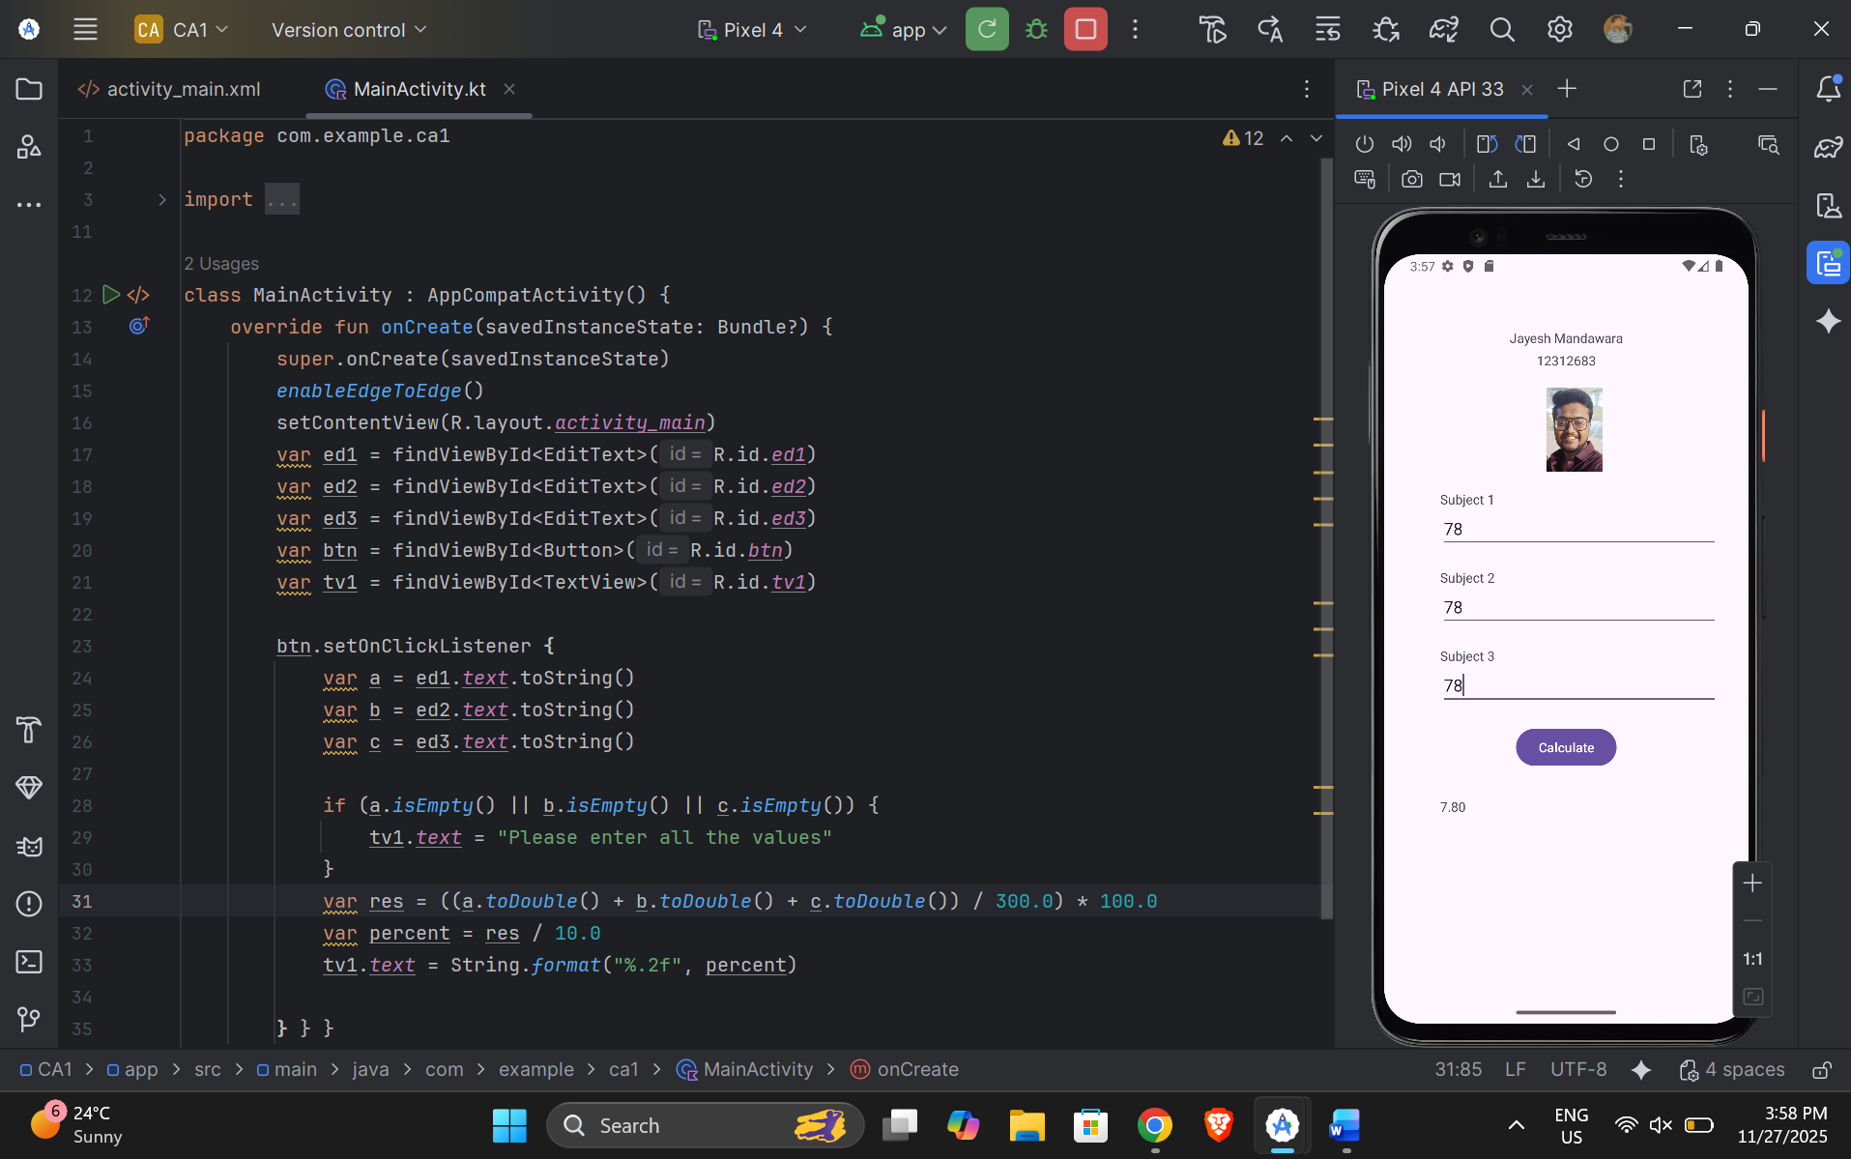

Here is the GitHub Link for this code: - https://github.com/Jayesh-Mandawara/Android_CA1_12312683_JayeshMandawara

