**Practical - 1**

**Aim:** To experiment on Simulation Tools: (CISCO PACKET TRACER).

**About CISCO Packet Tracer:**

**What is CISCO Packet Tracer?**

**Cisco Packet Tracer** is a powerful network simulation tool developed by Cisco Systems. It allows users to design, configure, and troubleshoot virtual networks, making it ideal for learning networking concepts. The software supports a wide range of devices, including routers, switches, PCs, and IoT devices, enabling users to simulate real-world networking scenarios. Packet Tracer is widely used in educational environments for CCNA and other networking certifications, as it helps students practice skills without requiring physical hardware. Its user-friendly interface and drag-and-drop functionality make it accessible to beginners. Additionally, it supports multi-user collaboration, allowing users to work on the same network simulation in real-time. Overall, Cisco Packet Tracer is an essential tool for building practical networking knowledge and skills.

**Features of CISCO Packet Tracer:**

* **Network Topology Creation**: Supports designing complex networks with devices like routers, switches, PCs, and IoT components.
* **Realistic Simulation**: Provides a virtual environment to practice network configuration, troubleshooting, and protocol implementation.
* **User-Friendly Interface**: Features a drag-and-drop interface, making it easy to use for beginners.
* **Real-Time and Simulation Modes**: Allows users to observe network behavior and analyze packet flow.
* **Multi-User Collaboration**: Enables teams to work together on the same network project simultaneously.
* **Integration with Cisco Courses**: Works seamlessly with Cisco Networking Academy for hands-on learning and certifications like CCNA.
* **Lightweight Design**: Runs efficiently on various systems without heavy resource requirements.
* **Diverse Device Support**: Includes support for a variety of devices, from traditional network components to IoT devices.

**What is topology?**

A **topology** refers to the layout or arrangement of devices and connections in a network. It defines how computers, switches, routers, and other devices are physically or logically connected to communicate with one another. Topologies can be **physical** (actual hardware connections) or **logical** (how data flows within the network). Common types include **bus, star, ring, mesh**, and **hybrid** topologies, each with unique advantages and use cases. The choice of topology impacts network performance, scalability, and reliability.

1. **Bus Topology**:
   * All devices are connected to a single central cable (bus) with terminators at both ends.
   * Data travels in both directions along the bus, and all devices share the same communication line.
   * 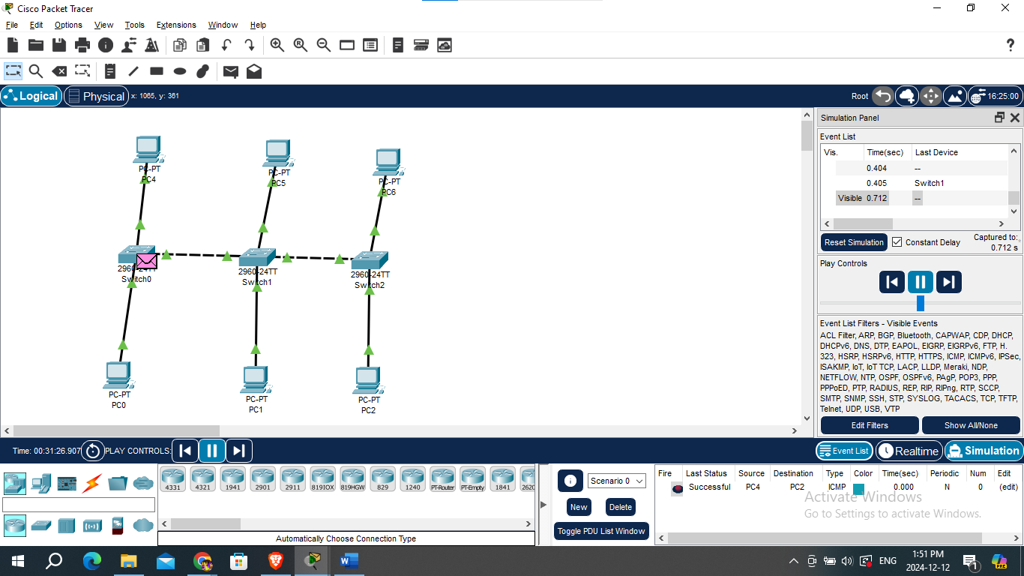It is simple and cost-effective but can experience data collisions and network failure if the main cable is damaged.
2. **Star Topology**:
   * All devices are connected to a central hub or switch, acting as a point of communication.
   * It is easy to install, manage, and troubleshoot, as a single device failure doesn’t affect others.
   * However, the central hub is a single point of failure, and its failure can bring down the entire network.

1. **Ring Topology**:
   * Devices are connected in a circular loop, where data travels in one direction (unidirectional) or both directions (bidirectional).
   * It reduces the risk of collisions, but a single device failure can disrupt the entire network unless redundancy is in place.
   * Common in older networks and token-based communication systems.

1. **Mesh Topology**:
   * Every device connects directly to every other device, creating multiple paths for data transmission.
   * It offers high reliability and fault tolerance, as data can take alternative paths if a connection fails.
   * However, it is expensive and complex to implement due to the large number of connections.

1. **Hybrid Topology**:
   * Combines two or more types of topologies (e.g., star-bus or star-ring) to meet specific network requirements.
   * It is highly flexible, scalable, and reliable, making it suitable for large and complex networks.
   * A computer screen shot of a network

     Description automatically generatedHowever, it can be expensive and challenging to design and manage.

**Conclusion:**

In this practical, we explored the capabilities of **Cisco Packet Tracer** as a powerful network simulation tool. We learned how to create different network topologies, configure various networking devices, and simulate network behavior. Packet Tracer's user-friendly interface and wide range of supported devices allowed us to design and test networks without the need for physical hardware. This practical demonstrated how effective Cisco Packet Tracer is for learning networking concepts, troubleshooting, and practicing real-world network configurations. Overall, Packet Tracer proved to be an invaluable tool for gaining hands-on experience in networking and preparing for certifications like **CCNA**.