**Practical – 3**

**Aim :** To study behavior of generic devices used for networking: (CISCO PACKET TRACER)

**PC (Personal Computer):**

**Description:**

* End-user devices used to send and receive data in a network.
* Operates at the Application Layer of the OSI model.
* Requires IP address configuration for communication.
* Can simulate tasks like ping and data exchange.

**Practical Task:**

1. Drag and drop two PCs into the Cisco Packet Tracer workspace.
2. Assign IP addresses:
   * **PC1:** IP - 192.168.1.2, Subnet Mask - 255.255.255.0.
   * **PC2:** IP - 192.168.1.3, Subnet Mask - 255.255.255.0.
3. Test communication between PCs by using the **ping** command.
   * On PC1, open **Command Prompt** and type:
   * A computer screen shot of a computer screen

     Description automatically generatedping 192.168.1.3

**Switch:**

**Description:**

* Layer 2 device in the OSI model for connecting devices within a LAN.
* Forwards data based on MAC addresses, reducing network collisions.
* Supports VLANs and other configurations in managed switches.
* Used for efficient communication within the same subnet.

**Practical Task:**

1. Drag and drop a Switch into the workspace.
2. Connect the PCs to the Switch using **straight-through cables**:
   * PC1 → Switch (FastEthernet0/1).
   * PC2 → Switch (FastEthernet0/2).
3. A computer screen shot of a computer screen

   Description automatically generatedVerify connectivity between the PCs by testing with the **ping** command as above.

**Hub:**

**Description:**

* Layer 1 device that broadcasts data to all connected devices.
* Creates a single collision domain, leading to less efficient performance compared to switches.
* Best suited for small and simple networks.
* Does not require configuration.

**Practical Task:**

1. Drag and drop a Hub into the workspace.
2. Connect the PCs to the Hub using **straight-through cables**:
   * PC1 → Hub (Port 1).
   * PC2 → Hub (Port 2).
3. A computer screen shot of a computer screen

   Description automatically generatedTest communication between the PCs using the **ping** command. Observe that communication works, but the Hub broadcasts data to all ports.

**Router:**

**Description:**

* Layer 3 device that connects multiple networks and routes packets based on IP addresses.
* Determines the best path for data transmission.
* Requires configuration of interfaces and routing protocols.
* Essential for inter-network communication.

**Practical Task:**

1. Drag and drop a Router into the workspace.
2. Connect the Switch to the Router using a **straight-through cable**:

* Switch (FastEthernet0/0) → Router.

1. Configure the Router:

* Open the **CLI** tab on the Router and execute the following commands:
* Router> enable (Enter privileged exec mode)
* Router# configure terminal (Enter global configuration mode)
* Router(config)# interface fastEthernet 0/0 (Select interface connected to PC1)
* Router(config-if)# ip address 192.168.1.1 255.255.255.0 (Assign IP address to FastEthernet0/0)
* Router(config-if)# no shutdown (Enable the interface)
* Router(config-if)# exit (Exit interface configuration mode)

1. Test communication between the PCs through the Router by setting the default gateway of each PC to 192.168.1.1.

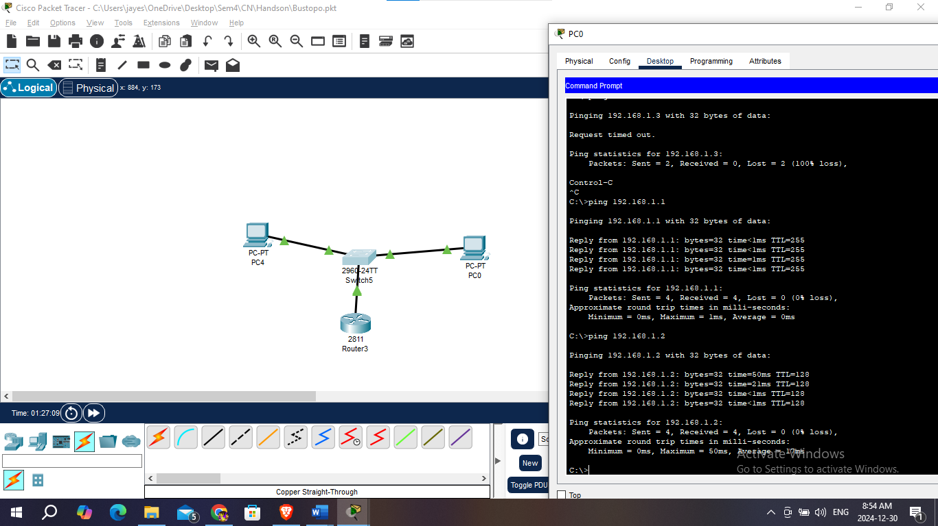

**Conclusion:**

In this practical, we successfully studied and configured the behavior of various networking devices using Cisco Packet Tracer. By simulating the operation of **PCs**, **Switches**, **Hubs**, and **Routers**, we gained a better understanding of their roles in a network.

* **PCs** allowed us to simulate end-user communication by assigning IP addresses and testing connectivity using the ping command.
* **Switches** facilitated efficient data transfer between connected devices, showcasing their role in reducing network collisions.
* **Hubs**, while still functional, demonstrated less efficient data handling by broadcasting data to all devices in the network.
* **Routers** provided the crucial role of inter-network communication, routing data between different networks and managing traffic with IP addressing.

Overall, this practical exercise reinforced key networking concepts and provided hands-on experience in configuring and understanding the behavior of networking devices in a simulated environment. This knowledge is fundamental for building and troubleshooting real-world networks.