Experiment :1

Q1) Write a program to demonstrate status of key on JFrame windows such as keypressed,

keyReleased, keyUp,keyDown.

import javax.swing.*;

import java.awt.event.*;

public class KeyStatusFrame extends JFrame implements KeyListener {

private JLabel statusLabel;

public KeyStatusFrame() {

setTitle("Key Event Demo");

setSize(400, 200);

setDefaultCloseOperation(JFrame.EXIT_ON_CLOSE);

setLayout(new FlowLayout());

statusLabel = new JLabel("Press any key...");

add(statusLabel);

// Add key listener to the frame

addKeyListener(this);

setFocusable(true);

requestFocusInWindow();

}

public void keyPressed(KeyEvent e) {

statusLabel.setText("Key Pressed: " + KeyEvent.getKeyText(e.getKeyCode()));

}

public void keyReleased(KeyEvent e) {

statusLabel.setText("Key Released: " + KeyEvent.getKeyText(e.getKeyCode()));

}

public void keyTyped(KeyEvent e) {

statusLabel.setText("Key Typed: " + e.getKeyChar());

}

public static void main(String[] args) {

KeyStatusFrame frame = new KeyStatusFrame();

frame.setVisible(true);

}

}

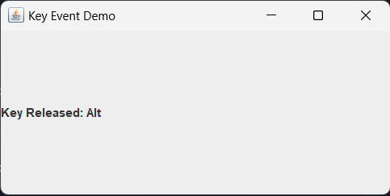

Q2) Develop a program to create three buttons yes, no and exit using JFrame . When user click on button "yes" it will show the message "you pressed yes" if riser press "no" button it will show " you pressed no" else show "you pressed exit".

import javax.swing.*;

import java.awt.*;

import java.awt.event.ActionEvent;

import java.awt.event.ActionListener;

public class ButtonClickFrame extends JFrame implements ActionListener {

private JButton yesButton, noButton, exitButton;

private JLabel messageLabel;

public ButtonClickFrame() {

setTitle("Button Click Example");

setSize(300, 150);

setDefaultCloseOperation(JFrame.EXIT_ON_CLOSE);

setLayout(new FlowLayout());

yesButton = new JButton("Yes");

noButton = new JButton("No");

exitButton = new JButton("Exit");

yesButton.addActionListener(this);

noButton.addActionListener(this);

exitButton.addActionListener(this);

add(yesButton);

add(noButton);

add(exitButton);

messageLabel = new JLabel("");

add(messageLabel);

}

public void actionPerformed(ActionEvent e) {

if (e.getSource() == yesButton) {

messageLabel.setText("You pressed Yes");

} else if (e.getSource() == noButton) {

messageLabel.setText("You pressed No");

} else if (e.getSource() == exitButton) {

messageLabel.setText("You pressed Exit");

Timer timer = new Timer(1000, new ActionListener() {

public void actionPerformed(ActionEvent evt) {

System.exit(0);

}

});

timer.setRepeats(false);

timer.start();

}

}

public static void main(String[] args) {

ButtonClickFrame frame = new ButtonClickFrame();

frame.setVisible(true);

}

}

