Experiment 2

Q1Develop a program to create Frame to accept a number in two Textfield and display

the largest of two numbers when a button with the caption ,,Largest,, is pressed

import javax.swing.*;

import java.awt.*;

import java.awt.event.ActionEvent;

import java.awt.event.ActionListener;

public class LargestNumberFrame extends JFrame implements ActionListener {

private JTextField num1Field, num2Field;

private JButton findLargestButton;

private JLabel resultLabel;

public LargestNumberFrame() {

setTitle("Find the Largest Number");

setSize(400, 200);

setDefaultCloseOperation(JFrame.EXIT_ON_CLOSE);

setLayout(new FlowLayout());

num1Field = new JTextField(10);

num2Field = new JTextField(10);

add(new JLabel("Number 1:"));

add(num1Field);

add(new JLabel("Number 2:"));

add(num2Field);

findLargestButton = new JButton("Largest");

findLargestButton.addActionListener(this);

add(findLargestButton);

resultLabel = new JLabel("");

add(resultLabel);

}

@Override

public void actionPerformed(ActionEvent e) {

try {

int number1 = Integer.parseInt(num1Field.getText());

int number2 = Integer.parseInt(num2Field.getText());

int largest = Math.max(number1, number2);

resultLabel.setText("Largest number is: " + largest);

} catch (NumberFormatException ex) {

resultLabel.setText("Please enter valid numbers.");

}

}

public static void main(String[] args) {

LargestNumberFrame frame = new LargestNumberFrame();

frame.setVisible(true);

}

}

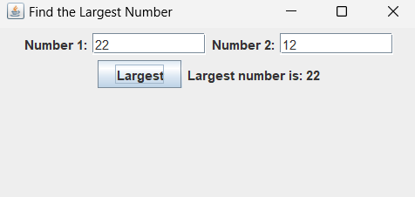

Q2)Develop a program to create Frame to accept a number in a fextfietd and display

the square of a number when a button with the caption ,,Square,, is pressed

import javax.swing.*;

import java.awt.*;

import java.awt.event.ActionEvent;

import java.awt.event.ActionListener;

public class SquareNumberFrame extends JFrame implements ActionListener {

private JTextField numberField;

private JButton squareButton;

private JLabel resultLabel;

public SquareNumberFrame() {

setTitle("Square Number Calculator");

setSize(300, 150);

setDefaultCloseOperation(JFrame.EXIT_ON_CLOSE);

setLayout(new FlowLayout());

numberField = new JTextField(10);

add(new JLabel("Number:"));

add(numberField);

squareButton = new JButton("Square");

squareButton.addActionListener(this);

add(squareButton);

resultLabel = new JLabel("");

add(resultLabel);

}

@Override

public void actionPerformed(ActionEvent e) {

try {

int number = Integer.parseInt(numberField.getText());

int square = number * number;

resultLabel.setText("Square of " + number + " is: " + square);

} catch (NumberFormatException ex) {

resultLabel.setText("Please enter a valid number.");

}

}

public static void main(String[] args) {

SquareNumberFrame frame = new SquareNumberFrame();

frame.setVisible(true);

}

}

