Student Academic Performance Analysis Dashboard
B.Tech Computer Engineering Mini-Project
Prepared as an educational project template. Replace institution, student, guide, and academic-year details before submission.

1. Abstract
The Student Academic Performance Analysis Dashboard is a Python-based application that processes student marks and presents academic information through tables, summary indicators, and charts. It uses Pandas for data manipulation, NumPy for numerical operations, Matplotlib for visualizations, and Streamlit for the interactive interface. Users can load a sample dataset or upload a CSV file, filter records, inspect subject-wise performance, review grade distribution, and download analyzed results.

2. Problem Statement
Academic records may be stored as spreadsheets that are difficult to summarize consistently. Manually comparing subjects, classes, and student performance can take time and can introduce calculation errors. This project demonstrates a repeatable way to summarize a structured dataset and visualize patterns.

3. Objectives
- Load student records from CSV files.
- Validate required fields and marks ranges.
- Calculate total marks, averages, grades, pass/fail status, and ranks.
- Visualize subject averages and grade distributions.
- Provide filters, search, and downloadable results.

4. Scope
The project is a learning and demonstration tool. It does not connect to a college management system, authenticate users, or make official academic decisions. The grading rules in the prototype must be changed to match an institution's policy before any real use.

5. Technology Stack
- Python: application logic.
- NumPy: numerical calculations and pass/fail condition support.
- Pandas: CSV loading, data validation, grouping, and aggregation.
- Matplotlib: bar, pie, and histogram charts.
- Streamlit: interactive web interface.
- CSV: portable input/output format.

6. System Architecture
The data flows from a CSV dataset through validation and analysis. The processed data is passed to chart functions and the Streamlit dashboard.
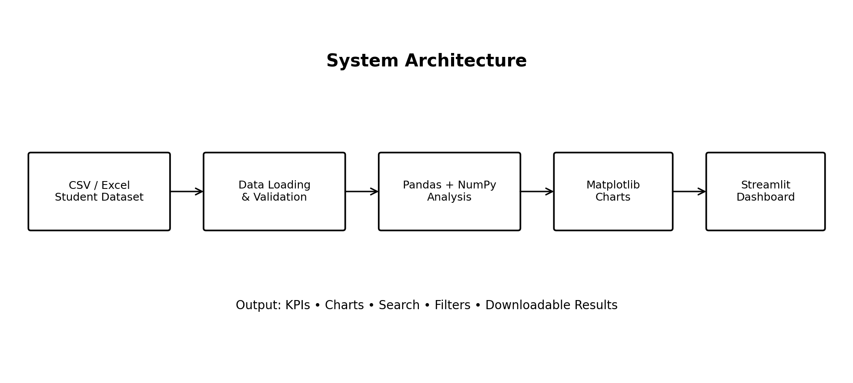

7. Methodology
- Read the uploaded CSV or bundled sample dataset.
- Check required columns, numeric marks, allowed mark range, and unique student IDs.
- Compute total and average marks across four subjects.
- Assign a grade using the demonstration grade boundaries.
- Mark a student as passing when the average is at least 40 and each subject is at least 35.
- Calculate summary metrics and group-level summaries.
- Render charts and interactive tables in Streamlit.

8. Demonstration Rules
The prototype uses four subjects: Math, Science, English, and Computer. Marks are expected from 0 to 100. Grade boundaries: A ≥ 80, B ≥ 70, C ≥ 60, D ≥ 50, E ≥ 40, F < 40. Pass requires average marks ≥ 40 and each subject mark ≥ 35. These rules are illustrative, not an assertion of DBATU or any college policy.

9. Testing Plan
Test | Expected behavior | Status
Open with sample dataset | Dashboard loads with KPIs and charts | To be verified by user
Upload valid CSV | Records are analyzed and displayed | To be verified by user
Missing required column | Readable validation error is shown | To be verified by user
Marks below 0 or above 100 | Dataset is rejected with an error | To be verified by user
Search by name or ID | Table shows matching records | To be verified by user
Download filtered results | CSV file downloads with visible records | To be verified by user

10. Limitations
- Prototype uses a fixed set of four subjects.
- Grade and pass rules are demonstration values.
- CSV data is not stored in a database.
- No login or role-based access is implemented.
- Sample data is fictional; real data requires authorization and privacy safeguards.

11. Future Enhancements
- Add subject selection and configurable grading rules.
- Add database storage and authenticated roles.
- Support semester-to-semester trend analysis with suitable data.
- Export a formatted PDF report.
- Add unit tests and deployment.

12. Conclusion
This project demonstrates how Python data-analysis libraries can transform structured student marks into summary indicators and visualizations. It provides a foundation for learning data cleaning, aggregation, charting, and dashboard development.

13. References
- Python documentation: https://docs.python.org/
- Pandas documentation: https://pandas.pydata.org/docs/
- NumPy documentation: https://numpy.org/doc/
- Matplotlib documentation: https://matplotlib.org/stable/
- Streamlit documentation: https://docs.streamlit.io/

