**BIRLA INSTITUTE OF TECHNOLOGY AND SCIENCE, PILANI**

**Integrated Biology (BIO F214) -** First Semester 2017-18

**Compre – Part B - CLOSED BOOK - Solutions**

Date: 09/12/2017 Max Duration: 2 hrs. Max Marks: 61 (30.5% weightage)

**Name: ID No.:**

**1.** DIAGRAM BASED QUESTIONS: (5 x 4M = 20M)

In each of the next five questions, draw well-labelled diagrams only to explain the specific concept.

**(i)**

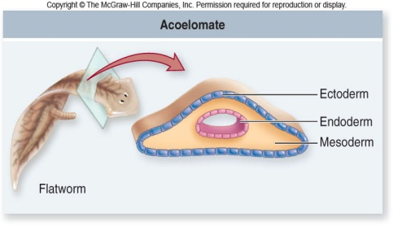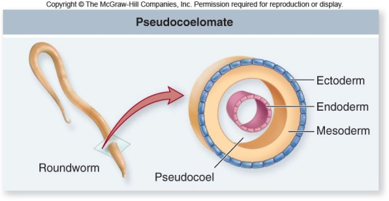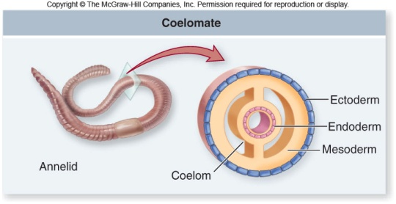

**(ii)**

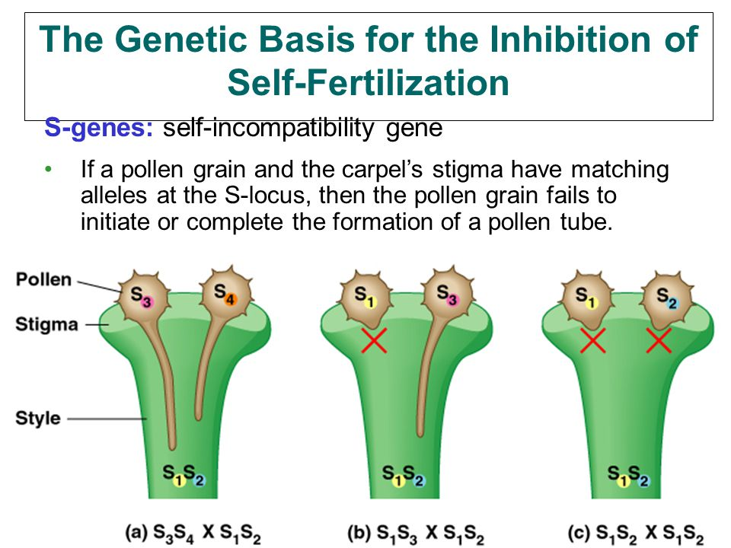

**(iii)**

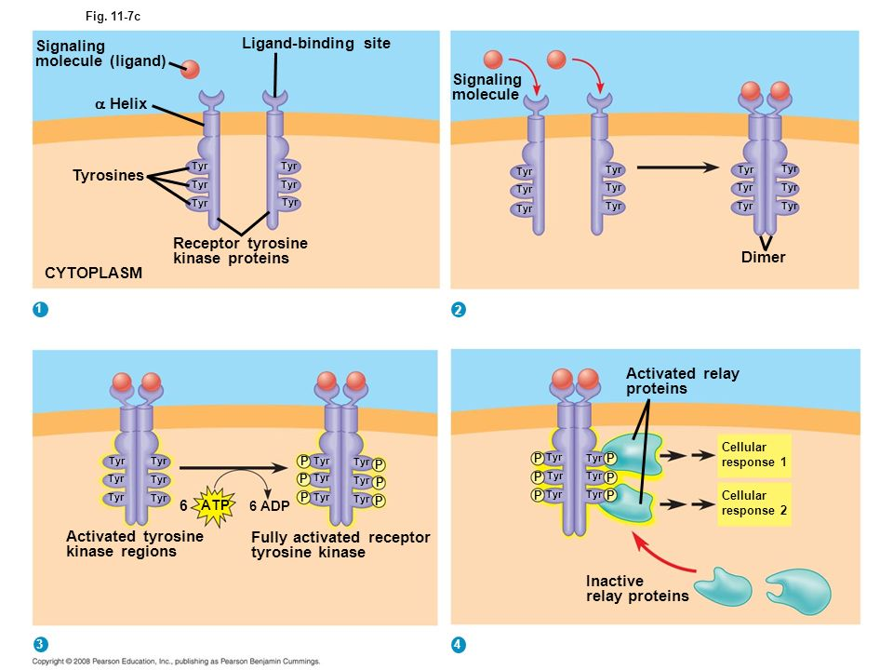

**(iv)**

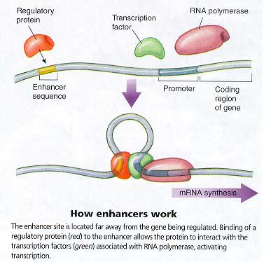

**(v)**

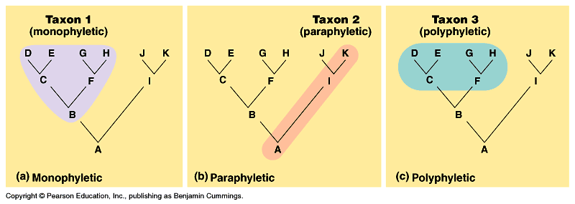

**2.** TRUE/FALSE QUESTIONS: (10 x 2M=20M)

Identify whether the given statements are true or false. In case the statement is false, justify the same in one line. No marks would be awarded for wrong/missing justification. No need to justify the true statements.

**(i)** **TRUE**

**(ii)** **FALSE; Constructive gene flow does not cause, but spreads beneficial mutation to other populations.**

**(iii)** **FALSE; Double fertilization is a characteristic feature of angiosperm reproduction.**

**(iv)** **FALSE; ….can be explained by pleiotropy or linkage.**

**(v)** **TRUE**

**(vi)** **TRUE**

**(vii)** **FALSE: Both were allopolyploid events.**

**(viii)** **FALSE; Drosophila *Antennapedia* mutant has a leg where an antenna should be present.**

**(ix)** **TRUE**

**(x)** **FALSE; ….differs by two amino acids.**

**3.** BRIEF NOTES: (4x4M=16M)

Write brief notes (around 100 words) to explain each of the following concepts/phenomena.

**(i)**

**Ans. Arthropods' rigid exoskeletons provide protection. Disadvantages are: Since the exoskeleton is hard and its outer layer is non-living, it cannot grow bigger by small increments as the human skeleton does. Instead, arthropods must go through the delicate process of shedding the old exoskeleton and expanding to a larger size before the new exoskeleton hardens (Molting).**

**(ii)**

**Ans. Flowers – to attract pollinators; seed – better structure than spores for resisting harsh weather conditions; vascular system – to conduct water and nutrients; fruit – for protection of seed; true leaves – for efficient capture of sunlight. Also, stems and roots.**

**(iii)**

**Ans. Natural apples, grown from seeds, are tremendously diverse and bitter tasting. This is easy to understand as the bitterness compounds are protective against insects and herbivores. This is natural selection. The bitter apples have been used by humans for producing cider. Humans have selected the sweet varieties and propagated them not from seeds but by grafting. These sweet varieties form the major market produce today.**

**(iv)**

**Ans. Biological species concept defines species as groups of interbreeding populations that are reproductively isolated.**

**Ecological species concept defines a species to be a population perfectly adapted to a given set of environmental conditions (ecological niche).**

**Phylogenetic species concept defines species as a population or set of populations characterized by one or more shared derived characters. Here evolutionary history is important.**

**4.** CONCEPT MAP QUESTION: (5M)

Draw a single, detailed and precise concept map to logically and scientifically link the following concepts/phenomena studied in this course (not necessarily in the sequence given): Hardy-Weinberg Equilibrium, HIV evolution, disease treatment by comparative genomics approach, types of evidences for Darwinian evolution, forbidden archaeology, creationism.

**Ans. To be evaluated based on the merit of the answer.**